The Little Tubes Data With R

> tubes = read.table("http://www.utstat.utoronto.ca/~brunner/data/legal/LittleTubes2.data.txt")
> tubes # See the whole data set
mcg length10 weight
1 198 27.80 0.5996
2 198 28.20 0.6040
3 198 27.60 0.6172
4 198 27.50 0.6053
5 205 24.95 0.6769
6 205 25.70 0.7057
7 205 25.40 0.7271
8 205 25.30 0.6029
9 213 26.85 0.6023
10 213 24.35 0.6976
11 213 24.70 0.7154
12 213 24.35 0.6575
13 221 23.35 0.5958
14 221 23.00 0.6789
15 221 22.30 0.6965
16 221 23.15 0.6433
17 223 24.10 0.5479
18 223 24.55 0.5604
19 223 24.35 0.5446
20 223 24.40 0.5398
21 225 23.55 0.5615
22 225 24.55 0.6363
23 225 24.70 0.5753
24 225 23.85 0.6627
> summary(tubes)
mcg length10 weight
Min. :198.0 Min. :22.30 Min. :0.5398
1st Qu.:205.0 1st Qu.:24.04 1st Qu.:0.5907
Median :217.0 Median :24.55 Median :0.6112
Mean :214.2 Mean :24.94 Mean :0.6273
3rd Qu.:223.0 3rd Qu.:25.48 3rd Qu.:0.6774
Max. :225.0 Max. :28.20 Max. :0.7271
> attach(tubes)
> # mcg is categorical. Make it a factor

> mcg = factor(mcg); table(mcg)
mcg
198 205 213 221 223 225
4 4 4 4 4 4
>
> # Look what you have to do to get a table of means and standard deviations.
> aggregate(length10,by=list(mcg),FUN=mean)
Group.1 x
1 198 27.7750
2 205 25.3375
3 213 25.0625
4 221 22.9500
5 223 24.3500
6 225 24.1625

> # Aggregate returns a data frame. Get a nice table.
> Mean = aggregate(length10,by=list(mcg),FUN=mean)$x
> SD = sqrt(aggregate(length10,by=list(mcg),FUN=var)$x)
> Meanz = data.frame(table(mcg),Mean,SD); Meanz
mcg Freq Mean SD
1 198 4 27.7750 0.3095696
2 205 4 25.3375 0.3092329
3 213 4 25.0625 1.2030344
4 221 4 22.9500 0.4564355
5 223 4 24.3500 0.1870829
6 225 4 24.1625 0.5513242
> contrasts(mcg) # See the dummy variable coding scheme
205 213 221 223 225
198 0 0 0 0 0
205 1 0 0 0 0
213 0 1 0 0 0
221 0 0 1 0 0
223 0 0 0 1 0
225 0 0 0 0 1

> mod1 = lm(length10 ~ mcg); summary(mod1)

Call:
lm(formula = length10 ~ mcg)

Residuals:
Min 1Q Median 3Q Max
-0.7125 -0.3250 0.0125 0.2406 1.7875

Coefficients:
Estimate Std. Error t value Pr(>|t|)
(Intercept) 27.7750 0.3018 92.030 < 2e-16 ***
mcg205 -2.4375 0.4268 -5.711 2.05e-05 ***
mcg213 -2.7125 0.4268 -6.355 5.49e-06 ***
mcg221 -4.8250 0.4268 -11.305 1.31e-09 ***
mcg223 -3.4250 0.4268 -8.025 2.35e-07 ***
mcg225 -3.6125 0.4268 -8.464 1.09e-07 ***
---
Signif. codes: 0 ‘***’ 0.001 ‘**’ 0.01 ‘*’ 0.05 ‘.’ 0.1 ‘ ’ 1

Residual standard error: 0.6036 on 18 degrees of freedom
Multiple R-squared: 0.8889, Adjusted R-squared: 0.8581
F-statistic: 28.81 on 5 and 18 DF, p-value: 5.415e-08

> # Look at residuals
> dsr = rstudent(mod1)
> hist(dsr)

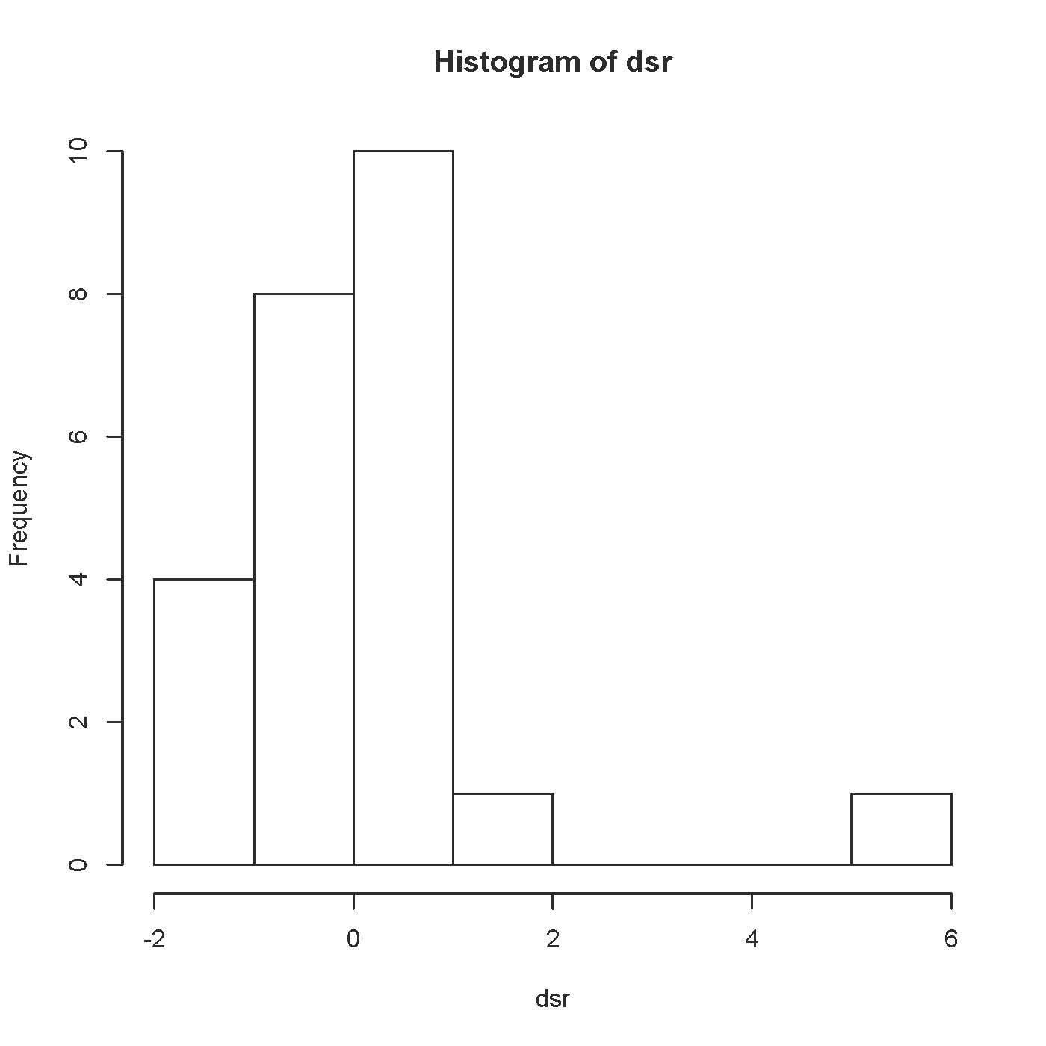

> sort(dsr)
10 12 15 21 5 11
-1.39876217 -1.39876217 -1.26392161 -1.18478153 -0.73165799 -0.68311253
24 4 17 3 8 19
-0.58682517 -0.51523021 -0.46775769 -0.32636103 -0.06972642 0.00000000
1 20 14 7 16 18
0.04648059 0.09297890 0.09297890 0.11624025 0.37334224 0.37334224
6 22 13 2 23 9
0.68311253 0.73165799 0.75604063 0.80503969 1.02997597 5.61400431

> # Likely outlier. Check with Bonferroni correction.
> n = length(mcg)
> bcrit = qt(1-0.05/(2*n),17); bcrit
[1] 3.626963
> # Could do it automatically for larger data sets.
> dsr[abs(dsr)>bcrit]
9
5.614004
>

> # Should have done this plot first
> plot(mcg,length10); title("Fungus length at day 10") # Oops

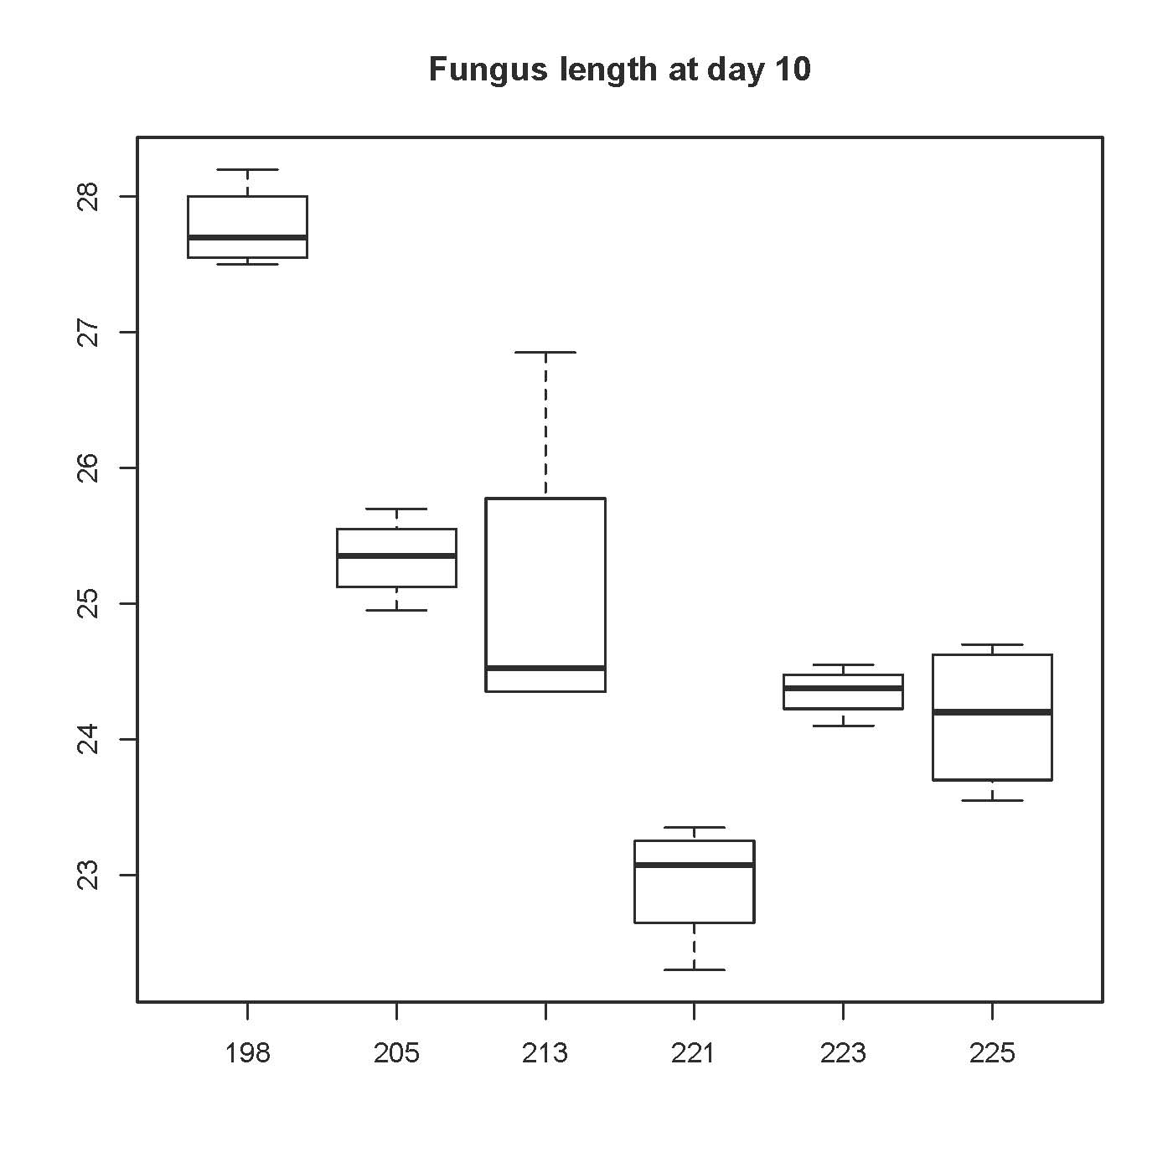

> # Do it right and make it look good
> MCG = as.numeric(mcg) # Has values 1:6
> plot(MCG,length10,xaxt='n',xlab='Mycelial Compatibility Group')
> axis(side=1,at=1:6,labels=unique(mcg))
> title("Fungus length at day 10")
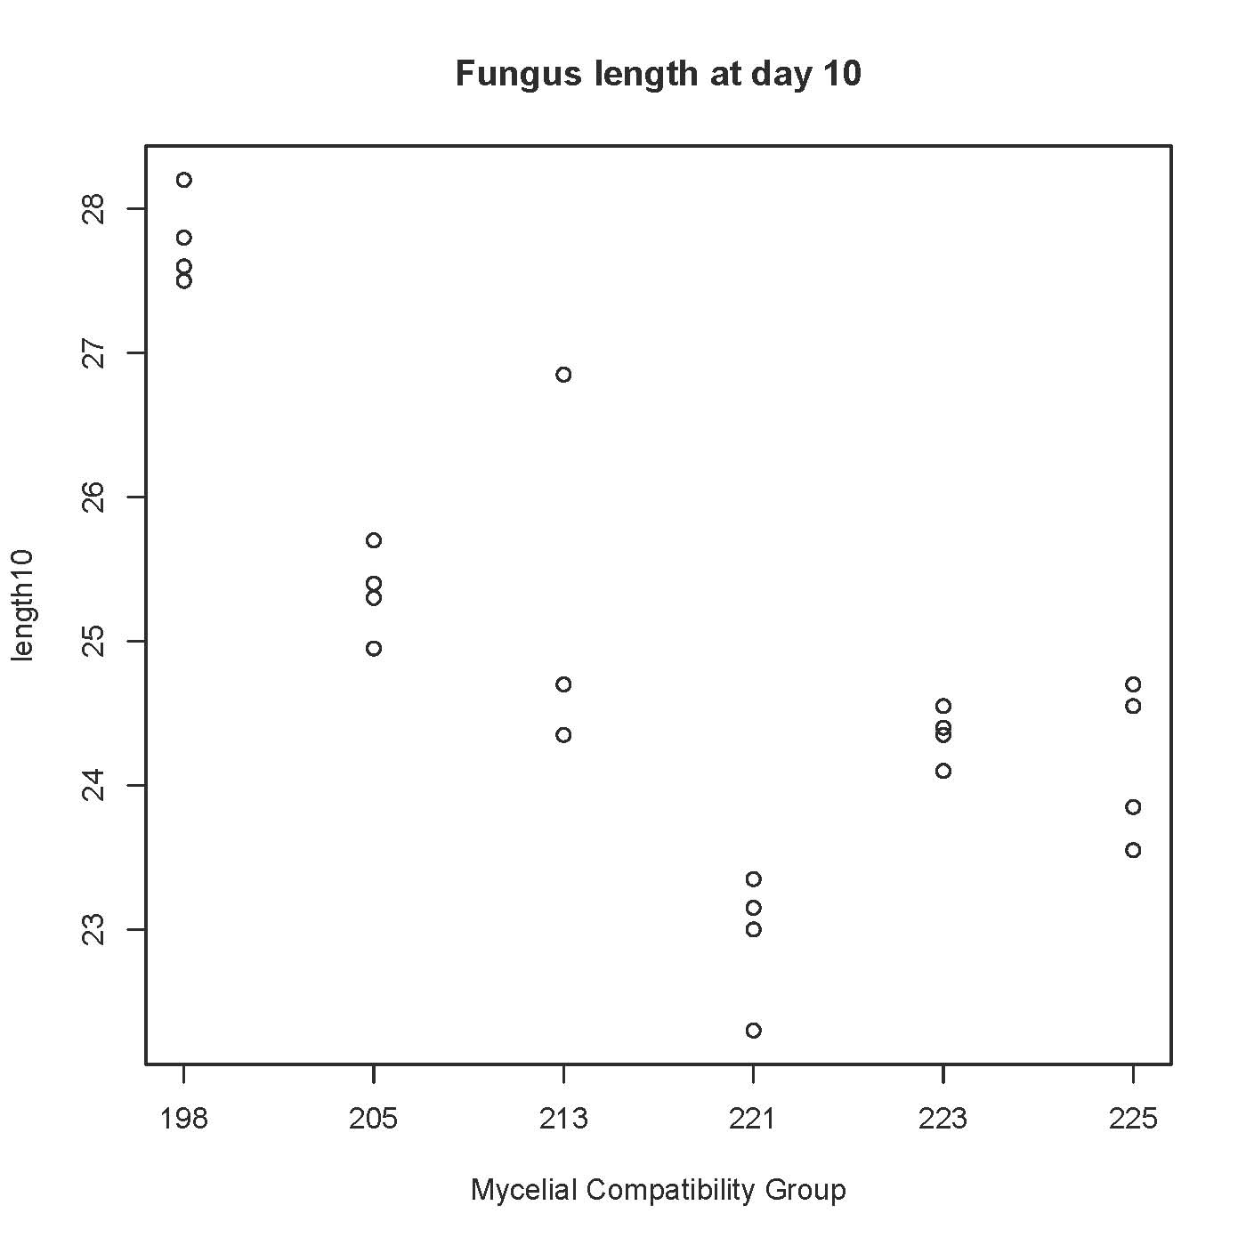
>
> sort(length10[mcg==213])
[1] 24.35 24.35 24.70 26.85
> length10[9] # That's the outlier.
[1] 26.85
> # The botanists persuaded me to throw it out.
> length10[9] = NA # Missing value
>
> # Means and standard deviations again
> Mean = aggregate(length10,by=list(mcg),FUN=mean)$x
> SD = sqrt(aggregate(length10,by=list(mcg),FUN=var)$x)
> Meanz = data.frame(table(mcg),Mean,SD); Meanz
mcg Freq Mean SD
1 198 4 27.7750 0.3095696
2 205 4 25.3375 0.3092329
3 213 4 NA NA
4 221 4 22.9500 0.4564355
5 223 4 24.3500 0.1870829
6 225 4 24.1625 0.5513242
> # Irritating.

> Mean = aggregate(length10,by=list(mcg),FUN=mean,na.rm=T)$x
> SD = sqrt(aggregate(length10,by=list(mcg),FUN=var,na.rm=T)$x)
> Meanz = data.frame(table(mcg),Mean,SD); Meanz
mcg Freq Mean SD
1 198 4 27.77500 0.3095696
2 205 4 25.33750 0.3092329
3 213 4 24.46667 0.2020726
4 221 4 22.95000 0.4564355
5 223 4 24.35000 0.1870829
6 225 4 24.16250 0.5513242
> # Mean and SD are correct now, but n is still wrong.
> mcg[9] = NA; table(mcg)
mcg
198 205 213 221 223 225
4 4 3 4 4 4
> Mean = aggregate(length10,by=list(mcg),FUN=mean,na.rm=T)$x
> SD = sqrt(aggregate(length10,by=list(mcg),FUN=var,na.rm=T)$x)
> Meanz = data.frame(table(mcg),Mean,SD); Meanz
mcg Freq Mean SD
1 198 4 27.77500 0.3095696
2 205 4 25.33750 0.3092329
3 213 3 24.46667 0.2020726
4 221 4 22.95000 0.4564355
5 223 4 24.35000 0.1870829
6 225 4 24.16250 0.5513242
>
>

> # Fit the model again
> mod2 = lm(length10 ~ mcg); summary(mod2)

Call:
lm(formula = length10 ~ mcg)

Residuals:
Min 1Q Median 3Q Max
-0.6500 -0.2125 0.0250 0.2167 0.5375

Coefficients:
Estimate Std. Error t value Pr(>|t|)
(Intercept) 27.7750 0.1838 151.092 < 2e-16 ***
mcg205 -2.4375 0.2600 -9.376 3.95e-08 ***
mcg213 -3.3083 0.2808 -11.782 1.33e-09 ***
mcg221 -4.8250 0.2600 -18.560 1.01e-12 ***
mcg223 -3.4250 0.2600 -13.174 2.38e-10 ***
mcg225 -3.6125 0.2600 -13.896 1.04e-10 ***
---
Signif. codes: 0 ‘***’ 0.001 ‘**’ 0.01 ‘*’ 0.05 ‘.’ 0.1 ‘ ’ 1

Residual standard error: 0.3677 on 17 degrees of freedom
(1 observation deleted due to missingness)
Multiple R-squared: 0.9584, Adjusted R-squared: 0.9462
F-statistic: 78.34 on 5 and 17 DF, p-value: 3.953e-11

> # Compare R^2 = 0.8889 and F = 28.81
>
> # MCG198 clearly grows faster than the others. Compare all the others.
> source("http://www.utstat.utoronto.ca/~brunner/Rfunctions/ftest.txt")
> # Make a table
> L1 = rbind(c( 0, 1,-1, 0, 0, 0),
+ c( 0, 0, 1,-1, 0, 0),
+ c( 0, 0, 0, 1,-1, 0),
+ c( 0, 0, 0, 0, 1,-1) )
> ftest(mod2,L1)
F df1 df2 p-value
2.164083e+01 4.000000e+00 1.700000e+01 1.731025e-06

>
> # Multiple comparisons. TukeyHSD is easiest.
> aov2 = aov(length10 ~ mcg); summary(aov2)
Df Sum Sq Mean Sq F value Pr(>F)
mcg 5 52.94 10.589 78.33 3.95e-11 ***
Residuals 17 2.30 0.135
---
Signif. codes: 0 ‘***’ 0.001 ‘**’ 0.01 ‘*’ 0.05 ‘.’ 0.1 ‘ ’ 1
1 observation deleted due to missingness
> TukeyHSD(aov2)
Tukey multiple comparisons of means
95% family-wise confidence level

Fit: aov(formula = length10 ~ mcg)

$mcg
diff lwr upr p adj
205-198 -2.4375000 -3.269076 -1.60592404 0.0000005
213-198 -3.3083333 -4.206538 -2.41012864 0.0000000
221-198 -4.8250000 -5.656576 -3.99342404 0.0000000
223-198 -3.4250000 -4.256576 -2.59342404 0.0000000
225-198 -3.6125000 -4.444076 -2.78092404 0.0000000
213-205 -0.8708333 -1.769038 0.02737136 0.0603187
221-205 -2.3875000 -3.219076 -1.55592404 0.0000007
223-205 -0.9875000 -1.819076 -0.15592404 0.0151272
225-205 -1.1750000 -2.006576 -0.34342404 0.0034487
221-213 -1.5166667 -2.414871 -0.61846197 0.0005762
223-213 -0.1166667 -1.014871 0.78153803 0.9981172
225-213 -0.3041667 -1.202371 0.59403803 0.8814129
223-221 1.4000000 0.568424 2.23157596 0.0005949
225-221 1.2125000 0.380924 2.04407596 0.0025656
225-223 -0.1875000 -1.019076 0.64407596 0.9765713

>
> # Bonferroni and Scheffe will be easier with cell means coding.
> # Make dummy variables ...
> # The missing values create such complications that I will quit R,
> # read the data again, and get rid of tube 9 another way.
>

> rm(list=ls())
> tubes = read.table("http://www.utstat.toronto.edu/~brunner/appliedf14/code_n_data/lecture/littletubes.data")
> tubes = tubes[-9,] # All rows but 9, all columns
> tubes
mcg length10 weight
1 198 27.80 0.5996
2 198 28.20 0.6040
3 198 27.60 0.6172
4 198 27.50 0.6053
5 205 24.95 0.6769
6 205 25.70 0.7057
7 205 25.40 0.7271
8 205 25.30 0.6029
10 213 24.35 0.6976
11 213 24.70 0.7154
12 213 24.35 0.6575
13 221 23.35 0.5958
14 221 23.00 0.6789
15 221 22.30 0.6965
16 221 23.15 0.6433
17 223 24.10 0.5479
18 223 24.55 0.5604
19 223 24.35 0.5446
20 223 24.40 0.5398
21 225 23.55 0.5615
22 225 24.55 0.6363
23 225 24.70 0.5753
24 225 23.85 0.6627
> attach(tubes)
> # Make indicator dummy variables
> mcg198 = mcg205 = mcg213 = mcg221 = mcg223 = mcg225 = numeric(23)
> mcg198[mcg==198] = 1
> mcg205[mcg==205] = 1
> mcg213[mcg==213] = 1
> mcg221[mcg==221] = 1
> mcg223[mcg==223] = 1
> mcg225[mcg==225] = 1

> cbind(mcg,mcg198,mcg205,mcg213,mcg221,mcg223,mcg225)
mcg mcg198 mcg205 mcg213 mcg221 mcg223 mcg225
[1,] 198 1 0 0 0 0 0
[2,] 198 1 0 0 0 0 0
[3,] 198 1 0 0 0 0 0
[4,] 198 1 0 0 0 0 0
[5,] 205 0 1 0 0 0 0
[6,] 205 0 1 0 0 0 0
[7,] 205 0 1 0 0 0 0
[8,] 205 0 1 0 0 0 0
[9,] 213 0 0 1 0 0 0
[10,] 213 0 0 1 0 0 0
[11,] 213 0 0 1 0 0 0
[12,] 221 0 0 0 1 0 0
[13,] 221 0 0 0 1 0 0
[14,] 221 0 0 0 1 0 0
[15,] 221 0 0 0 1 0 0
[16,] 223 0 0 0 0 1 0
[17,] 223 0 0 0 0 1 0
[18,] 223 0 0 0 0 1 0
[19,] 223 0 0 0 0 1 0
[20,] 225 0 0 0 0 0 1
[21,] 225 0 0 0 0 0 1
[22,] 225 0 0 0 0 0 1
[23,] 225 0 0 0 0 0 1

> # Fit a model with no intercept
> mod3 = lm(length10 ~ 0 + mcg198+mcg205+mcg213+mcg221+mcg223+mcg225)
> summary(mod3) # Look out

Call:
lm(formula = length10 ~ 0 + mcg198 + mcg205 + mcg213 + mcg221 +
mcg223 + mcg225)

Residuals:
Min 1Q Median 3Q Max
-0.6500 -0.2125 0.0250 0.2167 0.5375

Coefficients:
Estimate Std. Error t value Pr(>|t|)
mcg198 27.7750 0.1838 151.1 <2e-16 ***
mcg205 25.3375 0.1838 137.8 <2e-16 ***
mcg213 24.4667 0.2123 115.3 <2e-16 ***
mcg221 22.9500 0.1838 124.8 <2e-16 ***
mcg223 24.3500 0.1838 132.5 <2e-16 ***
mcg225 24.1625 0.1838 131.4 <2e-16 ***
---
Signif. codes: 0 ‘***’ 0.001 ‘**’ 0.01 ‘*’ 0.05 ‘.’ 0.1 ‘ ’ 1

Residual standard error: 0.3677 on 17 degrees of freedom
Multiple R-squared: 0.9998, Adjusted R-squared: 0.9998
F-statistic: 1.759e+04 on 6 and 17 DF, p-value: < 2.2e-16

> # Compare means
> Mean = aggregate(length10,by=list(mcg),FUN=mean)$x
> SD = sqrt(aggregate(length10,by=list(mcg),FUN=var)$x)
> Meanz = data.frame(table(mcg),Mean,SD); Meanz
mcg Freq Mean SD
1 198 4 27.77500 0.3095696
2 205 4 25.33750 0.3092329
3 213 3 24.46667 0.2020726
4 221 4 22.95000 0.4564355
5 223 4 24.35000 0.1870829
6 225 4 24.16250 0.5513242
>

> # Overall F was 78.34: Check
> source("http://www.utstat.utoronto.ca/~brunner/Rfunctions/ftest.txt")
> L2 = rbind(c( 1,-1, 0, 0, 0, 0),
+ c( 0, 1,-1, 0, 0, 0),
+ c( 0, 0, 1,-1, 0, 0),
+ c( 0, 0, 0, 1,-1, 0),
+ c( 0, 0, 0, 0, 1,-1) )
> ftest(mod3,L2)
F df1 df2 p-value
7.833542e+01 5.000000e+00 1.700000e+01 3.952683e-11
>
> # Bonferroni pairwise comparisons
> choose(6,2)
[1] 15
> # Make a matrix of p-values and test statistics
> testmatrix = diag(1,6,6) # Start with an identity matrix.
> labelz = as.character(unique(mcg))
> rownames(testmatrix) = labelz; colnames(testmatrix) = labelz
> testmatrix
198 205 213 221 223 225
198 1 0 0 0 0 0
205 0 1 0 0 0 0
213 0 0 1 0 0 0
221 0 0 0 1 0 0
223 0 0 0 0 1 0
225 0 0 0 0 0 1
>
> for(i in 1:5)
+ {
+ for(j in (i+1):6)
+ {
+ LL = rbind(c(0,0,0,0,0,0))
+ LL[i]=1; LL[j]=-1
+ # print(LL) # Just to check
+ Fstat = ftest(mod3,L=LL)
+ testmatrix[i,j] = Fstat[1]; testmatrix[j,i]=min(Fstat[4]*15,1)
+ } # Next j
+ } # Next i
>

> # Test statistics (F with df=1,17) are in the upper triangle,
> # p-values in lower
> round(testmatrix,4)
198 205 213 221 223 225
198 1 87.9091 138.8086 344.4604 173.5665 193.0903
205 0 1.0000 9.6176 84.3396 14.4284 20.4277
213 0 0.0973 1.0000 29.1728 0.1726 1.1733
221 0 0.0000 0.0007 1.0000 29.0002 21.7524
223 0 0.0215 1.0000 0.0007 1.0000 0.5202
225 0 0.0045 1.0000 0.0033 1.0000 1.0000
>
> # Scheffe Tests: Adjusted p-value is the tail area beyond F/(p-1)
> # Using the null distribution of the INITIAL test
> # Just re-compute the adjusted p-values
> for(i in 1:5)
+ {
+ for(j in (i+1):6)
+ {
+ testmatrix[j,i] = 1-pf(testmatrix[i,j]/5,5,17)
+ } # Next j
+ } # Next i
> round(testmatrix,4)
198 205 213 221 223 225
198 1 87.9091 138.8086 344.4604 173.5665 193.0903
205 0 1.0000 9.6176 84.3396 14.4284 20.4277
213 0 0.1431 1.0000 29.1728 0.1726 1.1733
221 0 0.0000 0.0026 1.0000 29.0002 21.7524
223 0 0.0459 0.9993 0.0027 1.0000 0.5202
225 0 0.0128 0.9419 0.0099 0.9899 1.0000
>

The real data file

Fungus was grown in a test tubes for 14 days. Twice a day, the investigators' graduate students measured the length of the fungus in the tube, the fuzzy "leading edge" of the growth, and the number of sclerotia, which are like little seed pods; actually they're spores, not seeds. At the end of the experiment, they also weighed the sclerotia and calculated the slope of the least-squares line relating day to length. There are 14 lines of data per case. On each line, the variables are

- Line number
- Mycelial Compatibility Group (MCG): Genetic type of fungus
- Replication (1-4)
- Day
- Morning length
- Morning number of sclerotia
- Morning leading edge
- Evening length
- Evening number of sclerotia
- Evening leading edge
- Least-squares slope of morning measurements
- Least-squares slope of evening measurements
- Total weight of sclerotia at the end of the experiment

The last 3 measurements are missing except on day 14. Thanks to Linda Kohn, who gives permission for these data to be used for non-commercial purposes.

id mcg r day AML AMS AMld PML PMS PMld AMslp PMslp SWeight
1 198 1 1 0.6 . . 0.8 . .
2 198 1 2 1.8 . . 2.8 . .
3 198 1 3 4.7 1 . 6.1 1 .
4 198 1 4 7.8 4 2.0 8.7 5 2.1
5 198 1 5 11.2 6 1.8 12.1 7 2.0
6 198 1 6 14.3 12 1.9 15.0 11 1.4
7 198 1 7 17.5 12 2.1 18.5 13 1.6
8 198 1 8 20.9 19 1.1 21.9 19 1.7
9 198 1 9 24.0 22 1.6 25.2 22 1.3
10 198 1 10 27.2 26 2.1 28.4 26 1.2
11 198 1 11 30.7 28 1.4 32.3 28 1.5
12 198 1 12 . 31 . . 31 .
13 198 1 13 . 37 . . 36 .
14 198 1 14 . 37 . . 38 . 3.11 3.18 0.5996
15 198 2 1 0.5 . . 0.6 . .
16 198 2 2 1.4 . . 2.3 . .
17 198 2 3 4.15 1 . 5.6 1 .
18 198 2 4 7.4 2 2.0 8.7 4 2.1
19 198 2 5 10.8 5 2.2 12.0 8 2.0
20 198 2 6 14.2 10 1.7 15.3 13 1.6
21 198 2 7 17.1 13 2.2 18.1 16 1.7
22 198 2 8 21.3 18 1.1 22.2 18 1.4
23 198 2 9 24.4 27 1.4 25.6 24 1.2
24 198 2 10 27.6 26 2.1 28.8 28 1.2
25 198 2 11 31.2 29 1.9 32.5 29 1.3
26 198 2 12 . 33 . . 36 .
27 198 2 13 . 38 . . 41 .
28 198 2 14 . 42 . . 42 . 3.21 3.26 0.6040

This handout was prepared by Jerry Brunner, Department of Statistical Sciences, University of Toronto. It is licensed under a Creative Commons Attribution - ShareAlike 3.0 Unported License. Use any part of it as you like and share the result freely. The OpenOffice.org document is available from the course website:

http://www.utstat.toronto.edu/~brunner/oldclass/appliedf16

