Factorial Analysis of Variance with R

> # Potato Data with R
> potato = read.table("http://www.utstat.toronto.edu/~brunner/data/legal/potato2.data")
> potato
Bact Temp Rot
1 1 1 7
2 1 1 7
3 1 1 9
4 1 1 0

. . . .
. . . .
. . . .

53 3 2 24
54 3 2 8
> attach(potato)
> hist(Rot)
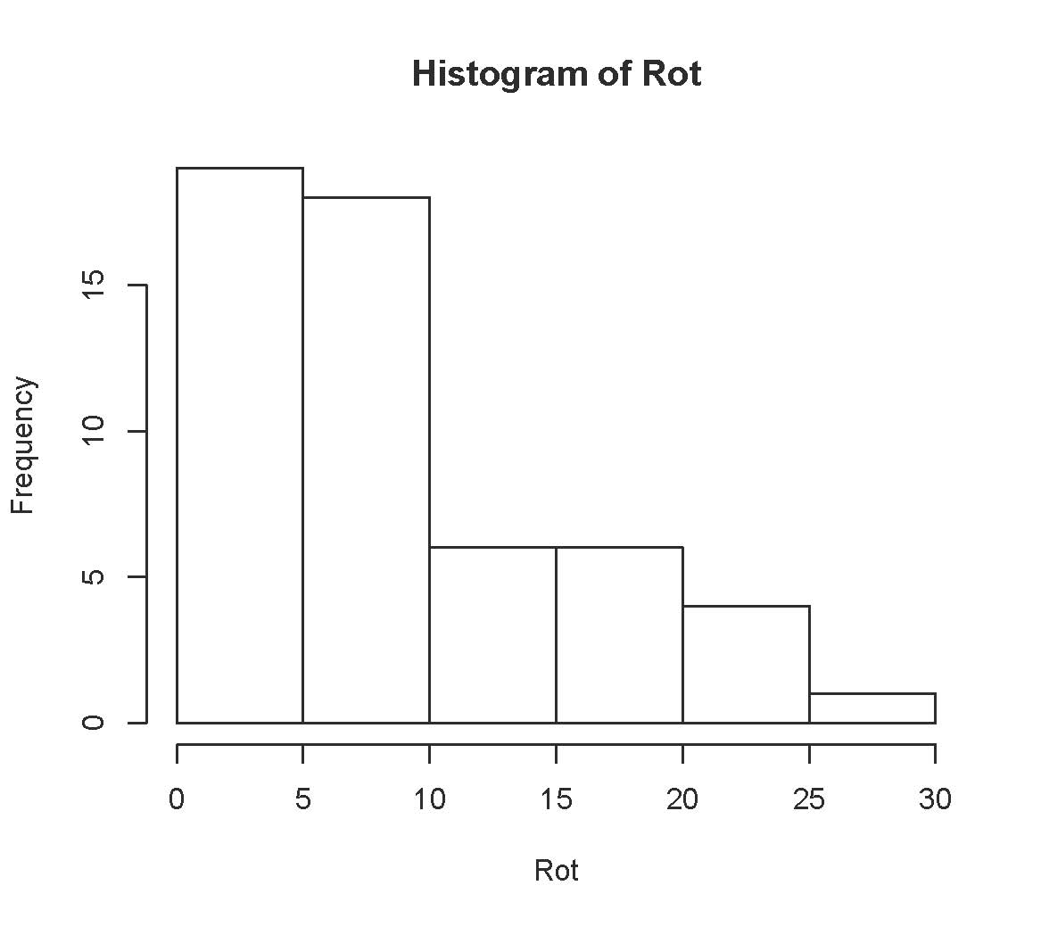

> table(Rot)
Rot
0 2 3 4 5 6 7 8 9 10 11 13 14 15 17 18 19 20 22 23 24 26
7 2 2 5 3 1 5 3 3 6 1 1 1 3 2 2 1 1 1 1 2 1
> table(Temp,Bact)
Bact
Temp 1 2 3
1 9 9 9
2 9 9 9
> meanz = aggregate(Rot~Temp+Bact, FUN=mean); meanz
Temp Bact Rot
1 1 1 3.555556
2 2 1 7.000000
3 1 2 4.777778
4 2 2 13.555556
5 1 3 8.000000
6 2 3 19.555556
>
> meantable = meanz[,3]; dim(meantable) = c(2,3); meantable
[,1] [,2] [,3]
[1,] 3.555556 4.777778 8.00000
[2,] 7.000000 13.555556 19.55556
> dimnames(meantable) = list(c("Cool","Warm"),c("Bact1","Bact2","Bact3"))
> meantable
Bact1 Bact2 Bact3
Cool 3.555556 4.777778 8.00000
Warm 7.000000 13.555556 19.55556
>
> # Plot the means
> cool = meantable[1,]; warm = meantable[2,]
> Bacteria = c(1:3,1:3); MeanRot = c(cool,warm)
> # Invisible points at first, x axis points at 1,2,3; see help(plot)
> plot(Bacteria,MeanRot,pch=" ",xaxp=c(1,3,2), xlab="Bacteria Type",
+ ylab="Mean Rot")
> title("Mean Rot as a Function of Temperature and Bacteria Type")
> points(1:3,warm,col='red',pch=15) # Red squares
> points(1:3,cool,col='blue',pch=19) # Blue circles
> lines(1:3,warm,lty=1,col='red'); lines(1:3,cool,lty=3,col='blue')
> # Annotate the plot
> x1 = c(1.1,1.6); y1 = c(18,18); lines(x1,y1,lty=1,col='red')
> points(1.35,18,col='red',pch=15)
> text(1.75,18,'Warm',col='red')
> x2 = c(1.1,1.6); y2 = c(16,16); lines(x2,y2,lty=3,col='blue')
> points(1.35,16,col='blue',pch=19)
> text(1.75,16,'Cool',col='blue')
>

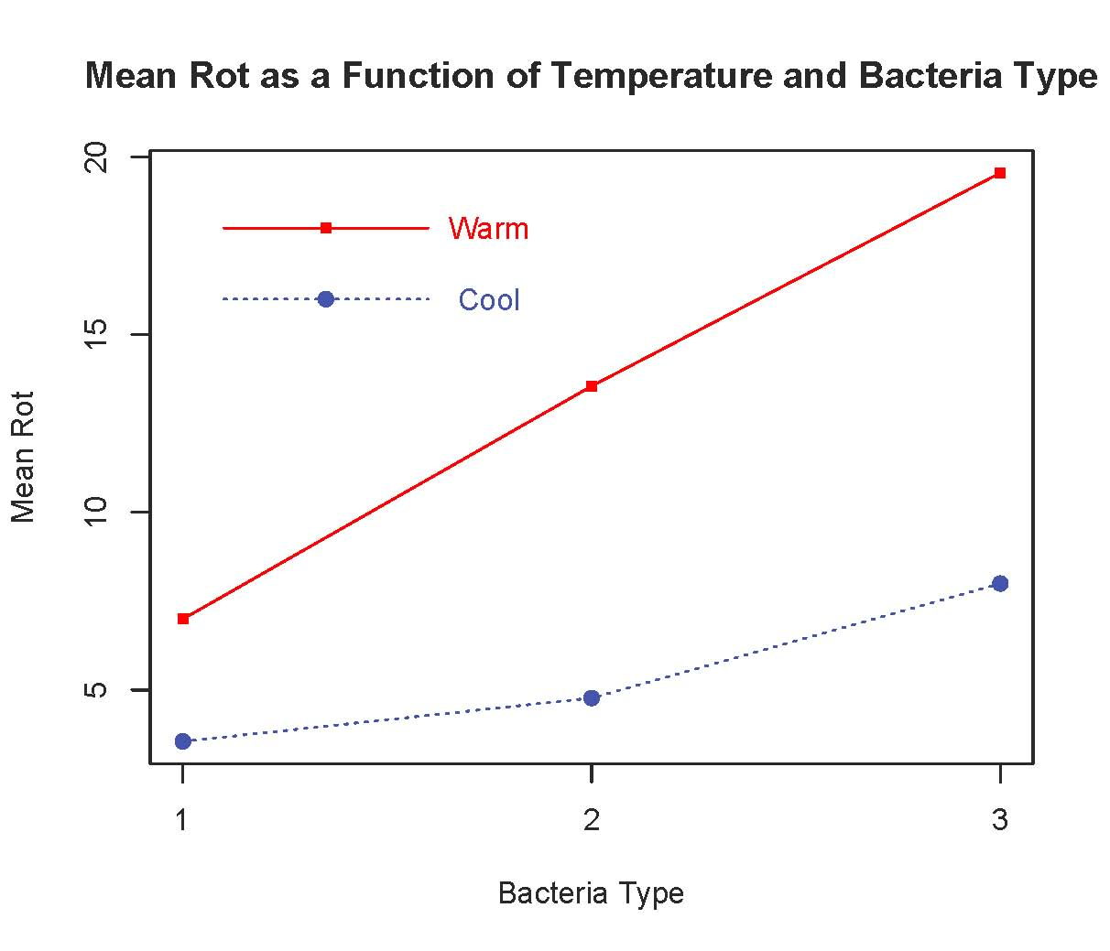
> # Two-factor ANOVA, several different ways
>
> # First with Dummy variable regression, cell means coding and contrasts.
> # Make 6 indicator dummy variables.
> n = length(Rot)
> p11 = p12 = p13 =
+ p21 = p22 = p23 = numeric(n)
> TB = 10*Temp + Bact # Yields 11 12 13 21 22 23
> table(TB)
TB
11 12 13 21 22 23
9 9 9 9 9 9
> p11[TB==11] = 1; p12[TB==12] = 1; p13[TB==13] = 1
> p21[TB==21] = 1; p22[TB==22] = 1; p23[TB==23] = 1
> # data.frame(Temp,Bact,p11,p12,p13,p21,p22,p23) # To check

> cellmeans_model = lm(Rot ~ 0 + p11+p12+p13 + p21+p22+p23)
> summary(cellmeans_model)

Call:
lm(formula = Rot ~ 0 + p11 + p12 + p13 + p21 + p22 + p23)

Residuals:
Min 1Q Median 3Q Max
-11.5556 -3.5556 0.2222 3.4444 9.4444

Coefficients:
Estimate Std. Error t value Pr(>|t|)
p11 3.556 1.562 2.276 0.02734 *
p12 4.778 1.562 3.058 0.00363 **
p13 8.000 1.562 5.121 5.33e-06 ***
p21 7.000 1.562 4.481 4.60e-05 ***
p22 13.556 1.562 8.677 2.13e-11 ***
p23 19.556 1.562 12.518 < 2e-16 ***
---
Signif. codes: 0 ‘***’ 0.001 ‘**’ 0.01 ‘*’ 0.05 ‘.’ 0.1 ‘ ’ 1

Residual standard error: 4.686 on 48 degrees of freedom
Multiple R-squared: 0.8592, Adjusted R-squared: 0.8416
F-statistic: 48.81 on 6 and 48 DF, p-value: < 2.2e-16

> # Define ftest = function(model,L,h=0)
> source("http://www.utstat.utoronto.ca/~brunner/Rfunctions/ftest.txt")
> # For any factorial design, THE BASICS are an overall test for equality of
> # treatment means, and also tests for all the main effects and interactions.
> # For the potato data, first the overall test for equality of the 6
> # treatment means
> L1 = rbind(c(1,-1, 0, 0, 0, 0),
+ c(0, 1,-1, 0, 0, 0),
+ c(0, 0, 1,-1, 0, 0),
+ c(0, 0, 0, 1,-1, 0),
+ c(0, 0, 0, 0, 1,-1))
> round(ftest(cellmeans_model,L1),5)
F df1 df2 p-value
15.05093 5.00000 48.00000 0.00000
> # Test for differences between marginal means (Main effects)
> # Better LOOK at the marginal means

> addmargins(meantable,c(1,2),FUN=mean)
Margins computed over dimensions
in the following order:
1:
2:
Bact1 Bact2 Bact3 mean
Cool 3.555556 4.777778 8.00000 5.444444
Warm 7.000000 13.555556 19.55556 13.370370
mean 5.277778 9.166667 13.77778 9.407407
> # Averaging across Bacteria Types, does Storage Temperature affect
> # the amount of rot?
> L2 = rbind(c(1,1,1,-1,-1,-1))
> round(ftest(cellmeans_model,L2),5)
F df1 df2 p-value
38.61383 1.00000 48.00000 0.00000
> # Averaging across Storage Temperatures, does Bacteria Type affect
> # the amount of rot?
> L3 = rbind(c(1,-1, 0, 1,-1, 0),
+ c(0, 1,-1, 0, 1,-1))
> round(ftest(cellmeans_model,L3),5)
F df1 df2 p-value
14.83895 2.00000 48.00000 0.00001
> # Now the Interaction: Does the effect of Temperature depend on type of bacteria?
> # H0: mu21-mu11 = mu22-mu12 = mu23-mu13
> # <=> (-1)*mu11 + (1)*mu12 + (0)*mu13 + (1)*mu21 + (-1)*mu22 + (0)*mu23 = 0 and
> # (0)*mu11 + (-1)*mu12 + (1)*mu13 + (0)*mu21 + (1)*mu22 + (-1)*mu23 = 0
> L4 = rbind(c(-1, 1, 0, 1,-1, 0),
+ c( 0,-1, 1, 0, 1,-1) )
> round(ftest(cellmeans_model,L4),5)
F df1 df2 p-value
3.48145 2.00000 48.00000 0.03874
>
> # Dummy variable regression with effect coding
> t1 = numeric(n); t1[Temp==1] = 1; t1[Temp==2] = -1
> b1 = numeric(n); b1[Bact==1] = 1; b1[Bact==3] = -1
> b2 = numeric(n); b2[Bact==2] = 1; b2[Bact==3] = -1
> tb1 = t1*b1; tb2 = t1*b2
> effect_coding_model = lm(Rot ~ t1 + b1 + b2 + tb1 + tb2)
> summary(effect_coding_model)

> summary(effect_coding_model)
Call:
lm(formula = Rot ~ t1 + b1 + b2 + tb1 + tb2)

Residuals:
Min 1Q Median 3Q Max
-11.5556 -3.5556 0.2222 3.4444 9.4444

Coefficients:
Estimate Std. Error t value Pr(>|t|)
(Intercept) 9.4074 0.6377 14.751 < 2e-16 ***
t1 -3.9630 0.6377 -6.214 1.18e-07 ***
b1 -4.1296 0.9019 -4.579 3.33e-05 ***
b2 -0.2407 0.9019 -0.267 0.7907
tb1 2.2407 0.9019 2.484 0.0165 *
tb2 -0.4259 0.9019 -0.472 0.6389
---
Signif. codes: 0 ‘***’ 0.001 ‘**’ 0.01 ‘*’ 0.05 ‘.’ 0.1 ‘ ’ 1

Residual standard error: 4.686 on 48 degrees of freedom
Multiple R-squared: 0.6106, Adjusted R-squared: 0.57
F-statistic: 15.05 on 5 and 48 DF, p-value: 7.003e-09

> # Test main effects for temperature with full vs. reduced
> notemp = update(effect_coding_model, . ~ . - t1)
> anova(notemp,effect_coding_model)
Analysis of Variance Table

Model 1: Rot ~ b1 + b2 + tb1 + tb2
Model 2: Rot ~ t1 + b1 + b2 + tb1 + tb2
Res.Df RSS Df Sum of Sq F Pr(>F)
1 49 1902.3
2 48 1054.2 1 848.07 38.614 1.18e-07 ***
---
Signif. codes: 0 ‘***’ 0.001 ‘**’ 0.01 ‘*’ 0.05 ‘.’ 0.1 ‘ ’ 1
> # Main effects for Bacteria Type
> nobact = update(effect_coding_model, . ~ . - b1 - b2)
> anova(nobact,effect_coding_model)
Analysis of Variance Table

Model 1: Rot ~ t1 + tb1 + tb2
Model 2: Rot ~ t1 + b1 + b2 + tb1 + tb2
Res.Df RSS Df Sum of Sq F Pr(>F)
1 50 1706.0
2 48 1054.2 2 651.81 14.839 9.608e-06 ***
---
Signif. codes: 0 ‘***’ 0.001 ‘**’ 0.01 ‘*’ 0.05 ‘.’ 0.1 ‘ ’ 1

> # Test interaction
> nointer = update(effect_coding_model, . ~ . - tb1 - tb2)
> anova(nointer,effect_coding_model)
Analysis of Variance Table

Model 1: Rot ~ t1 + b1 + b2
Model 2: Rot ~ t1 + b1 + b2 + tb1 + tb2
Res.Df RSS Df Sum of Sq F Pr(>F)
1 50 1207.2
2 48 1054.2 2 152.93 3.4815 0.03874 *
---
Signif. codes: 0 ‘***’ 0.001 ‘**’ 0.01 ‘*’ 0.05 ‘.’ 0.1 ‘ ’ 1
> # Could have used general linear test for all this
> # For example, test main effects for Bacteria
> L5 = rbind(c(0,0,1,0,0,0),
+ c(0,0,0,1,0,0) )
> round(ftest(effect_coding_model,L5),5)
F df1 df2 p-value
14.83895 2.00000 48.00000 0.00001
>

> # Now finally do it the easy way
>
> Bacteria=factor(Bact); Temperature = factor(Temp, labels = c("Cool","Warm"))
> easy = lm(Rot~Temperature+Bacteria+Temperature:Bacteria)
> summary(easy)

Call:
lm(formula = Rot ~ Temperature + Bacteria + Temperature:Bacteria)

Residuals:
Min 1Q Median 3Q Max
-11.5556 -3.5556 0.2222 3.4444 9.4444

Coefficients:
Estimate Std. Error t value Pr(>|t|)
(Intercept) 3.556 1.562 2.276 0.0273 *
TemperatureWarm 3.444 2.209 1.559 0.1255
Bacteria2 1.222 2.209 0.553 0.5827
Bacteria3 4.444 2.209 2.012 0.0499 *
TemperatureWarm:Bacteria2 5.333 3.124 1.707 0.0943 .
TemperatureWarm:Bacteria3 8.111 3.124 2.596 0.0125 *
---
Signif. codes: 0 ‘***’ 0.001 ‘**’ 0.01 ‘*’ 0.05 ‘.’ 0.1 ‘ ’ 1

Residual standard error: 4.686 on 48 degrees of freedom
Multiple R-squared: 0.6106, Adjusted R-squared: 0.57
F-statistic: 15.05 on 5 and 48 DF, p-value: 7.003e-09

> # What happened with the t-test for TemperatureWarm?
> anova(easy)
Analysis of Variance Table

Response: Rot
Df Sum Sq Mean Sq F value Pr(>F)
Temperature 1 848.07 848.07 38.6138 1.180e-07 ***
Bacteria 2 651.81 325.91 14.8390 9.608e-06 ***
Temperature:Bacteria 2 152.93 76.46 3.4815 0.03874 *
Residuals 48 1054.22 21.96
---
Signif. codes: 0 ‘***’ 0.001 ‘**’ 0.01 ‘*’ 0.05 ‘.’ 0.1 ‘ ’ 1
> # It worked because sample sizes are equal, and R saved us from the
> # dummy variable coding method.
> # WARNING: If factors are related, test effects one at a time with
> # full-reduced approach or general linear test.
>

> # Can make R use effect coding for factors
> contrasts(Temperature) = contr.sum(2)
> contrasts(Bacteria) = contr.sum(3); contrasts(Bacteria)
[,1] [,2]
1 1 0
2 0 1
3 -1 -1
> easy2 = lm(Rot~Temperature+Bacteria+Temperature:Bacteria)
> summary(easy2)

Call:
lm(formula = Rot ~ Temperature + Bacteria + Temperature:Bacteria)

Residuals:
Min 1Q Median 3Q Max
-11.5556 -3.5556 0.2222 3.4444 9.4444

Coefficients:
Estimate Std. Error t value Pr(>|t|)
(Intercept) 9.4074 0.6377 14.751 < 2e-16 ***
Temperature1 -3.9630 0.6377 -6.214 1.18e-07 ***
Bacteria1 -4.1296 0.9019 -4.579 3.33e-05 ***
Bacteria2 -0.2407 0.9019 -0.267 0.7907
Temperature1:Bacteria1 2.2407 0.9019 2.484 0.0165 *
Temperature1:Bacteria2 -0.4259 0.9019 -0.472 0.6389
---
Signif. codes: 0 ‘***’ 0.001 ‘**’ 0.01 ‘*’ 0.05 ‘.’ 0.1 ‘ ’ 1

Residual standard error: 4.686 on 48 degrees of freedom
Multiple R-squared: 0.6106, Adjusted R-squared: 0.57
F-statistic: 15.05 on 5 and 48 DF, p-value: 7.003e-09

> anova(easy2)
Analysis of Variance Table

Response: Rot
Df Sum Sq Mean Sq F value Pr(>F)
Temperature 1 848.07 848.07 38.6138 1.180e-07 ***
Bacteria 2 651.81 325.91 14.8390 9.608e-06 ***
Temperature:Bacteria 2 152.93 76.46 3.4815 0.03874 *
Residuals 48 1054.22 21.96
---
Signif. codes: 0 ‘***’ 0.001 ‘**’ 0.01 ‘*’ 0.05 ‘.’ 0.1 ‘ ’ 1

>

> # Residuals for all the models are the same
> delstudres = rstudent(easy)
> hist(delstudres) # Very nice lesson – compare histogram of Rot

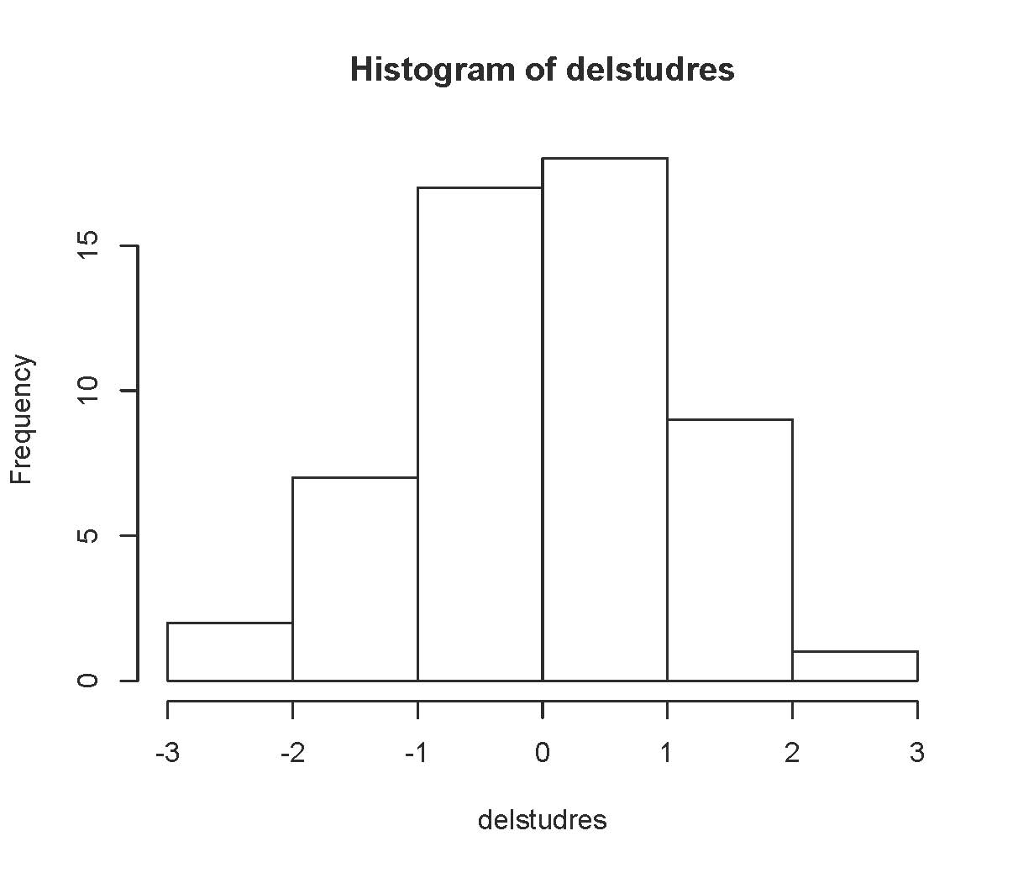
>
> # To test non-standard hypotheses, it is easiest to use the cell means model
> # Just a few examples out of MANY possible
>
> # Is there an effect of bacteria type at cool temperatures?
> # H0: mu11=mu12=mu13
> L6 = rbind(c(1,-1, 0, 0, 0, 0),
+ c(0, 1,-1, 0, 0, 0) )
> round(ftest(cellmeans_model,L6),5)
F df1 df2 p-value
2.16020 2.00000 48.00000 0.12638
>

> # Is there an effect of bacteria type at warm temperatures?
> # H0: mu21=mu22=mu23
> L7 = rbind(c(0, 0, 0, 1,-1, 0),
+ c(0, 0, 0, 0, 1,-1) )
> round(ftest(cellmeans_model,L7),5)
F df1 df2 p-value
16.1602 2.0000 48.0000 0.0000
>
> # Is the effect of temperature different for Bacteria types 1 and 3?
> # H0: mu11-mu21 = mu13-mu23
> L8 = rbind(c(1, 0,-1,-1, 0, 1))
> round(ftest(cellmeans_model,L8),5)
F df1 df2 p-value
6.73988 1.00000 48.00000 0.01247
> # Could look at all pairwise comparisons of differences
> # between Cool and Warm

> # Any of these F- tests could be Scheffe follow-ups to the test with null
> # hypothesis no main effects and no interactions, which is the same as
> # H0: all expected values equal.

> # Make a table of fa = r/s * f.
> f = qf(0.95,5,48); f # Critical value of initial test
[1] 2.408514
> r=5; s = 1:5; fa = r/s * f
> cbind(s,fa)
s fa
[1,] 1 12.042571
[2,] 2 6.021285
[3,] 3 4.014190
[4,] 4 3.010643
[5,] 5 2.408514
> # For example look,
> anova(easy2)

Df Sum Sq Mean Sq F value Pr(>F)
Temperature 1 848.07 848.07 38.6138 1.180e-07 ***
Bacteria 2 651.81 325.91 14.8390 9.608e-06 ***
Temperature:Bacteria 2 152.93 76.46 3.4815 0.03874 *
Residuals 48 1054.22 21.96

This handout was prepared by Jerry Brunner, Department of Statistical Sciences, University of Toronto. It is licensed under a Creative Commons Attribution - ShareAlike 3.0 Unported License. Use any part of it as you like and share the result freely. The OpenOffice.org document is available from the course website:

http://www.utstat.toronto.edu/~brunner/oldclass/appliedf16

