A Brief Introduction to R

> 1+1
[1] 2
> 2^3 # Two to the power 3
[1] 8

> 1:30
[1] 1 2 3 4 5 6 7 8 9 10 11 12 13 14 15 16 17 18 19 20 21 22 23 24 25
[26] 26 27 28 29 30

> gamma(.5)^2 # Gamma(1/2) = Sqrt(Pi)
[1] 3.141593

> x <- 1 # Assigns the value 1 to x
> y <- 2
> x+y
[1] 3
> z <- x+y
> z
[1] 3
> x <- c(1,2,3,4,5,6) # Collect these numbers; x is now a vector

> z # No dynamic updating; it's not a spreadsheet
[1] 3
> x+y
[1] 3 4 5 6 7 8

> y = 1 + 2*x # Another way to do assignment
> cbind(x,y)
x y
[1,] 1 3
[2,] 2 5
[3,] 3 7
[4,] 4 9
[5,] 5 11
[6,] 6 13

> z <- y[x>4] # z gets y such that x > 4
> z
[1] 11 13

> # If you put an array of integers inside the brackets, you get those
> # elements, in the order indicated.

> y[c(6,5,4,3,2,1)] # y in opposite order
[1] 13 11 9 7 5 3
> y[c(2,2,2,3,4)] # Repeats are okay
[1] 5 5 5 7 9
> y[7] # There is no seventh element. NA is the missing value code
[1] NA

> # Computing probabilities, etc.
>
> pnorm(0) # Area less than zero for a standard normal
[1] 0.5
>
> pnorm(160,mean=100,sd=15) # IQ of 160
[1] 0.9999683
>
> pcauchy(4)
[1] 0.9220209
>
> dnorm(0) # height of the curve
[1] 0.3989423
>
> dpois(0,lambda=3) # P(Y=0) for Y ~ Poisson(3)
[1] 0.04978707
>
> qnorm(0.975) # z value with P(Z<z) = 0.975
[1] 1.959964
>
> qf(0.975,df1=6,df2=122) # Critical value for F, not in any table
[1] 2.513606
>
> CriticalValue = qchisq(0.95,df=1:8)
> df=1:8; cbind(df,CriticalValue)
df CriticalValue
[1,] 1 3.841459
[2,] 2 5.991465
[3,] 3 7.814728
[4,] 4 9.487729
[5,] 5 11.070498
[6,] 6 12.591587
[7,] 7 14.067140
[8,] 8 15.507313

> # Random number generation
> # Maybe transforming a uniform by inverse CDF
> help(Exponential) # Could also use help(rexp)

Exponential {stats} | R Documentation
The Exponential Distribution
Description
Density, distribution function, quantile function and random generation for the exponential distribution with rate rate (i.e., mean 1/rate).
Usage
dexp(x, rate = 1, log = FALSE)
pexp(q, rate = 1, lower.tail = TRUE, log.p = FALSE)
qexp(p, rate = 1, lower.tail = TRUE, log.p = FALSE)
rexp(n, rate = 1)

> expdata = rexp(50,rate=1/2) # Random sample from exponential distribution, mean=theta=2
> expdata
[1] 0.4330015 5.7893762 0.9803759 0.7172530 2.2696433 4.0045302 3.3989651 0.3104736
[9] 1.2026790 0.8543951 1.0438012 5.5095891 0.7587579 1.9263300 6.0660176 9.3017992
[17] 1.0910204 0.6551285 1.5747176 5.9417700 0.8464761 7.6684436 0.1107589 1.6787699
[25] 2.4744338 3.3470232 0.3209082 4.4307811 4.5510434 1.4316870 0.3457547 0.1302476
[33] 0.5777305 1.0898631 1.4467458 3.2472808 1.8113195 0.5090032 2.4633656 0.8972205
[41] 0.7562905 2.4623634 0.3413955 2.3122374 0.4166320 2.6279765 1.5072294 3.5732947
[49] 3.5449348 2.6472542
> mean(expdata) # The MLE
[1] 2.267962
> hist(expdata)

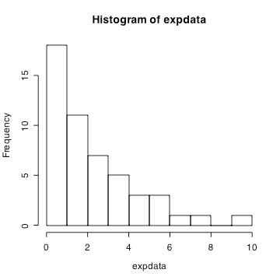

> # data() lists available data sets
> trees
Girth Height Volume
1 8.3 70 10.3
2 8.6 65 10.3
3 8.8 63 10.2
4 10.5 72 16.4
5 10.7 81 18.8
6 10.8 83 19.7
7 11.0 66 15.6
8 11.0 75 18.2
9 11.1 80 22.6
10 11.2 75 19.9
11 11.3 79 24.2
12 11.4 76 21.0
13 11.4 76 21.4
14 11.7 69 21.3
15 12.0 75 19.1
16 12.9 74 22.2
17 12.9 85 33.8
18 13.3 86 27.4
19 13.7 71 25.7
20 13.8 64 24.9
21 14.0 78 34.5
22 14.2 80 31.7
23 14.5 74 36.3
24 16.0 72 38.3
25 16.3 77 42.6
26 17.3 81 55.4
27 17.5 82 55.7
28 17.9 80 58.3
29 18.0 80 51.5
30 18.0 80 51.0
31 20.6 87 77.0
> mean(trees$Height); var(trees$Height)
[1] 76
[1] 40.6
> mean(Height)
Error in mean(Height) : object 'Height' not found
> attach(trees)
> mean(Height)
[1] 76
> summary(trees)
Girth Height Volume
Min. : 8.30 Min. :63 Min. :10.20
1st Qu.:11.05 1st Qu.:72 1st Qu.:19.40
Median :12.90 Median :76 Median :24.20
Mean :13.25 Mean :76 Mean :30.17
3rd Qu.:15.25 3rd Qu.:80 3rd Qu.:37.30
Max. :20.60 Max. :87 Max. :77.00

> cor(trees)
Girth Height Volume
Girth 1.0000000 0.5192801 0.9671194
Height 0.5192801 1.0000000 0.5982497
Volume 0.9671194 0.5982497 1.0000000
> plot(trees$Girth,trees$Volume)

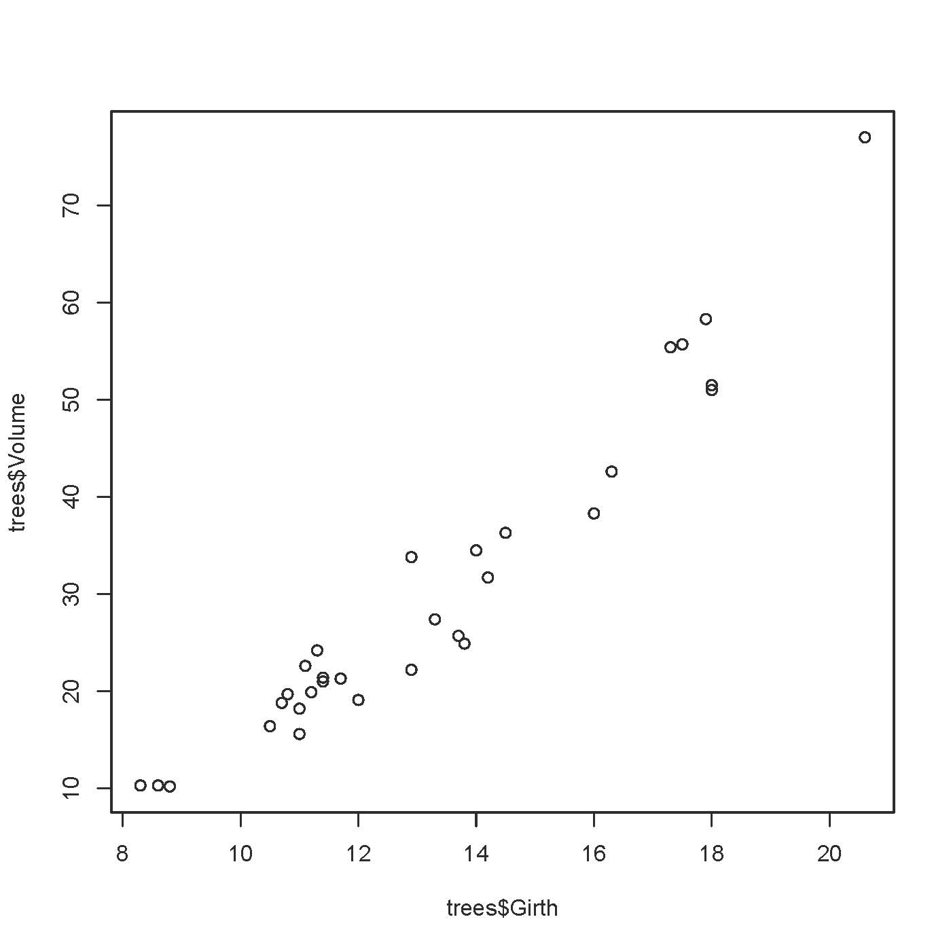

> pairs(trees) # Can also give it a matrix, in which the columns are variables

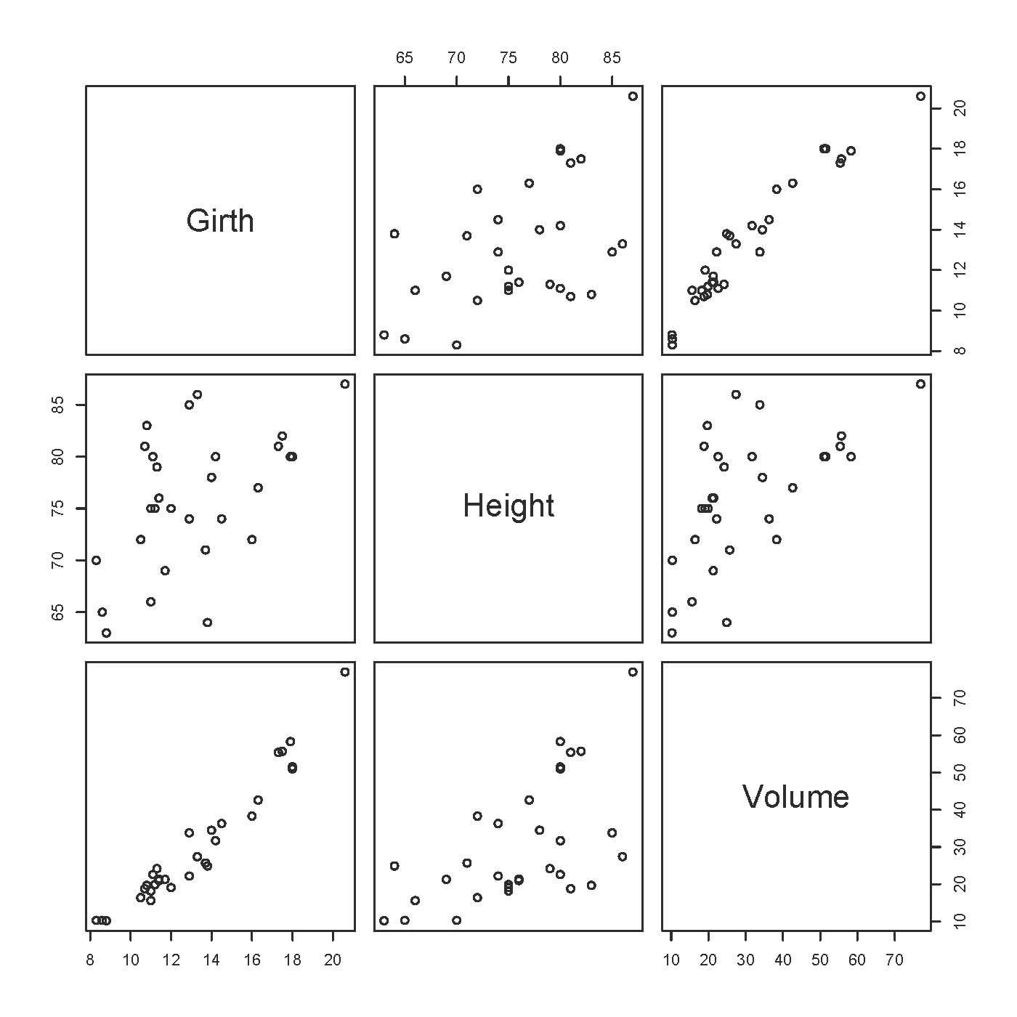
> # Linear regression
> treemodel1 = lm(Volume ~ Girth + Height)
> # Could also do treemodel1 = lm(Volume ~ Girth + Height,data=trees)
> summary(treemodel1)

Call:
lm(formula = Volume ~ Girth + Height)

Residuals:
Min 1Q Median 3Q Max
-6.4065 -2.6493 -0.2876 2.2003 8.4847

Coefficients:
Estimate Std. Error t value Pr(>|t|)
(Intercept) -57.9877 8.6382 -6.713 2.75e-07 ***
Girth 4.7082 0.2643 17.816 < 2e-16 ***
Height 0.3393 0.1302 2.607 0.0145 *
---
Signif. codes: 0 ‘***’ 0.001 ‘**’ 0.01 ‘*’ 0.05 ‘.’ 0.1 ‘ ’ 1

Residual standard error: 3.882 on 28 degrees of freedom
Multiple R-squared: 0.948, Adjusted R-squared: 0.9442
F-statistic: 255 on 2 and 28 DF, p-value: < 2.2e-16

> resid1 = treemodel1$residuals; mean(resid1)
[1] 1.504453e-16
> plot(Height,resid1)
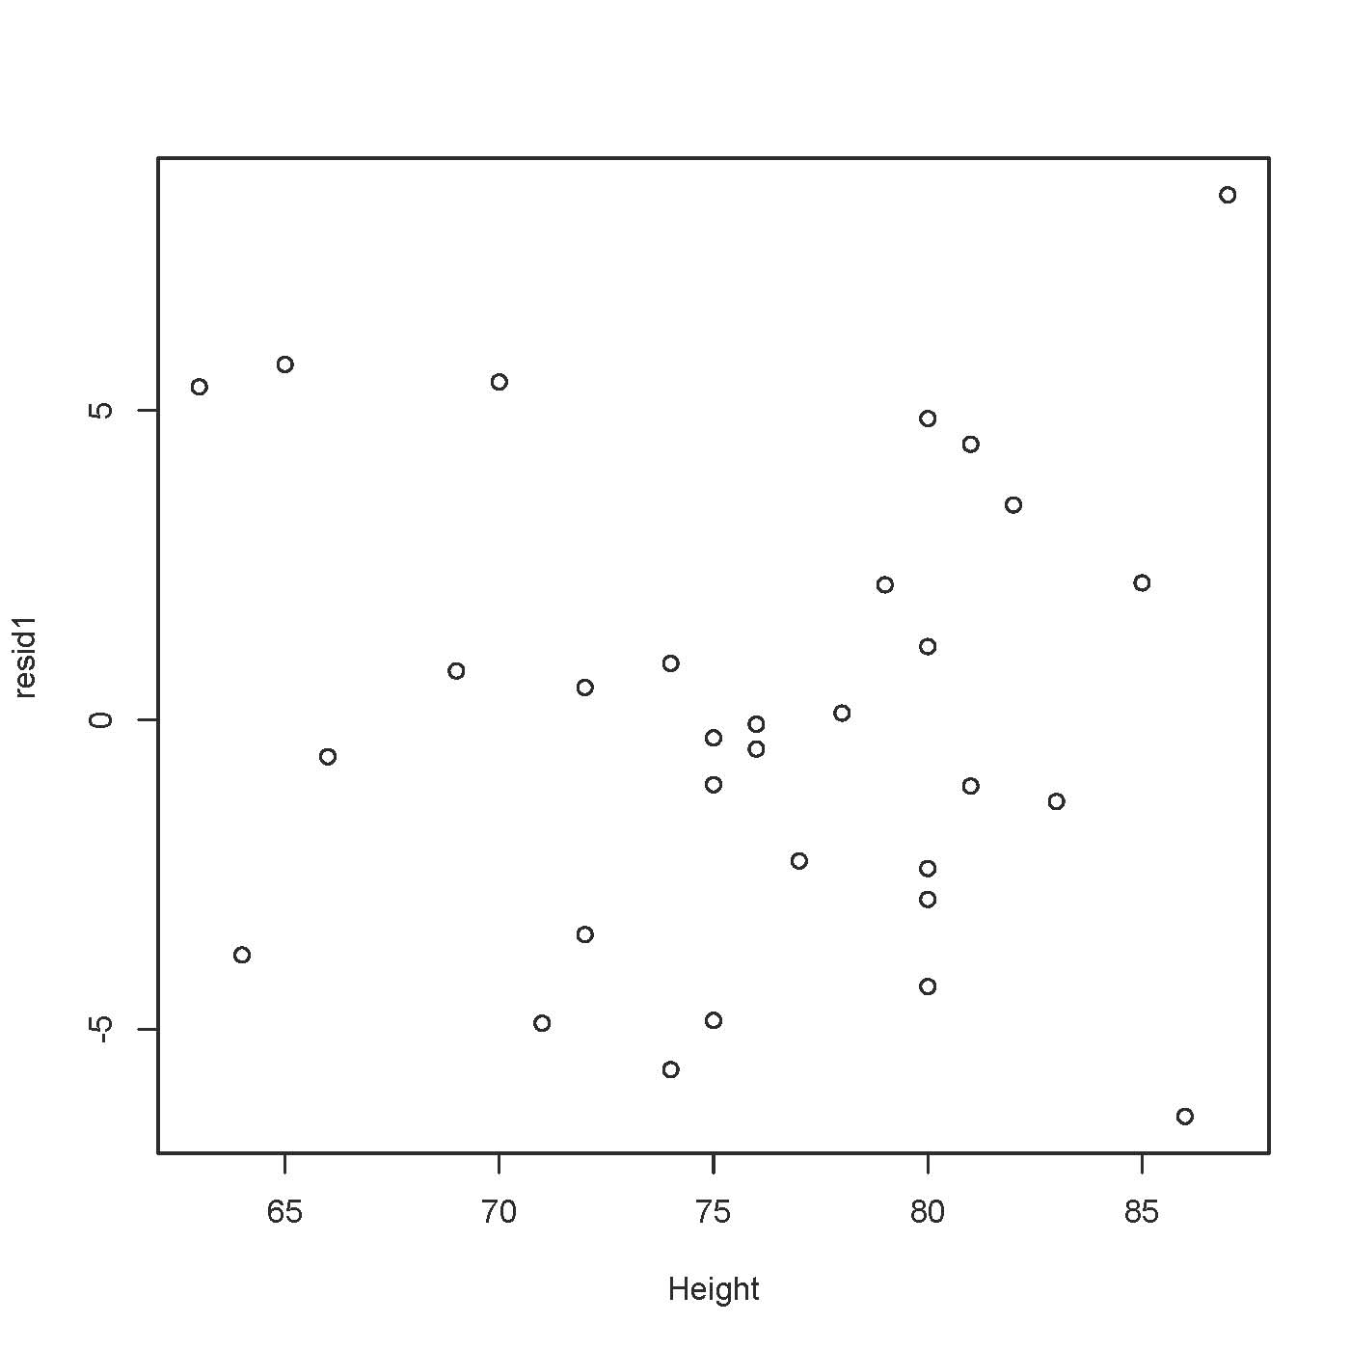

> plot(Girth,resid1)
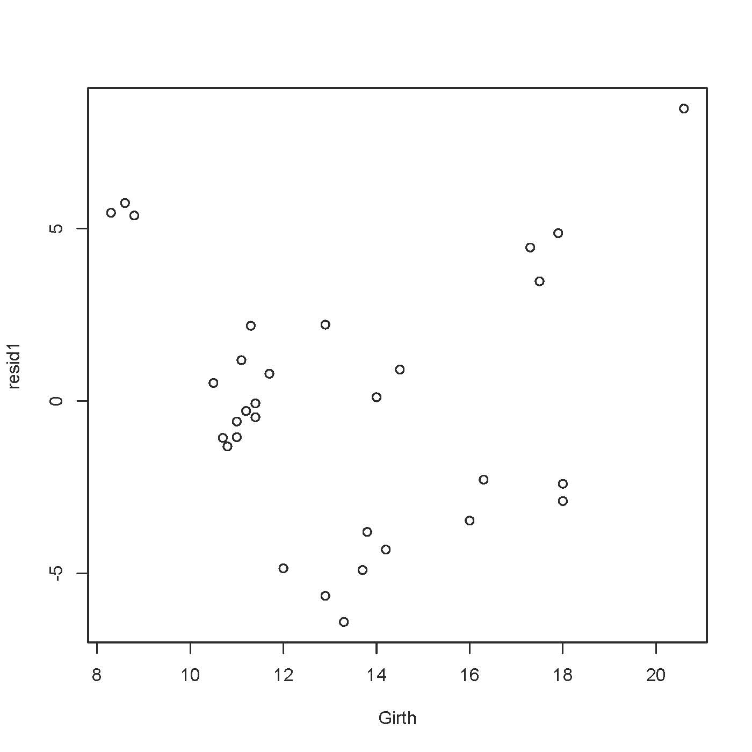
> girthsq = Girth^2
> treemodel2 = lm(Volume ~ Girth + Height + girthsq)
> summary(treemodel2)

Going further on your own

Look at the free mini-book An introduction to R by Venables et al. A copy is available at http://www.utstat.toronto.edu/~brunner/help/R-intro.pdf. Or, try

> library(help="stats")

AIC Akaike's An Information Criterion
ARMAacf Compute Theoretical ACF for an ARMA Process
ARMAtoMA Convert ARMA Process to Infinite MA Process
Beta The Beta Distribution
Binomial The Binomial Distribution
Box.test Box-Pierce and Ljung-Box Tests
C Sets Contrasts for a Factor
Cauchy The Cauchy Distribution
Chisquare The (non-central) Chi-Squared Distribution
Exponential The Exponential Distribution
FDist The F Distribution
GammaDist The Gamma Distribution
Geometric The Geometric Distribution
HoltWinters Holt-Winters Filtering

. . . list continues!

To see details on one of these packages, type something like

> help(t.test)

Generally, R's help assumes knowledge of the topic, but they often give references. For a quicker introduction to many statistical topics, try the Wikipedia:

http://en.wikipedia.org

Or you could ask me, but I might have to look in the Wikipedia.

This document was prepared by Jerry Brunner, University of Toronto. It is licensed under a Creative Commons Attribution - ShareAlike 3.0 Unported License: http://creativecommons.org/licenses/by-sa/3.0/deed.en_US. Use any part of it as you like and share the result freely.

