Brand Awareness*

A major Canadian coffee shop chain is trying to break into the U.S. Market. They assess the following variables twice on a random sample of coffee-drinking adults. The two measurements of each variable are conducted at different times by different interviewers asking somewhat different questions, in such a way that the errors of measurement may be assumed independent. The variables are

- Brand Awareness: Familiarity with the coffee shop chain
- Advertising Awareness: Recall for advertising of the coffee shop chain
- Interest in the product category: Mostly this was how much they say they like doughnuts.
- Purchase Intention: Expressed willingness to go to an outlet of the coffeeshop chain and make an order.
- Purchase behaviour: Reported dollars spent at the chain during the 2 months following the interview, based on a later telephone interview.

All variables were measured on a scale from 0 to 100 except purchase behaviour, which is in dollars.

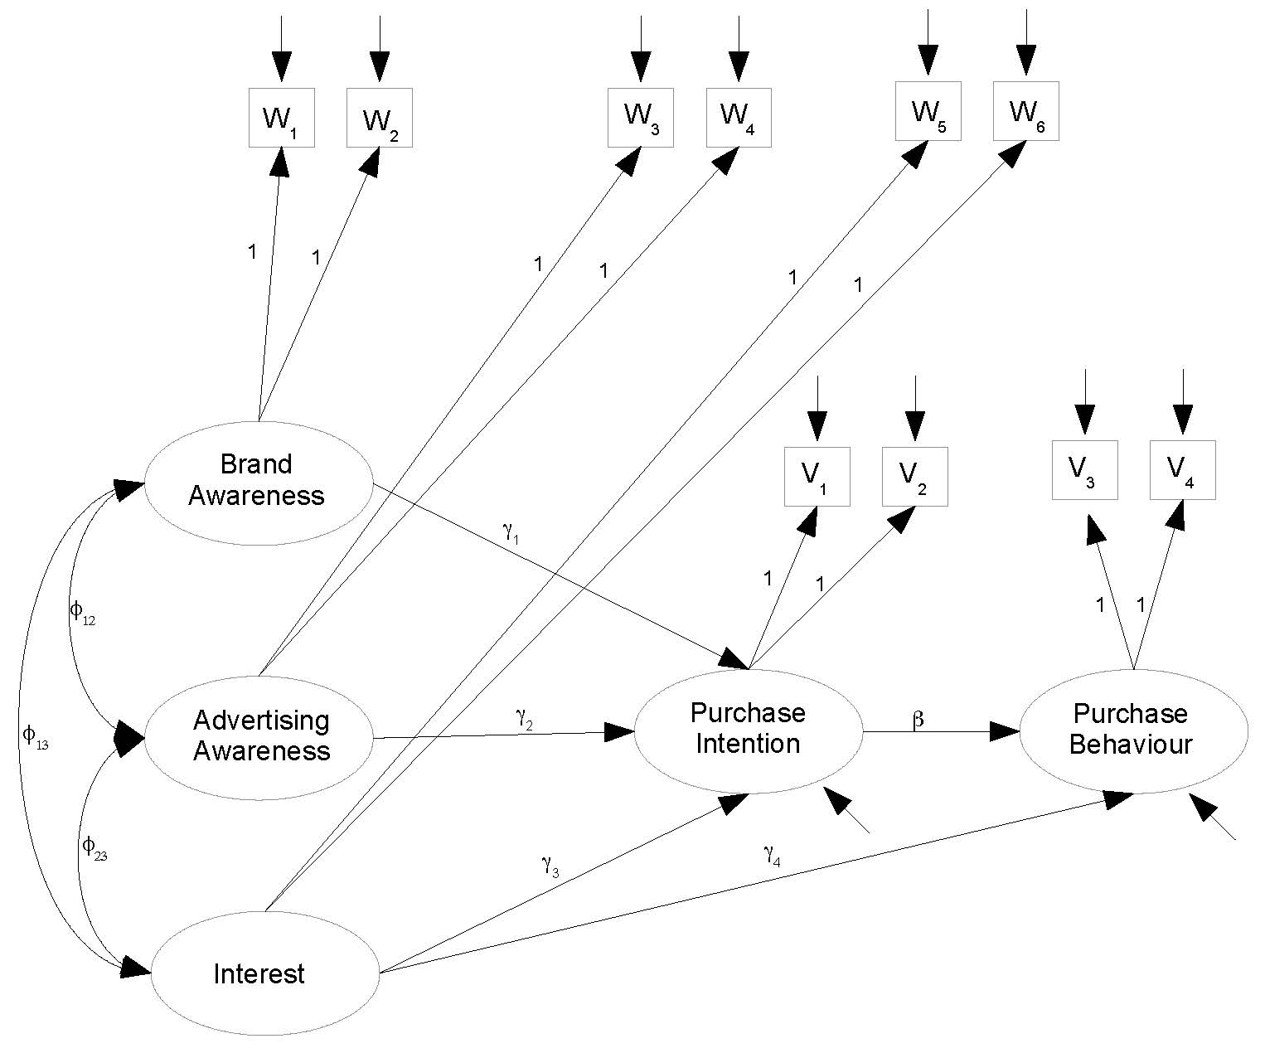

> rm(list=ls()); options(scipen=999)
> # install.packages("lavaan", dependencies = TRUE) # Only need to do this once
> library(lavaan)
This is lavaan 0.6-11
lavaan is FREE software! Please report any bugs.
>
> coffee = read.table("http://www.utstat.toronto.edu/brunner/openSEM/data/timmy1.data.txt")
> head(coffee)
w1 w2 w3 w4 w5 w6 v1 v2 v3 v4
1 40 23 26 21 48 38 22 22 15 15
2 45 24 29 23 49 48 26 13 8 13
3 29 21 21 13 42 37 18 12 13 13
4 38 26 18 19 47 42 20 9 12 10
5 47 31 30 18 48 52 26 16 22 16
6 31 24 18 13 39 40 20 12 16 18
>
> # Observed variables
> # w1 = Brand Awareness 1
> # w2 = Brand Awareness 2
> # w3 = Ad Awareness 1
> # w4 = Ad Awareness 2
> # w5 = Interest 1
> # w6 = Interest 2
> # v1 = Purchase Intention 1
> # v2 = Purchase Intention 2
> # v3 = Purchase Behaviour 1
> # v4 = Purchase Behaviour 2
> # Latent variables
> # L_BrAw = True brand awareness
> # L_AdAw = True advertising awareness
> # L_Inter = True interest in the product category
> # L_PI = True purchase intention
> # L_PBeh = True purchase behaviour
>
> torus1 =
+ '
+ # Latent variable model
+ L_PI ~ gamma1*L_BrAw + gamma2*L_AdAw + gamma3*L_Inter
+ L_PBeh ~ gamma4*L_Inter + beta*L_PI
+ # Measurement model (simple double measurement)
+ L_BrAw =~ 1*w1 + 1*w2
+ L_AdAw =~ 1*w3 + 1*w4
+ L_Inter =~ 1*w5 + 1*w6
+ L_PI =~ 1*v1 + 1*v2
+ L_PBeh =~ 1*v3 + 1*v4
+ # Variances and covariances
+ # Exogenous latent variables
+ L_BrAw ~~ phi11*L_BrAw # Var(L_BrAw) = phi11
+ L_BrAw ~~ phi12*L_AdAw # Cov(L_BrAw,L_AdAw) = phi12
+ L_BrAw ~~ phi13*L_Inter # Cov(L_BrAw,L_Inter) = phi13
+ L_AdAw ~~ phi22*L_AdAw # Var(L_AdAw) = phi22
+ L_AdAw ~~ phi23*L_Inter # Cov(L_AdAw,L_Inter) = phi23
+ L_Inter ~~ phi33*L_Inter # Var(L_Inter) = phi33
+ # Errors in the latent model (epsilons)
+ L_PI ~~ psi1*L_PI # Var(epsilon1) = psi1
+ L_PBeh ~~ psi2*L_PBeh # Var(epsilon2) = psi2
+ # Measurement errors
+ w1 ~~ omega1*w1 # Var(e1) = omega1
+ w2 ~~ omega2*w2 # Var(e2) = omega2
+ w3 ~~ omega3*w3 # Var(e3) = omega3
+ w4 ~~ omega4*w4 # Var(e4) = omega4
+ w5 ~~ omega5*w5 # Var(e5) = omega5
+ w6 ~~ omega6*w6 # Var(e6) = omega6
+ v1 ~~ omega7*v1 # Var(e7) = omega7
+ v2 ~~ omega8*v2 # Var(e8) = omega8
+ v3 ~~ omega9*v3 # Var(e9) = omega9
+ v4 ~~ omega10*v4 # Var(e10) = omega10
+ # Bounds (Variances are positive)
+ phi11 > 0; phi22 > 0; phi33 > 0
+ psi1 > 0; psi2 > 0
+ omega1 > 0; omega2 > 0; omega3 > 0; omega4 > 0; omega5 > 0
+ omega6 > 0; omega7 > 0; omega8 > 0; omega9 > 0; omega10 > 0
+ ' # End of model torus1

> fit1 = lavaan(torus1, data=coffee)
> show(fit1)
lavaan 0.6-11 ended normally after 113 iterations

Estimator ML
Optimization method NLMINB
Number of model parameters 23
Number of inequality constraints 15

Number of observations 200

Model Test User Model:

Test statistic 77.752
Degrees of freedom 32
P-value (Chi-square) 0.000

>
> # It did not fit, and matched SAS.
> # Split the problem up into parts. Look first at the measurement model.
>

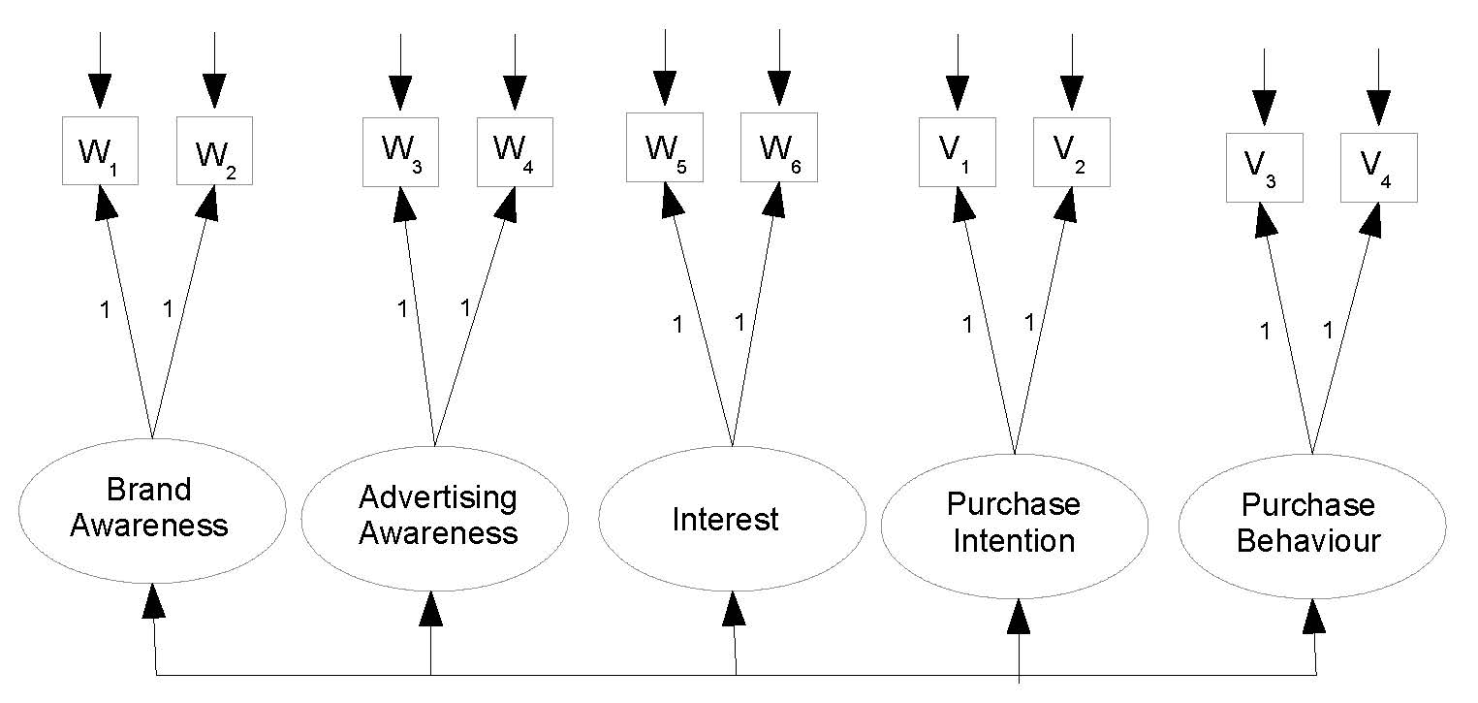

> torus2 =
+ '
+ # Measurement model (still simple double measurement)
+ L_BrAw =~ 1*w1 + 1*w2
+ L_AdAw =~ 1*w3 + 1*w4
+ L_Inter =~ 1*w5 + 1*w6
+ L_PI =~ 1*v1 + 1*v2
+ L_PBeh =~ 1*v3 + 1*v4
+ # Variances and covariances
+ # Latent variables
+ L_BrAw ~~ phi11*L_BrAw # Var(L_BrAw) = phi11
+ L_BrAw ~~ phi12*L_AdAw # Cov(L_BrAw, L_AdAw) = phi12
+ L_BrAw ~~ phi13*L_Inter # Cov(L_BrAw, L_Inter) = phi13
+ L_BrAw ~~ phi14*L_PI # Cov(L_BrAw, L_PI) = phi14
+ L_BrAw ~~ phi15*L_PBeh # Cov(L_BrAw, L_PBeh) = phi15
+
+ L_AdAw ~~ phi22*L_AdAw # Var(L_AdAw) = phi22
+ L_AdAw ~~ phi23*L_Inter # Cov(L_AdAw, L_Inter) = phi23
+ L_AdAw ~~ phi24*L_PI # Cov(L_AdAw, L_PI) = phi24
+ L_AdAw ~~ phi25*L_PBeh # Cov(L_AdAw, L_PBeh) = phi25
+
+ L_Inter ~~ phi33*L_Inter # Var(L_Inter) = phi33
+ L_Inter ~~ phi34*L_PI # Cov(L_Inter, L_PI) = phi34
+ L_Inter ~~ phi35*L_PBeh # Cov(L_Inter, L_PBeh) = phi35
+
+ L_PI ~~ phi44*L_PI # Var(L_PI) = phi44
+ L_PI ~~ phi45*L_PBeh # Cov(L_PI, L_PBeh) = phi45
+
+ L_PBeh ~~ phi55*L_PBeh # Var(L_PBeh) = phi55
+ # Measurement errors
+ w1 ~~ omega1*w1 # Var(e1) = omega1
+ w2 ~~ omega2*w2 # Var(e2) = omega2
+ w3 ~~ omega3*w3 # Var(e3) = omega3
+ w4 ~~ omega4*w4 # Var(e4) = omega4
+ w5 ~~ omega5*w5 # Var(e5) = omega5
+ w6 ~~ omega6*w6 # Var(e6) = omega6
+ v1 ~~ omega7*v1 # Var(e7) = omega7
+ v2 ~~ omega8*v2 # Var(e8) = omega8
+ v3 ~~ omega9*v3 # Var(e9) = omega9
+ v4 ~~ omega10*v4 # Var(e10) = omega10
+ # Bounds (Variances are positive)
+ phi11 > 0; phi22 > 0; phi33 > 0; phi44 > 0; phi55 > 0
+ omega1 > 0; omega2 > 0; omega3 > 0; omega4 > 0; omega5 > 0
+ omega6 > 0; omega7 > 0; omega8 > 0; omega9 > 0; omega10 > 0
+ ' # End of model torus2

> fit2 = lavaan(torus2, data=coffee)
> show(fit2)

lavaan 0.6-11 ended normally after 124 iterations

Estimator ML
Optimization method NLMINB
Number of model parameters 25
Number of inequality constraints 15

Number of observations 200

Model Test User Model:

Test statistic 76.380
Degrees of freedom 30
P-value (Chi-square) 0.000

>
> # Specify the model more briefly, without all those variances and covariances.
> torus2b =
+ '
+ # Measurement model (still simple double measurement)
+ L_BrAw =~ 1*w1 + 1*w2
+ L_AdAw =~ 1*w3 + 1*w4
+ L_Inter =~ 1*w5 + 1*w6
+ L_PI =~ 1*v1 + 1*v2
+ L_PBeh =~ 1*v3 + 1*v4
+ ' # End of model torus2b
> fit2b = cfa(torus2b, data=coffee) # Using cfa (confirmatory factor analysis)
>
> show(fit2b)

lavaan 0.6-11 ended normally after 139 iterations

Estimator ML
Optimization method NLMINB
Number of model parameters 25

Number of observations 200

Model Test User Model:

Test statistic 76.380
Degrees of freedom 30
P-value (Chi-square) 0.000

> # The measurement model does not fit. Try a true double measurement model, allowing covariances within sets.

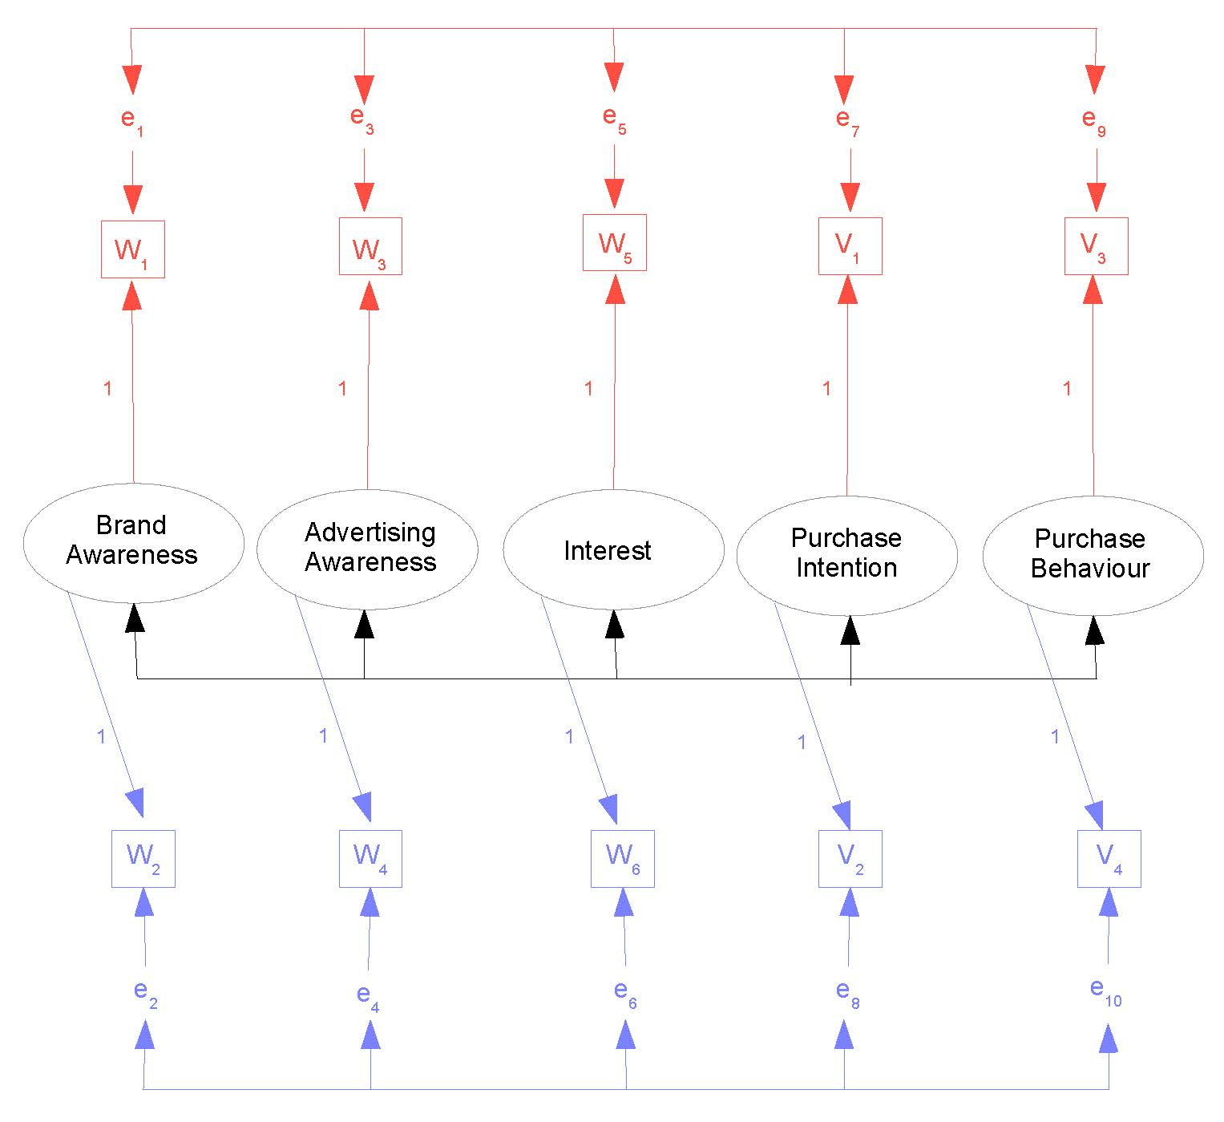

> torus3 =
+ '
+ # Measurement model (still simple double measurement)
+ L_BrAw =~ 1*w1 + 1*w2
+ L_AdAw =~ 1*w3 + 1*w4
+ L_Inter =~ 1*w5 + 1*w6
+ L_PI =~ 1*v1 + 1*v2
+ L_PBeh =~ 1*v3 + 1*v4
+ # Add covariances between measurement error terms, without naming them
+ w1 ~~ w3; w1 ~~ w5; w1 ~~ v1; w1 ~~ v3
+ w3 ~~ w5; w3 ~~ v1; w3 ~~ v3
+ w5 ~~ v1; w5 ~~ v3
+ v1 ~~ v3
+ w2 ~~ w4; w2 ~~ w6; w2 ~~ v2; w2 ~~ v4
+ w4 ~~ w6; w4 ~~ v2; w4 ~~ v4
+ w6 ~~ v2; w6 ~~ v4
+ v2 ~~ v4
+ ' # End of model torus3

> fit3 = cfa(torus3, data=coffee)

Warning message:
In lav_object_post_check(object) :
lavaan WARNING: the covariance matrix of the residuals of the observed
variables (theta) is not positive definite;
use lavInspect(fit, "theta") to investigate.

>
> lavInspect(fit3, "theta")
w1 w2 w3 w4 w5 w6 v1 v2 v3 v4
w1 10.617
w2 0.000 10.477
w3 2.700 0.000 11.704
w4 0.000 -1.726 0.000 11.263
w5 1.246 0.000 0.475 0.000 8.786
w6 0.000 -3.239 0.000 -1.904 0.000 5.053
v1 3.208 0.000 2.999 0.000 3.933 0.000 13.013
v2 0.000 -2.484 0.000 -1.490 0.000 -3.382 0.000 6.854
v3 0.555 0.000 -0.485 0.000 1.049 0.000 0.875 0.000 4.699
v4 0.000 -1.408 0.000 -1.756 0.000 -0.663 0.000 -1.499 0.000 3.911

> eigen(lavInspect(fit3, "theta"))$values

[1] 19.183427 12.752307 11.726917 10.823940 9.555380 8.270761 6.184626 4.599928 4.356615
[10] -1.076578

> # Maybe model is wrong, or maybe bad starting values.
> # Obtain MOM estimates for use as starting values.
>
> d1 = as.matrix(coffee[,c(1,3,5,7,9)]) # Measurement set one
> d2 = as.matrix(coffee[,c(2,4,6,8,10)]) # Measurement set two
> Phi_hat = cov(d1,d2); Phi_hat
w2 w4 w6 v2 v4
w1 10.186131 6.670427 15.123116 11.928618 8.162688
w3 6.655075 8.684598 12.766332 11.339975 6.893844
w5 7.627940 6.536859 16.409548 10.881683 6.290829
v1 8.347940 7.563392 16.891960 15.024598 10.119975
v3 4.674573 3.738015 7.650754 6.998216 17.746859

> # Make it symmetric
> Phi_hat = (Phi_hat + t(Phi_hat) )/2; Phi_hat

w2 w4 w6 v2 v4
w1 10.186131 6.662751 11.375528 10.138279 6.418631
w3 6.662751 8.684598 9.651595 9.451683 5.315930
w5 11.375528 9.651595 16.409548 13.886822 6.970791
v1 10.138279 9.451683 13.886822 15.024598 8.559095
v3 6.418631 5.315930 6.970791 8.559095 17.746859

> eigen(Phi_hat)$values # Is Phi-hat positive definite?
[1] 50.164191 12.097980 2.925981 1.668071 1.195511

> Omega1_hat = cov(d1) - Phi_hat
> Omega2_hat = cov(d2) - Phi_hat
> eigen(Omega1_hat)$values # Is Omega1_hat positive definite?
[1] 26.402687 9.301147 8.288868 5.106178 2.868356

> eigen(Omega2_hat)$values # Is Omega2_hat positive definite?
[1] 12.867799 11.828405 9.847771 4.712254 -3.393667

> # Method of moments estimate is outside the parameter space

Recall that the two measurements of each latent variable are different. One of the interviews is in-person, and the other is by telephone call-back. Maybe they're not really equivalent. Perhaps one in each set (say number two, the call-backs) should have a coefficient not equal to one.

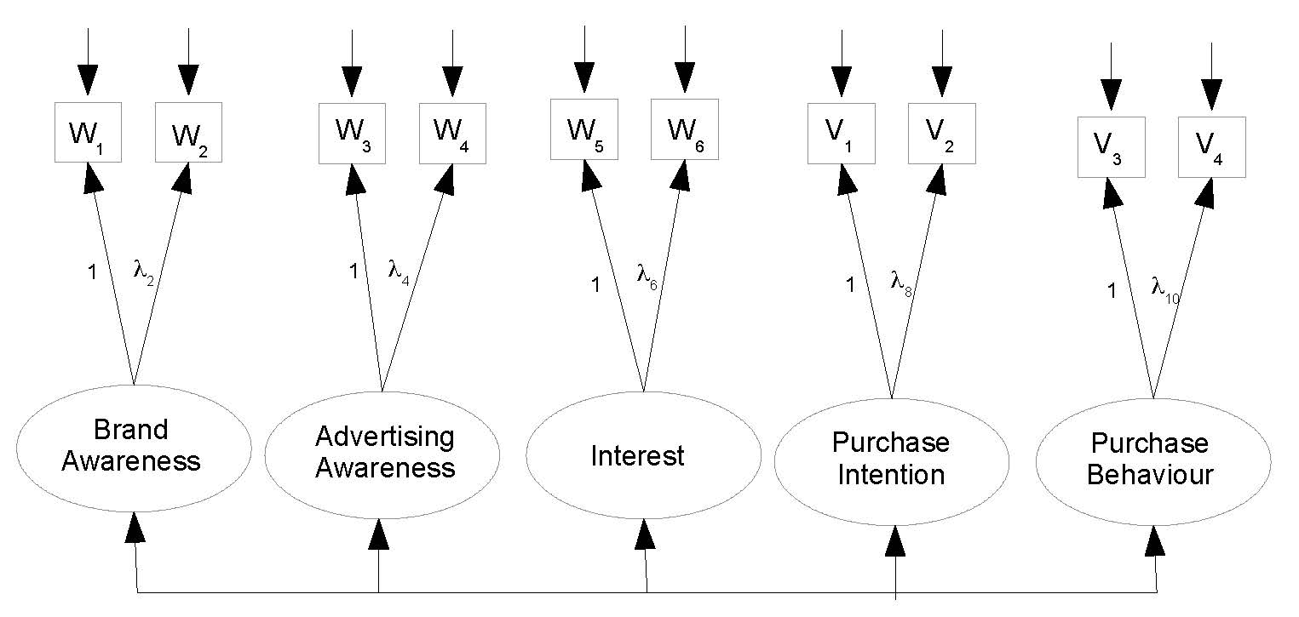

> torus4 =
+ '
+ # Measurement model
+ L_BrAw =~ 1*w1 + lambda2*w2
+ L_AdAw =~ 1*w3 + lambda4*w4
+ L_Inter =~ 1*w5 + lambda6*w6
+ L_PI =~ 1*v1 + lambda8*v2
+ L_PBeh =~ 1*v3 + lambda10*v4
+ ' # End of model torus4
> fit4 = cfa(torus4, data=coffee)
> show(fit4)

lavaan 0.6-11 ended normally after 161 iterations

Estimator ML
Optimization method NLMINB
Number of model parameters 30

Number of observations 200

Model Test User Model:

Test statistic 17.837
Degrees of freedom 25
P-value (Chi-square) 0.849

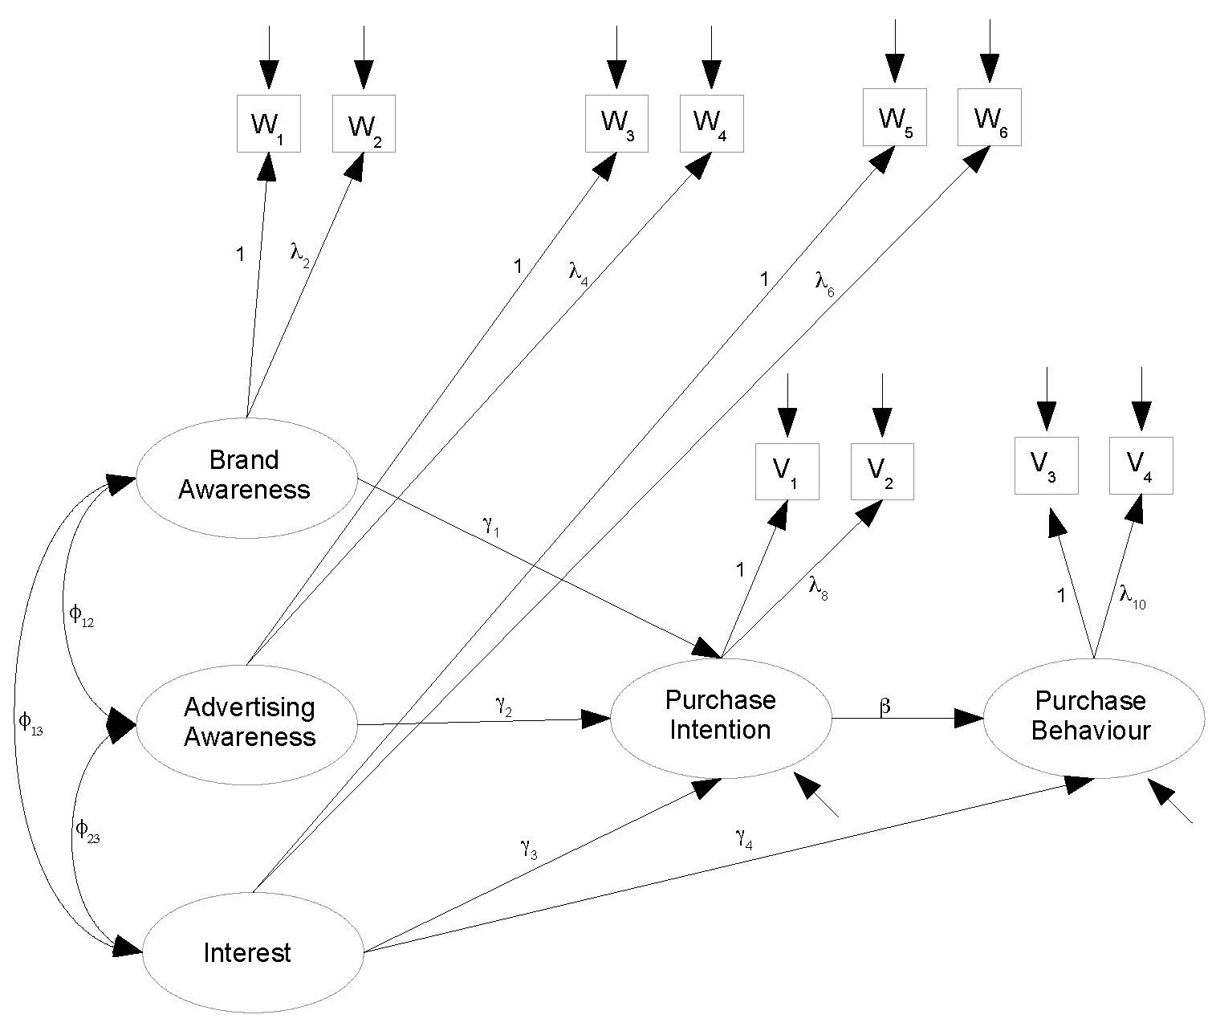

> # Just edit the measurement model part of model 1
> torus5 =
+ '
+ # Latent variable model
+ L_PI ~ gamma1*L_BrAw + gamma2*L_AdAw + gamma3*L_Inter
+ L_PBeh ~ gamma4*L_Inter + beta*L_PI
+ # Measurement model
+ L_BrAw =~ 1*w1 + lambda2*w2
+ L_AdAw =~ 1*w3 + lambda4*w4
+ L_Inter =~ 1*w5 + lambda6*w6
+ L_PI =~ 1*v1 + lambda8*v2
+ L_PBeh =~ 1*v3 + lambda10*v4
+ # Variances and covariances
+ # Exogenous latent variables
+ L_BrAw ~~ phi11*L_BrAw # Var(L_BrAw) = phi11
+ L_BrAw ~~ phi12*L_AdAw # Cov(L_BrAw,L_AdAw) = phi12
+ L_BrAw ~~ phi13*L_Inter # Cov(L_BrAw,L_Inter) = phi13
+ L_AdAw ~~ phi22*L_AdAw # Var(L_AdAw) = phi22
+ L_AdAw ~~ phi23*L_Inter # Cov(L_AdAw,L_Inter) = phi23
+ L_Inter ~~ phi33*L_Inter # Var(L_Inter) = phi33
+ # Errors in the latent model (epsilons)
+ L_PI ~~ psi1*L_PI # Var(epsilon1) = psi1
+ L_PBeh ~~ psi2*L_PBeh # Var(epsilon2) = psi2
+ # Measurement errors
+ w1 ~~ omega1*w1 # Var(e1) = omega1
+ w2 ~~ omega2*w2 # Var(e2) = omega2
+ w3 ~~ omega3*w3 # Var(e3) = omega3
+ w4 ~~ omega4*w4 # Var(e4) = omega4
+ w5 ~~ omega5*w5 # Var(e5) = omega5
+ w6 ~~ omega6*w6 # Var(e6) = omega6
+ v1 ~~ omega7*v1 # Var(e7) = omega7
+ v2 ~~ omega8*v2 # Var(e8) = omega8
+ v3 ~~ omega9*v3 # Var(e9) = omega9
+ v4 ~~ omega10*v4 # Var(e10) = omega10
+ # Bounds (Variances are positive)
+ phi11 > 0; phi22 > 0; phi33 > 0
+ psi1 > 0; psi2 > 0
+ omega1 > 0; omega2 > 0; omega3 > 0; omega4 > 0; omega5 > 0
+ omega6 > 0; omega7 > 0; omega8 > 0; omega9 > 0; omega10 > 0
+ ' # End of model torus5
> fit5 = lavaan(torus5, data=coffee)

Warning messages:

1: In lav_model_vcov(lavmodel = lavmodel, lavsamplestats = lavsamplestats, :
lavaan WARNING:
Could not compute standard errors! The information matrix could
not be inverted. This may be a symptom that the model is not
identified.
2: In lav_object_post_check(object) :
lavaan WARNING: covariance matrix of latent variables
is not positive definite;
use lavInspect(fit, "cov.lv") to investigate.

> summary(fit5)
lavaan 0.6-11 ended normally after 2096 iterations

Estimator ML
Optimization method NLMINB
Number of model parameters 28
Number of inequality constraints 15

Number of observations 200

Model Test User Model:

Test statistic 31.127
Degrees of freedom 27
P-value (Chi-square) 0.266

Parameter Estimates:

Standard errors Standard
Information Expected
Information saturated (h1) model Structured

Latent Variables:
Estimate Std.Err z-value P(>|z|)
L_BrAw =~
w1 1.000
w2 (lmb2) 0.535 NA
L_AdAw =~
w3 1.000
w4 (lmb4) 0.552 NA
L_Inter =~
w5 1.000
w6 (lmb6) 1.094 NA
L_PI =~
v1 1.000
v2 (lmb8) 0.708 NA
L_PBeh =~
v3 1.000
v4 (lm10) 1.034 NA

(to be continued)

Comparing the estimates from the good measurement model,

> coef(fit4)
lambda2 lambda4 lambda6 lambda8 lambda10
0.530 0.543 1.090 0.708 1.029
w1~~w1 w2~~w2 w3~~w3 w4~~w4 w5~~w5
5.106 12.955 7.034 13.401 6.205
w6~~w6 v1~~v1 v2~~v2 v3~~v3 v4~~v4
6.134 8.322 10.301 4.440 3.993
L_BrAw~~L_BrAw L_AdAw~~L_AdAw L_Inter~~L_Inter L_PI~~L_PI L_PBeh~~L_PBeh
19.135 15.914 14.980 21.128 17.155
L_BrAw~~L_AdAw L_BrAw~~L_Inter L_BrAw~~L_PI L_BrAw~~L_PBeh L_AdAw~~L_Inter
12.297 13.502 16.248 7.883 11.306
L_AdAw~~L_PI L_AdAw~~L_PBeh L_Inter~~L_PI L_Inter~~L_PBeh L_PI~~L_PBeh
15.070 6.144 15.564 6.533 9.619

Continuing to look at the output of summary(fit5),

Regressions:
Estimate Std.Err z-value P(>|z|)
L_PI ~
L_BrAw (gmm1) 47.719 NA
L_AdAw (gmm2) -156.406 NA
L_Inter (gmm3) 80.361 NA
L_PBeh ~
L_Inter (gmm4) -0.156 NA
L_PI (beta) 0.570 NA

Covariances:
Estimate Std.Err z-value P(>|z|)
L_BrAw ~~
L_AdAw (ph12) 12.498 NA
L_Inter (ph13) 13.407 NA
L_AdAw ~~
L_Inter (ph23) 11.621 NA

Variances:
Estimate Std.Err z-value P(>|z|)
L_BrAw (ph11) 18.730 NA
L_AdAw (ph22) 9.691 NA
L_Inter (ph33) 14.851 NA
.L_PI (psi1) 260.320 NA
.L_PBeh (psi2) 12.623 NA
.w1 (omg1) 5.511 NA
.w2 (omg2) 12.959 NA
.w3 (omg3) 13.263 NA
.w4 (omg4) 15.139 NA
.w5 (omg5) 6.335 NA
.w6 (omg6) 6.158 NA
.v1 (omg7) 8.341 NA
.v2 (omg8) 10.301 NA
.v3 (omg9) 4.524 NA
.v4 (om10) 3.903 NA

> lavInspect(fit5, "cov.lv")
L_BrAw L_AdAw L_Intr L_PI L_PBeh
L_BrAw 18.730
L_AdAw 12.498 9.691
L_Inter 13.407 11.621 14.851
L_PI 16.411 14.534 15.565 21.059
L_PBeh 7.261 6.469 6.554 9.572 17.054
> lavInspect(fit4, "cov.lv") # True MLE
L_BrAw L_AdAw L_Intr L_PI L_PBeh
L_BrAw 19.135
L_AdAw 12.297 15.914
L_Inter 13.502 11.306 14.980
L_PI 16.248 15.070 15.564 21.128
L_PBeh 7.883 6.144 6.533 9.619 17.155
>
> # Believe the values from fit4. They are the real MLEs

# Based on the sub-model y1 = gamma^t x + epsilon1 (details omitted)
# Get estimates of gamma and psi1 = Var(epsilon1)

>
> # The names of all these quantities should include "hat."
> Phi = lavInspect(fit4, "cov.lv")
> Phix = Phi[1:3,1:3]; Phix
L_BrAw L_AdAw L_Inter
L_BrAw 19.13510 12.29660 13.50213
L_AdAw 12.29660 15.91372 11.30579
L_Inter 13.50213 11.30579 14.98033
> Phixy = as.matrix(Phi[1:3,4]); Phixy
[,1]
L_BrAw 16.24761
L_AdAw 15.07005
L_Inter 15.56443
> gamma = t(Phixy) %*% solve(Phix); gamma
L_BrAw L_AdAw L_Inter
[1,] 0.1996458 0.3932861 0.5622287
> psi1 = Phi[4,4] - as.numeric(gamma %*% Phix %*% t(gamma)); psi1
[1] 3.206661
>
> # These numbers are much more reasonable. See if I can get away with specifying just 10 starting values. Drop the inequality constraints too, since lavaan will issue a warning if any variance estimate is negative.

>
> torus6 =
+ '
+ # Latent variable model
+ L_PI ~ gamma1*L_BrAw + start(0.1996458)*L_BrAw +
+ gamma2*L_AdAw + start(0.3932861)*L_AdAw +
+ gamma3*L_Inter + start(0.5622287)*L_Inter
+ L_PBeh ~ gamma4*L_Inter + beta*L_PI
+ # Measurement model
+ L_BrAw =~ 1*w1 + lambda2*w2
+ L_AdAw =~ 1*w3 + lambda4*w4
+ L_Inter =~ 1*w5 + lambda6*w6
+ L_PI =~ 1*v1 + lambda8*v2
+ L_PBeh =~ 1*v3 + lambda10*v4
+ # Variances and covariances
+ # Exogenous latent variables
+ L_BrAw ~~ phi11*L_BrAw + start(19.13510)*L_BrAw # Var(L_BrAw) = phi11
+ L_BrAw ~~ phi12*L_AdAw + start(12.29660)*L_AdAw # Cov(L_BrAw,L_AdAw) = phi12
+ L_BrAw ~~ phi13*L_Inter + start(13.50213)*L_Inter # Cov(L_BrAw,L_Inter) = phi13
+ L_AdAw ~~ phi22*L_AdAw + start(15.91372)*L_AdAw # Var(L_AdAw) = phi22
+ L_AdAw ~~ phi23*L_Inter + start(11.30579)*L_Inter # Cov(L_AdAw,L_Inter) = phi23
+ L_Inter ~~ phi33*L_Inter + start(14.98033)*L_Inter # Var(L_Inter) = phi33
+ # Errors in the latent model (epsilons)
+ L_PI ~~ psi1*L_PI + start(3.206661)*L_PI # Var(epsilon1) = psi1
+ L_PBeh ~~ psi2*L_PBeh # Var(epsilon2) = psi2
+ # Measurement errors
+ w1 ~~ omega1*w1 # Var(e1) = omega1
+ w2 ~~ omega2*w2 # Var(e2) = omega2
+ w3 ~~ omega3*w3 # Var(e3) = omega3
+ w4 ~~ omega4*w4 # Var(e4) = omega4
+ w5 ~~ omega5*w5 # Var(e5) = omega5
+ w6 ~~ omega6*w6 # Var(e6) = omega6
+ v1 ~~ omega7*v1 # Var(e7) = omega7
+ v2 ~~ omega8*v2 # Var(e8) = omega8
+ v3 ~~ omega9*v3 # Var(e9) = omega9
+ v4 ~~ omega10*v4 # Var(e10) = omega10
+ ' # End of model torus6
> fit6 = lavaan(torus6, data=coffee)
> fit6

lavaan 0.6-11 ended normally after 108 iterations

Estimator ML
Optimization method NLMINB
Number of model parameters 28

Number of observations 200

Model Test User Model:

Test statistic 18.962
Degrees of freedom 27
P-value (Chi-square) 0.871

> summary(fit6)
lavaan 0.6-11 ended normally after 108 iterations

Estimator ML
Optimization method NLMINB
Number of model parameters 28

Number of observations 200

Model Test User Model:

Test statistic 18.962
Degrees of freedom 27
P-value (Chi-square) 0.871

Parameter Estimates:

Standard errors Standard
Information Expected
Information saturated (h1) model Structured

Latent Variables:
Estimate Std.Err z-value P(>|z|)
L_BrAw =~
w1 1.000
w2 (lmb2) 0.528 0.077 6.861 0.000
L_AdAw =~
w3 1.000
w4 (lmb4) 0.543 0.090 6.013 0.000
L_Inter =~
w5 1.000
w6 (lmb6) 1.092 0.081 13.528 0.000
L_PI =~
v1 1.000
v2 (lmb8) 0.707 0.066 10.745 0.000
L_PBeh =~
v3 1.000
v4 (lm10) 1.040 0.110 9.457 0.000

Regressions:
Estimate Std.Err z-value P(>|z|)
L_PI ~
L_BrAw (gmm1) 0.229 0.145 1.581 0.114
L_AdAw (gmm2) 0.369 0.161 2.285 0.022
L_Inter (gmm3) 0.553 0.170 3.253 0.001
L_PBeh ~
L_Inter (gmm4) -0.129 0.257 -0.502 0.615
L_PI (beta) 0.546 0.224 2.438 0.015

Covariances:
Estimate Std.Err z-value P(>|z|)
L_BrAw ~~
L_AdAw (ph12) 12.301 1.864 6.598 0.000
L_Inter (ph13) 13.480 1.831 7.360 0.000
L_AdAw ~~
L_Inter (ph23) 11.312 1.694 6.679 0.000

Variances:
Estimate Std.Err z-value P(>|z|)
L_BrAw (ph11) 19.200 3.110 6.174 0.000
L_AdAw (ph22) 15.910 3.033 5.246 0.000
L_Inter (ph33) 14.961 2.153 6.949 0.000
.L_PI (psi1) 3.301 1.340 2.463 0.014
.L_PBeh (psi2) 12.620 2.097 6.019 0.000
.w1 (omg1) 5.041 2.075 2.430 0.015
.w2 (omg2) 12.974 1.413 9.179 0.000
.w3 (omg3) 7.038 2.218 3.172 0.002
.w4 (omg4) 13.400 1.477 9.074 0.000
.w5 (omg5) 6.224 0.960 6.484 0.000
.w6 (omg6) 6.098 1.063 5.735 0.000
.v1 (omg7) 8.280 1.479 5.598 0.000
.v2 (omg8) 10.299 1.215 8.477 0.000
.v3 (omg9) 4.612 1.682 2.742 0.006
.v4 (om10) 3.809 1.789 2.129 0.033

> parTable(fit6)
id lhs op rhs user block group free ustart exo label plabel start est se
1 1 L_PI ~ L_BrAw 1 1 1 1 0.200 0 gamma1 .p1. 0.200 0.229 0.145
2 2 L_PI ~ L_AdAw 1 1 1 2 0.393 0 gamma2 .p2. 0.393 0.369 0.161
3 3 L_PI ~ L_Inter 1 1 1 3 0.562 0 gamma3 .p3. 0.562 0.553 0.170
4 4 L_PBeh ~ L_Inter 1 1 1 4 NA 0 gamma4 .p4. 0.000 -0.129 0.257
5 5 L_PBeh ~ L_PI 1 1 1 5 NA 0 beta .p5. 0.000 0.546 0.224
6 6 L_BrAw =~ w1 1 1 1 0 1.000 0 .p6. 1.000 1.000 0.000
7 7 L_BrAw =~ w2 1 1 1 6 NA 0 lambda2 .p7. 0.476 0.528 0.077
8 8 L_AdAw =~ w3 1 1 1 0 1.000 0 .p8. 1.000 1.000 0.000
9 9 L_AdAw =~ w4 1 1 1 7 NA 0 lambda4 .p9. 0.421 0.543 0.090
10 10 L_Inter =~ w5 1 1 1 0 1.000 0 .p10. 1.000 1.000 0.000
11 11 L_Inter =~ w6 1 1 1 8 NA 0 lambda6 .p11. 0.724 1.092 0.081
12 12 L_PI =~ v1 1 1 1 0 1.000 0 .p12. 1.000 1.000 0.000
13 13 L_PI =~ v2 1 1 1 9 NA 0 lambda8 .p13. 0.594 0.707 0.066
14 14 L_PBeh =~ v3 1 1 1 0 1.000 0 .p14. 1.000 1.000 0.000
15 15 L_PBeh =~ v4 1 1 1 10 NA 0 lambda10 .p15. 0.807 1.040 0.110
16 16 L_BrAw ~~ L_BrAw 1 1 1 11 19.135 0 phi11 .p16. 19.135 19.200 3.110
17 17 L_BrAw ~~ L_AdAw 1 1 1 12 12.297 0 phi12 .p17. 12.297 12.301 1.864
18 18 L_BrAw ~~ L_Inter 1 1 1 13 13.502 0 phi13 .p18. 13.502 13.480 1.831
19 19 L_AdAw ~~ L_AdAw 1 1 1 14 15.914 0 phi22 .p19. 15.914 15.910 3.033
20 20 L_AdAw ~~ L_Inter 1 1 1 15 11.306 0 phi23 .p20. 11.306 11.312 1.694
21 21 L_Inter ~~ L_Inter 1 1 1 16 14.980 0 phi33 .p21. 14.980 14.961 2.153
22 22 L_PI ~~ L_PI 1 1 1 17 3.207 0 psi1 .p22. 3.207 3.301 1.340
23 23 L_PBeh ~~ L_PBeh 1 1 1 18 NA 0 psi2 .p23. 0.050 12.620 2.097
24 24 w1 ~~ w1 1 1 1 19 NA 0 omega1 .p24. 12.120 5.041 2.075
25 25 w2 ~~ w2 1 1 1 20 NA 0 omega2 .p25. 9.162 12.974 1.413
26 26 w3 ~~ w3 1 1 1 21 NA 0 omega3 .p26. 11.474 7.038 2.218
27 27 w4 ~~ w4 1 1 1 22 NA 0 omega4 .p27. 9.046 13.400 1.477
28 28 w5 ~~ w5 1 1 1 23 NA 0 omega5 .p28. 10.593 6.224 0.960
29 29 w6 ~~ w6 1 1 1 24 NA 0 omega6 .p29. 11.965 6.098 1.063
30 30 v1 ~~ v1 1 1 1 25 NA 0 omega7 .p30. 14.725 8.280 1.479
31 31 v2 ~~ v2 1 1 1 26 NA 0 omega8 .p31. 10.439 10.299 1.215
32 32 v3 ~~ v3 1 1 1 27 NA 0 omega9 .p32. 10.797 4.612 1.682
33 33 v4 ~~ v4 1 1 1 28 NA 0 omega10 .p33. 11.085 3.809 1.789

> # Likelihood ratio test of
> # H0: lambda2 = lambda4 = lambda6 = lambda8 = lambda10 = 1
> anova(fit1,fit6)
Chi-Squared Difference Test

Df AIC BIC Chisq Chisq diff Df diff Pr(>Chisq)
fit6 27 10947 11039 18.962
fit1 32 10996 11071 77.752 58.789 5 0.00000000002162 ***
---
Signif. codes: 0 ‘***’ 0.001 ‘**’ 0.01 ‘*’ 0.05 ‘.’ 0.1 ‘ ’ 1

> # Which ones are different from one?
> pt6 = parTable(fit6); dim(pt6)
[1] 33 15
> z = as.numeric( (pt6[,14]-1)/pt6[,15] )
> # Extract only meaningful z statistics (for lambda_j)
> z = z[c(7,9,11,13,15)]
> names(z) = c('lambda2', 'lambda4', 'lambda6', 'lambda8', 'lambda10')
> z
lambda2 lambda4 lambda6 lambda8 lambda10
-6.1368432 -5.0581710 1.1367154 -4.4540676 0.3614714
> pt6[c(7,9,11,13,15),14] # Corresponding lambda-hats
[1] 0.5278696 0.5431214 1.0917385 0.7069418 1.0397428

*This handout was prepared by Jerry Brunner, Department of Statistical Sciences, University of Toronto. It is licensed under a Creative Commons Attribution - ShareAlike 3.0 Unported License. Use any part of it as you like and share the result freely. The OpenOffice.org document is available from the course website: http://www.utstat.toronto.edu/brunner/oldclass/431s23

