The BMI Health Study*
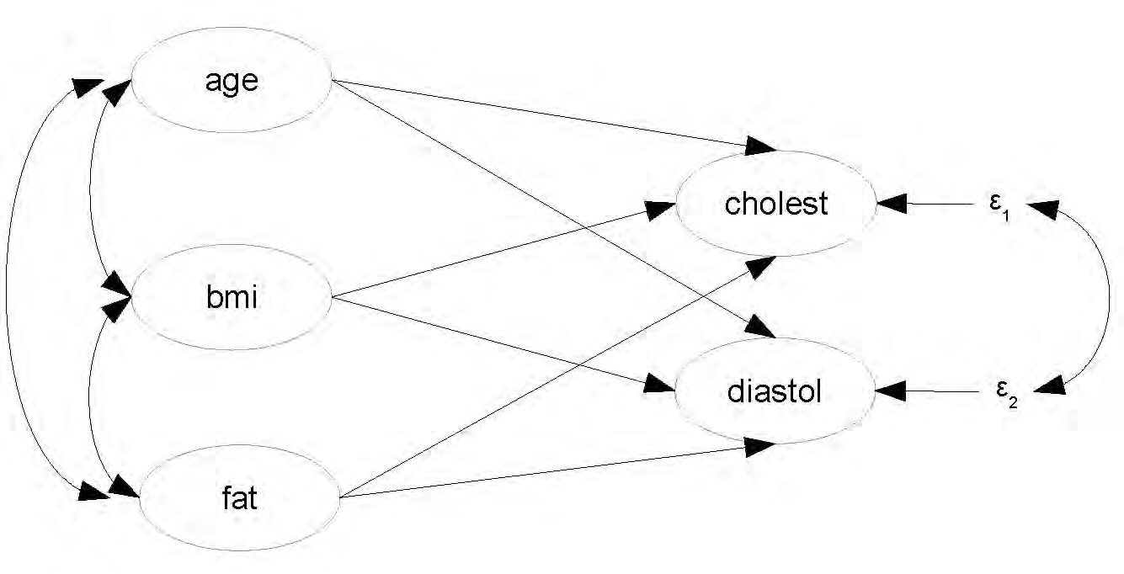
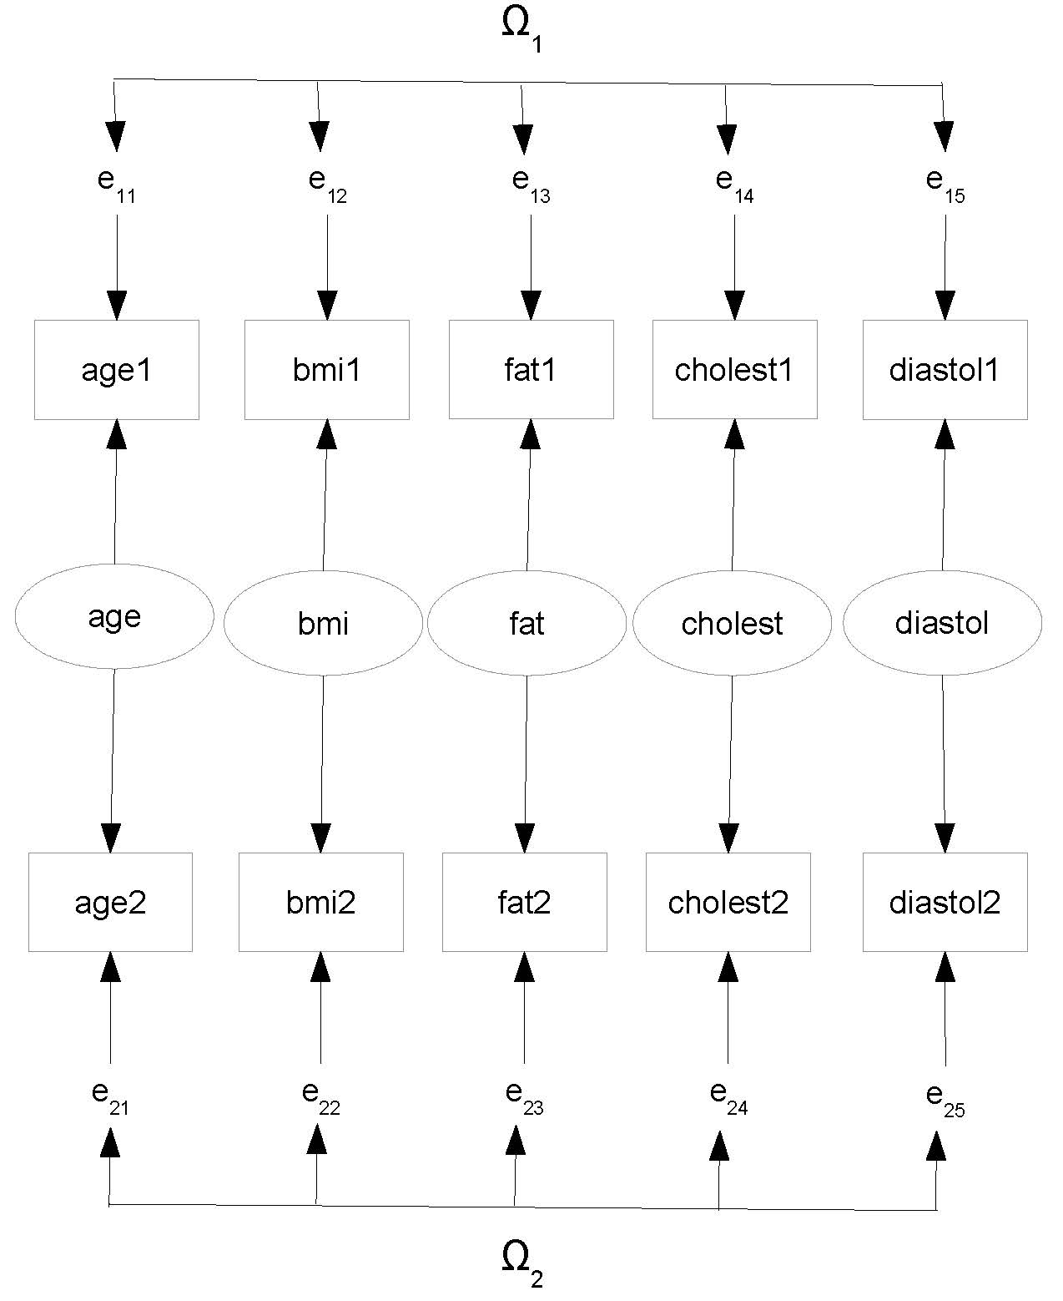

> rm(list=ls()); options(scipen=999)
> bmidata = read.table("http://www.utstat.toronto.edu/~brunner/openSEM/data/bmi.data.txt")
>
> head(bmidata)
age1 bmi1 fat1 cholest1 diastol1 age2 bmi2 fat2 cholest2 diastol2
1 63 24.5 16.5 195.4 38 60 23.9 20.1 203.5 66
2 42 13.0 1.9 184.3 86 44 14.8 2.6 197.3 78
3 32 22.5 14.6 354.1 104 33 21.7 20.4 374.3 73
4 59 25.5 19.0 214.6 93 58 28.5 20.0 203.7 106
5 45 26.5 17.8 324.8 97 43 25.0 12.3 329.7 92
6 31 19.4 17.1 280.7 92 42 19.9 19.9 276.7 87
> dim(bmidata)
[1] 500 10
>
> ###################################
> # Naive surface regression #
> ###################################
>
> bmi = within(bmidata,{
+ age = (age1+age2)/2; bmi = (bmi1+bmi2)/2; fat = (fat1+fat2)/2
+ cholest = (cholest1+cholest2)/2; diastol = (diastol1+diastol2)/2
+ })
> dim(bmi)
[1] 500 15
> fullmod = lm( cbind(cholest,diastol) ~ age + fat + bmi, data=bmi)
> summary(fullmod)
Response cholest :

Call:
lm(formula = cholest ~ age + fat + bmi, data = bmi)

Residuals:
Min 1Q Median 3Q Max
-148.550 -34.243 2.626 33.661 165.582

Coefficients:
Estimate Std. Error t value Pr(>|t|)
(Intercept) 220.0610 21.0109 10.474 < 0.0000000000000002 ***
age -0.2714 0.2002 -1.356 0.17578
fat 2.2334 0.5792 3.856 0.00013 ***
bmi 0.5164 1.0154 0.509 0.61128
---
Signif. codes: 0 ‘***’ 0.001 ‘**’ 0.01 ‘*’ 0.05 ‘.’ 0.1 ‘ ’ 1

Residual standard error: 52.43 on 496 degrees of freedom
Multiple R-squared: 0.09701, Adjusted R-squared: 0.09155
F-statistic: 17.76 on 3 and 496 DF, p-value: 0.00000000005762

Response diastol :

Call:
lm(formula = diastol ~ age + fat + bmi, data = bmi)

Residuals:
Min 1Q Median 3Q Max
-44.841 -7.140 -0.408 7.612 41.377

Coefficients:
Estimate Std. Error t value Pr(>|t|)
(Intercept) 49.69194 4.52512 10.981 < 0.0000000000000002 ***
age 0.12648 0.04311 2.934 0.003504 **
fat 0.64056 0.12474 5.135 0.000000406 ***
bmi 0.82627 0.21869 3.778 0.000177 ***
---
Signif. codes: 0 ‘***’ 0.001 ‘**’ 0.01 ‘*’ 0.05 ‘.’ 0.1 ‘ ’ 1

Residual standard error: 11.29 on 496 degrees of freedom
Multiple R-squared: 0.3333, Adjusted R-squared: 0.3293
F-statistic: 82.67 on 3 and 496 DF, p-value: < 0.00000000000000022
>
> restrictedmod = update(fullmod, . ~ . - bmi) # Remove var(s) being tested
> anova(fullmod,restrictedmod) # Gives multivariate test.
Analysis of Variance Table

Model 1: cbind(cholest, diastol) ~ age + fat + bmi
Model 2: cbind(cholest, diastol) ~ age + fat
Res.Df Df Gen.var. Pillai approx F num Df den Df Pr(>F)
1 496 591.89
2 497 1 599.36 0.02869 7.3106 2 495 0.0007431 ***
---
Signif. codes: 0 ‘***’ 0.001 ‘**’ 0.01 ‘*’ 0.05 ‘.’ 0.1 ‘ ’ 1

>
> ###################################
> # Structural equation model #
> ###################################
> # install.packages("lavaan", dependencies = TRUE) # Only need to do this once
> library(lavaan)
This is lavaan 0.6-11
lavaan is FREE software! Please report any bugs.
>

bmimodel1 =
########################################################
# Latent variable model
# ---------------------
'Lcholest ~ beta11*Lage + beta12*Lbmi + beta13*Lfat
Ldiastol ~ beta21*Lage + beta22*Lbmi + beta23*Lfat
#
# Measurement model
# -----------------
Lage =~ 1*age1 + 1*age2
Lbmi =~ 1*bmi1 + 1*bmi2
Lfat =~ 1*fat1 +1*fat2
Lcholest =~ 1*cholest1 + 1*cholest2
Ldiastol =~ 1*diastol1 + 1*diastol2
#
# Variances and covariances
# -------------------------
# Of latent explanatory variables
Lage ~~ phi11*Lage; Lage ~~ phi12*Lbmi; Lage ~~ phi13*Lfat
Lbmi ~~ phi22*Lbmi; Lbmi ~~ phi23*Lfat
Lfat ~~ phi33*Lfat
# Of error terms in latent the regression (epsilon_ij)
Lcholest ~~ psi11*Lcholest; Lcholest ~~ psi12*Ldiastol
Ldiastol ~~ psi22*Ldiastol
# Of measurement errors (e_ijk) for measurement set 1
age1 ~~ w111*age1; age1 ~~ w112*bmi1; age1 ~~ w113*fat1;
age1 ~~ w114*cholest1; age1 ~~ w115*diastol1
bmi1 ~~ w122*bmi1; bmi1 ~~ w123*fat1; bmi1 ~~ w124*cholest1; bmi1 ~~ w125*diastol1
fat1 ~~ w133*fat1; fat1 ~~ w134*cholest1; fat1 ~~ w135*diastol1
cholest1 ~~ w144*cholest1; cholest1 ~~ w145*diastol1
diastol1 ~~ w155*diastol1
# Of measurement errors (e_ijk) for measurement set 2
age2 ~~ w211*age2; age2 ~~ w212*bmi2; age2 ~~ w213*fat2;
age2 ~~ w214*cholest2; age2 ~~ w215*diastol2
bmi2 ~~ w222*bmi2; bmi2 ~~ w223*fat2; bmi2 ~~ w224*cholest2; bmi2 ~~ w225*diastol2
fat2 ~~ w233*fat2; fat2 ~~ w234*cholest2; fat2 ~~ w235*diastol2
cholest2 ~~ w244*cholest2; cholest2 ~~ w245*diastol2
diastol2 ~~ w255*diastol2
' ################# End of bmimodel1 #################

> fit1 = lavaan(bmimodel1, data=bmidata)
Warning messages:
1: In lav_model_vcov(lavmodel = lavmodel, lavsamplestats = lavsamplestats, :
lavaan WARNING:
Could not compute standard errors! The information matrix could
not be inverted. This may be a symptom that the model is not
identified.
2: In lav_object_post_check(object) :
lavaan WARNING: some estimated lv variances are negative

> summary(fit1)
lavaan 0.6-11 ended normally after 4241 iterations

Estimator ML
Optimization method NLMINB
Number of model parameters 45

Number of observations 500

Model Test User Model:

Test statistic 89.369
Degrees of freedom 10
P-value (Chi-square) 0.000

Parameter Estimates:

Standard errors Standard
Information Expected
Information saturated (h1) model Structured

Latent Variables:
Estimate Std.Err z-value P(>|z|)
Lage =~
age1 1.000
age2 1.000
Lbmi =~
bmi1 1.000
bmi2 1.000
Lfat =~
fat1 1.000
fat2 1.000
Lcholest =~
cholest1 1.000
cholest2 1.000
Ldiastol =~
diastol1 1.000
diastol2 1.000

Regressions:
Estimate Std.Err z-value P(>|z|)
Lcholest ~
Lage (bt11) -26.391 NA
Lbmi (bt12) -354.932 NA
Lfat (bt13) 203.432 NA
Ldiastol ~
Lage (bt21) -28.583 NA
Lbmi (bt22) -390.464 NA
Lfat (bt23) 221.685 NA

Covariances:
Estimate Std.Err z-value P(>|z|)
Lage ~~
Lbmi (ph12) 3.288 NA
Lfat (ph13) 24.865 NA
Lbmi ~~
Lfat (ph23) 22.225 NA
.Lcholest ~~
.Ldiastl (ps12) -2633.270 NA
.age1 ~~
.bmi1 (w112) 4.361 NA
.fat1 (w113) 0.994 NA
.cholst1 (w114) 3.102 NA
.diastl1 (w115) 12.808 NA

.bmi1 ~~
.fat1 (w123) 7.385 NA
.cholst1 (w124) -0.497 NA
.diastl1 (w125) 12.340 NA
.fat1 ~~
.cholst1 (w134) 7.835 NA
.diastl1 (w135) -6.960 NA
.cholest1 ~~
.diastl1 (w145) 0.038 NA
.age2 ~~
.bmi2 (w212) 0.752 NA
.fat2 (w213) -4.120 NA
.cholst2 (w214) -2.601 NA
.diastl2 (w215) 5.903 NA
.bmi2 ~~
.fat2 (w223) -3.043 NA
.cholst2 (w224) -3.469 NA
.diastl2 (w225) 6.602 NA
.fat2 ~~
.cholst2 (w234) -10.098 NA
.diastl2 (w235) -9.933 NA
.cholest2 ~~
.diastl2 (w245) -10.026 NA

Variances:
Estimate Std.Err z-value P(>|z|)
Lage (ph11) 146.720 NA
Lbmi (ph22) 12.318 NA
Lfat (ph33) 42.615 NA
.Lcholst (ps11) 169.820 NA
.Ldiastl (ps22) -2785.532 NA
.age1 (w111) 18.767 NA
.bmi1 (w122) 9.177 NA
.fat1 (w133) 18.669 NA
.cholst1 (w144) 200.123 NA
.diastl1 (w155) 204.316 NA
.age2 (w211) 8.326 NA
.bmi2 (w222) 2.460 NA
.fat2 (w233) 9.975 NA
.cholst2 (w244) 344.031 NA
.diastl2 (w255) 59.441 NA

> p1 = parTable(fit1); p1
id lhs op rhs user block group free ustart exo label plabel start est se
1 1 Lcholest ~ Lage 1 1 1 1 NA 0 beta11 .p1. 0.000 -26.391 NA
2 2 Lcholest ~ Lbmi 1 1 1 2 NA 0 beta12 .p2. 0.000 -354.932 NA
3 3 Lcholest ~ Lfat 1 1 1 3 NA 0 beta13 .p3. 0.000 203.432 NA
4 4 Ldiastol ~ Lage 1 1 1 4 NA 0 beta21 .p4. 0.000 -28.583 NA
5 5 Ldiastol ~ Lbmi 1 1 1 5 NA 0 beta22 .p5. 0.000 -390.464 NA
6 6 Ldiastol ~ Lfat 1 1 1 6 NA 0 beta23 .p6. 0.000 221.685 NA
7 7 Lage =~ age1 1 1 1 0 1 0 .p7. 1.000 1.000 0
8 8 Lage =~ age2 1 1 1 0 1 0 .p8. 1.000 1.000 0
9 9 Lbmi =~ bmi1 1 1 1 0 1 0 .p9. 1.000 1.000 0
10 10 Lbmi =~ bmi2 1 1 1 0 1 0 .p10. 1.000 1.000 0
11 11 Lfat =~ fat1 1 1 1 0 1 0 .p11. 1.000 1.000 0
12 12 Lfat =~ fat2 1 1 1 0 1 0 .p12. 1.000 1.000 0
13 13 Lcholest =~ cholest1 1 1 1 0 1 0 .p13. 1.000 1.000 0
14 14 Lcholest =~ cholest2 1 1 1 0 1 0 .p14. 1.000 1.000 0
15 15 Ldiastol =~ diastol1 1 1 1 0 1 0 .p15. 1.000 1.000 0
16 16 Ldiastol =~ diastol2 1 1 1 0 1 0 .p16. 1.000 1.000 0
17 17 Lage ~~ Lage 1 1 1 7 NA 0 phi11 .p17. 0.050 146.720 NA
18 18 Lage ~~ Lbmi 1 1 1 8 NA 0 phi12 .p18. 0.000 3.288 NA
19 19 Lage ~~ Lfat 1 1 1 9 NA 0 phi13 .p19. 0.000 24.865 NA
20 20 Lbmi ~~ Lbmi 1 1 1 10 NA 0 phi22 .p20. 0.050 12.318 NA
21 21 Lbmi ~~ Lfat 1 1 1 11 NA 0 phi23 .p21. 0.000 22.225 NA
22 22 Lfat ~~ Lfat 1 1 1 12 NA 0 phi33 .p22. 0.050 42.615 NA
23 23 Lcholest ~~ Lcholest 1 1 1 13 NA 0 psi11 .p23. 0.050 169.820 NA
24 24 Lcholest ~~ Ldiastol 1 1 1 14 NA 0 psi12 .p24. 0.000 -2633.270 NA
25 25 Ldiastol ~~ Ldiastol 1 1 1 15 NA 0 psi22 .p25. 0.050 -2785.532 NA
26 26 age1 ~~ age1 1 1 1 16 NA 0 w111 .p26. 83.763 18.767 NA
27 27 age1 ~~ bmi1 1 1 1 17 NA 0 w112 .p27. 0.000 4.361 NA
28 28 age1 ~~ fat1 1 1 1 18 NA 0 w113 .p28. 0.000 0.994 NA
29 29 age1 ~~ cholest1 1 1 1 19 NA 0 w114 .p29. 0.000 3.102 NA
30 30 age1 ~~ diastol1 1 1 1 20 NA 0 w115 .p30. 0.000 12.808 NA
31 31 bmi1 ~~ bmi1 1 1 1 21 NA 0 w122 .p31. 10.925 9.177 NA
32 32 bmi1 ~~ fat1 1 1 1 22 NA 0 w123 .p32. 0.000 7.385 NA
33 33 bmi1 ~~ cholest1 1 1 1 23 NA 0 w124 .p33. 0.000 -0.497 NA
34 34 bmi1 ~~ diastol1 1 1 1 24 NA 0 w125 .p34. 0.000 12.340 NA
35 35 fat1 ~~ fat1 1 1 1 25 NA 0 w133 .p35. 30.023 18.669 NA
36 36 fat1 ~~ cholest1 1 1 1 26 NA 0 w134 .p36. 0.000 7.835 NA
37 37 fat1 ~~ diastol1 1 1 1 27 NA 0 w135 .p37. 0.000 -6.960 NA
38 38 cholest1 ~~ cholest1 1 1 1 28 NA 0 w144 .p38. 1548.559 200.123 NA
39 39 cholest1 ~~ diastol1 1 1 1 29 NA 0 w145 .p39. 0.000 0.038 NA
40 40 diastol1 ~~ diastol1 1 1 1 30 NA 0 w155 .p40. 162.507 204.316 NA
41 41 age2 ~~ age2 1 1 1 31 NA 0 w211 .p41. 76.888 8.326 NA
42 42 age2 ~~ bmi2 1 1 1 32 NA 0 w212 .p42. 0.000 0.752 NA
43 43 age2 ~~ fat2 1 1 1 33 NA 0 w213 .p43. 0.000 -4.120 NA
44 44 age2 ~~ cholest2 1 1 1 34 NA 0 w214 .p44. 0.000 -2.601 NA
45 45 age2 ~~ diastol2 1 1 1 35 NA 0 w215 .p45. 0.000 5.903 NA
46 46 bmi2 ~~ bmi2 1 1 1 36 NA 0 w222 .p46. 7.156 2.460 NA
47 47 bmi2 ~~ fat2 1 1 1 37 NA 0 w223 .p47. 0.000 -3.043 NA
48 48 bmi2 ~~ cholest2 1 1 1 38 NA 0 w224 .p48. 0.000 -3.469 NA
49 49 bmi2 ~~ diastol2 1 1 1 39 NA 0 w225 .p49. 0.000 6.602 NA
50 50 fat2 ~~ fat2 1 1 1 40 NA 0 w233 .p50. 27.528 9.975 NA
51 51 fat2 ~~ cholest2 1 1 1 41 NA 0 w234 .p51. 0.000 -10.098 NA
52 52 fat2 ~~ diastol2 1 1 1 42 NA 0 w235 .p52. 0.000 -9.933 NA
53 53 cholest2 ~~ cholest2 1 1 1 43 NA 0 w244 .p53. 1608.286 344.031 NA
54 54 cholest2 ~~ diastol2 1 1 1 44 NA 0 w245 .p54. 0.000 -10.026 NA
55 55 diastol2 ~~ diastol2 1 1 1 45 NA 0 w255 .p55. 88.049 59.441 NA

> fit1B = lavaan(bmimodel1, data=bmidata, start = 'Mplus')
Warning messages:
1: In lav_model_vcov(lavmodel = lavmodel, lavsamplestats = lavsamplestats, :
lavaan WARNING:
Could not compute standard errors! The information matrix could
not be inverted. This may be a symptom that the model is not
identified.
2: In lav_object_post_check(object) :
lavaan WARNING: some estimated lv variances are negative
> # Same warnings, 4241 iterations again

Try starting at Method of Moments estimates

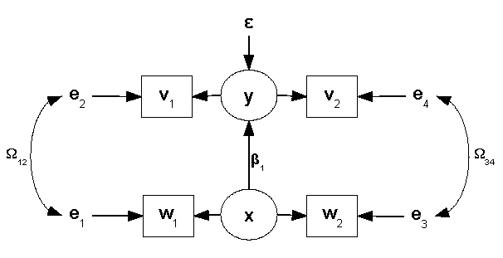

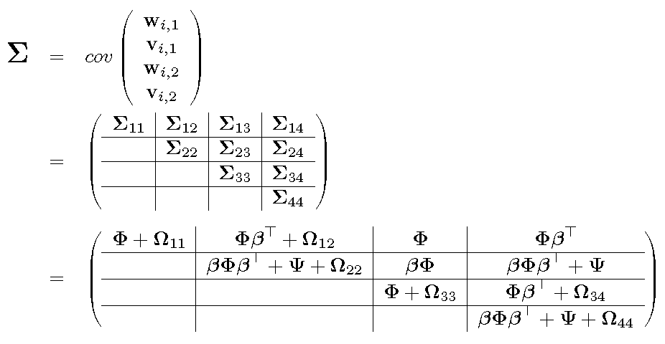

> # Start at Method of Moment estimates.
>
> head(bmidata)
age1 bmi1 fat1 cholest1 diastol1 age2 bmi2 fat2 cholest2 diastol2
1 63 24.5 16.5 195.4 38 60 23.9 20.1 203.5 66
2 42 13.0 1.9 184.3 86 44 14.8 2.6 197.3 78
3 32 22.5 14.6 354.1 104 33 21.7 20.4 374.3 73
4 59 25.5 19.0 214.6 93 58 28.5 20.0 203.7 106
5 45 26.5 17.8 324.8 97 43 25.0 12.3 329.7 92
6 31 19.4 17.1 280.7 92 42 19.9 19.9 276.7 87
> W1 = as.matrix(bmidata[,1:3]) # age1 bmi1 fat1
> V1 = as.matrix(bmidata[,4:5]) # cholest1 diastol1
> W2 = as.matrix(bmidata[,6:8]) # age2 bmi2 fat2
> V2 = as.matrix(bmidata[,9:10]) # cholest2 diastol2
> var(W1,W2) # Matrix of sample covariances
age2 bmi2 fat2
age1 148.220782 3.621581 25.29808
bmi1 5.035726 13.194016 21.42201
fat1 23.542289 20.613490 45.13296
> # Using S as short for Sigmahat, and not worrying about n vs. n-1,
> S11 = var(W1); S12 = var(W1,V1); S13 = var(W1,W2); S14 = var(W1,V2)
> S22 = var(V1); S23 = var(V1,W2); S24 = var(V1,V2)
> S33 = var(W2); S34 = var(W2,V2)
> S44 = var(V2)
> # The matrices below should all have "hat" in the name, because they are estimates
> Phi = (S13+t(S13))/2
> rownames(Phi) = colnames(Phi) = c('Lage','Lbmi','Lfat'); Phi
Lage Lbmi Lfat
Lage 148.220782 4.328654 24.42019
Lbmi 4.328654 13.194016 21.01775
Lfat 24.420185 21.017749 45.13296
> # To my surprise, these are quite close to the MLEs from the first run.
> Beta = 0.5*(t(S14)+S23) %*% solve(Phi)
> rownames(Beta) = c('Lcholest','Ldiastol')
> colnames(Beta) = c('Lage','Lbmi','Lfat'); Beta
Lage Lbmi Lfat
Lcholest -0.3851327 -0.1885072 2.968322
Ldiastol 0.0224190 -0.3556138 1.407425
> # These are miles away from the supposed MLEs
> # Can just say some of the rest are close and others are not.
>
> Psi = S24 - Beta %*% Phi %*% t(Beta)
> rownames(Psi) = colnames(Psi) = c('Lcholest','Ldiastol') # epsilon1, epsilon2
> Psi
Lcholest Ldiastol
Lcholest 2548.17303 -44.56069
Ldiastol -28.70087 57.64153
> # Oops, it should be symmetric.
> Psi = ( Psi+t(Psi) )/2; Psi
Lcholest Ldiastol
Lcholest 2548.17303 -36.63078
Ldiastol -36.63078 57.64153
> # Again, far away.
> Omega11 = S11 - Phi; Omega11
age1 bmi1 fat1
age1 19.640040 4.610807 1.634183
bmi1 4.610807 8.699533 8.754484
fat1 1.634183 8.754484 15.033932
> # Supposed MLEs are pretty close here.
> Omega12 = S12 - ( S14+t(S23) )/2; Omega12 # Not too bad
cholest1 diastol1
age1 4.499017 12.164192
bmi1 -1.517733 10.671443
fat1 3.888565 -2.196681
> Omega22 = S22-S24 # A little rough but consistent
> Omega22 = (Omega22 + t(Omega22) )/2
> Omega22 # Variances okay, covariance off.
cholest1 diastol1
cholest1 213.76117 11.24971
diastol1 11.24971 196.44520
> Omega33 = S33 - Phi; Omega33 # Not too bad
age2 bmi2 fat2
age2 5.862661 -1.219843 -2.155736
bmi2 -1.219843 1.146991 -1.714769
fat2 -2.155736 -1.714769 10.033984
> Omega34 = S34 - ( S14+t(S23) )/2; Omega34 # Not too bad
cholest2 diastol2
age2 -2.978041 0.7795992
bmi2 -1.206256 2.1081739
fat2 -6.422983 -4.9125882
> Omega44 = S44 - S24 ; Omega44 = ( Omega44 + t(Omega44) )/2
> Omega44 # Not terrible
cholest2 diastol2
cholest2 333.45335 -21.65923
diastol2 -21.65923 47.23065
>
> # Carefully assemble the MOM estimates into a vector, same order as p1 = parTable(fit1)
>
> mom = c(Beta[1,1], Beta[1,2], Beta[1,3], Beta[2,1], Beta[2,2], Beta[2,3],
+ 1,1,1,1,1,1,1,1,1,1,
+ Phi[1,1], Phi[1,2], Phi[1,3], Phi[2,2], Phi[2,3], Phi[3,3],
+ Psi[1,1], Psi[1,2], Psi[2,2],
+ Omega11[1,1], Omega11[1,2], Omega11[1,3], Omega12[1,1], Omega12[1,2],
+ Omega11[2,2], Omega11[2,3], Omega12[2,1], Omega12[2,2],
+ Omega11[3,3], Omega12[3,1], Omega12[3,2],
+ Omega22[1,1], Omega22[1,2], Omega22[2,2],
+ Omega33[1,1], Omega33[1,2], Omega33[1,3], Omega34[1,1], Omega34[1,2],
+ Omega33[2,2], Omega33[2,3], Omega34[2,1], Omega34[2,2],
+ Omega33[3,3], Omega34[3,1], Omega34[3,2],
+ Omega44[1,1], Omega44[1,2], Omega44[2,2] )
> length(mom)
[1] 55
>
> p1mom = p1; p1mom[,14] = mom # Replace column 14 (est) with mom

> fit2 = lavaan(bmimodel1, data=bmidata, start = p1mom); fit2
lavaan 0.6-11 ended normally after 242 iterations

Estimator ML
Optimization method NLMINB
Number of model parameters 45

Number of observations 500

Model Test User Model:

Test statistic 4.654
Degrees of freedom 10
P-value (Chi-square) 0.913

> summary(fit2)
lavaan 0.6-11 ended normally after 242 iterations

Estimator ML
Optimization method NLMINB
Number of model parameters 45

Number of observations 500

Model Test User Model:

Test statistic 4.654
Degrees of freedom 10
P-value (Chi-square) 0.913

Parameter Estimates:

Standard errors Standard
Information Expected
Information saturated (h1) model Structured

Latent Variables:
Estimate Std.Err z-value P(>|z|)
Lage =~
age1 1.000
age2 1.000
Lbmi =~
bmi1 1.000
bmi2 1.000
Lfat =~
fat1 1.000
fat2 1.000
Lcholest =~
cholest1 1.000
cholest2 1.000
Ldiastol =~
diastol1 1.000
diastol2 1.000

Regressions:
Estimate Std.Err z-value P(>|z|)
Lcholest ~
Lage (bt11) -0.320 0.228 -1.404 0.160
Lbmi (bt12) 0.393 1.708 0.230 0.818
Lfat (bt13) 2.774 0.980 2.829 0.005
Ldiastol ~
Lage (bt21) 0.020 0.050 0.407 0.684
Lbmi (bt22) -0.480 0.419 -1.145 0.252
Lfat (bt23) 1.480 0.235 6.312 0.000

Covariances:
Estimate Std.Err z-value P(>|z|)
Lage ~~
Lbmi (ph12) 4.160 2.141 1.944 0.052
Lfat (ph13) 23.320 3.986 5.851 0.000
Lbmi ~~
Lfat (ph23) 20.976 1.584 13.244 0.000
.Lcholest ~~
.Ldiastl (ps12) -45.861 24.968 -1.837 0.066
.age1 ~~
.bmi1 (w112) 3.998 0.945 4.231 0.000
.fat1 (w113) 2.389 1.505 1.587 0.112
.cholst1 (w114) 2.702 9.091 0.297 0.766
.diastl1 (w115) 10.562 3.824 2.762 0.006
.bmi1 ~~
.fat1 (w123) 8.969 0.956 9.382 0.000
.cholst1 (w124) -0.884 4.178 -0.212 0.832
.diastl1 (w125) 10.060 2.274 4.424 0.000
.fat1 ~~
.cholst1 (w134) 7.923 6.741 1.175 0.240
.diastl1 (w135) -2.927 3.409 -0.859 0.390
.cholest1 ~~
.diastl1 (w145) -0.098 16.907 -0.006 0.995
.age2 ~~
.bmi2 (w212) -0.661 0.735 -0.899 0.369
.fat2 (w213) -2.703 1.369 -1.974 0.048
.cholst2 (w214) -1.962 8.962 -0.219 0.827
.diastl2 (w215) 2.273 2.710 0.839 0.402
.bmi2 ~~
.fat2 (w223) -1.849 0.705 -2.624 0.009
.cholst2 (w224) -2.653 3.476 -0.763 0.445
.diastl2 (w225) 2.652 1.487 1.784 0.074
.fat2 ~~
.cholst2 (w234) -11.376 6.546 -1.738 0.082
.diastl2 (w235) -4.839 2.536 -1.908 0.056
.cholest2 ~~
.diastl2 (w245) -8.972 12.605 -0.712 0.477

Variances:
Estimate Std.Err z-value P(>|z|)
Lage (ph11) 147.330 9.699 15.190 0.000
Lbmi (ph22) 13.341 0.986 13.528 0.000
Lfat (ph33) 44.485 3.101 14.345 0.000
.Lcholst (ps11) 2534.505 171.258 14.799 0.000
.Ldiastl (ps22) 56.169 9.221 6.092 0.000
.age1 (w111) 18.584 2.914 6.378 0.000
.bmi1 (w122) 8.665 0.708 12.239 0.000
.fat1 (w133) 16.125 1.659 9.717 0.000
.cholst1 (w144) 200.109 57.422 3.485 0.000
.diastl1 (w155) 195.040 14.323 13.617 0.000
.age2 (w211) 6.861 2.701 2.540 0.011
.bmi2 (w222) 1.089 0.491 2.220 0.026
.fat2 (w233) 9.332 1.539 6.064 0.000
.cholst2 (w244) 344.449 60.290 5.713 0.000
.diastl2 (w255) 48.349 8.246 5.864 0.000

>
> parTable(fit2)

id lhs op rhs user block group free ustart exo label plabel start est
1 1 Lcholest ~ Lage 1 1 1 1 NA 0 beta11 .p1. -0.385 -0.320
2 2 Lcholest ~ Lbmi 1 1 1 2 NA 0 beta12 .p2. -0.189 0.393
3 3 Lcholest ~ Lfat 1 1 1 3 NA 0 beta13 .p3. 2.968 2.774
4 4 Ldiastol ~ Lage 1 1 1 4 NA 0 beta21 .p4. 0.022 0.020
5 5 Ldiastol ~ Lbmi 1 1 1 5 NA 0 beta22 .p5. -0.356 -0.480
6 6 Ldiastol ~ Lfat 1 1 1 6 NA 0 beta23 .p6. 1.407 1.480
7 7 Lage =~ age1 1 1 1 0 1 0 .p7. 1.000 1.000
8 8 Lage =~ age2 1 1 1 0 1 0 .p8. 1.000 1.000
9 9 Lbmi =~ bmi1 1 1 1 0 1 0 .p9. 1.000 1.000
10 10 Lbmi =~ bmi2 1 1 1 0 1 0 .p10. 1.000 1.000
11 11 Lfat =~ fat1 1 1 1 0 1 0 .p11. 1.000 1.000
12 12 Lfat =~ fat2 1 1 1 0 1 0 .p12. 1.000 1.000
13 13 Lcholest =~ cholest1 1 1 1 0 1 0 .p13. 1.000 1.000
14 14 Lcholest =~ cholest2 1 1 1 0 1 0 .p14. 1.000 1.000
15 15 Ldiastol =~ diastol1 1 1 1 0 1 0 .p15. 1.000 1.000
16 16 Ldiastol =~ diastol2 1 1 1 0 1 0 .p16. 1.000 1.000
17 17 Lage ~~ Lage 1 1 1 7 NA 0 phi11 .p17. 148.221 147.330
18 18 Lage ~~ Lbmi 1 1 1 8 NA 0 phi12 .p18. 4.329 4.160
19 19 Lage ~~ Lfat 1 1 1 9 NA 0 phi13 .p19. 24.420 23.320
20 20 Lbmi ~~ Lbmi 1 1 1 10 NA 0 phi22 .p20. 13.194 13.341
21 21 Lbmi ~~ Lfat 1 1 1 11 NA 0 phi23 .p21. 21.018 20.976
22 22 Lfat ~~ Lfat 1 1 1 12 NA 0 phi33 .p22. 45.133 44.485
23 23 Lcholest ~~ Lcholest 1 1 1 13 NA 0 psi11 .p23. 2548.173 2534.505
24 24 Lcholest ~~ Ldiastol 1 1 1 14 NA 0 psi12 .p24. -36.631 -45.861
25 25 Ldiastol ~~ Ldiastol 1 1 1 15 NA 0 psi22 .p25. 57.642 56.169
26 26 age1 ~~ age1 1 1 1 16 NA 0 w111 .p26. 19.640 18.584
27 27 age1 ~~ bmi1 1 1 1 17 NA 0 w112 .p27. 4.611 3.998
28 28 age1 ~~ fat1 1 1 1 18 NA 0 w113 .p28. 1.634 2.389
29 29 age1 ~~ cholest1 1 1 1 19 NA 0 w114 .p29. 4.499 2.702
30 30 age1 ~~ diastol1 1 1 1 20 NA 0 w115 .p30. 12.164 10.562
31 31 bmi1 ~~ bmi1 1 1 1 21 NA 0 w122 .p31. 8.700 8.665
32 32 bmi1 ~~ fat1 1 1 1 22 NA 0 w123 .p32. 8.754 8.969
33 33 bmi1 ~~ cholest1 1 1 1 23 NA 0 w124 .p33. -1.518 -0.884
34 34 bmi1 ~~ diastol1 1 1 1 24 NA 0 w125 .p34. 10.671 10.060
35 35 fat1 ~~ fat1 1 1 1 25 NA 0 w133 .p35. 15.034 16.125
36 36 fat1 ~~ cholest1 1 1 1 26 NA 0 w134 .p36. 3.889 7.923
37 37 fat1 ~~ diastol1 1 1 1 27 NA 0 w135 .p37. -2.197 -2.927
38 38 cholest1 ~~ cholest1 1 1 1 28 NA 0 w144 .p38. 213.761 200.109
39 39 cholest1 ~~ diastol1 1 1 1 29 NA 0 w145 .p39. 11.250 -0.098
40 40 diastol1 ~~ diastol1 1 1 1 30 NA 0 w155 .p40. 196.445 195.040
41 41 age2 ~~ age2 1 1 1 31 NA 0 w211 .p41. 5.863 6.861
42 42 age2 ~~ bmi2 1 1 1 32 NA 0 w212 .p42. -1.220 -0.661
43 43 age2 ~~ fat2 1 1 1 33 NA 0 w213 .p43. -2.156 -2.703
44 44 age2 ~~ cholest2 1 1 1 34 NA 0 w214 .p44. -2.978 -1.962
45 45 age2 ~~ diastol2 1 1 1 35 NA 0 w215 .p45. 0.780 2.273
46 46 bmi2 ~~ bmi2 1 1 1 36 NA 0 w222 .p46. 1.147 1.089
47 47 bmi2 ~~ fat2 1 1 1 37 NA 0 w223 .p47. -1.715 -1.849
48 48 bmi2 ~~ cholest2 1 1 1 38 NA 0 w224 .p48. -1.206 -2.653
49 49 bmi2 ~~ diastol2 1 1 1 39 NA 0 w225 .p49. 2.108 2.652
50 50 fat2 ~~ fat2 1 1 1 40 NA 0 w233 .p50. 10.034 9.332
51 51 fat2 ~~ cholest2 1 1 1 41 NA 0 w234 .p51. -6.423 -11.376
52 52 fat2 ~~ diastol2 1 1 1 42 NA 0 w235 .p52. -4.913 -4.839
53 53 cholest2 ~~ cholest2 1 1 1 43 NA 0 w244 .p53. 333.453 344.449
54 54 cholest2 ~~ diastol2 1 1 1 44 NA 0 w245 .p54. -21.659 -8.972
55 55 diastol2 ~~ diastol2 1 1 1 45 NA 0 w255 .p55. 47.231 48.349

> # Now a LR test of BMI, H0: beta12 = beta22 = 0
> # Will the constraint conflict with the starting values?
>
> nobmi = lavaan(bmimodel1, data=bmidata, start = p1mom,
+ constraints = 'beta12 == 0
+ beta22 == 0')
>
> anova(nobmi,fit2)
Chi-Squared Difference Test

Df AIC BIC Chisq Chisq diff Df diff Pr(>Chisq)
fit2 10 35758 35947 4.6537
nobmi 12 35755 35936 6.1457 1.492 2 0.4743

> # Two follow-up issues
> # Shorter syntax
> # Bootstrap

> cat(bmimodel1)
########################################################
# Latent variable model
# ---------------------
Lcholest ~ beta11*Lage + beta12*Lbmi + beta13*Lfat
Ldiastol ~ beta21*Lage + beta22*Lbmi + beta23*Lfat
#
# Measurement model
# -----------------
Lage =~ 1*age1 + 1*age2
Lbmi =~ 1*bmi1 + 1*bmi2
Lfat =~ 1*fat1 +1*fat2
Lcholest =~ 1*cholest1 + 1*cholest2
Ldiastol =~ 1*diastol1 + 1*diastol2
#
# Variances and covariances
# -------------------------
# Of latent explanatory variables
Lage ~~ phi11*Lage; Lage ~~ phi12*Lbmi; Lage ~~ phi13*Lfat
Lbmi ~~ phi22*Lbmi; Lbmi ~~ phi23*Lfat
Lfat ~~ phi33*Lfat
# Of error terms in latent the regression (epsilon_ij)
Lcholest ~~ psi11*Lcholest; Lcholest ~~ psi12*Ldiastol
Ldiastol ~~ psi22*Ldiastol
# Of measurement errors (e_ijk) for measurement set 1
age1 ~~ w111*age1; age1 ~~ w112*bmi1; age1 ~~ w113*fat1;
age1 ~~ w114*cholest1; age1 ~~ w115*diastol1
bmi1 ~~ w122*bmi1; bmi1 ~~ w123*fat1; bmi1 ~~ w124*cholest1; bmi1 ~~ w125*diastol1
fat1 ~~ w133*fat1; fat1 ~~ w134*cholest1; fat1 ~~ w135*diastol1
cholest1 ~~ w144*cholest1; cholest1 ~~ w145*diastol1
diastol1 ~~ w155*diastol1
# Of measurement errors (e_ijk) for measurement set 2
age2 ~~ w211*age2; age2 ~~ w212*bmi2; age2 ~~ w213*fat2;
age2 ~~ w214*cholest2; age2 ~~ w215*diastol2
bmi2 ~~ w222*bmi2; bmi2 ~~ w223*fat2; bmi2 ~~ w224*cholest2; bmi2 ~~ w225*diastol2
fat2 ~~ w233*fat2; fat2 ~~ w234*cholest2; fat2 ~~ w235*diastol2
cholest2 ~~ w244*cholest2; cholest2 ~~ w245*diastol2
diastol2 ~~ w255*diastol2
> bmimodel2 =
+ '########################################################
+ # Latent variable model
+ # ---------------------
+ Lcholest ~ beta11*Lage + beta12*Lbmi + beta13*Lfat
+ Ldiastol ~ beta21*Lage + beta22*Lbmi + beta23*Lfat
+ #
+ # Measurement model
+ # -----------------
+ Lage =~ 1*age1 + 1*age2; Lbmi =~ 1*bmi1 + 1*bmi2; Lfat =~ 1*fat1 +1*fat2
+ Lcholest =~ 1*cholest1 + 1*cholest2; Ldiastol =~ 1*diastol1 + 1*diastol2
+ #
+ # Variances and covariances DO NOT NEED NAMES!
+ # -------------------------
+ # Of latent explanatory variables
+ Lage ~~ Lage + Lbmi + Lfat
+ Lbmi ~~ Lbmi + Lfat
+ Lfat ~~ Lfat
+ # Of error terms in the latent regression
+ Lcholest ~~ Lcholest + Ldiastol
+ Ldiastol ~~ Ldiastol
+ # Of measurement errors for measurement set 1
+ age1 ~~ age1 + bmi1 + fat1 + cholest1 + diastol1
+ bmi1 ~~ bmi1 + fat1 + cholest1 + diastol1
+ fat1 ~~ fat1 + cholest1 + diastol1
+ cholest1 ~~ cholest1 + diastol1
+ diastol1 ~~ diastol1
+ # Of measurement errors for measurement set 2
+ age2 ~~ age2 + bmi2 + fat2 + cholest2 + diastol2
+ bmi2 ~~ bmi2 + fat2 + cholest2 + diastol2
+ fat2 ~~ fat2 + cholest2 + diastol2
+ cholest2 ~~ cholest2 + diastol2
+ diastol2 ~~ diastol2
+ ' ################# End of bmimodel2 #################
> fit3 = lavaan(bmimodel2, data=bmidata, start = fit2); fit3
lavaan 0.6-11 ended normally after 2 iterations

Estimator ML
Optimization method NLMINB
Number of model parameters 45

Number of observations 500

Model Test User Model:

Test statistic 4.654
Degrees of freedom 10
P-value (Chi-square) 0.913
> summary(fit3)
lavaan 0.6-11 ended normally after 2 iterations

Estimator ML
Optimization method NLMINB
Number of model parameters 45

Number of observations 500

Model Test User Model:

Test statistic 4.654
Degrees of freedom 10
P-value (Chi-square) 0.913

Parameter Estimates:

Standard errors Standard
Information Expected
Information saturated (h1) model Structured

Latent Variables:
Estimate Std.Err z-value P(>|z|)
Lage =~
age1 1.000
age2 1.000
Lbmi =~
bmi1 1.000
bmi2 1.000
Lfat =~
fat1 1.000
fat2 1.000
Lcholest =~
cholest1 1.000
cholest2 1.000
Ldiastol =~
diastol1 1.000
diastol2 1.000

Regressions:
Estimate Std.Err z-value P(>|z|)
Lcholest ~
Lage (bt11) -0.320 0.228 -1.404 0.160
Lbmi (bt12) 0.393 1.708 0.230 0.818
Lfat (bt13) 2.774 0.980 2.829 0.005
Ldiastol ~
Lage (bt21) 0.020 0.050 0.407 0.684
Lbmi (bt22) -0.480 0.419 -1.145 0.252
Lfat (bt23) 1.480 0.235 6.312 0.000

Covariances:
Estimate Std.Err z-value P(>|z|)
Lage ~~
Lbmi 4.160 2.141 1.944 0.052
Lfat 23.320 3.986 5.851 0.000
Lbmi ~~
Lfat 20.976 1.584 13.244 0.000
.Lcholest ~~
.Ldiastol -45.861 24.968 -1.837 0.066
.age1 ~~
.bmi1 3.998 0.945 4.231 0.000
.fat1 2.389 1.505 1.587 0.112
.cholest1 2.702 9.091 0.297 0.766
.diastol1 10.562 3.824 2.762 0.006
.bmi1 ~~
.fat1 8.969 0.956 9.382 0.000
.cholest1 -0.884 4.178 -0.212 0.832
.diastol1 10.060 2.274 4.424 0.000
.fat1 ~~
.cholest1 7.923 6.741 1.175 0.240
.diastol1 -2.927 3.409 -0.859 0.390
.cholest1 ~~
.diastol1 -0.098 16.907 -0.006 0.995
.age2 ~~
.bmi2 -0.661 0.735 -0.899 0.369
.fat2 -2.703 1.369 -1.974 0.048
.cholest2 -1.962 8.962 -0.219 0.827
.diastol2 2.273 2.710 0.839 0.402
.bmi2 ~~
.fat2 -1.849 0.705 -2.624 0.009
.cholest2 -2.653 3.476 -0.763 0.445
.diastol2 2.652 1.487 1.784 0.074
.fat2 ~~
.cholest2 -11.376 6.546 -1.738 0.082
.diastol2 -4.839 2.536 -1.908 0.056
.cholest2 ~~
.diastol2 -8.972 12.605 -0.712 0.477

Variances:
Estimate Std.Err z-value P(>|z|)
Lage 147.330 9.699 15.190 0.000
Lbmi 13.341 0.986 13.528 0.000
Lfat 44.485 3.101 14.345 0.000
.Lcholest 2534.505 171.258 14.799 0.000
.Ldiastol 56.169 9.221 6.092 0.000
.age1 18.584 2.914 6.378 0.000
.bmi1 8.665 0.708 12.239 0.000
.fat1 16.125 1.659 9.717 0.000
.cholest1 200.109 57.422 3.485 0.000
.diastol1 195.040 14.323 13.617 0.000
.age2 6.861 2.701 2.540 0.011
.bmi2 1.089 0.491 2.220 0.026
.fat2 9.332 1.539 6.064 0.000
.cholest2 344.449 60.290 5.713 0.000
.diastol2 48.349 8.246 5.864 0.000

> # Even shorter syntax: Do we really need the beta symbols?
>
> bmimodel3 =
+ '#### Regressions ####
+ Lcholest ~ Lage + Lbmi + Lfat
+ Ldiastol ~ Lage + Lbmi + Lfat
+ #### Measurement model ####
+ Lage =~ 1*age1 + 1*age2; Lbmi =~ 1*bmi1 + 1*bmi2; Lfat =~ 1*fat1 +1*fat2
+ Lcholest =~ 1*cholest1 + 1*cholest2; Ldiastol =~ 1*diastol1 + 1*diastol2
+ #### Variances and covariances ####
+ Lage ~~ Lage + Lbmi + Lfat
+ Lbmi ~~ Lbmi + Lfat
+ Lfat ~~ Lfat
+ Lcholest ~~ Lcholest + Ldiastol
+ Ldiastol ~~ Ldiastol
+ age1 ~~ age1 + bmi1 + fat1 + cholest1 + diastol1
+ bmi1 ~~ bmi1 + fat1 + cholest1 + diastol1
+ fat1 ~~ fat1 + cholest1 + diastol1
+ cholest1 ~~ cholest1 + diastol1
+ diastol1 ~~ diastol1
+ age2 ~~ age2 + bmi2 + fat2 + cholest2 + diastol2
+ bmi2 ~~ bmi2 + fat2 + cholest2 + diastol2
+ fat2 ~~ fat2 + cholest2 + diastol2
+ cholest2 ~~ cholest2 + diastol2
+ diastol2 ~~ diastol2
+ ' ################# End of bmimodel3 #################
>
> fit4 = lavaan(bmimodel3, data=bmidata, start = fit2); fit4
lavaan 0.6-11 ended normally after 2 iterations

Estimator ML
Optimization method NLMINB
Number of model parameters 45

Number of observations 500

Model Test User Model:

Test statistic 4.654
Degrees of freedom 10
P-value (Chi-square) 0.913
>
> summary(fit4)

Some output omitted.

Regressions:
Estimate Std.Err z-value P(>|z|)
Lcholest ~
Lage -0.320 0.228 -1.404 0.160
Lbmi 0.393 1.708 0.230 0.818
Lfat 2.774 0.980 2.829 0.005
Ldiastol ~
Lage 0.020 0.050 0.407 0.684
Lbmi -0.480 0.419 -1.145 0.252
Lfat 1.480 0.235 6.312 0.000

More output omitted.
> # Bootstrap
> fit3B = lavaan(bmimodel2, data=bmidata, start = fit2, se = "bootstrap")
> # Waited between 2 and 3 minutes
> summary(fit3B)
lavaan 0.6-11 ended normally after 2 iterations

Estimator ML
Optimization method NLMINB
Number of model parameters 45

Number of observations 500

Model Test User Model:

Test statistic 4.654
Degrees of freedom 10
P-value (Chi-square) 0.913

Parameter Estimates:

Standard errors Bootstrap
Number of requested bootstrap draws 1000
Number of successful bootstrap draws 1000

Latent Variables:
Estimate Std.Err z-value P(>|z|)
Lage =~
age1 1.000
age2 1.000
Lbmi =~
bmi1 1.000
bmi2 1.000
Lfat =~
fat1 1.000
fat2 1.000
Lcholest =~
cholest1 1.000
cholest2 1.000
Ldiastol =~
diastol1 1.000
diastol2 1.000

Regressions:
Estimate Std.Err z-value P(>|z|)
Lcholest ~
Lage (bt11) -0.320 0.232 -1.381 0.167
Lbmi (bt12) 0.393 1.732 0.227 0.820
Lfat (bt13) 2.774 1.026 2.705 0.007
Ldiastol ~
Lage (bt21) 0.020 0.053 0.383 0.702
Lbmi (bt22) -0.480 0.456 -1.051 0.293
Lfat (bt23) 1.480 0.257 5.754 0.000

Covariances:
Estimate Std.Err z-value P(>|z|)
Lage ~~
Lbmi 4.160 2.027 2.053 0.040
Lfat 23.320 3.918 5.952 0.000
Lbmi ~~
Lfat 20.976 1.687 12.435 0.000
.Lcholest ~~
.Ldiastol -45.861 26.501 -1.731 0.084
.age1 ~~
.bmi1 3.998 0.924 4.328 0.000
.fat1 2.389 1.438 1.661 0.097
.cholest1 2.702 9.090 0.297 0.766
.diastol1 10.562 3.997 2.643 0.008
.bmi1 ~~
.fat1 8.969 0.883 10.154 0.000
.cholest1 -0.884 4.057 -0.218 0.828
.diastol1 10.060 2.068 4.865 0.000
.fat1 ~~
.cholest1 7.923 6.450 1.228 0.219
.diastol1 -2.927 3.298 -0.888 0.375
.cholest1 ~~
.diastol1 -0.098 17.721 -0.006 0.996
.age2 ~~
.bmi2 -0.661 0.723 -0.913 0.361
.fat2 -2.703 1.295 -2.088 0.037
.cholest2 -1.962 8.650 -0.227 0.821
.diastol2 2.273 2.873 0.791 0.429
.bmi2 ~~
.fat2 -1.849 0.656 -2.819 0.005
.cholest2 -2.653 3.537 -0.750 0.453
.diastol2 2.652 1.353 1.961 0.050
.fat2 ~~
.cholest2 -11.376 6.829 -1.666 0.096
.diastol2 -4.839 2.410 -2.008 0.045
.cholest2 ~~
.diastol2 -8.972 12.716 -0.706 0.480

Variances:
Estimate Std.Err z-value P(>|z|)
Lage 147.330 9.419 15.642 0.000
Lbmi 13.341 0.987 13.518 0.000
Lfat 44.485 3.411 13.041 0.000
.Lcholest 2534.505 176.818 14.334 0.000
.Ldiastol 56.169 9.689 5.797 0.000
.age1 18.584 2.770 6.708 0.000
.bmi1 8.665 0.679 12.756 0.000
.fat1 16.125 1.491 10.815 0.000
.cholest1 200.109 53.771 3.722 0.000
.diastol1 195.040 14.805 13.174 0.000
.age2 6.861 2.833 2.422 0.015
.bmi2 1.089 0.436 2.498 0.012
.fat2 9.332 1.373 6.799 0.000
.cholest2 344.449 59.165 5.822 0.000
.diastol2 48.349 8.194 5.901 0.000

Normal model for comparison

Variances:
Estimate Std.Err z-value P(>|z|)
Lage (ph11) 147.330 9.699 15.190 0.000
Lbmi (ph22) 13.341 0.986 13.528 0.000
Lfat (ph33) 44.485 3.101 14.345 0.000
.Lcholst (ps11) 2534.505 171.258 14.799 0.000
.Ldiastl (ps22) 56.169 9.221 6.092 0.000
.age1 (w111) 18.584 2.914 6.378 0.000
.bmi1 (w122) 8.665 0.708 12.239 0.000
.fat1 (w133) 16.125 1.659 9.717 0.000
.cholst1 (w144) 200.109 57.422 3.485 0.000
.diastl1 (w155) 195.040 14.323 13.617 0.000
.age2 (w211) 6.861 2.701 2.540 0.011
.bmi2 (w222) 1.089 0.491 2.220 0.026
.fat2 (w233) 9.332 1.539 6.064 0.000
.cholst2 (w244) 344.449 60.290 5.713 0.000
.diastl2 (w255) 48.349 8.246 5.864 0.000

*This handout was prepared by Jerry Brunner, Department of Statistical Sciences, University of Toronto. It is licensed under a Creative Commons Attribution - ShareAlike 3.0 Unported License. Use any part of it as you like and share the result freely. The OpenOffice.org document is available from the course website: http://www.utstat.toronto.edu/brunner/oldclass/431s23

