Tests and Confidence Intervals with R*

Before the beginning of the Fall term, students in a first-year Calculus class took a diagnostic test with two parts: Pre-calculus and Calculus. Their High School Calculus marks and their marks in University Calculus were also available. In order, the variables in the data file are: Identification code, Mark in High School Calculus, Score on the Pre-calculus portion of the diagnostic test, Score on the Calculus portion of the diagnostic test, and mark in University Calculus. Thanks to Dr. Cleo Boyd for permission to use these data.

1 65 2 0 39
2 54 6 2 57
3 77 4 4 62
4 80 5 2 76
5 87 4 4 86
6 53 3 1 60

. . . . .
. . . . .
. . . . .

290 83 4 3 56
291 81 6 3 70
292 73 5 9 60
293 80 5 2 50
294 56 4 2 50
295 80 6 1 61

> math = read.table("http://www.utstat.toronto.edu/~brunner/data/legal/mathtest.txt")
> head(math)
V1 V2 V3 V4 V5
1 1 65 2 0 39
2 2 54 6 2 57
3 3 77 4 4 62
4 4 80 5 2 76
5 5 87 4 4 86
6 6 53 3 1 60
> colnames(math) = c("ID","HScalc","PreCalcScore","CalcScore","UnivCalc")
> head(math)
ID HScalc PreCalcScore CalcScore UnivCalc
1 1 65 2 0 39
2 2 54 6 2 57
3 3 77 4 4 62
4 4 80 5 2 76
5 5 87 4 4 86
6 6 53 3 1 60
> summary(math)
ID HScalc PreCalcScore CalcScore UnivCalc
Min. : 1.0 Min. : 50.00 Min. :1.000 Min. : 0.000 Min. :12.00
1st Qu.: 74.5 1st Qu.: 71.50 1st Qu.:4.000 1st Qu.: 2.000 1st Qu.:51.00
Median :148.0 Median : 80.00 Median :5.000 Median : 4.000 Median :60.00
Mean :148.0 Mean : 78.51 Mean :4.837 Mean : 3.963 Mean :60.91
3rd Qu.:221.5 3rd Qu.: 87.00 3rd Qu.:6.000 3rd Qu.: 6.000 3rd Qu.:73.00
Max. :295.0 Max. :100.00 Max. :9.000 Max. :11.000 Max. :99.00
> attach(math) # Make variable names available
> # PreCalc score is out of 9 and Calc score is out of 11. Convert to percentages.
> PreCalcScore = 100 * PreCalcScore/9
> CalcScore = 100 * CalcScore/11

> ########## Descriptive stats ##########
> datamat = cbind(HScalc,PreCalcScore,CalcScore,UnivCalc)
> boxplot(datamat); title("Box plots of the math data")

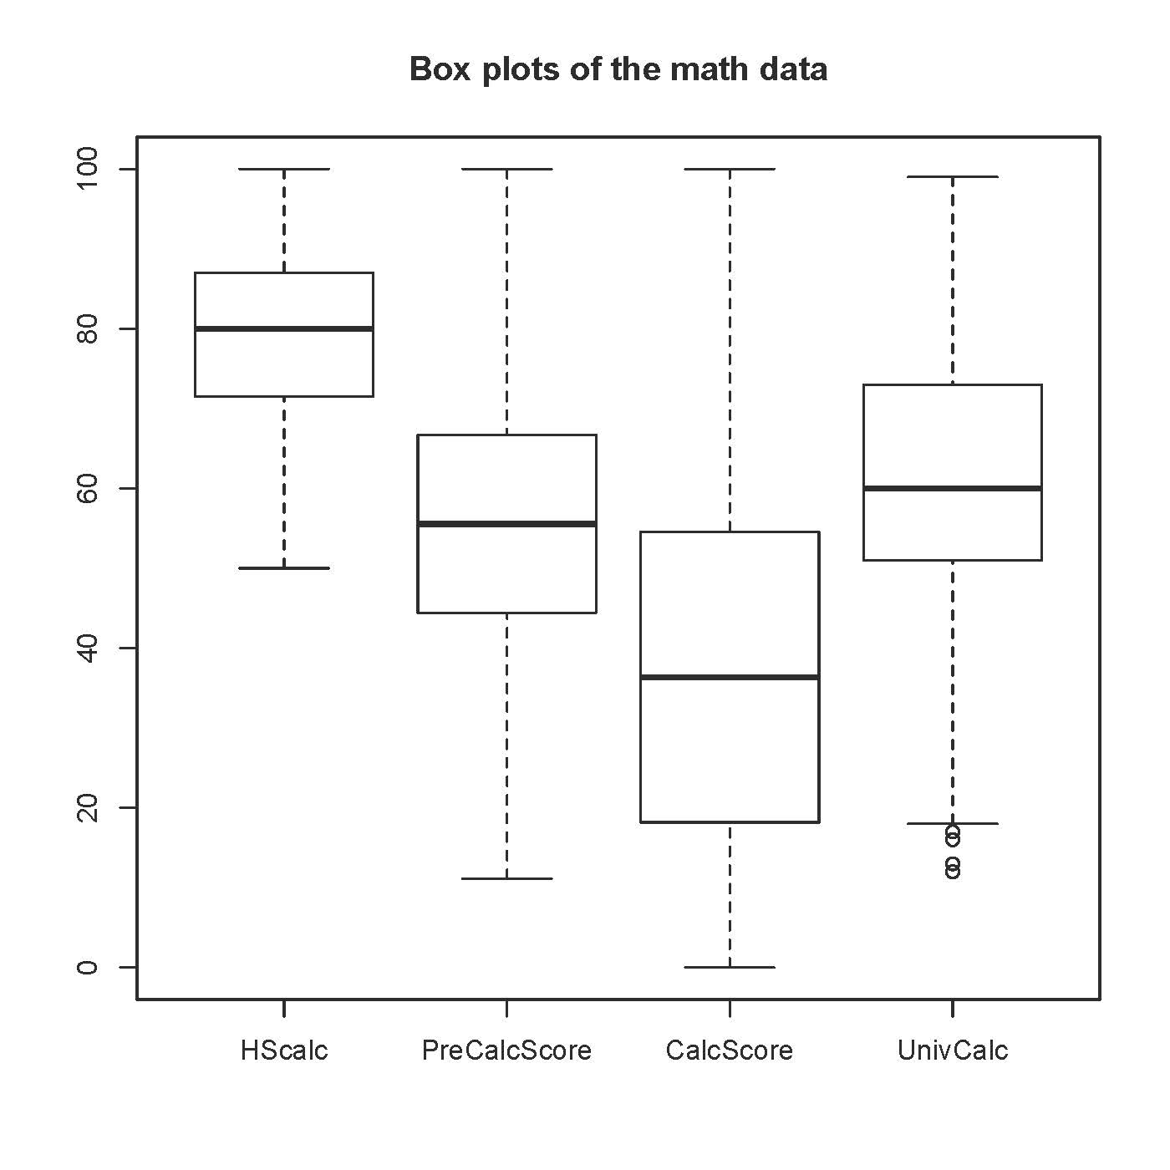
> # upper whisker = min(max(x), Q_3 + 1.5 * IQR)
> # lower whisker = max(min(x), Q_1 – 1.5 * IQR)
> summary(datamat)

HScalc PreCalcScore CalcScore UnivCalc
Min. : 50.00 Min. : 11.11 Min. : 0.00 Min. :12.00
1st Qu.: 71.50 1st Qu.: 44.44 1st Qu.: 18.18 1st Qu.:51.00
Median : 80.00 Median : 55.56 Median : 36.36 Median :60.00
Mean : 78.51 Mean : 53.75 Mean : 36.02 Mean :60.91
3rd Qu.: 87.00 3rd Qu.: 66.67 3rd Qu.: 54.55 3rd Qu.:73.00
Max. :100.00 Max. :100.00 Max. :100.00 Max. :99.00

> cor(datamat); pairs(datamat)

HScalc PreCalcScore CalcScore UnivCalc
HScalc 1.0000000 0.3271197 0.4132186 0.5548571
PreCalcScore 0.3271197 1.0000000 0.4573164 0.3736003
CalcScore 0.4132186 0.4573164 1.0000000 0.3793398
UnivCalc 0.5548571 0.3736003 0.3793398 1.0000000

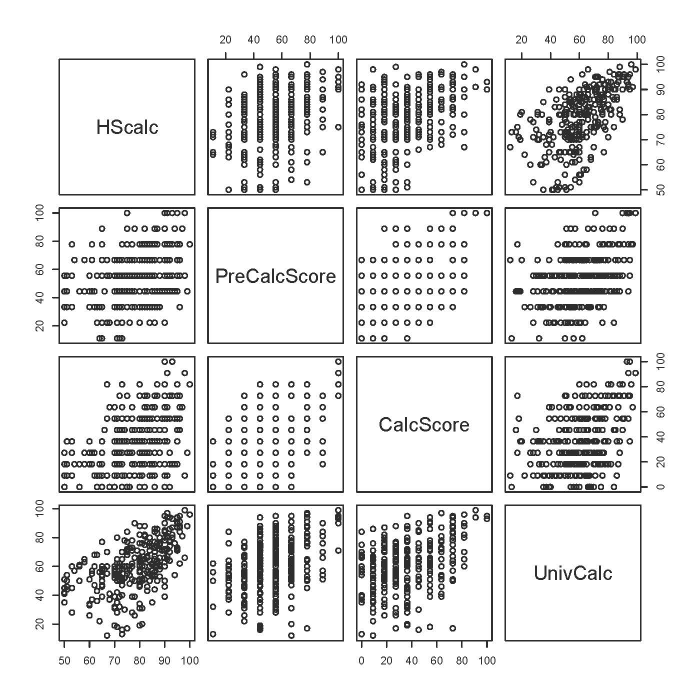

> ########### Fit the full regression model ##########
> fullmodel = lm(UnivCalc ~ HScalc+PreCalcScore+CalcScore)
> sumfull = summary(fullmodel); sumfull

Call:
lm(formula = UnivCalc ~ HScalc + PreCalcScore + CalcScore)

Residuals:
Min 1Q Median 3Q Max
-48.699 -7.954 1.603 9.242 30.260

Coefficients:
Estimate Std. Error t value Pr(>|t|)
(Intercept) -6.32155 6.01019 -1.052 0.29376
HScalc 0.70097 0.08133 8.619 4.4e-16 ***
PreCalcScore 0.16849 0.05182 3.252 0.00128 **
CalcScore 0.08722 0.04282 2.037 0.04257 *
---
Signif. codes: 0 ‘***’ 0.001 ‘**’ 0.01 ‘*’ 0.05 ‘.’ 0.1 ‘ ’ 1

Residual standard error: 14.16 on 291 degrees of freedom
Multiple R-squared: 0.3583, Adjusted R-squared: 0.3517
F-statistic: 54.17 on 3 and 291 DF, p-value: < 2.2e-16

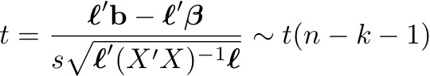

> # Reproduce the test for H0: beta1=0
> ell = as.matrix(c(0,1,0,0)); ell
[,1]
[1,] 0
[2,] 1
[3,] 0
[4,] 0
> b = coefficients(fullmodel)
> MSE.XpXinv = vcov(fullmodel) # Very handy
> dfe = df.residual(fullmodel) # n-k-1
> tstat = t(ell) %*% b / sqrt( t(ell)%*%MSE.XpXinv%*%ell ) # tstat is a 1x1 matrix
> tstat = as.numeric(tstat) # Make it a number
> pvalue = 2 * ( 1-pt(abs(tstat),dfe) )
> c(tstat,pvalue)
[1] 8.618832e+00 4.440892e-16

> ########### Confidence intervals ###########

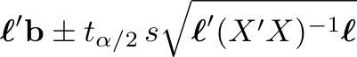

> # Confidence interval for beta_j is just b_j plus or minus t_{alpha/2} * Standard error
> t.025 = qt(0.975,dfe)
> t.025 # Definitely display t_{alpha/2} so you can produce confidence intervals by hand
[1] 1.96815
> # If High School calculus is 10 marks higher, expected university calculus increases by
> # 10*beta1. Estimate the increase and give a 95% confidence interval.
> me95 = 10 * t.025*0.08133 # Number copied from the printout.
> cat("University calculus mark is expected to be",10*b[2],"points higher, plus or minus",me95,"\n")
University calculus mark is expected to be 7.00972 points higher, plus or minus 1.600696

> # Confidence interval for beta3-beta2
> ell = as.matrix(c(0,0,-1,1)) # Now ell is different
> se = sqrt( t(ell)%*%MSE.XpXinv%*%ell ) # Standard error of the difference
> me95 = as.numeric( t.025*se ) # Now me95 is different
> estdiff = as.numeric( t(ell) %*% b ); estdiff
[1] -0.08127008
> Lower95 = estdiff - me95; Upper95 = estdiff + me95
> c(Lower95, Upper95)
[1] -0.23598624 0.07344609

> ########### General linear test ###########

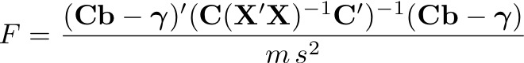

> # Reproduce the overall test: F = 54.17
> # First do it the hard way
> C1 = rbind( c(0,1,0,0),
+ c(0,0,1,0),
+ c(0,0,0,1) )
> m = dim(C1)[1] # Number of rows
> F1 = t(C1%*%b-0) %*% solve(C1 %*% MSE.XpXinv %*% t(C1)) %*% (C1%*%b-0) / m
> F1 # It's a 1x1 matrix
[,1]
[1,] 54.16969

> # The easy way: Use this function if you like.
> source("http://www.utstat.utoronto.ca/~brunner/Rfunctions/ftest.txt")
> ftest # See the function definition
function(model,L,h=0)
# General linear test of H0: L beta = h
{
BetaHat = model$coefficients
dimL = dim(L)
if(length(BetaHat) != dimL[2]) stop("Sizes of L and Beta are incompatible")
r = dimL[1]
if(qr(L)$rank != r) stop("Rows of L must be linearly independent.")
out = numeric(4)
names(out) = c("F","df1","df2","p-value")
dfe = df.residual(model)
diff = L%*%BetaHat-h
fstat = t(diff) %*% solve(L%*%vcov(model)%*%t(L)) %*% diff / r
# Note vcov = MSE * XtXinv
fstat = as.numeric(fstat)
out[1] = fstat; out[2]=r; out[3]=dfe
out[4] = 1-pf(fstat,r,dfe)
return(out)
}
> ftest(fullmodel,C1) # Compare F = 54.17
F df1 df2 p-value
54.16969 3.00000 291.00000 0.00000

> # Test the two subtests simultaneously, controlling for HS Calculus mark
> C2 = rbind( c(0,0,1,0),
+ c(0,0,0,1) )
> ftest(fullmodel,C2)
F df1 df2 p-value
1.144444e+01 2.000000e+00 2.910000e+02 1.642604e-05

> round(ftest(fullmodel,C2),4)
F df1 df2 p-value
11.4444 2.0000 291.0000 0.0000

> # Do it with the full-reduced approach
> JustHScalc = lm(UnivCalc ~ HScalc) # The reduced (restricted) model
> anova(JustHScalc,fullmodel)

Analysis of Variance Table

Model 1: UnivCalc ~ HScalc
Model 2: UnivCalc ~ HScalc + PreCalcScore + CalcScore
Res.Df RSS Df Sum of Sq F Pr(>F)
1 293 62967
2 291 58375 2 4591.5 11.444 1.643e-05 ***
---
Signif. codes: 0 ‘***’ 0.001 ‘**’ 0.01 ‘*’ 0.05 ‘.’ 0.1 ‘ ’ 1

> # What proportion of the remaining variation is being explained by the diagnostic test?

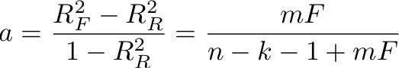

> # help(summary.lm) # The summary object has lots of good stuff!
> sumred = summary(JustHScalc)
> RsqF = sumfull$r.squared; RsqR = sumred$r.squared
> c(RsqR,RsqF)
[1] 0.3078664 0.3583370

> a = (RsqF-RsqR)/(1-RsqR) ; a
[1] 0.07292032

> # Using the F statistic based on just the full model
> Fstat = ftest(fullmodel,C2)[1] # First element
> 2*Fstat/(dfe+2*Fstat)
F
0.07292032
> # You can do this with a calculator. For t-tests, note t-squared = F

This handout was prepared by Jerry Brunner, Department of Statistical Sciences, University of Toronto. It is licensed under a Creative Commons Attribution - ShareAlike 3.0 Unported License. Use any part of it as you like and share the result freely. The OpenOffice.org document is available from the course website:

http://www.utstat.toronto.edu/~brunner/oldclass/302f16

* Copyright information is on the last page.

