Regression diagnostics with R*

> sat = read.table("http://www.utstat.utoronto.ca/~brunner/data/legal/openSAT.data.txt")
> head(sat)
VERBAL MATH GPA
1 623 509 2.6
2 454 471 2.3
3 643 700 2.4
4 585 719 3.0
5 719 710 3.1
6 693 643 2.9
> mod1 = lm(GPA ~ VERBAL+MATH, data=sat); summary(mod1)

Call:
lm(formula = GPA ~ VERBAL + MATH, data = sat)

Residuals:
Min 1Q Median 3Q Max
-2.24875 -0.35113 0.04659 0.38745 1.03527

Coefficients:
Estimate Std. Error t value Pr(>|t|)
(Intercept) 0.6062975 0.4414062 1.374 0.171
VERBAL 0.0023072 0.0005522 4.178 4.42e-05 ***
MATH 0.0009999 0.0006093 1.641 0.102
---
Signif. codes: 0 ‘***’ 0.001 ‘**’ 0.01 ‘*’ 0.05 ‘.’ 0.1 ‘ ’ 1

Residual standard error: 0.5484 on 197 degrees of freedom
Multiple R-squared: 0.1161, Adjusted R-squared: 0.1071
F-statistic: 12.93 on 2 and 197 DF, p-value: 5.284e-06

> attach(sat) # Make variable names accessible
>

> # Plot y-hat versus y
> yhat = mod1$fitted.values
> plot(yhat,GPA)
>

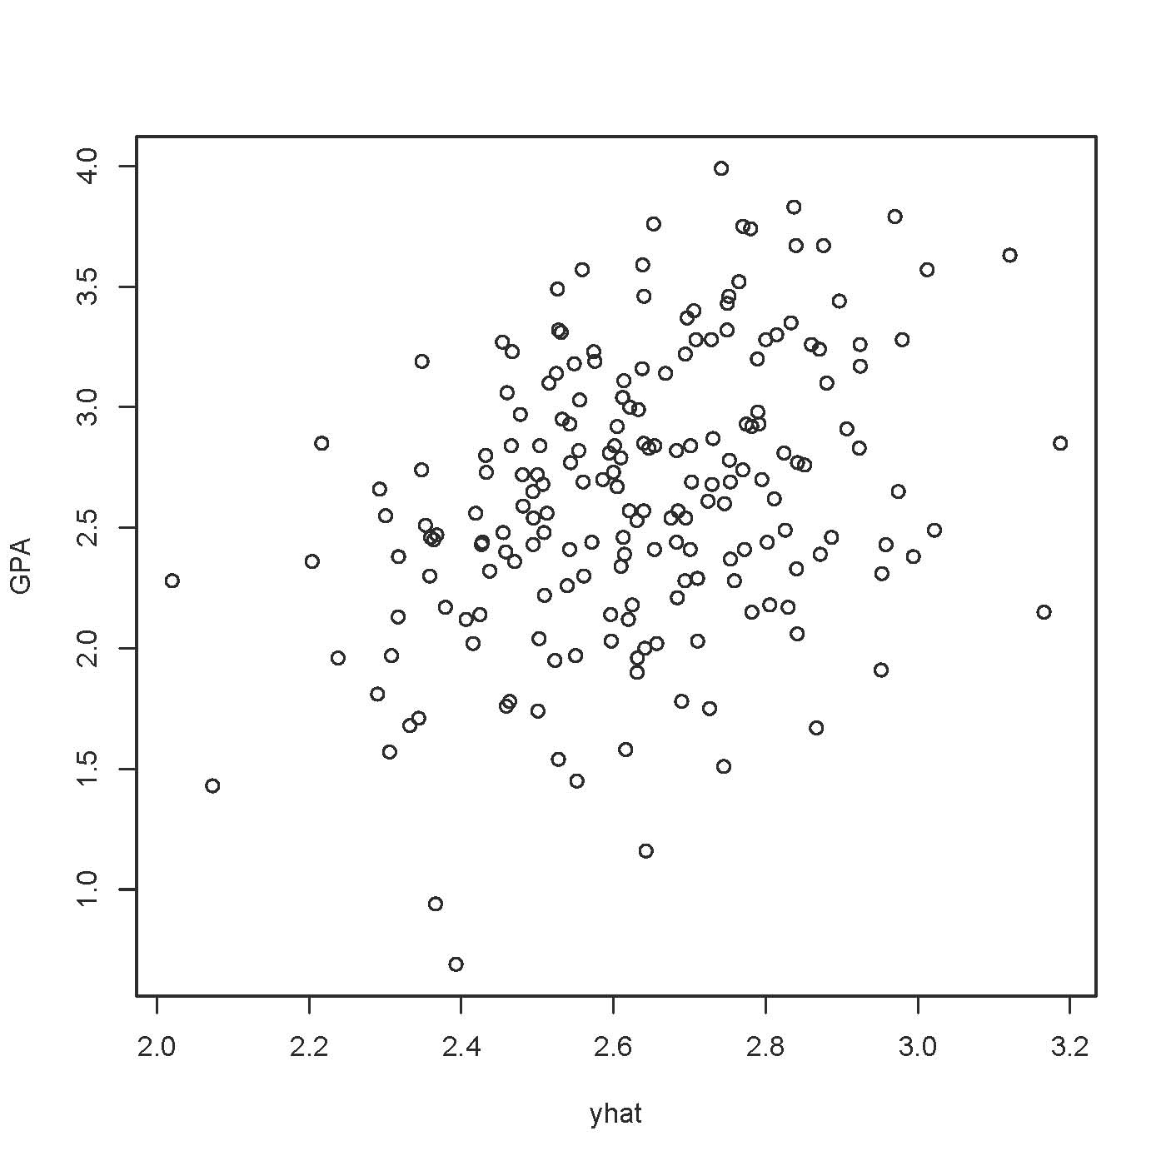
> cor(GPA,yhat)^2 # r-squared - R-squared
[1] 0.1160179

> # Plot y-hat versus residuals
> e = mod1$residuals
> plot(yhat,e)

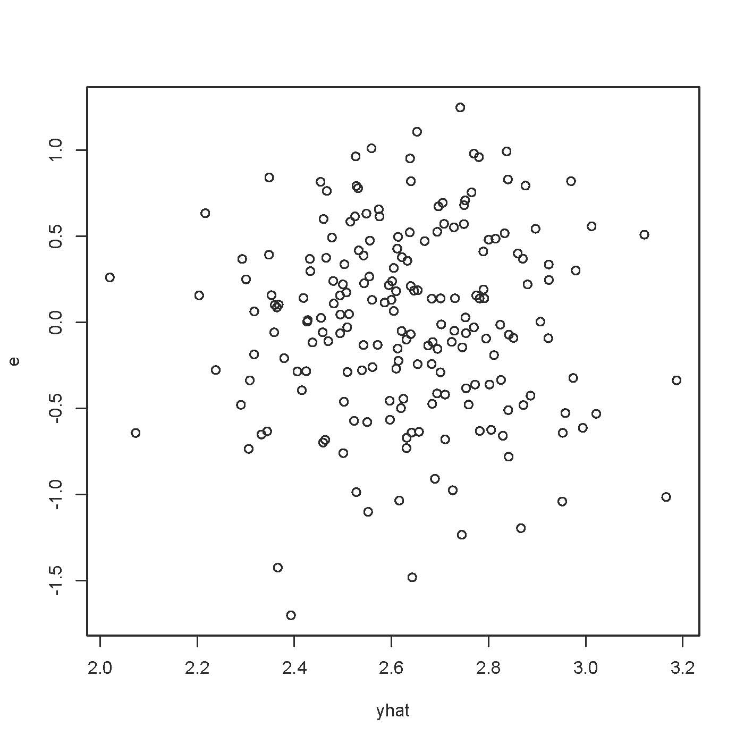
> cor(yhat,e) # Zero
[1] 2.898153e-16
> # Compare plot of standardized residuals
> sr = rstandard(mod1)
> plot(yhat,sr,ylab='Standardized Residual')

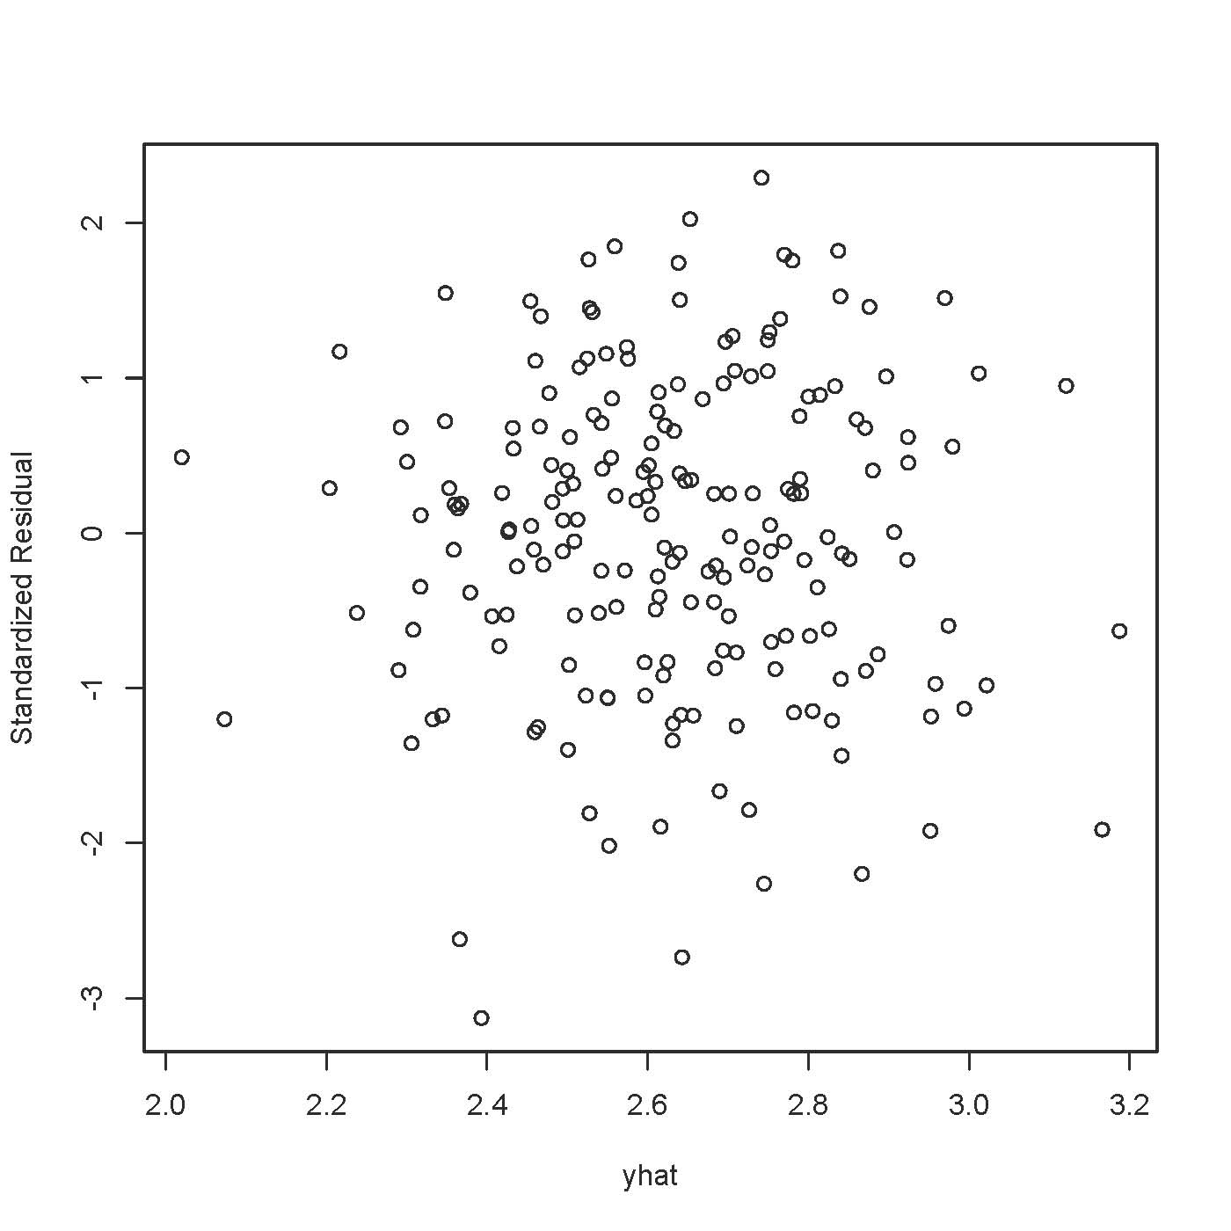

> # Three look like possible outliers: Investigate
> id = 1:200
> suspect = id[sr < -2.5]
> cbind(sat[suspect,],yhat[suspect],sr[suspect])
VERBAL MATH GPA yhat[suspect] sr[suspect]
20 497 640 0.69 2.392965 -3.128203
51 645 548 1.16 2.642644 -2.735853
73 516 569 0.94 2.365985 -2.620870

> # Studentized deleted residuals are t-statistics
> sdr = rstudent(mod1) # Studentized deleted residuals
> # Bonferroni critical value for n=200 tests, at joint alpha = 0.05 level
> dfe = mod1$df.residual; dfe
[1] 197
> alpha = 0.05; a = alpha/200; bcrit = qt(1-a/2,dfe-1); bcrit
[1] 3.730706
> summary(sdr)
Min. 1st Qu. Median Mean 3rd Qu. Max.
-3.201000 -0.672800 0.048340 -0.001731 0.710900 2.317000

> hist(sdr,xlab='Studentized Deleted Residual',
+ main='Histogram of Studentized Deleted Residuals')

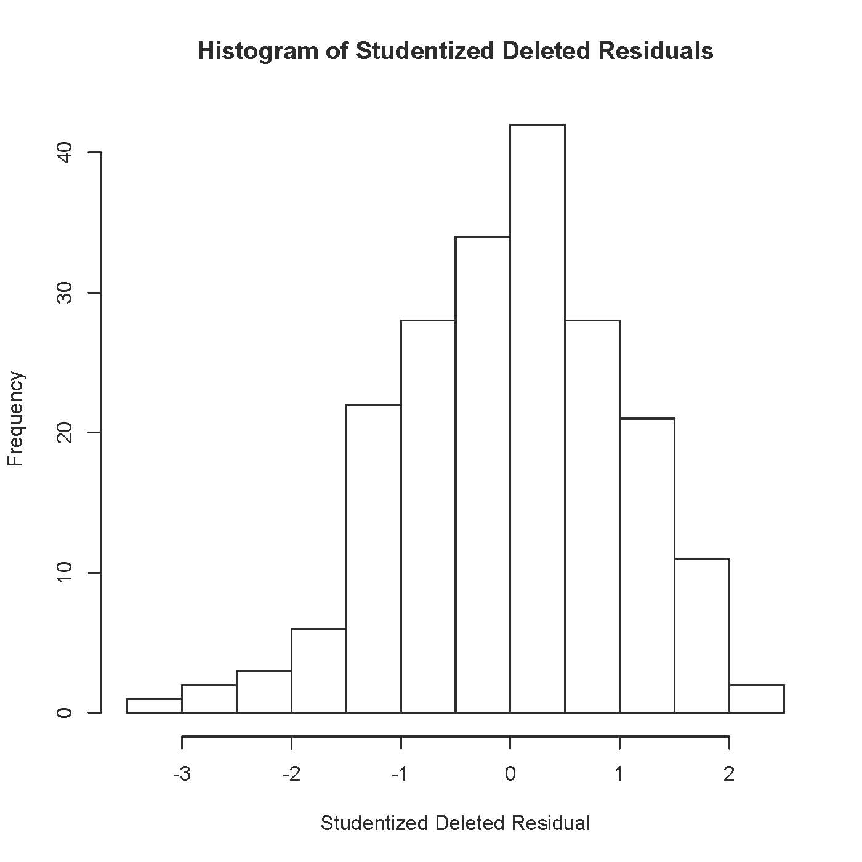

Should

> # Should we worry about normality? Not if maximum diagonal element of the hat matrix is less than 0.2
> hii = hatvalues(mod1)
> summary(hii) # Max should be less than 0.2 for robustness.
Min. 1st Qu. Median Mean 3rd Qu. Max.
0.005071 0.007824 0.011310 0.015000 0.019100 0.062370
> hist(hii)

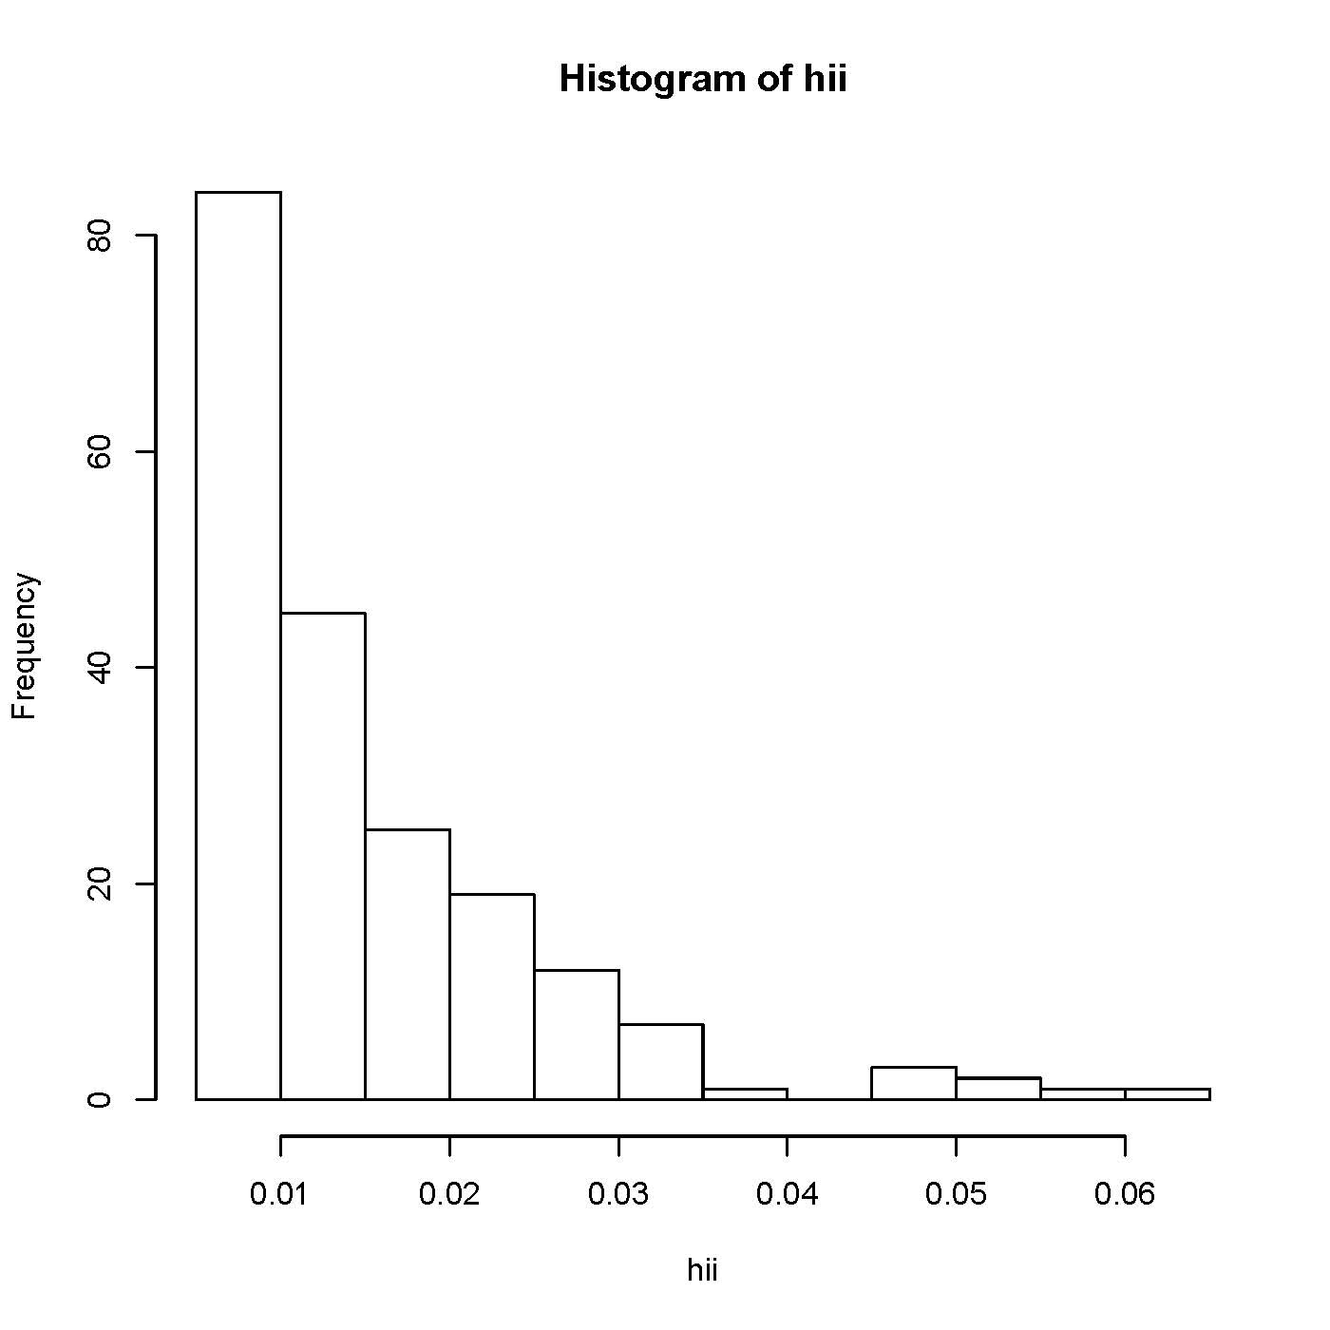
Trees Data

> rm(list=ls()) # Remove everything to start
> head(trees)
Girth Height Volume
1 8.3 70 10.3
2 8.6 65 10.3
3 8.8 63 10.2
4 10.5 72 16.4
5 10.7 81 18.8
6 10.8 83 19.7
> attach(trees)
> mod1 = lm(Volume ~ Girth + Height)
> summary(mod1)

Call:
lm(formula = Volume ~ Girth + Height)

Residuals:
Min 1Q Median 3Q Max
-6.4065 -2.6493 -0.2876 2.2003 8.4847

Coefficients:
Estimate Std. Error t value Pr(>|t|)
(Intercept) -57.9877 8.6382 -6.713 2.75e-07 ***
Girth 4.7082 0.2643 17.816 < 2e-16 ***
Height 0.3393 0.1302 2.607 0.0145 *
---
Signif. codes: 0 ‘***’ 0.001 ‘**’ 0.01 ‘*’ 0.05 ‘.’ 0.1 ‘ ’ 1

Residual standard error: 3.882 on 28 degrees of freedom
Multiple R-squared: 0.948, Adjusted R-squared: 0.9442
F-statistic: 255 on 2 and 28 DF, p-value: < 2.2e-16

>
> plot(yhat,Volume)

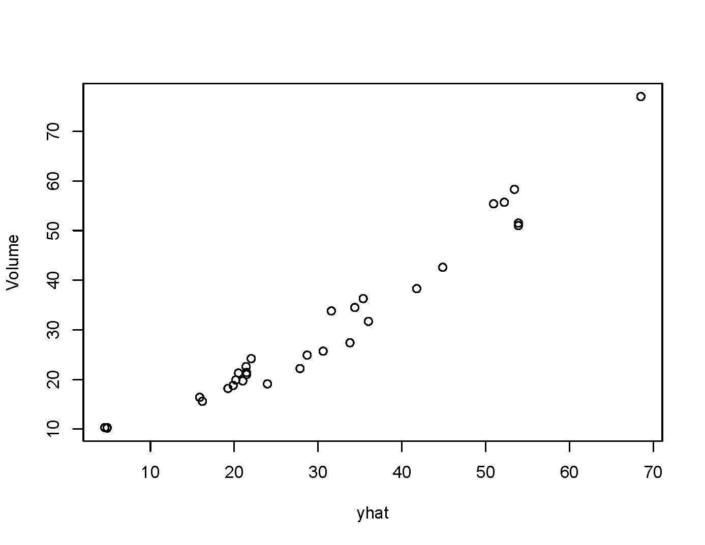

> rstud1 = rstudent(mod1) # Studentized deleted residuals
> plot(Girth,rstud1)

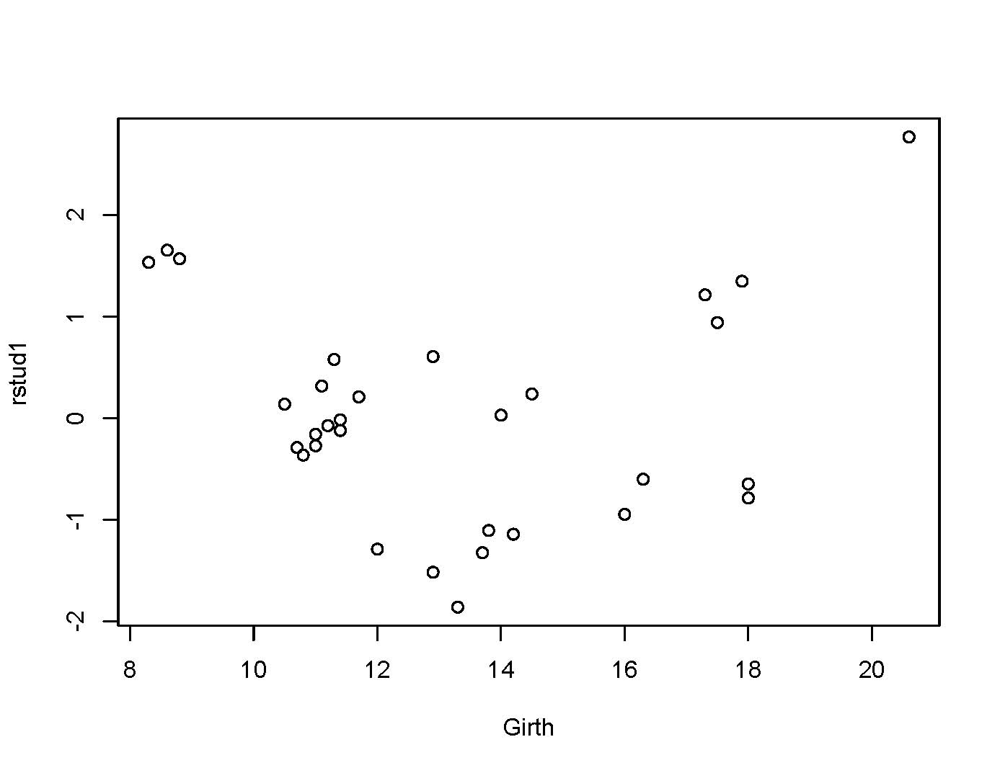
> plot(Height,rstud1) # No pattern
> Girthsq = Girth^2 # Polynomial term -- literally square it
> mod2 = lm(Volume ~ Girth + Girthsq + Height); summary(mod2)

Call:
lm(formula = Volume ~ Girth + Girthsq + Height)

Residuals:
Min 1Q Median 3Q Max
-4.2928 -1.6693 -0.1018 1.7851 4.3489

Coefficients:
Estimate Std. Error t value Pr(>|t|)
(Intercept) -9.92041 10.07911 -0.984 0.333729
Girth -2.88508 1.30985 -2.203 0.036343 *
Girthsq 0.26862 0.04590 5.852 3.13e-06 ***
Height 0.37639 0.08823 4.266 0.000218 ***
---
Signif. codes: 0 ‘***’ 0.001 ‘**’ 0.01 ‘*’ 0.05 ‘.’ 0.1 ‘ ’ 1

Residual standard error: 2.625 on 27 degrees of freedom
Multiple R-squared: 0.9771, Adjusted R-squared: 0.9745
F-statistic: 383.2 on 3 and 27 DF, p-value: < 2.2e-16
> a = (0.9771-0.948)/(1-0.948); a # Proportion of remaining variation
[1] 0.5596154

> 5.852^2/(27+5.852^2) # a = rF/(n-p+rF)
[1] 0.5591542

> rstud2 = rstudent(mod2)
> plot(Girth,rstud2) # Nothing
> plot(Height,rstud2) # Nothing
>
> # Look at prediction intervals
> cbind(Volume[1:5],predict(mod1,interval='predict')[1:5,])
fit lwr upr
1 10.3 4.837660 -3.561809 13.23713
2 10.3 4.553852 -3.962908 13.07061
3 10.2 4.816981 -3.809144 13.44311
4 16.4 15.874115 7.690594 24.05764
5 18.8 19.869008 11.451358 28.28666
Warning message:
In predict.lm(mod1, interval = "predict") :
predictions on current data refer to _future_ responses

>
> cbind(Volume[1:5],predict(mod2,interval='predict')[1:5,])
fit lwr upr
1 10.3 10.985950 4.902269 17.06963
2 10.3 9.600406 3.566753 15.63406
3 10.2 9.205421 3.163767 15.24708
4 16.4 16.501775 10.954762 22.04879
5 18.8 20.451204 14.746331 26.15608
Warning message:
In predict.lm(mod2, interval = "predict") :
predictions on current data refer to _future_ responses

This document is licensed under a Creative Commons Attribution - ShareAlike 3.0 Unported License: http://creativecommons.org/licenses/by-sa/3.0/deed.en_US. Use any part of it as you like and share the result freely.

* Copyright information is on the last page.

