Breaking Rocks

> rock = read.table("http://www.utstat.toronto.edu/~brunner/302f14/code_n_data/lecture/rock1.data")
> attach(rock)
> plot(support,bforce)
> title("Breaking strength of rock cores")

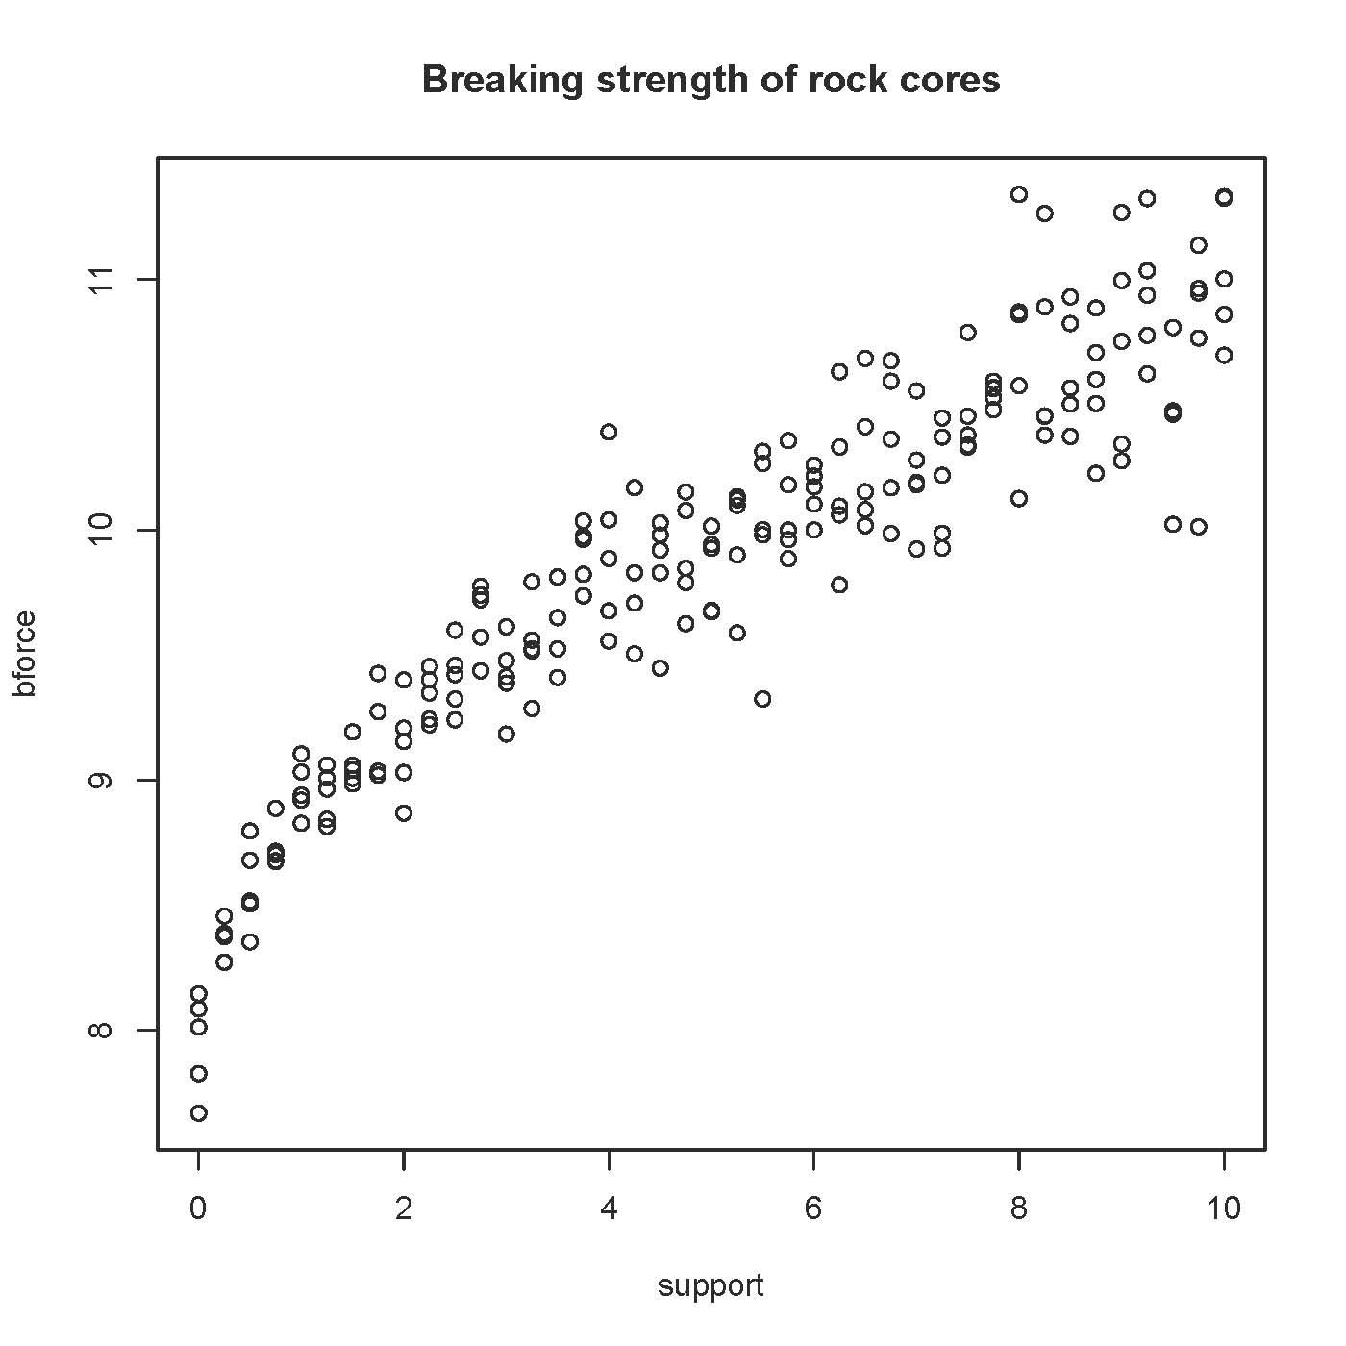
> # Plot least squares curve
> sqrtsup = sqrt(support)
> sqrtmodel = lm(bforce~sqrtsup)
> lines(support,sqrtmodel$fitted.values,type='l')
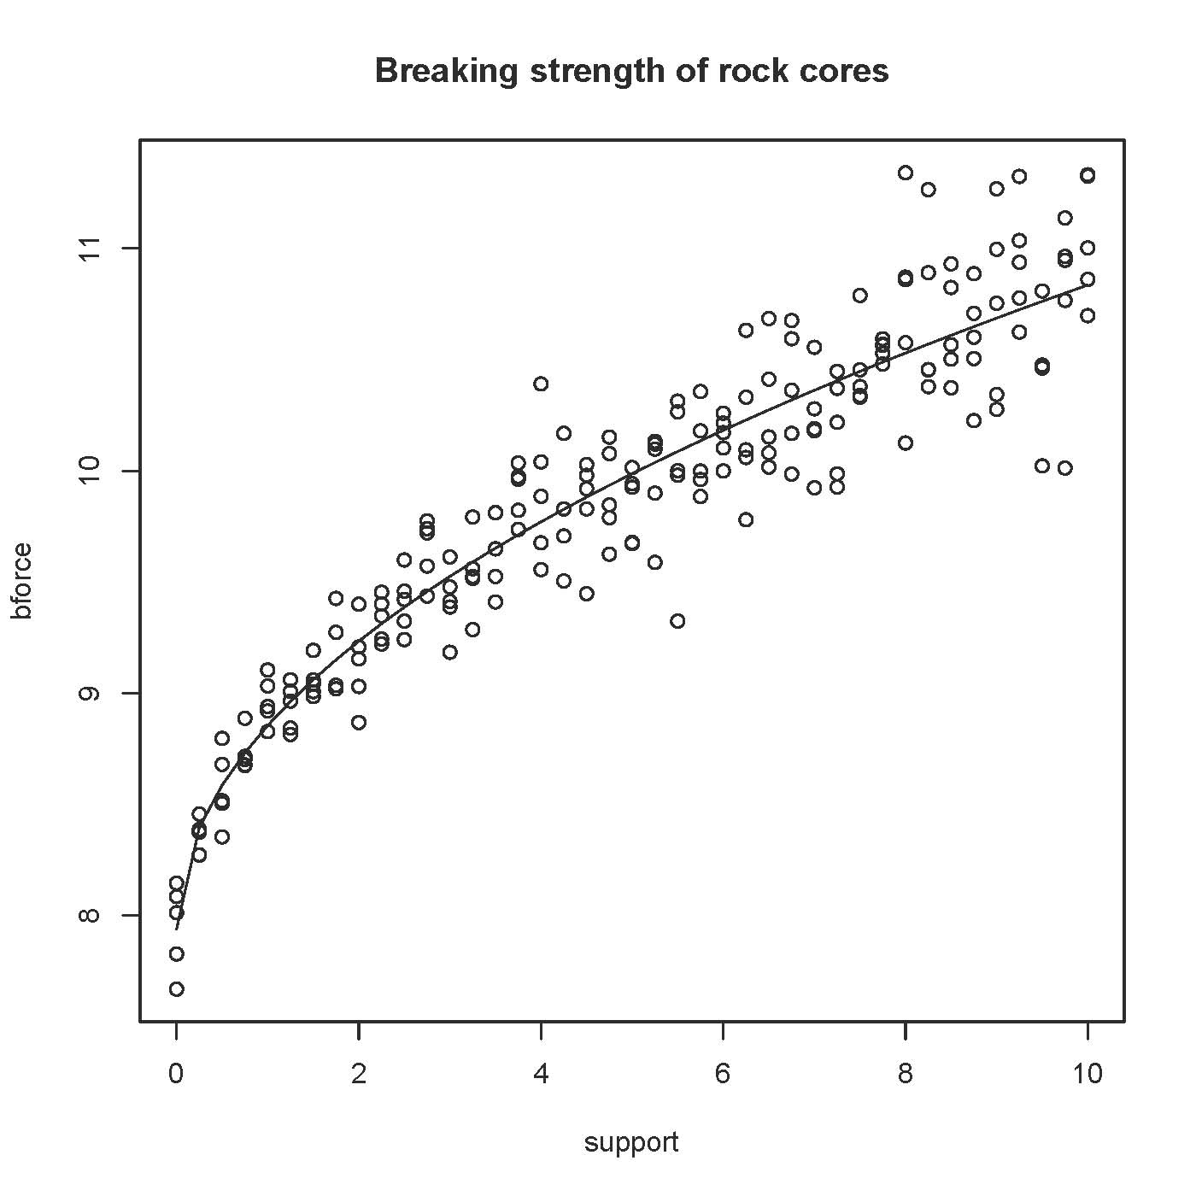
This document is licensed under a Creative Commons Attribution - ShareAlike 3.0 Unported License: http://creativecommons.org/licenses/by-sa/3.0/deed.en_US. Use any part of it as you like and share the result freely.

