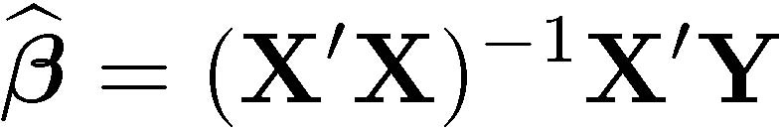
Least Squares Estimation with R:

> trees[1:4,] # First 4 rows, all columns
Girth Height Volume
1 8.3 70 10.3
2 8.6 65 10.3
3 8.8 63 10.2
4 10.5 72 16.4
> n = dim(trees)[1]; n
[1] 31
> attach(trees) # Makes variable names available
> int = numeric(n)+1 # Vector of ones, length n
> X = cbind(int, Girth, Height); Y = Volume
> X
int Girth Height
[1,] 1 8.3 70
[2,] 1 8.6 65
[3,] 1 8.8 63
[4,] 1 10.5 72
[5,] 1 10.7 81
[6,] 1 10.8 83
[7,] 1 11.0 66
[8,] 1 11.0 75
[9,] 1 11.1 80
[10,] 1 11.2 75
[11,] 1 11.3 79
[12,] 1 11.4 76
[13,] 1 11.4 76
[14,] 1 11.7 69
[15,] 1 12.0 75
[16,] 1 12.9 74
[17,] 1 12.9 85
[18,] 1 13.3 86
[19,] 1 13.7 71
[20,] 1 13.8 64
[21,] 1 14.0 78
[22,] 1 14.2 80
[23,] 1 14.5 74
[24,] 1 16.0 72
[25,] 1 16.3 77
[26,] 1 17.3 81
[27,] 1 17.5 82
[28,] 1 17.9 80
[29,] 1 18.0 80
[30,] 1 18.0 80
[31,] 1 20.6 87
> betahat = solve(t(X) %*% X) %*% t(X) %*% Y
> betahat
[,1]
int -57.9876589
Girth 4.7081605
Height 0.3392512
> # Predict volume for a tree 12 inchs in diameter, 80 feet tall
> betahat[1] + betahat[2]*12 + betahat[3]*80
[1] 25.65037
>
> # Better (not just more convenient) to let R do the calculation
> treefit = lsfit(cbind(Girth, Height),Volume) # Produces a linked list: see help(lsfit)
> treefit$coefficients
Intercept Girth Height
-57.9876589 4.7081605 0.3392512

This document is licensed under a Creative Commons Attribution - ShareAlike 3.0 Unported License: http://creativecommons.org/licenses/by-sa/3.0/deed.en_US. Use any part of it as you like and share the result freely.

