Regression diagnostics with R*

> sat = read.table("http://www.utstat.utoronto.ca/~brunner/302f13/code_n_data/lecture/sat.data")
> head(sat)
VERBAL MATH GPA
1 623 509 2.6
2 454 471 2.3
3 643 700 2.4
4 585 719 3.0
5 719 710 3.1
6 693 643 2.9
> mod1 = lm(GPA ~ VERBAL+MATH, data=sat); summary(mod1)

Call:
lm(formula = GPA ~ VERBAL + MATH, data = sat)

Residuals:
Min 1Q Median 3Q Max
-2.24875 -0.35113 0.04659 0.38745 1.03527

Coefficients:
Estimate Std. Error t value Pr(>|t|)
(Intercept) 0.6062975 0.4414062 1.374 0.171
VERBAL 0.0023072 0.0005522 4.178 4.42e-05 ***
MATH 0.0009999 0.0006093 1.641 0.102
---
Signif. codes: 0 ‘***’ 0.001 ‘**’ 0.01 ‘*’ 0.05 ‘.’ 0.1 ‘ ’ 1

Residual standard error: 0.5484 on 197 degrees of freedom
Multiple R-squared: 0.1161, Adjusted R-squared: 0.1071
F-statistic: 12.93 on 2 and 197 DF, p-value: 5.284e-06

> attach(sat) # Make variable names accessible
>

> # Plot y-hat versus y
> yhat = mod1$fitted.values
> plot(yhat,GPA)
>

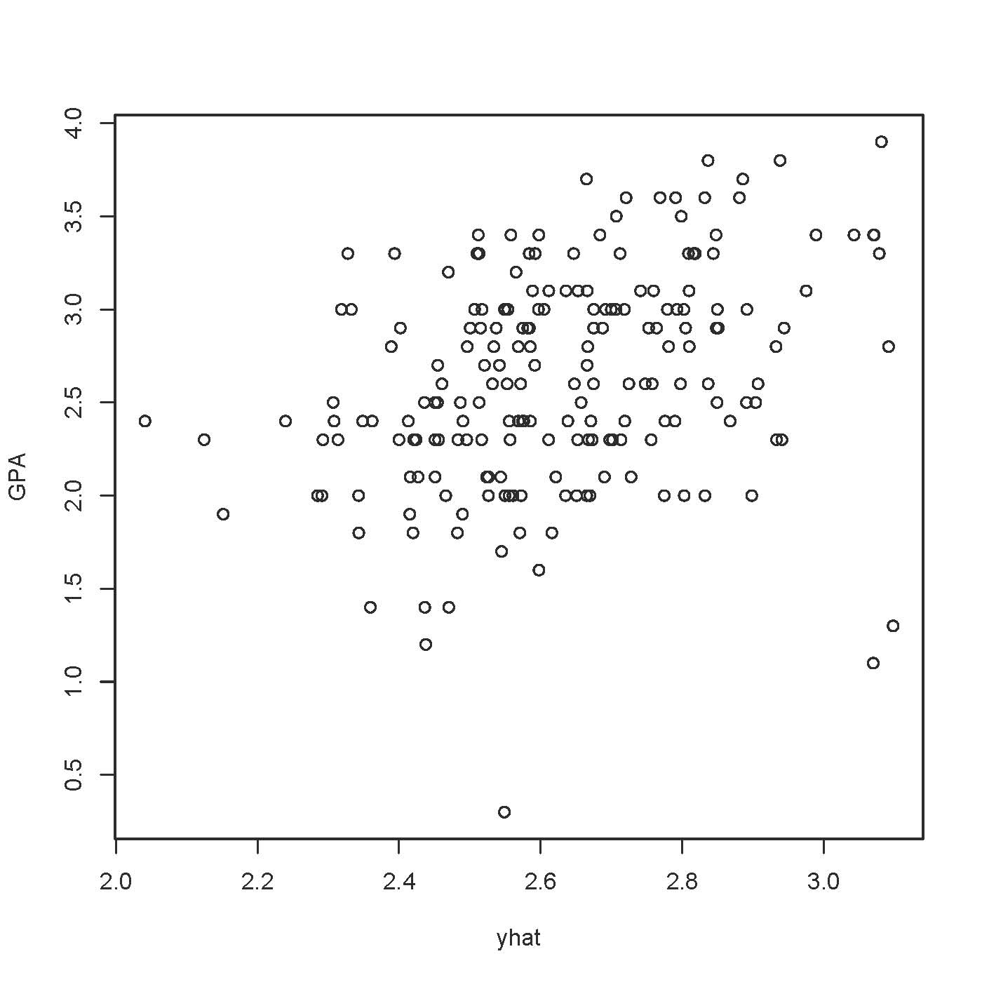

> # Plot y-hat versus residuals
> epsilonhat = mod1$residuals
> plot(yhat,epsilonhat)

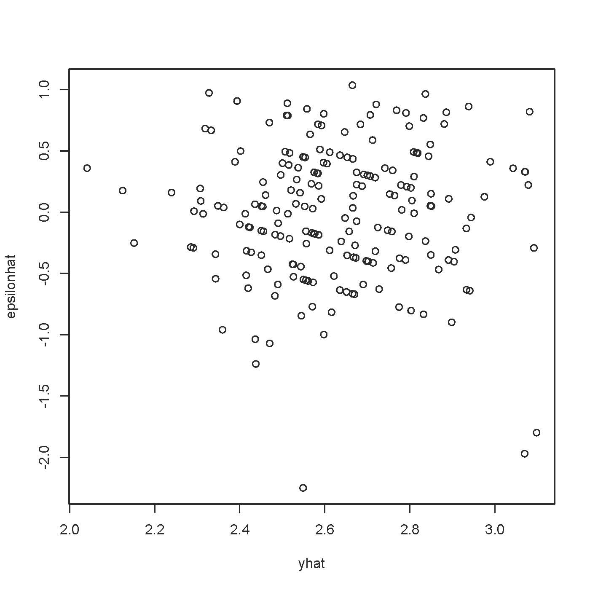

> # Compare plot of standardized residuals
> sr = rstandard(mod1)
> plot(yhat,sr,ylab='Standardized Residual')

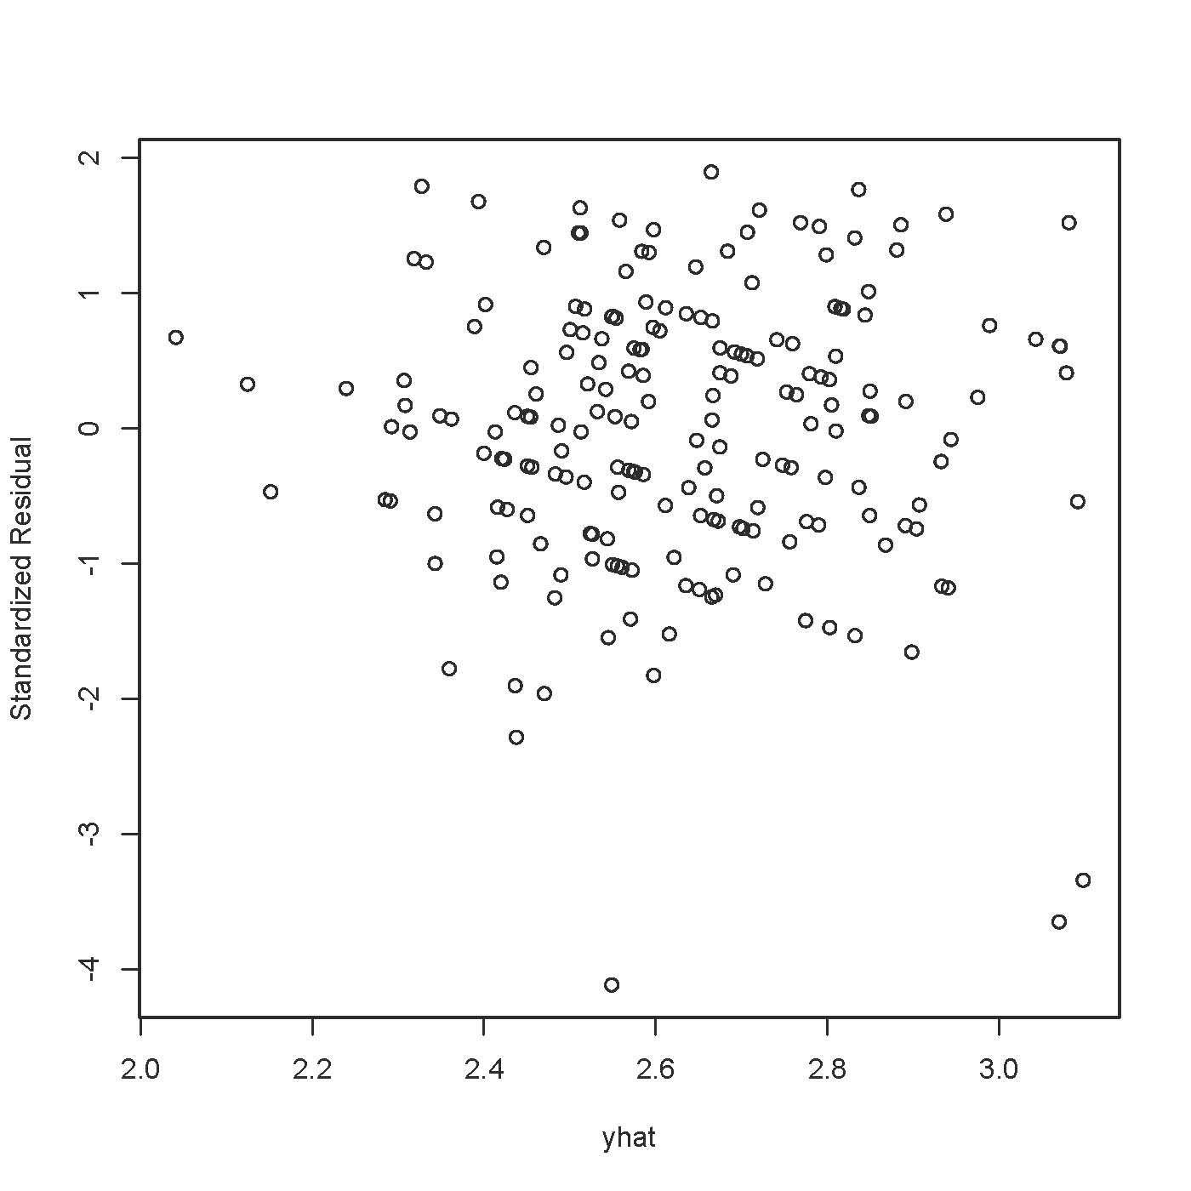

> # Three look like possible outliers: Investigate
> id = 1:200
> suspect = id[sr < -3]
> cbind(sat[suspect,],yhat[suspect],epsilonhat[suspect])
VERBAL MATH GPA yhat[suspect] epsilonhat[suspect]
121 780 692 1.3 3.097791 -1.797791
131 578 609 0.3 2.548754 -2.248754
136 760 710 1.1 3.069645 -1.969645

> # Studentized deleted residuals are t-statistics
> sdr = rstudent(mod1) # Studentized deleted residuals
> # Bonferroni critical value for n=200 tests, at joint alpha = 0.05 level
> dfe = mod1$df.residual; dfe
[1] 197
> alpha = 0.05; a = alpha/200; bcrit = qt(1-a/2,dfe-1); bcrit
[1] 3.730706
> sdr[abs(sdr)>bcrit]
131 136
-4.293141 -3.768640
>

I feel that all three suspicious points are worthy of investigation.
> # Detecting curvilinear trends
> curvy = read.table("http://www.utstat.toronto.edu/~brunner/302f13/code_n_data/lecture/curvy.data")
> mod1 = lm(y~x1+x2,data=curvy); summary(mod1)

Call:
lm(formula = y ~ x1 + x2, data = curvy)

Residuals:
Min 1Q Median 3Q Max
-4.7813 -1.3667 -0.0649 1.3356 6.5690

Coefficients:
Estimate Std. Error t value Pr(>|t|)
(Intercept) -22.4665 0.8172 -27.493 < 2e-16 ***
x1 0.9598 0.1474 6.511 6.05e-10 ***
x2 9.9476 0.1509 65.904 < 2e-16 ***
---
Signif. codes: 0 ‘***’ 0.001 ‘**’ 0.01 ‘*’ 0.05 ‘.’ 0.1 ‘ ’ 1

Residual standard error: 1.945 on 197 degrees of freedom
Multiple R-squared: 0.9663, Adjusted R-squared: 0.9659
F-statistic: 2823 on 2 and 197 DF, p-value: < 2.2e-16

> attach(curvy)
> yhat = mod1$fitted.values; epsilonhat = mod1$residuals
>

> # Plot y-hat versus y
> plot(yhat,y)

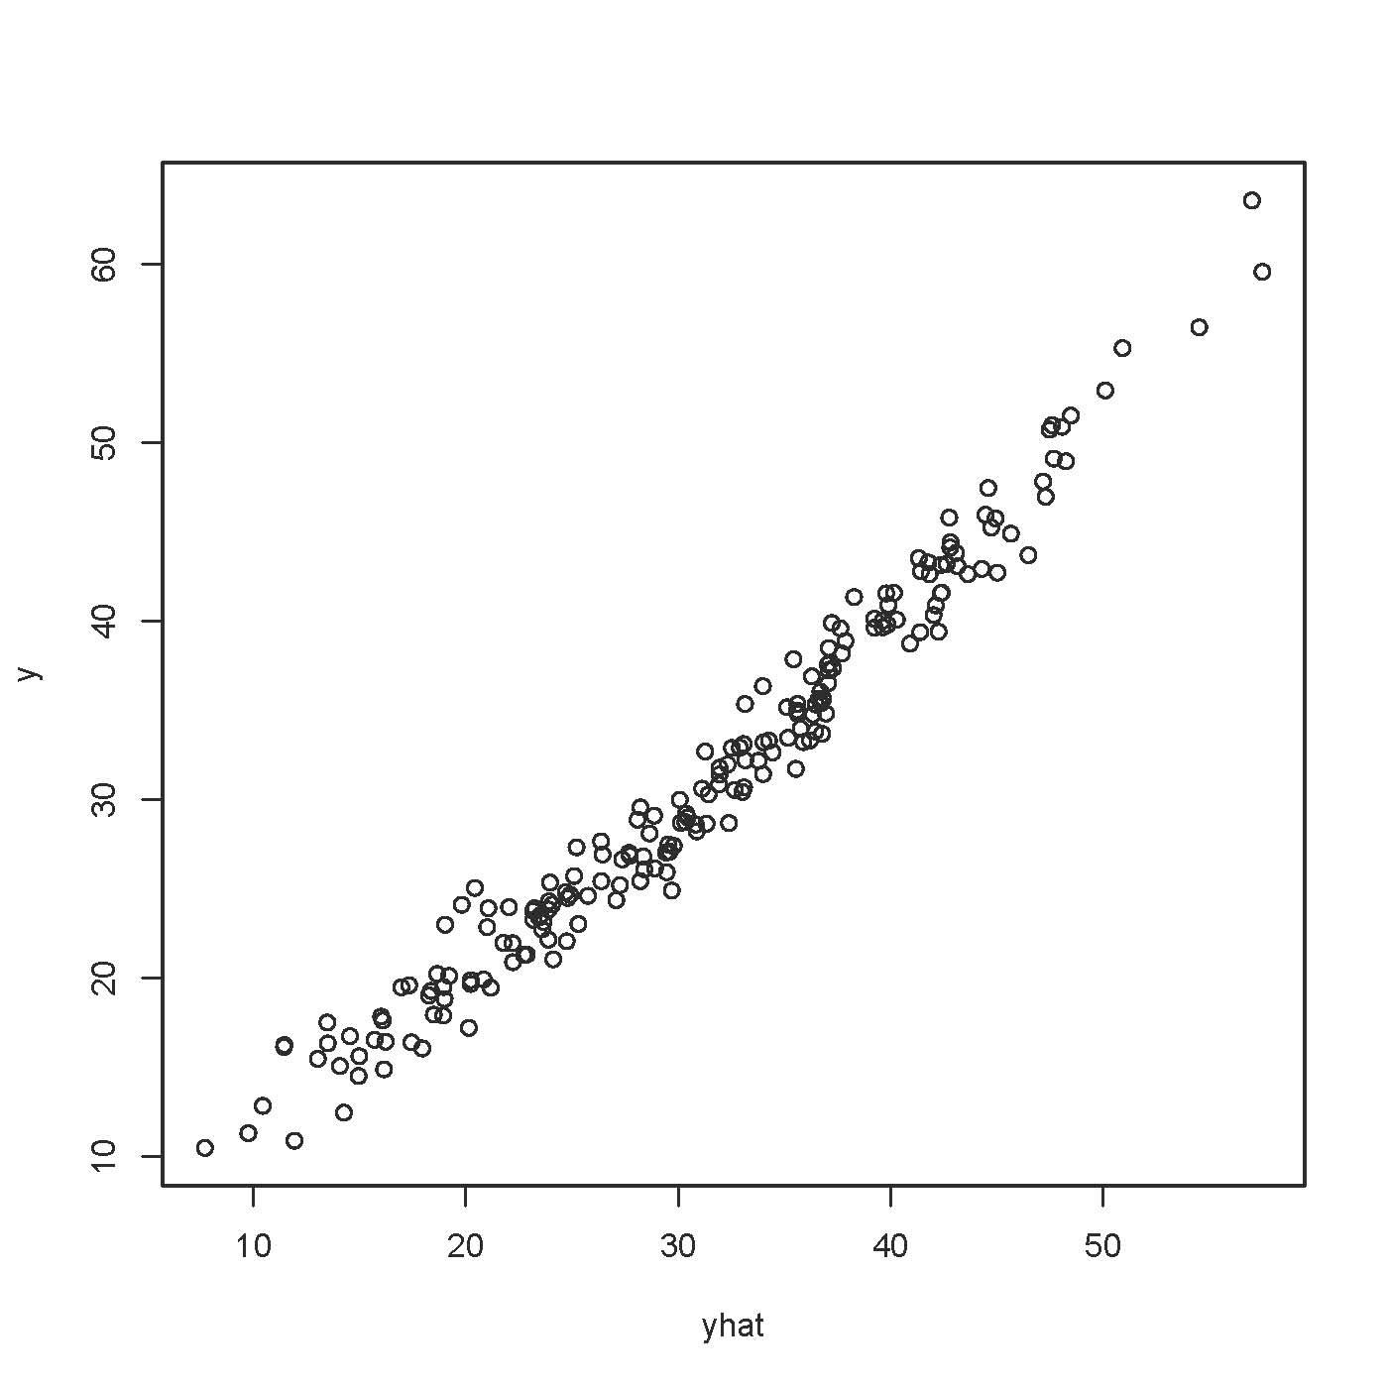

> # Plot y-hat versus residuals
> plot(yhat,epsilonhat)
>

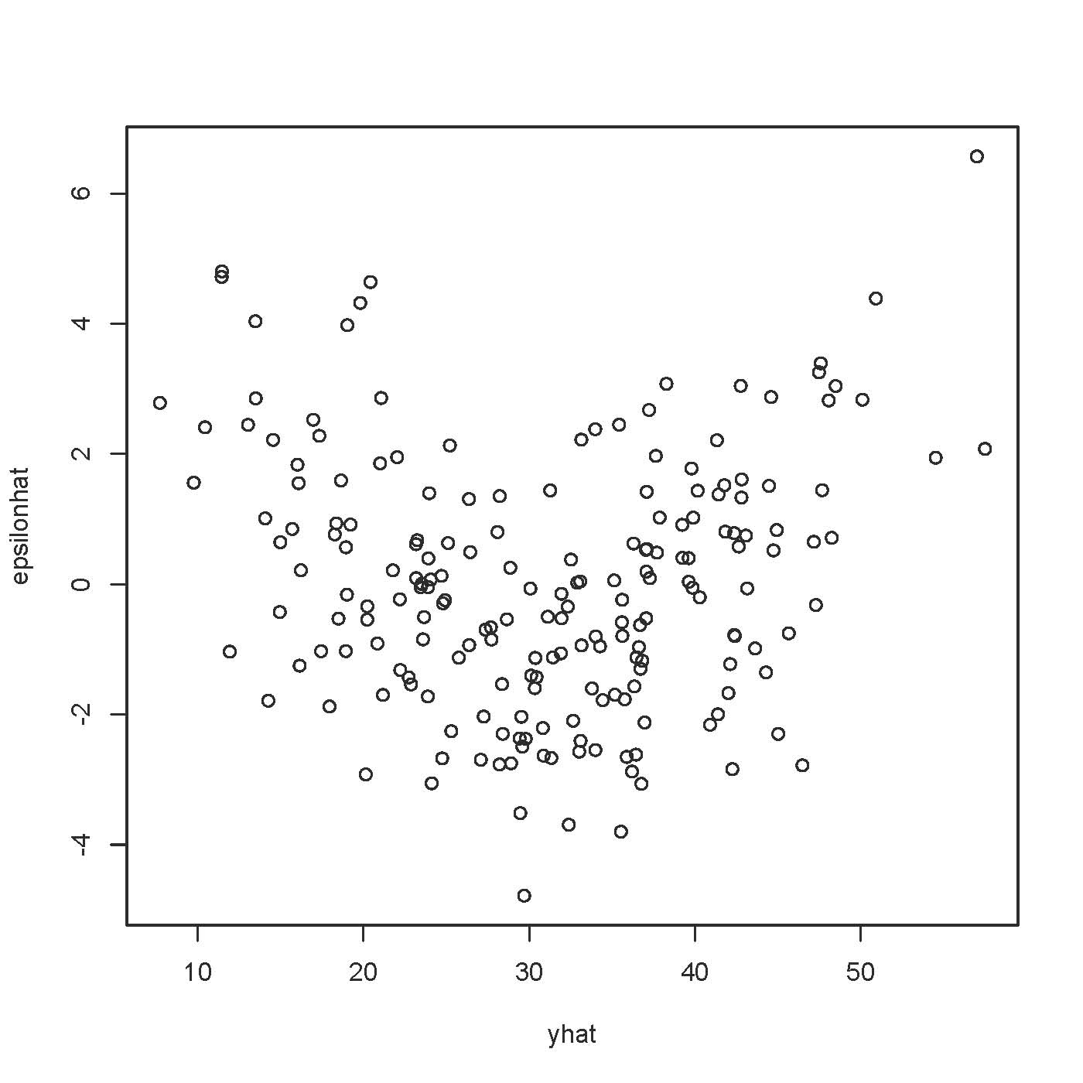
> plot(yhat,rstandard(mod1)) # Same picture
> plot(yhat,rstudent(mod1)) # Same picture

> # Plot residuals against variables in the model
> plot(x1,epsilonhat)

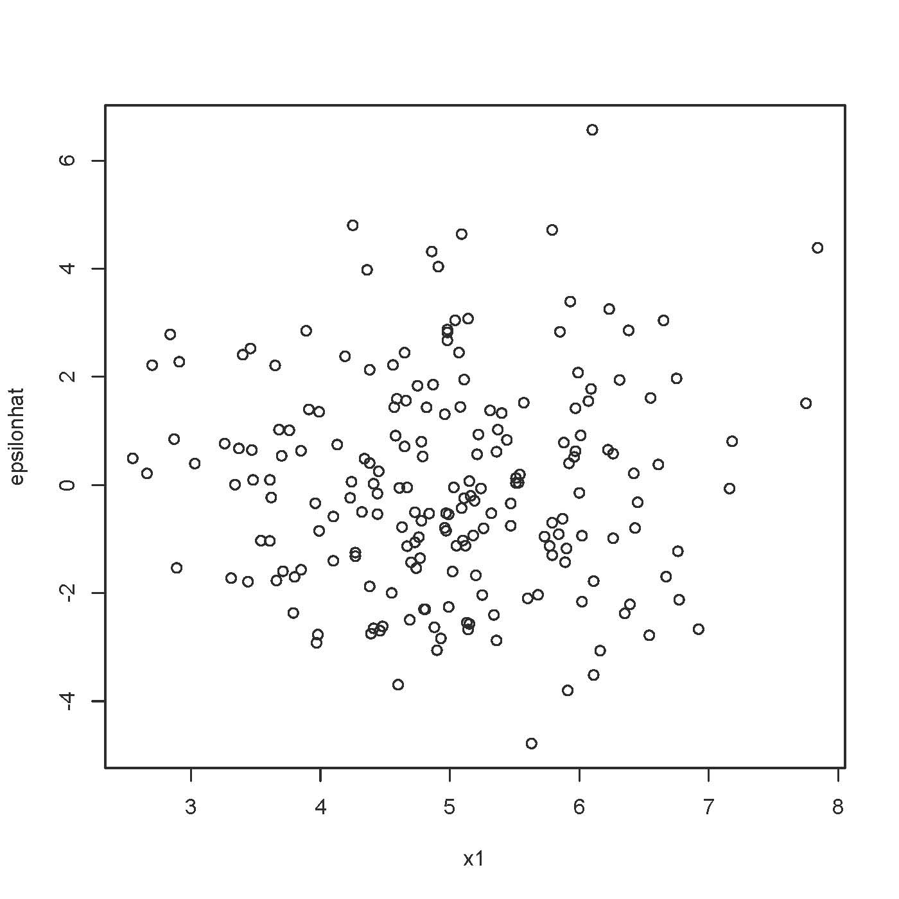

plot(x2,epsilonhat)
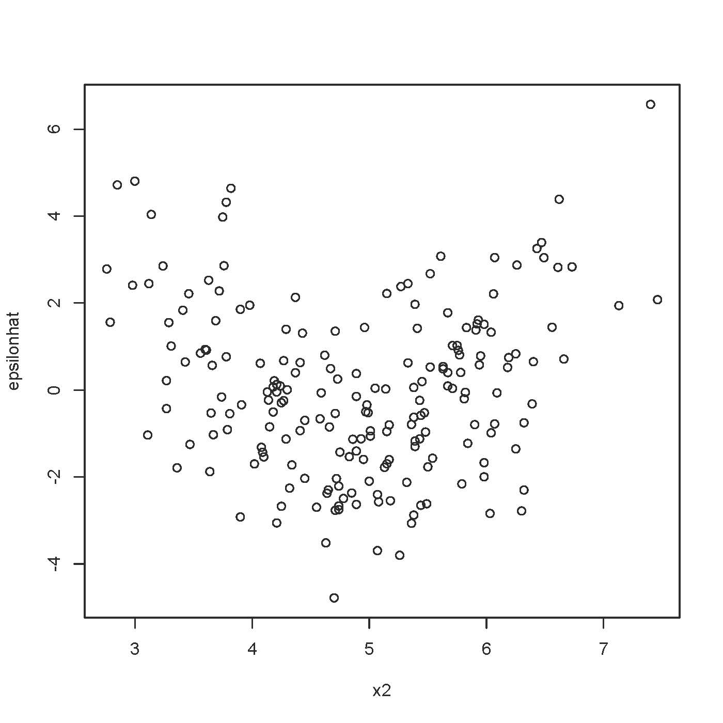

> # Try adding x2^2 to the model
> x2sq = x2^2
> mod2 = lm(y~x1+x2+x2sq,data=curvy); summary(mod2)

Call:
lm(formula = y ~ x1 + x2 + x2sq, data = curvy)

Residuals:
Min 1Q Median 3Q Max
-3.884 -1.219 0.041 1.101 4.509

Coefficients:
Estimate Std. Error t value Pr(>|t|)
(Intercept) -1.46607 2.41019 -0.608 0.544
x1 0.91057 0.12407 7.339 5.58e-12 ***
x2 1.08960 0.98266 1.109 0.269
x2sq 0.90596 0.09966 9.090 < 2e-16 ***
---
Signif. codes: 0 ‘***’ 0.001 ‘**’ 0.01 ‘*’ 0.05 ‘.’ 0.1 ‘ ’ 1

Residual standard error: 1.635 on 196 degrees of freedom
Multiple R-squared: 0.9763, Adjusted R-squared: 0.9759
F-statistic: 2690 on 3 and 196 DF, p-value: < 2.2e-16

>

> plot(x2,rstandard(mod2)) # In practice you would look at all the residual plots again.

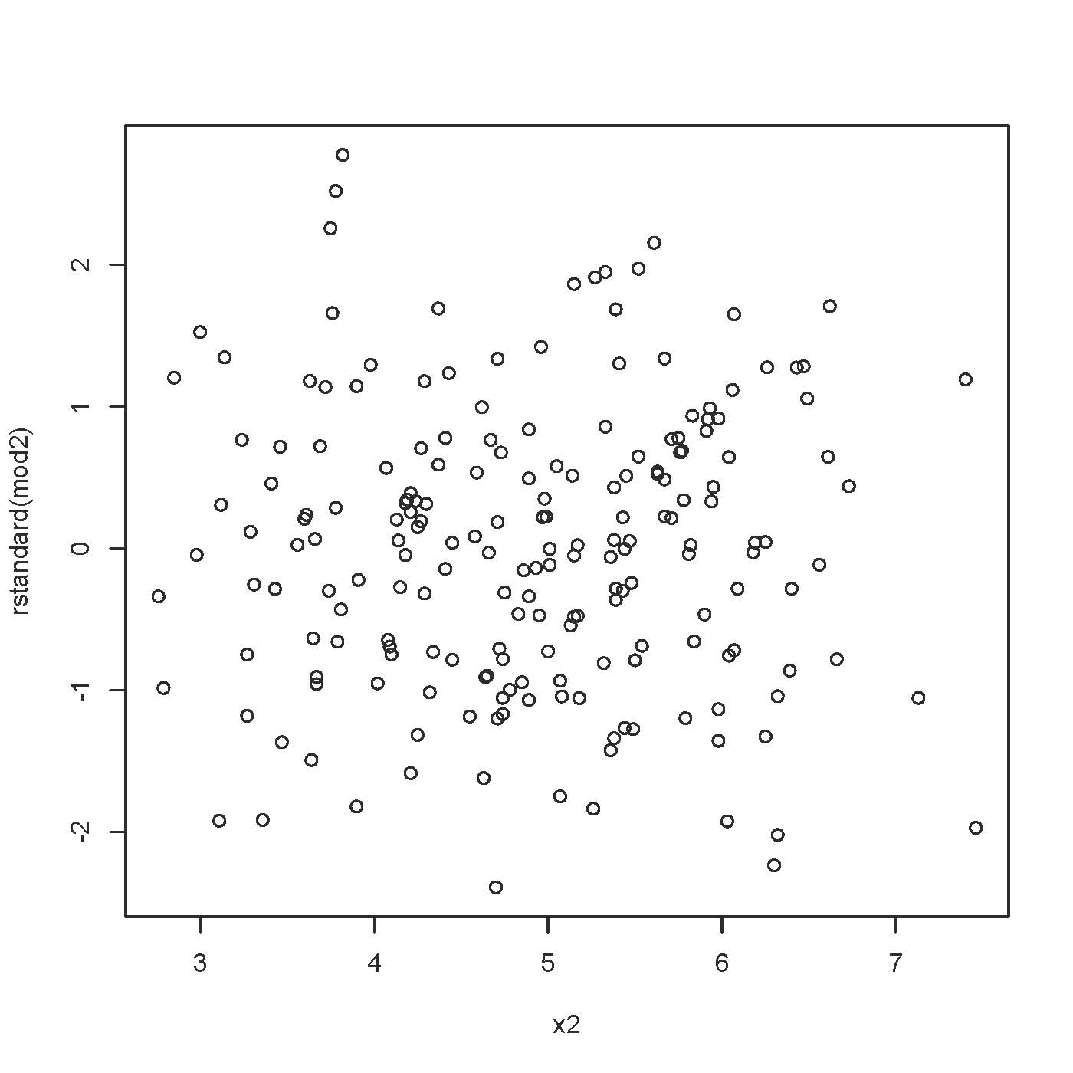

Non-constant variance (“Heteroscedasticity”)

Used Car Sales, n = number of dealerships
Y = Price paid by customer
x1 = Number of sales people
x2 = Average sales force years of experience
x3 = Average sales force years of education
x4 = Percent women on sales force
x5 = Average income of census tract where dealership is located, in thousands
x6 = Number of cars sold, not in model

> carsales = read.table("http://www.utstat.toronto.edu/~brunner/302f13/code_n_data/lecture/carsales.data")
> head(carsales)
salesforce yrsexp yrseduc women income nsales avprice
1 20 4.25 12.7 35 24 78 6099
2 16 6.42 13.8 6 87 77 6161
3 6 9.25 13.8 17 56 22 6094
4 17 6.08 11.6 24 26 71 6030
5 12 5.58 12.7 8 26 49 6108
6 8 7.33 15.5 50 42 33 6136

> auto = lm(avprice ~ salesforce + yrsexp + yrseduc + women + income, data=carsales)
> summary(auto)

Call:
lm(formula = avprice ~ salesforce + yrsexp + yrseduc + women +
income, data = carsales)

Residuals:
Min 1Q Median 3Q Max
-307.71 -62.60 0.80 54.38 356.01

Coefficients:
Estimate Std. Error t value Pr(>|t|)
(Intercept) 6099.1463 96.8659 62.965 < 2e-16 ***
salesforce 1.5577 1.6865 0.924 0.35724
yrsexp 14.4620 5.3166 2.720 0.00733 **
yrseduc -13.3943 7.0424 -1.902 0.05918 .
women 1.0157 0.6621 1.534 0.12721
income 0.6383 0.3099 2.059 0.04126 *
---
Signif. codes: 0 ‘***’ 0.001 ‘**’ 0.01 ‘*’ 0.05 ‘.’ 0.1 ‘ ’ 1

Residual standard error: 98.94 on 144 degrees of freedom
Multiple R-squared: 0.1103, Adjusted R-squared: 0.07939
F-statistic: 3.57 on 5 and 144 DF, p-value: 0.0045

> yhat = auto$fitted.values ; sr = rstandard(auto)
> attach(carsales) # Make variable names accessible without dollar signs
The following object(s) are masked from 'package:datasets':

women
> plot(yhat,avprice) # Plot y-hat versus y

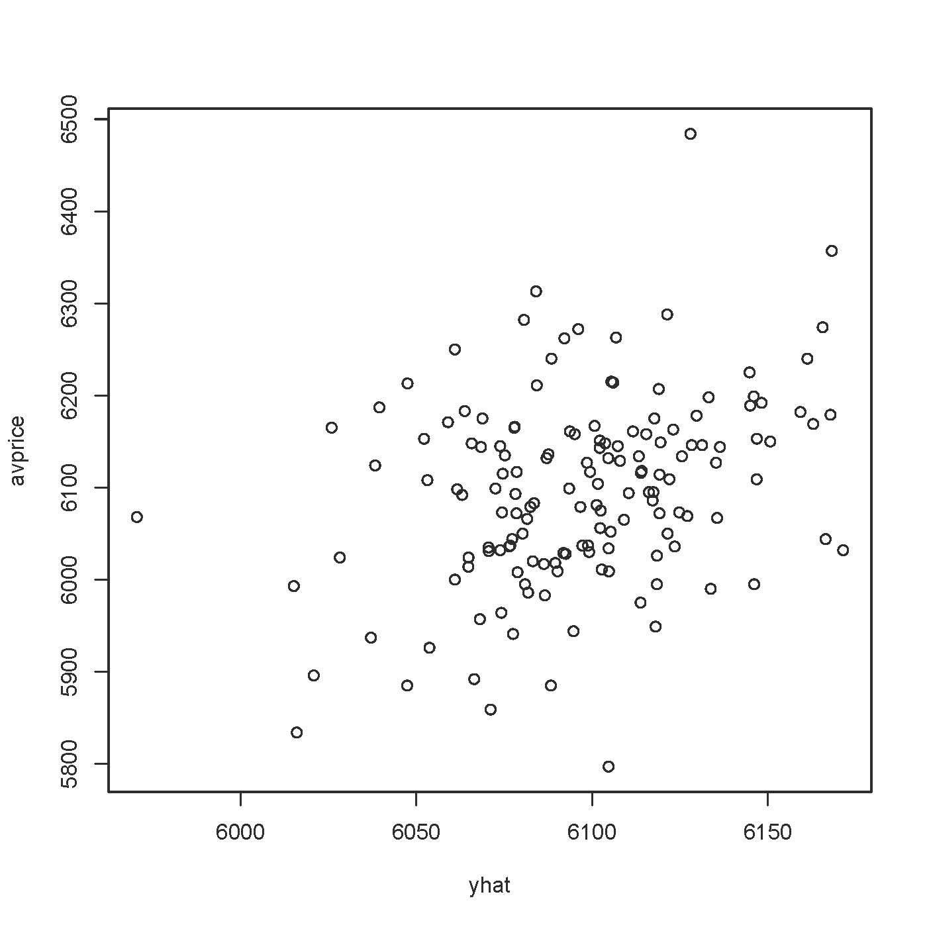
> # Plot y-hat versus standardized residual
> plot(yhat,sr,ylab='Standardized Residual')
> # One possible high outlier, one low
> n = length(nsales); n
[1] 150
> # Studentized deleted residuals are t-statistics
> sdr = rstudent(auto) # Studentized deleted residuals
> # Bonferroni critical value for n=200 tests, at joint alpha = 0.05 level
> dfe = auto$df.residual; dfe
[1] 144
> alpha = 0.05; a = alpha/n; bcrit = qt(1-a/2,dfe-1); bcrit
[1] 3.676863
> sdr[abs(sdr)>bcrit]
37
4.001458
>
> # Looks like one high outlier. Keep investigating.
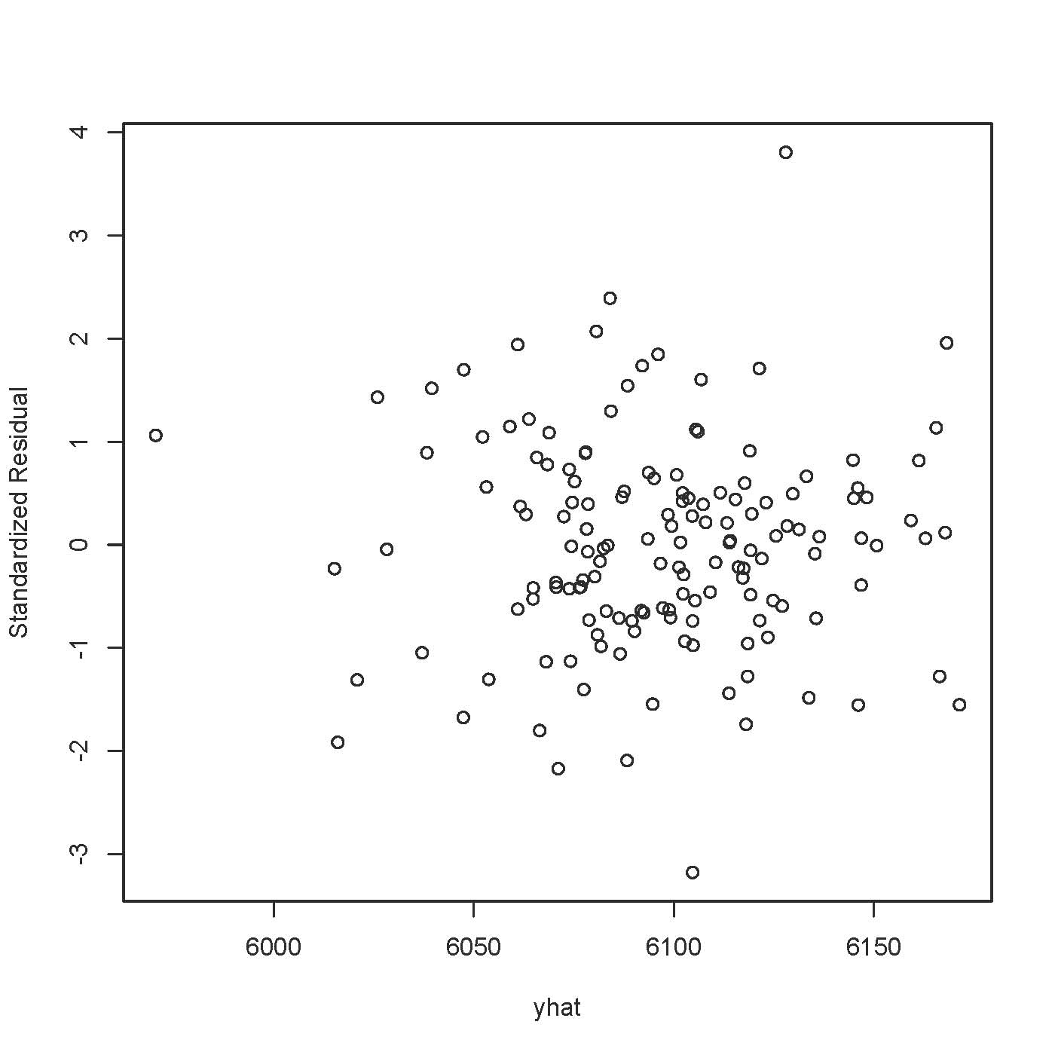
> # Plot standardized residuals against variables in the model
> plot(salesforce,sr,ylab='Standardized Residual')

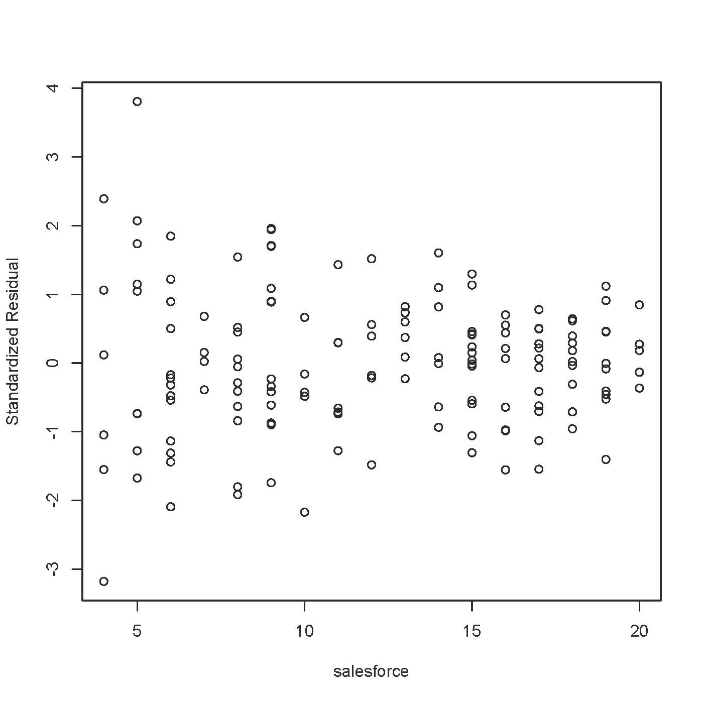
> # Possible non-constant variance

> plot(yrsexp,sr,ylab='Standardized Residual')

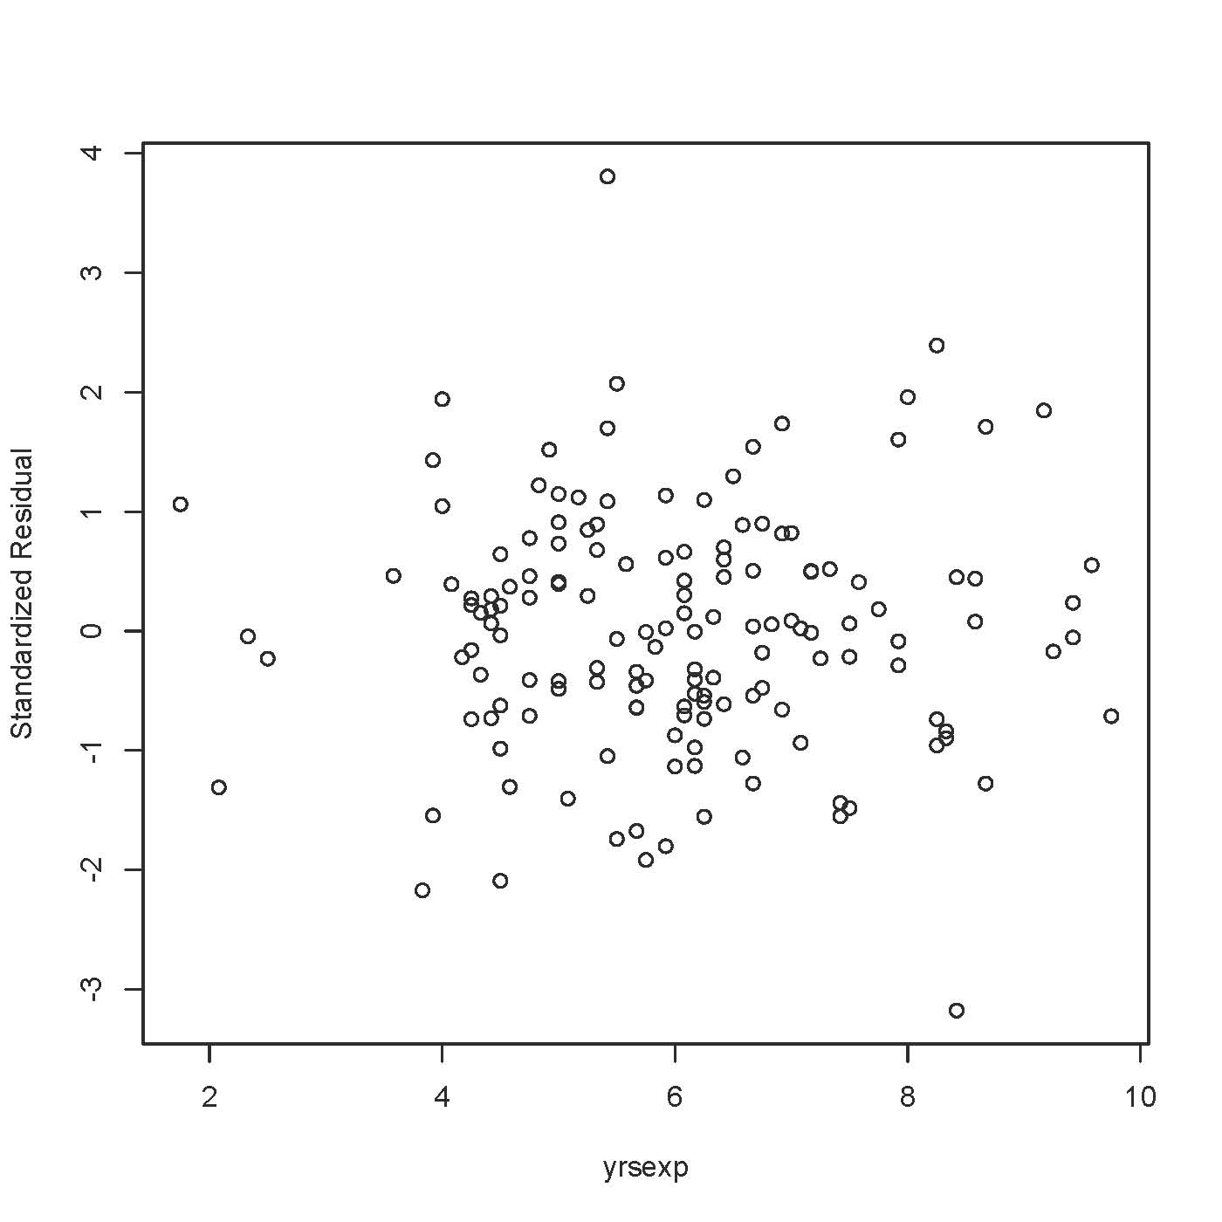

> plot(yrseduc,sr,ylab='Standardized Residual')
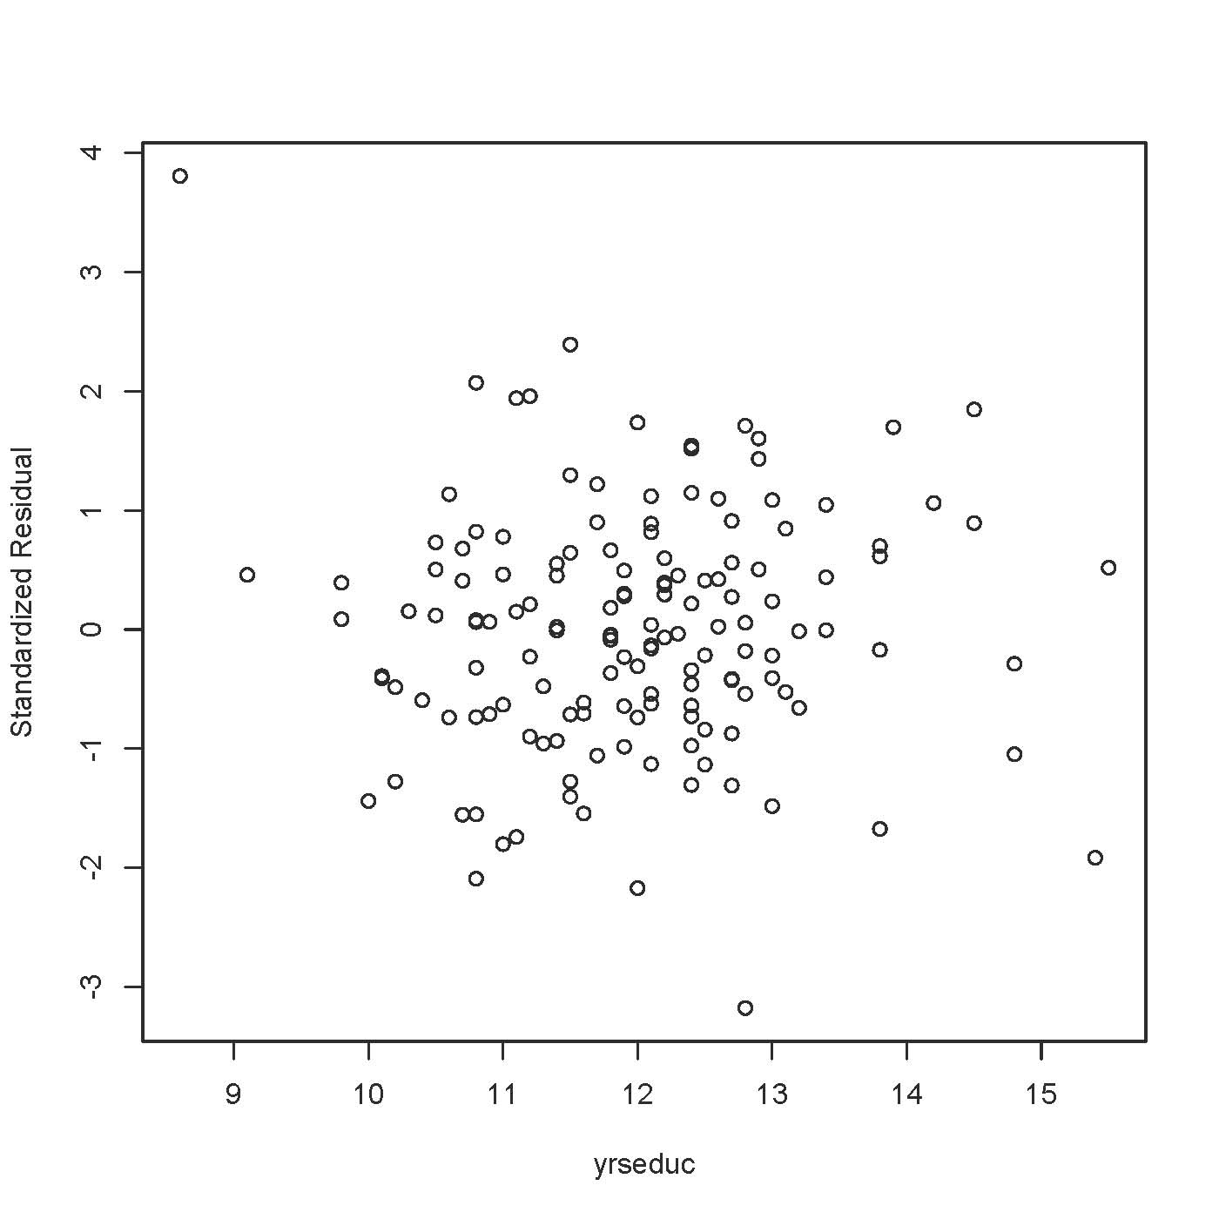

> plot(women,sr,ylab='Standardized Residual')

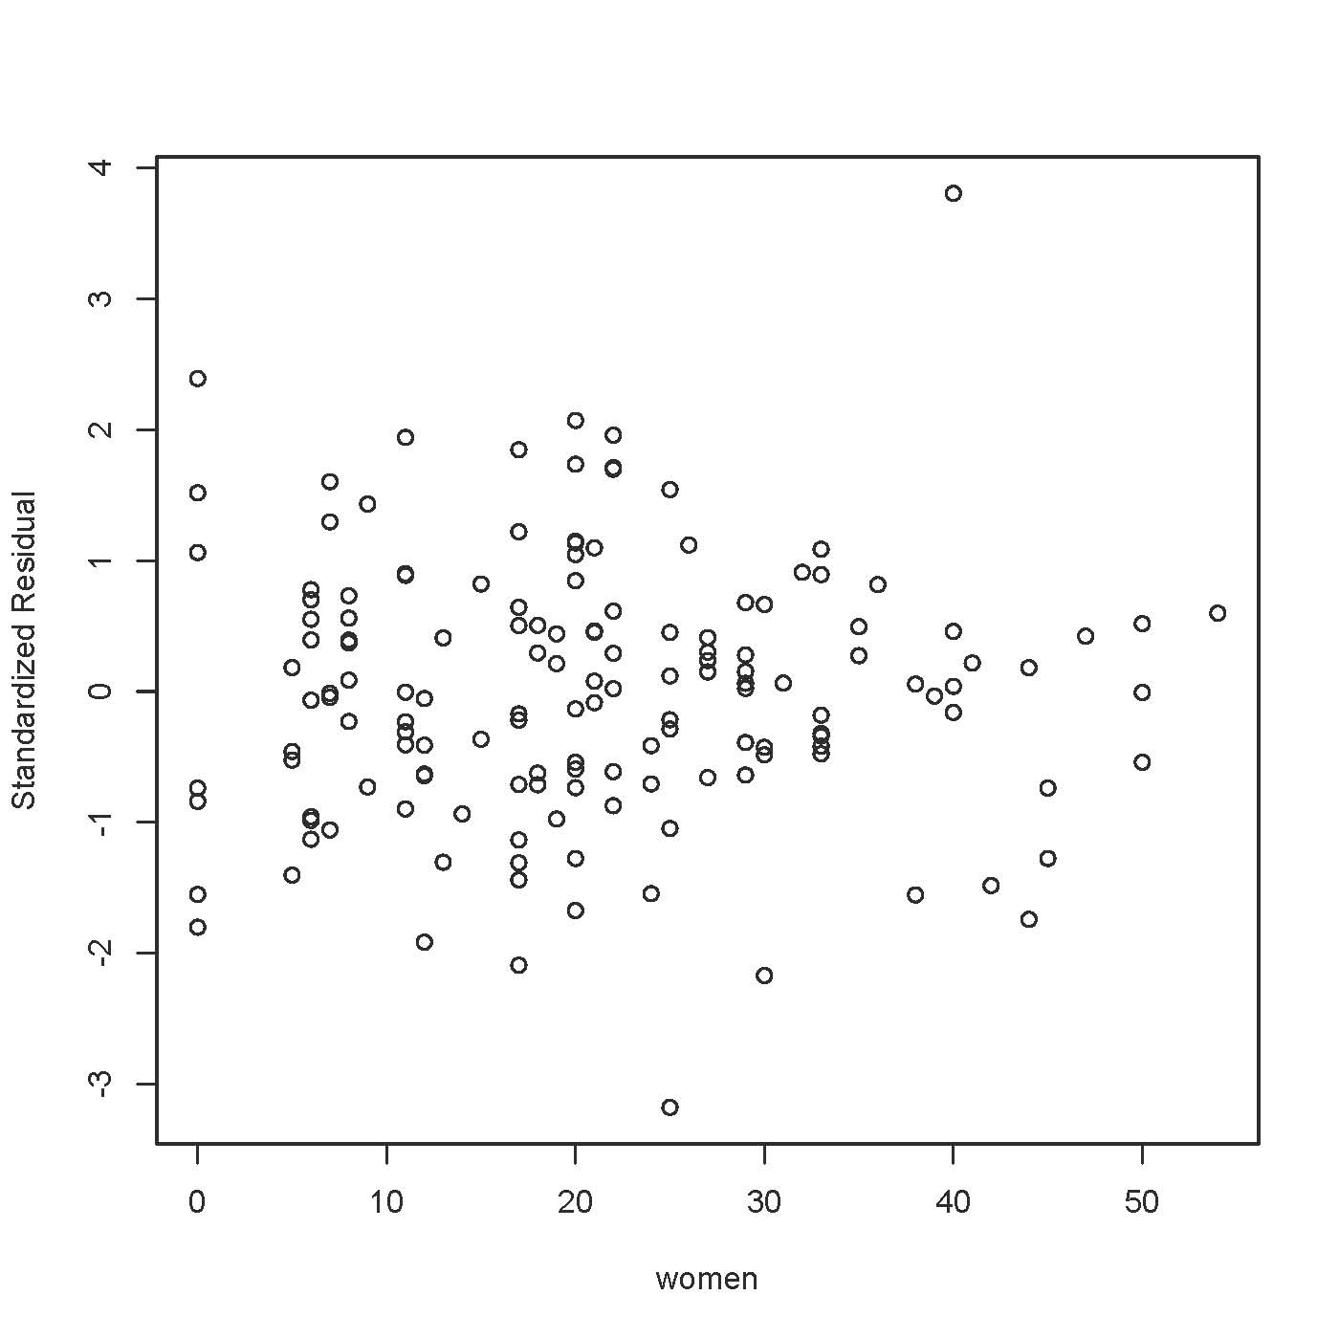

> plot(income,sr,ylab='Standardized Residual')
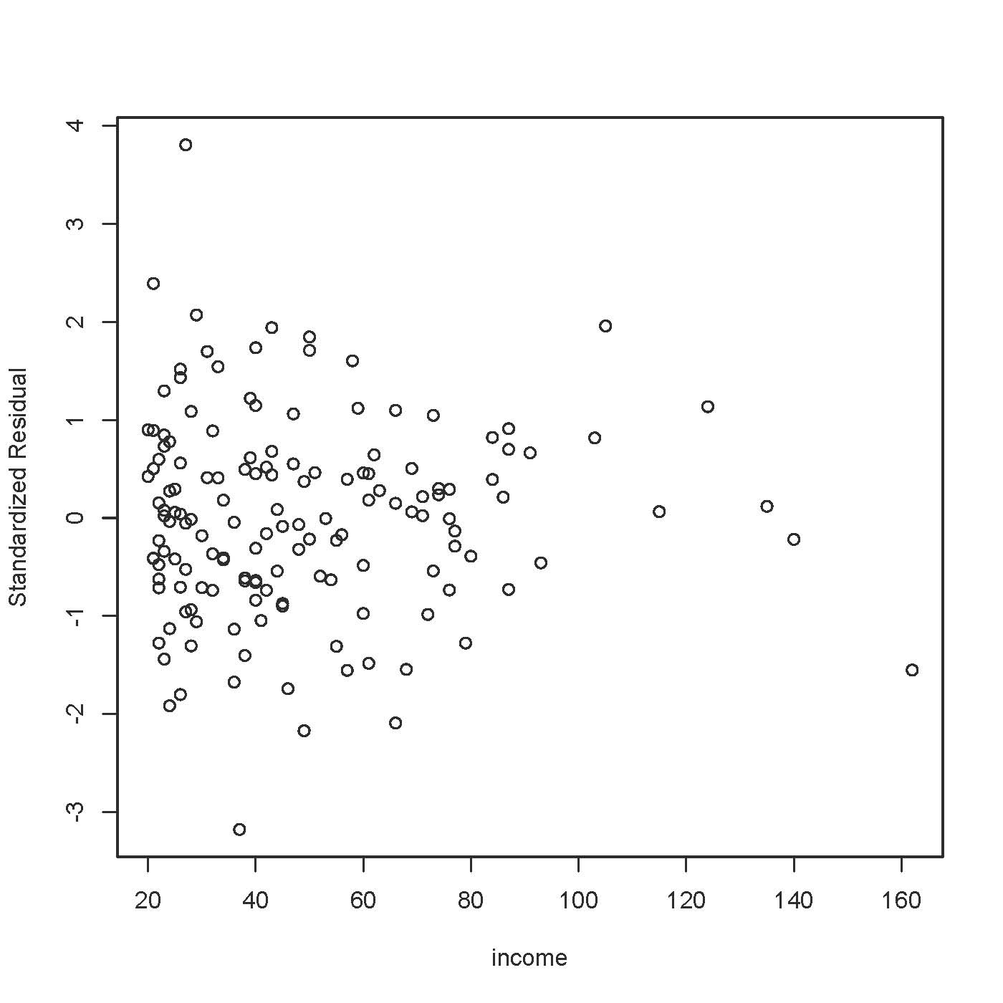

> # Plot standardized residuals against variable(s) NOT in the model
> plot(nsales,sr,ylab='Standardized Residual')

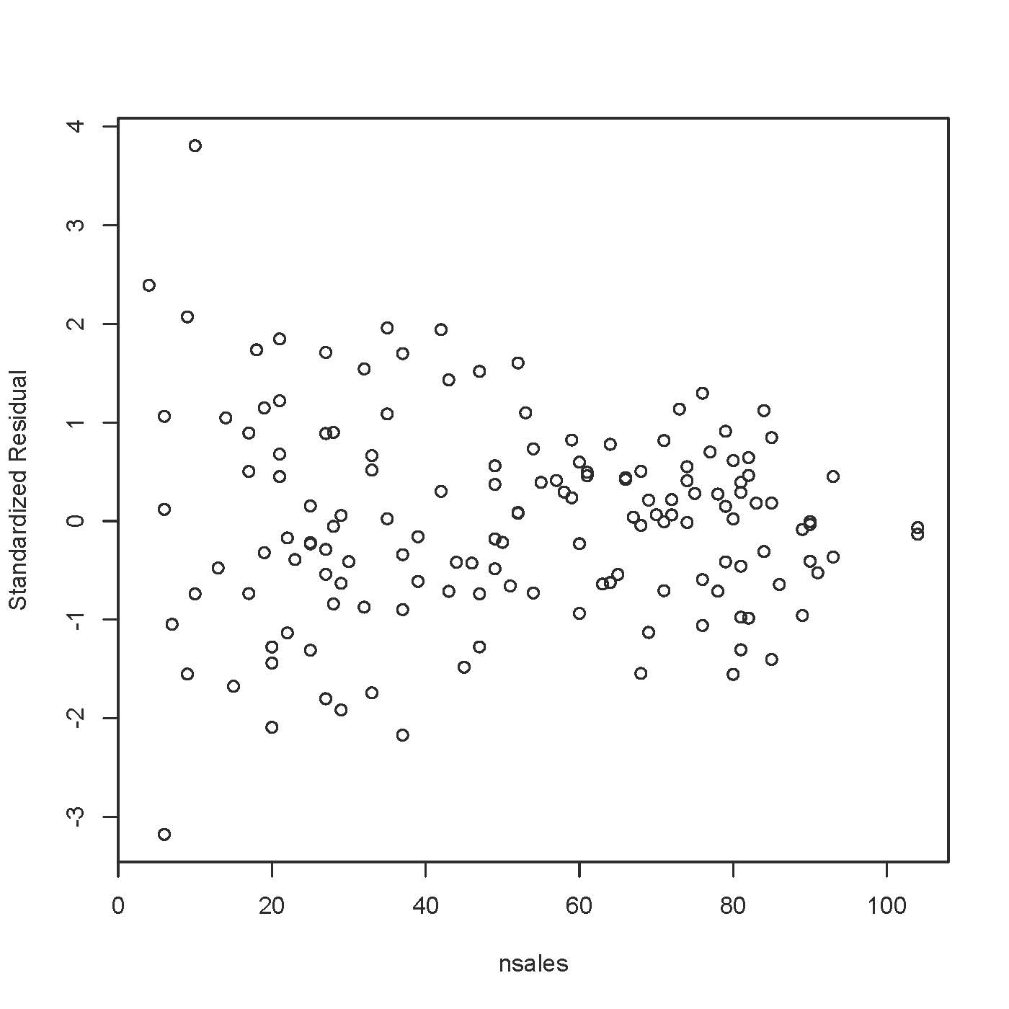
> # Likely non-constant variance, and it makes sense.
> # Var(x-bar) = sigma-squared/n

We need ways to deal with non-constant variance.

> help(lm)

weights | an optional vector of weights to be used in the fitting process. Should be NULL or a numeric vector. If non-NULL, weighted least squares is used with weights weights (that is, minimizing sum(w*e^2)); otherwise ordinary least squares is used. See also ‘Details’,

Non-NULL weights can be used to indicate that different observations have different variances (with the values in weights being inversely proportional to the variances); or equivalently, when the elements of weights are positive integers w_i, that each response y_i is the mean of w_i unit-weight observations (including the case that there are w_i observations equal to y_i and the data have been summarized).

> wmod = lm(avprice ~ salesforce + yrsexp + yrseduc + women + income, weights = nsales, data=carsales)
>
> summary(wmod)

Call:
lm(formula = avprice ~ salesforce + yrsexp + yrseduc + women +
income, data = carsales, weights = nsales)

Weighted Residuals:
Min 1Q Median 3Q Max
-1320.26 -408.78 5.58 390.12 1334.63

Coefficients:
Estimate Std. Error t value Pr(>|t|)
(Intercept) 5975.0290 90.4117 66.087 < 2e-16 ***
salesforce 1.7696 1.6318 1.084 0.280004
yrsexp 16.6338 4.6872 3.549 0.000523 ***
yrseduc -6.5467 6.6998 -0.977 0.330137
women 1.1456 0.5423 2.113 0.036357 *
income 1.0846 0.2741 3.957 0.000119 ***
---
Signif. codes: 0 ‘***’ 0.001 ‘**’ 0.01 ‘*’ 0.05 ‘.’ 0.1 ‘ ’ 1

Residual standard error: 575 on 144 degrees of freedom
Multiple R-squared: 0.1869, Adjusted R-squared: 0.1587
F-statistic: 6.621 on 5 and 144 DF, p-value: 1.407e-05

> wmodsres = rstandard(wmod)
> cars_sold = carsales$nsales ; plot(cars_sold,wmodsres)

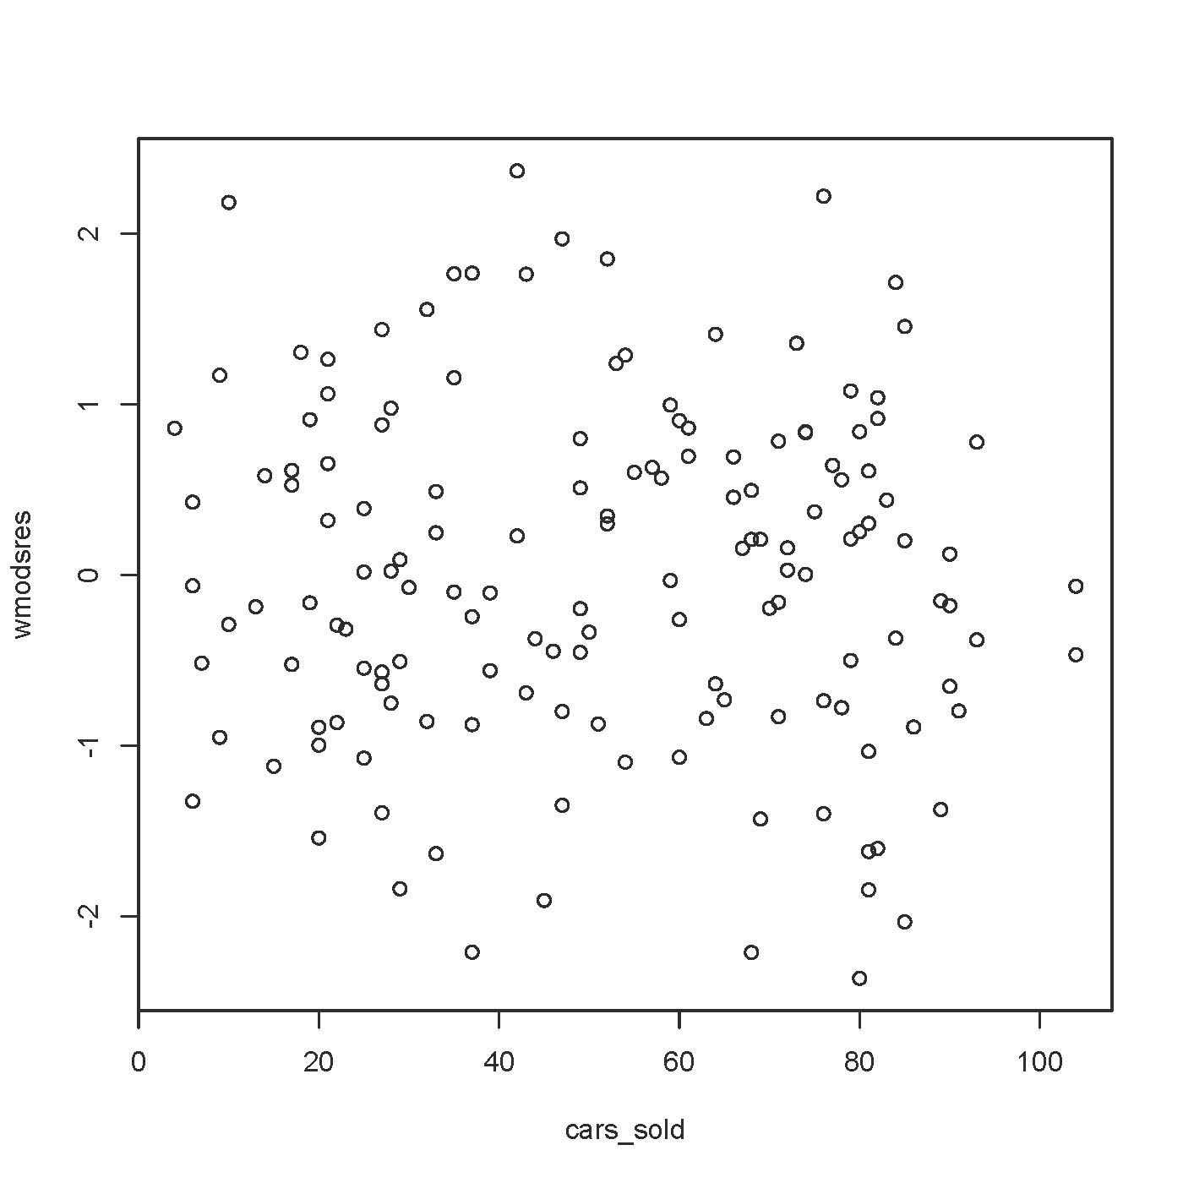

This document is licensed under a Creative Commons Attribution - ShareAlike 3.0 Unported License: http://creativecommons.org/licenses/by-sa/3.0/deed.en_US. Use any part of it as you like and share the result freely.

* Copyright information is on the last page.

