Proportional Hazards Regression with R: Part Two*

The kidney data set has data on the recurrence times to infection, at the point of insertion of the catheter, for kidney patients using portable dialysis equipment. Catheters may be removed for reasons other than infection, in which case the observation is censored.

> rm(list=ls()); # options(scipen=999)
> # install.packages("survival",dependencies=TRUE) # Only need to do this once
> library(survival) # Do this every time
>
> # help(kidney)
> head(kidney)
id time status age sex disease frail
1 1 8 1 28 1 Other 2.3
2 1 16 1 28 1 Other 2.3
3 2 23 1 48 2 GN 1.9
4 2 13 0 48 2 GN 1.9
5 3 22 1 32 1 Other 1.2
6 3 28 1 32 1 Other 1.2
> summary(kidney)

id time status age
Min. : 1.0 Min. : 2.0 Min. :0.0000 Min. :10.0
1st Qu.:10.0 1st Qu.: 16.0 1st Qu.:1.0000 1st Qu.:34.0
Median :19.5 Median : 39.5 Median :1.0000 Median :45.5
Mean :19.5 Mean :101.6 Mean :0.7632 Mean :43.7
3rd Qu.:29.0 3rd Qu.:149.8 3rd Qu.:1.0000 3rd Qu.:54.0
Max. :38.0 Max. :562.0 Max. :1.0000 Max. :69.0
sex disease frail
Min. :1.000 Other:26 Min. :0.200
1st Qu.:1.000 GN :18 1st Qu.:0.600
Median :2.000 AN :24 Median :1.100
Mean :1.737 PKD : 8 Mean :1.184
3rd Qu.:2.000 3rd Qu.:1.500
Max. :2.000 Max. :3.000
> dim(kidney)
[1] 76 7

> table(kidney$disease)

Other GN AN PKD
26 18 24 8

> contrasts(kidney$disease)
GN AN PKD
Other 0 0 0
GN 1 0 0
AN 0 1 0
PKD 0 0 1

> with(Kidney,cor(age,frail))
[1] 0.03876767

> # Make a new data frame with
> # 1=F, 0=M
> # age and frailty centered
>
> Kidney = within(kidney,{
+ sex = sex-1 # Indicator for female
+ # Centering age and frailty
+ age = age-mean(age)
+ frail = frail-mean(frail)
+ })
> with(Kidney,cor(age,frail))
[1] 0.03876767

> kmod1 = coxph( Surv(time,status) ~ age + sex + disease + frail, data=Kidney)
> summary(kmod1)
Call:
coxph(formula = Surv(time, status) ~ age + sex + disease + frail,
data = Kidney)

n= 76, number of events= 58

coef exp(coef) se(coef) z Pr(>|z|)
age 0.007714 1.007744 0.011907 0.648 0.517055
sex -2.099844 0.122475 0.392654 -5.348 8.90e-08 ***
diseaseGN 0.130666 1.139587 0.436114 0.300 0.764471
diseaseAN 0.640906 1.898200 0.447886 1.431 0.152442
diseasePKD -2.168515 0.114347 0.648825 -3.342 0.000831 ***
frail 1.791873 6.000682 0.257639 6.955 3.53e-12 ***
---
Signif. codes: 0 ‘***’ 0.001 ‘**’ 0.01 ‘*’ 0.05 ‘.’ 0.1 ‘ ’ 1

exp(coef) exp(-coef) lower .95 upper .95
age 1.0077 0.9923 0.98450 1.0315
sex 0.1225 8.1649 0.05673 0.2644
diseaseGN 1.1396 0.8775 0.48476 2.6790
diseaseAN 1.8982 0.5268 0.78904 4.5665
diseasePKD 0.1143 8.7453 0.03206 0.4079
frail 6.0007 0.1666 3.62158 9.9427

Concordance= 0.822 (se = 0.03 )
Likelihood ratio test= 68.71 on 6 df, p=8e-13
Wald test = 60.01 on 6 df, p=4e-11
Score (logrank) test = 86.24 on 6 df, p=<2e-16

> # Are se(coef) labelled correctly?
> se = sqrt(diag(vcov(kmod1))); se # Yes
age sex diseaseGN diseaseAN diseasePKD frail
0.01190684 0.39265430 0.43611383 0.44788559 0.64882505 0.25763894
>
> # CI for the hazard ratio exp(beta1)
> betahat = coef(kmod1); betahat
age sex diseaseGN diseaseAN diseasePKD frail
0.00771434 -2.09984449 0.13066624 0.64090624 -2.16851476 1.79187311
> CIbeta1 = c(betahat[1]-1.96*se[1], betahat[1]+1.96*se[1]); CIbeta1
age age
-0.01562307 0.03105175
> exp(CIbeta1)
age age
0.9844983 1.0315389
> # So summary is giving us confidence intervals for the hazard ratios,
> # not the coefficients.

> summary(kmod1)
Call:
coxph(formula = Surv(time, status) ~ age + sex + disease + frail,
data = Kidney)

n= 76, number of events= 58

coef exp(coef) se(coef) z Pr(>|z|)
age 0.007714 1.007744 0.011907 0.648 0.517055
sex -2.099844 0.122475 0.392654 -5.348 8.90e-08 ***
diseaseGN 0.130666 1.139587 0.436114 0.300 0.764471
diseaseAN 0.640906 1.898200 0.447886 1.431 0.152442
diseasePKD -2.168515 0.114347 0.648825 -3.342 0.000831 ***
frail 1.791873 6.000682 0.257639 6.955 3.53e-12 ***
---
Signif. codes: 0 ‘***’ 0.001 ‘**’ 0.01 ‘*’ 0.05 ‘.’ 0.1 ‘ ’ 1

exp(coef) exp(-coef) lower .95 upper .95
age 1.0077 0.9923 0.98450 1.0315
sex 0.1225 8.1649 0.05673 0.2644
diseaseGN 1.1396 0.8775 0.48476 2.6790
diseaseAN 1.8982 0.5268 0.78904 4.5665
diseasePKD 0.1143 8.7453 0.03206 0.4079
frail 6.0007 0.1666 3.62158 9.9427

Concordance= 0.822 (se = 0.03 )
Likelihood ratio test= 68.71 on 6 df, p=8e-13
Wald test = 60.01 on 6 df, p=4e-11
Score (logrank) test = 86.24 on 6 df, p=<2e-16

>
> # Estimated hazard of infection is ____ times as great for women as men.
> # Estimated hazard of infection is ____ times as great for disease type AN as it is for Other.
> # Estimated hazard of infection is ____ times as great for disease type AN as it is for disease type PKD.
> betahat = coef(kmod1); betahat
age sex diseaseGN diseaseAN diseasePKD frail
0.00771434 -2.09984449 0.13066624 0.64090624 -2.16851476 1.79187311

> exp(betahat[4]-betahat[5]) # Hazard ratio of AN/PKD
diseaseAN
16.6003

> # Test disease type with a partial likeihood ratio test
> k2 = coxph( Surv(time,status) ~ age + sex + frail, data=Kidney)
> anova(k2,kmod1)

Analysis of Deviance Table
Cox model: response is Surv(time, status)
Model 1: ~ age + sex + frail
Model 2: ~ age + sex + disease + frail
loglik Chisq Df Pr(>|Chi|)
1 -167.51
2 -153.55 27.93 3 3.756e-06 ***
---
Signif. codes: 0 ‘***’ 0.001 ‘**’ 0.01 ‘*’ 0.05 ‘.’ 0.1 ‘ ’ 1

> # Wald test: function(L,Tn,Vn,h=0) # H0: L theta = h
> Vn_hat = vcov(kmod1); betahat
age sex diseaseGN diseaseAN diseasePKD frail
0.00771434 -2.09984449 0.13066624 0.64090624 -2.16851476 1.79187311
> LL = rbind(c(0,0,1,0,0,0),
+ c(0,0,0,1,0,0),
+ c(0,0,0,0,1,0) )
> round( Wtest(LL,betahat,Vn_hat), 5)
W df p-value
20.67302 3.00000 0.00012

> # Comparing survival functions for males and females
> guy = data.frame(age=0, sex=0, disease="Other", frail=0) # An average guy
> gal = data.frame(age=0, sex=1, disease="Other", frail=0) # An average gal
> sexcomp = rbind(guy,gal); sexcomp

age sex disease frail
1 0 0 Other 0
2 0 1 Other 0

> rownames(sexcomp) = c("M","F"); sexcomp
age sex disease frail
M 0 0 Other 0
F 0 1 Other 0
>
> s1 = survfit(kmod1,newdata=sexcomp)
> s1
Call: survfit(formula = kmod1, newdata = sexcomp)

n events median 0.95LCL 0.95UCL
M 76 58 26 22 NA
F 76 58 141 96 245

> s1 = survfit(kmod1,newdata=sexcomp)
> s1
Call: survfit(formula = kmod1, newdata = sexcomp)

n events median 0.95LCL 0.95UCL
M 76 58 26 22 NA
F 76 58 141 96 245

> ls(s1)
[1] "call" "conf.int" "conf.type" "cumhaz" "logse" "lower"
[7] "n" "n.censor" "n.event" "n.risk" "std.chaz" "std.err"
[13] "surv" "time" "upper"

> summary(s1)
Call: survfit(formula = kmod1, newdata = sexcomp)

time n.risk n.event survival1 survival2
2 76 1 9.90e-01 9.99e-01
7 71 2 9.68e-01 9.96e-01
8 69 2 9.39e-01 9.92e-01
9 65 1 9.23e-01 9.90e-01
12 64 2 8.58e-01 9.81e-01
13 62 1 8.26e-01 9.77e-01
15 60 2 7.61e-01 9.67e-01

185 13 1 9.45e-06 2.42e-01
190 12 1 2.15e-06 2.02e-01
196 11 1 4.26e-07 1.66e-01
201 10 1 5.72e-08 1.30e-01
245 9 1 5.35e-09 9.70e-02
292 8 1 2.74e-10 6.74e-02
318 7 1 7.23e-12 4.32e-02
333 6 1 1.17e-13 2.61e-02
402 5 1 2.30e-16 1.22e-02
447 4 1 6.26e-20 4.45e-03
511 3 1 8.53e-25 1.13e-03
536 2 1 1.53e-34 7.22e-05
562 1 1 3.86e-56 1.63e-07
>
> head(s1$cumhaz)
[,1] [,2]
[1,] 0.009766264 0.001196128
[2,] 0.009766264 0.001196128
[3,] 0.009766264 0.001196128
[4,] 0.009766264 0.001196128
[5,] 0.032125563 0.003934594
[6,] 0.062982652 0.007713830

>
> head(s1$surv)
M F
[1,] 0.9902813 0.9988046
[2,] 0.9902813 0.9988046
[3,] 0.9902813 0.9988046
[4,] 0.9902813 0.9988046
[5,] 0.9683850 0.9960731
[6,] 0.9389598 0.9923158

> ls(s1)
[1] "call" "conf.int" "conf.type" "cumhaz" "logse" "lower"
[7] "n" "n.censor" "n.event" "n.risk" "std.chaz" "std.err"
[13] "surv" "time" "upper"

> S = s1$surv[1:10,1] # Col 1 is males
> H = s1$cumhaz[1:10,1]
> Q = exp(-H) # Question: Is this the survival function?
> cbind(H,S,Q)
H S Q
[1,] 0.009766264 0.9902813 0.9902813
[2,] 0.009766264 0.9902813 0.9902813
[3,] 0.009766264 0.9902813 0.9902813
[4,] 0.009766264 0.9902813 0.9902813
[5,] 0.032125563 0.9683850 0.9683850
[6,] 0.062982652 0.9389598 0.9389598
[7,] 0.079866525 0.9232396 0.9232396
[8,] 0.152667391 0.8584152 0.8584152
[9,] 0.191322662 0.8258661 0.8258661
[10,] 0.272747550 0.7612849 0.7612849
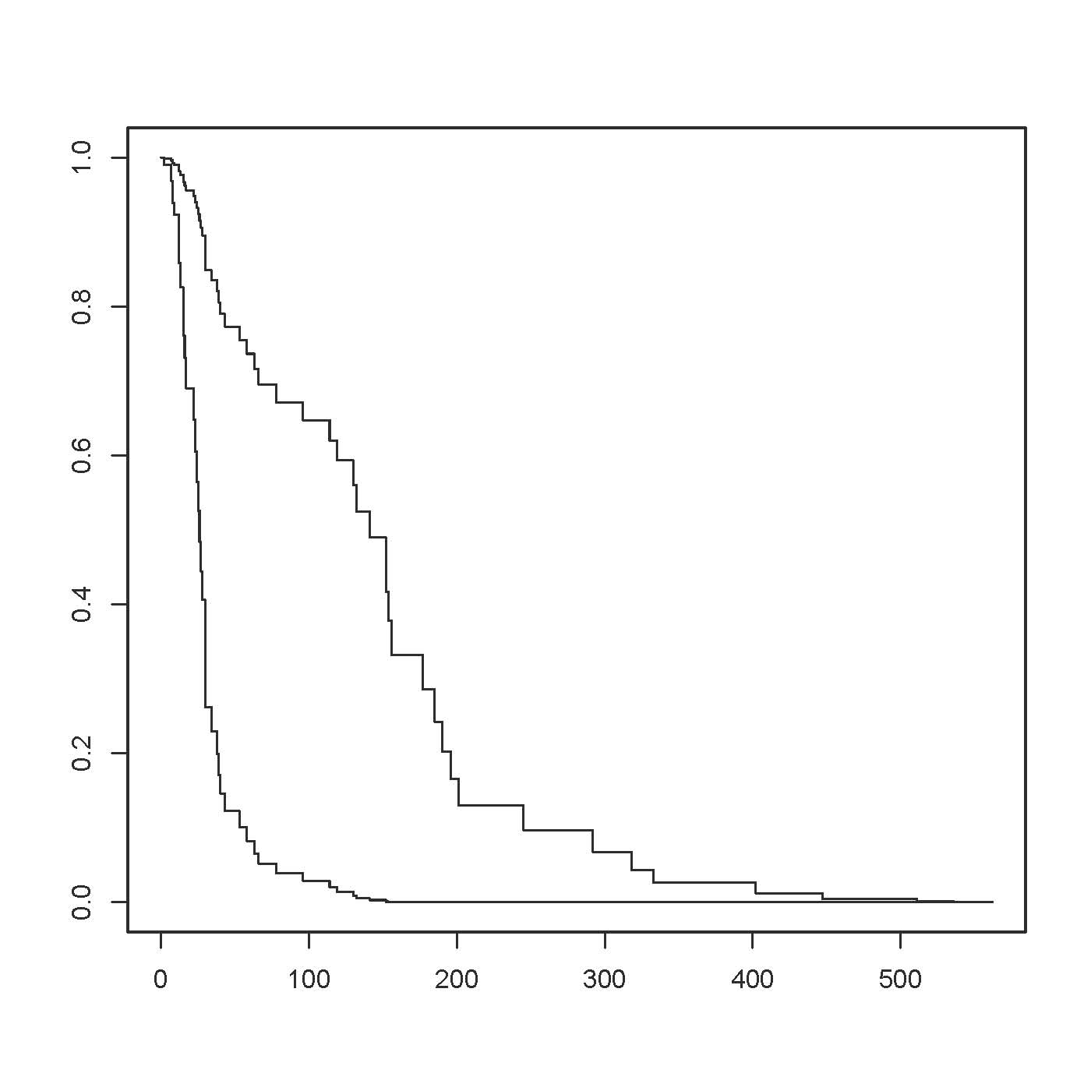
> plot(s1)

> # Try to locate the medians
> xx = c(0,400); yy = c(.5,0.5)
> lines(xx,yy,col="red")

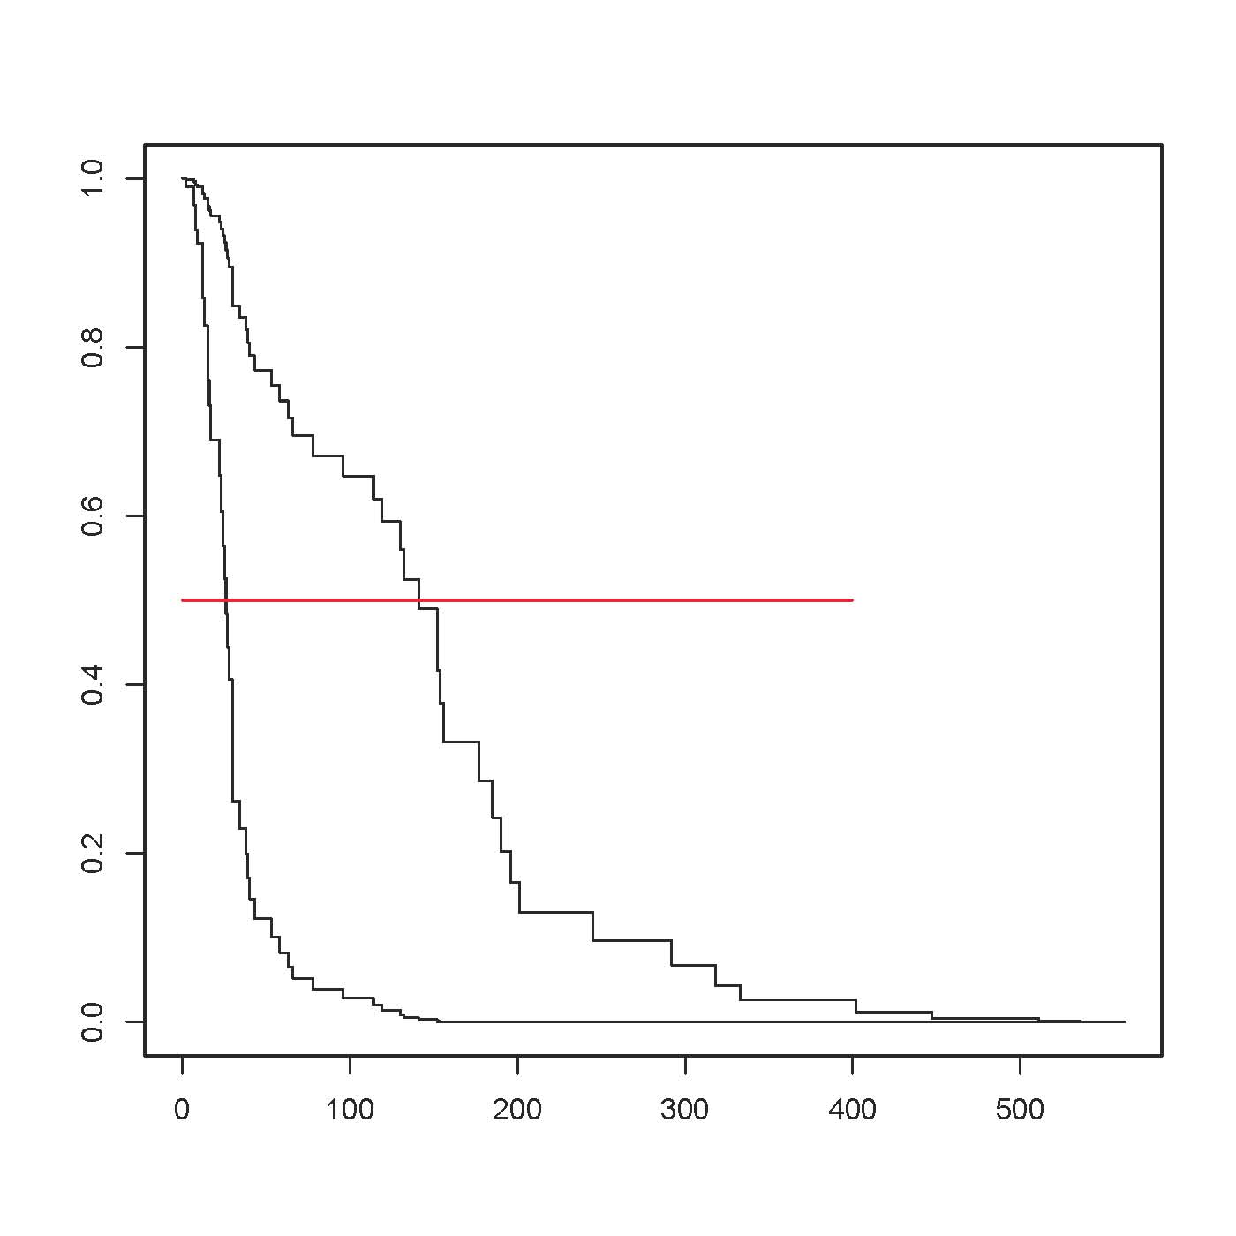

> # Median for M = 26, F = 141 ?

> # Median for M = 26, F = 141 ?
> xm = c(26,26); ym = c(0,1); lines(xm,ym,col="red")
> xf = c(141,141); yf = c(0,1); lines(xf,yf,col="blue")

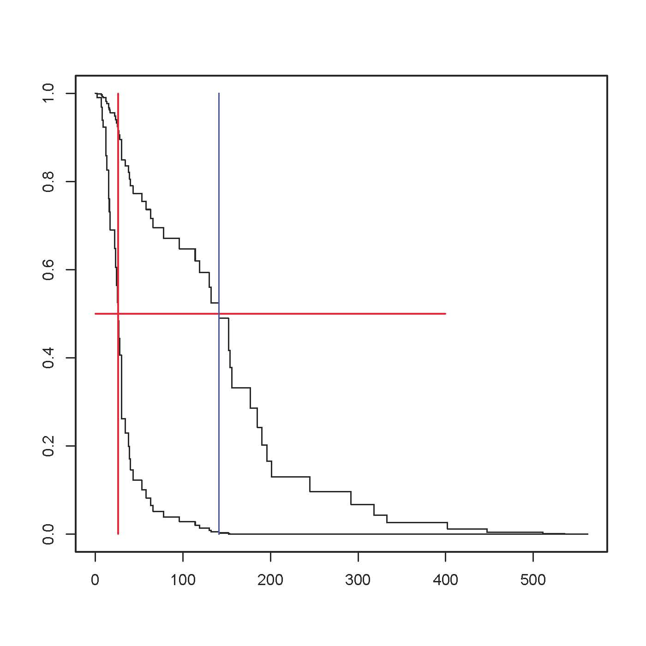

> # How about a nicer plot?
> plot(s1,lty = c(1,2),xlab="Days", ylab="Probability")
> title('Estimated "Survival" Probabilities for the Catheter')
>
> xm = c(350,450); ym = c(0.9,0.9); lines(xm,ym,lty=1)
> text(500,0.9,"Males ")
>
> xf = c(350,450); yf = c(0.8,0.8); lines(xf,yf,lty=2)
> text(500,0.8,"Females")

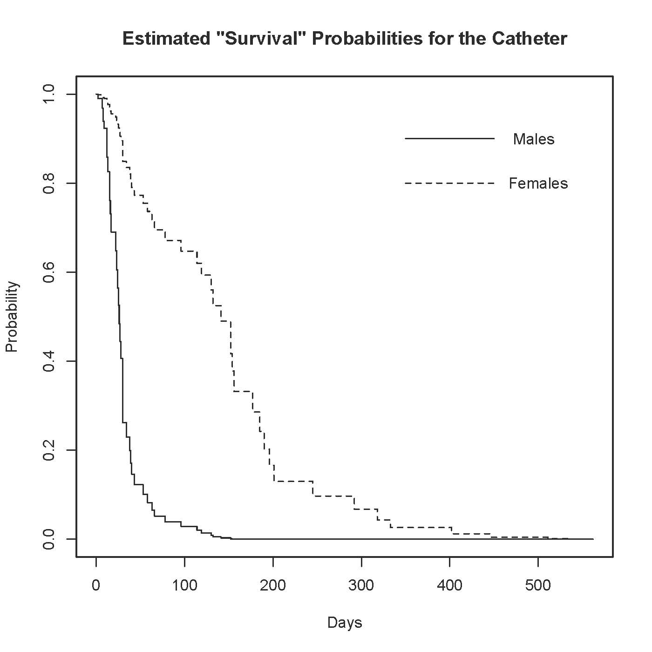

> # Compare disease types, just for women
> table(Kidney$disease)

Other GN AN PKD
26 18 24 8
>
> Other = data.frame(age=0, sex=1, disease="Other", frail=0)
> GN = data.frame(age=0, sex=1, disease="GN", frail=0)
> AN = data.frame(age=0, sex=1, disease="AN", frail=0)
> PKD = data.frame(age=0, sex=1, disease="PKD", frail=0)
> discomp = rbind(Other, GN, AN, PKD)
> rownames(discomp) = c("Other", "GN", "AN", "PKD")
> s2 = survfit(kmod1,newdata=discomp); s2
Call: survfit(formula = kmod1, newdata = discomp)

n events median 0.95LCL 0.95UCL
Other 76 58 141 96 245
GN 76 58 132 66 318
AN 76 58 78 40 177
PKD 76 58 511 318 NA
>
> summary(kmod1)
Call:
coxph(formula = Surv(time, status) ~ age + sex + disease + frail,
data = Kidney)

n= 76, number of events= 58

coef exp(coef) se(coef) z Pr(>|z|)
age 0.007714 1.007744 0.011907 0.648 0.517055
sex -2.099844 0.122475 0.392654 -5.348 8.90e-08 ***
diseaseGN 0.130666 1.139587 0.436114 0.300 0.764471
diseaseAN 0.640906 1.898200 0.447886 1.431 0.152442
diseasePKD -2.168515 0.114347 0.648825 -3.342 0.000831 ***
frail 1.791873 6.000682 0.257639 6.955 3.53e-12 ***
---
Signif. codes: 0 ‘***’ 0.001 ‘**’ 0.01 ‘*’ 0.05 ‘.’ 0.1 ‘ ’ 1

exp(coef) exp(-coef) lower .95 upper .95
age 1.0077 0.9923 0.98450 1.0315
sex 0.1225 8.1649 0.05673 0.2644
diseaseGN 1.1396 0.8775 0.48476 2.6790
diseaseAN 1.8982 0.5268 0.78904 4.5665
diseasePKD 0.1143 8.7453 0.03206 0.4079
frail 6.0007 0.1666 3.62158 9.9427

Concordance= 0.822 (se = 0.03 )
Likelihood ratio test= 68.71 on 6 df, p=8e-13
Wald test = 60.01 on 6 df, p=4e-11
Score (logrank) test = 86.24 on 6 df, p=<2e-16

>
> # Catheters for patients with PKD stay in longest.
> # How about some pairwise comparisons?
>

> s2
Call: survfit(formula = kmod1, newdata = discomp)

n events median 0.95LCL 0.95UCL
Other 76 58 141 96 245
GN 76 58 132 66 318
AN 76 58 78 40 177
PKD 76 58 511 318 NA

> plot(s2,lty = 1:4,xlab="Days", ylab="Probability")
> title('Estimated "Survival" Probabilities by Disease Type')

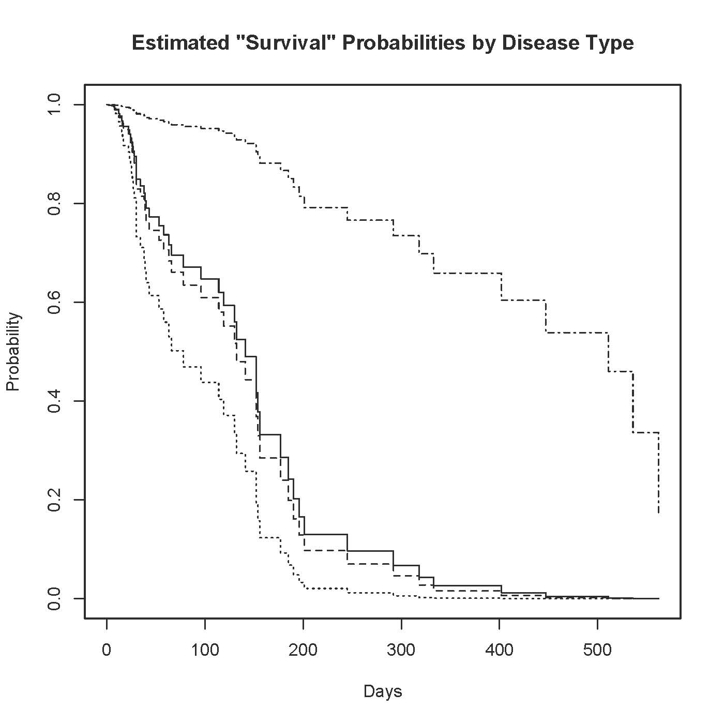

--------------------------------------------------------------------------------

This document was prepared by Jerry Brunner, University of Toronto. It is licensed under a Creative Commons Attribution - ShareAlike 3.0 Unported License: http://creativecommons.org/licenses/by-sa/3.0/deed.en_US. Use any part of it as you like and share the result freely. It is available in OpenOffice.org format from the course website:
http://www.utstat.toronto.edu/~brunner/oldclass/312f23

* Copyright information is on the last page.

