Maximum Likelihood for Censored Data with R*

> rm(list=ls()); options(scipen=999)
> wdata = read.table("http://www.utstat.utoronto.ca/~brunner/data/legal/Weibull.data2.txt")
> dim(wdata)
[1] 275 2
> head(wdata)
Time Uncensored
1 1.60 0
2 0.60 0
3 3.03 1
4 2.90 0
5 3.60 1
6 2.76 1
> summary(wdata)
Time Uncensored
Min. :0.010 Min. :0.0000
1st Qu.:1.680 1st Qu.:0.0000
Median :3.200 Median :1.0000
Mean :3.257 Mean :0.5236
3rd Qu.:4.675 3rd Qu.:1.0000
Max. :8.230 Max. :1.0000
> Time = wdata$Time; Uncensored = wdata$Uncensored # Avoiding the attach() function
>
> # Find MLE numerically

>
> mloglike = function(theta,t,delta)
+ { # Minus log likelihood function
+ alpha = theta[1]; lambda = theta[2]
+ # logf and logS will be of length n
+ logf = log(alpha)+log(lambda)+(alpha-1)*log(lambda*t) + -(lambda*t)^alpha
+ logS = -(lambda*t)^alpha
+ value = -sum(logf*delta) - sum(logS*(1-delta))
+ return(value)
+ } # End of function mloglike
>
> # Testing
> mloglike(c(3,0.2),t=Time,delta=Uncensored)
[1] 321.3091
>
> yes = Time[Uncensored==1]; no = Time[Uncensored==0]
> -sum(dweibull(yes,shape=3, scale=5,log=TRUE)) - sum(pweibull(no, shape=3, scale=5, lower.tail = FALSE, log.p = TRUE))
[1] 321.3091
>
>
>
> ################################################################################
> # Find MLE
> ################################################################################
>
> startvals = c(1,1/2) # I tried a few values
>
> search1 = optim(par=startvals, fn=mloglike, t=Time,delta=Uncensored,
+ hessian=TRUE, lower=c(0,0), method='L-BFGS-B')

> search1
$par
[1] 2.8417618 0.1968182

$value
[1] 320.7533

$counts
function gradient
14 14

$convergence
[1] 0

$message
[1] "CONVERGENCE: REL_REDUCTION_OF_F <= FACTR*EPSMCH"

$hessian
[,1] [,2]
[1,] 30.99060 1.94865
[2,] 1.94865 30020.31664

>
> # If both eigenvalues of the Hessian are positive, minus LL is concave up.
> H = search1$hessian
> eigen(H)$values
[1] 30020.31677 30.99047
>
> alphahat = search1$par[1]; lambdahat = search1$par[2]
>
> # These data were simulated, so I know the true parameter values.
> truealpha = 3; truelambda = 1/5
> # Compare:
> c(alphahat,truealpha)
[1] 2.841762 3.000000
> c(lambdahat,truelambda)
[1] 0.1968182 0.2000000

>
> ################################################################################
> # Calculate the estimated asymptotic covariance matrix of the MLEs.
> ################################################################################
>
> Vhat = solve(H); Vhat # Solve returns the inverse.
[,1] [,2]
[1,] 0.032267982000 -0.000002094548
[2,] -0.000002094548 0.000033310911
>
> ################################################################################
> # Point estimate and confidence interval for the median
> # Median = log(2)^(1/alpha) / lambda
> ################################################################################
>
> # Point estimate of median
> medhat = 1/lambdahat * log(2)^(1/alphahat); medhat
[1] 4.466034
> # Compare the truth
> truemedian = log(2)^(1/truealpha) / truelambda; truemedian
[1] 4.424985
>
> median(Time) # Sample median is way off, because it ignores censoring
[1] 3.2
>

> # Confidence interval for median
> # Need gdot
> # D[b^(1/a),a] works in Wolfram Alpha, as a check on hand calculation.
>
> gdot = cbind( - log(2)^(1/alphahat)*log(log(2))/(lambdahat*alphahat^2),
+ - log(2)^(1/alphahat)/lambdahat^2 )
> v_medhat = as.numeric( gdot %*% Vhat %*% t(gdot) ); se_medhat = sqrt(v_medhat)
> lower95 = medhat - 1.96*se_medhat; upper95 = medhat + 1.96*se_medhat
> c(lower95,upper95)
[1] 4.199471 4.732597
>
> ################################################################################
> # Plot hazard function h(t) = alpha*lambda^alpha * t^(alpha-1)
> ################################################################################
>
> x = seq(from=0,to=5,length=101)
> esthazard = alphahat*lambdahat^alphahat * x^(alphahat-1)
> truehazard = truealpha*truelambda^truealpha * x^(truealpha-1)
>
> plot(x,truehazard,type='l',xlab='Time',ylab='Hazard',
+ main='Hazard Function for the Weibull Data')
> lines(x,esthazard,lty=2)
> # Annotate the plot (Make the legend)
> x1 = c(0.5,1.5); y1 = c(0.5,0.5)
> lines(x1,y1,lty=1)
> text(2,0.5,'True h(t)')
> x2 = c(0.5,1.5); y2 = c(0.45,0.45)
> lines(x2,y2,lty=2)
> text(2.2,0.45,'Estimated h(t)')

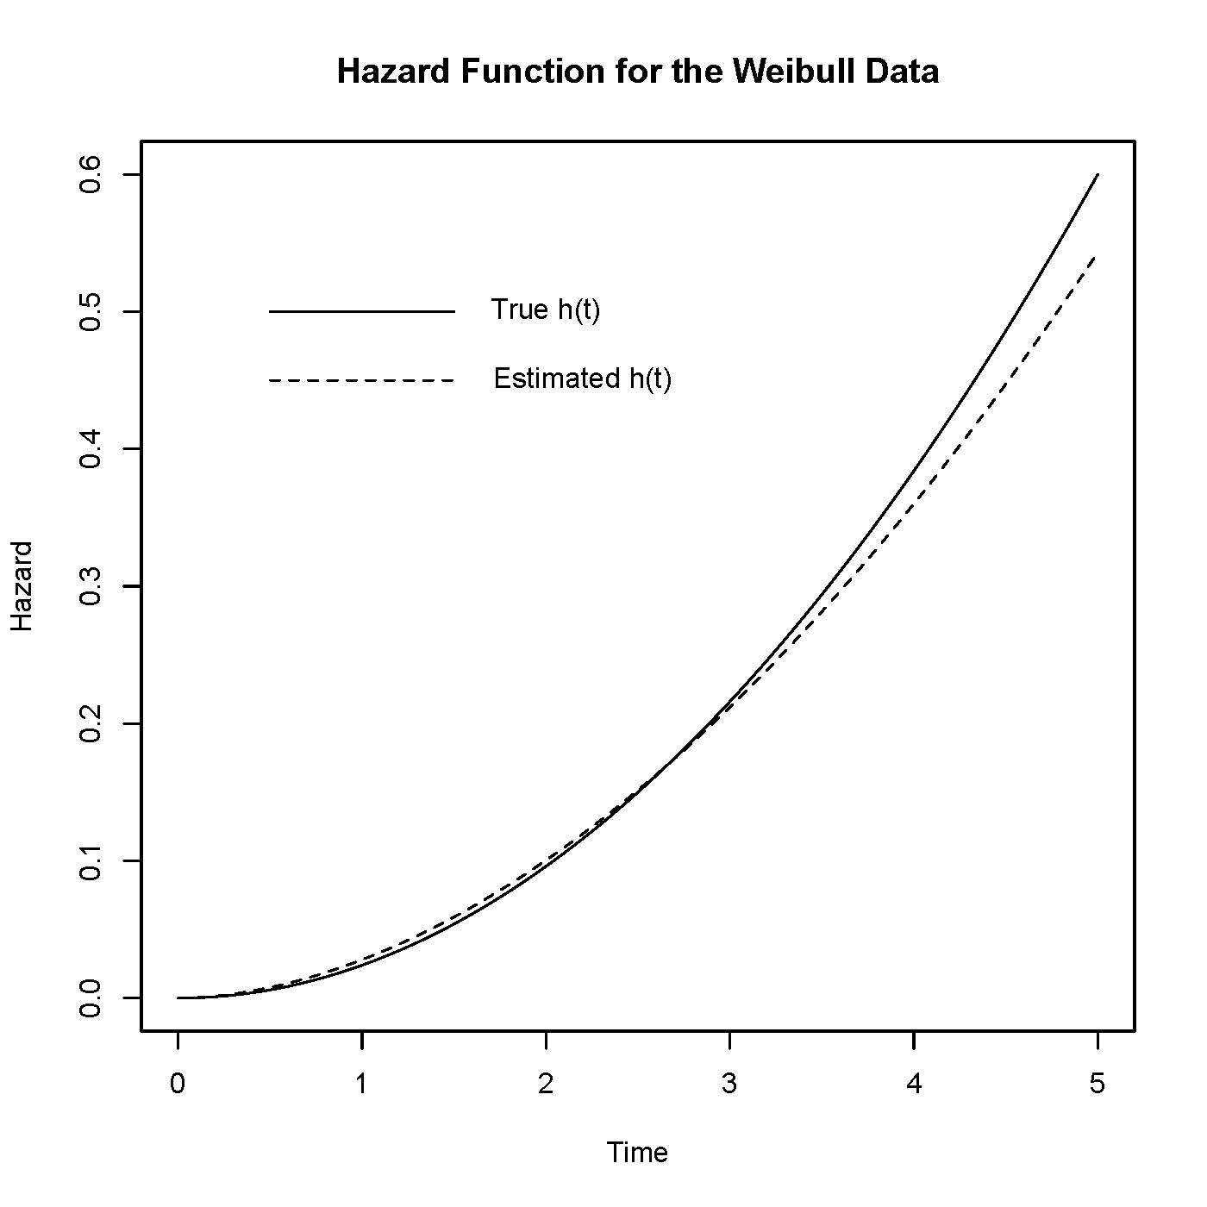

> # What if the (Weibull) model is wrong? Try bowl shaped hazard.
> t = seq(from=0,to=10,length=101)
> Density = exp(-8/3)* (t-2)^2 * exp(-(t-2)^3/3)
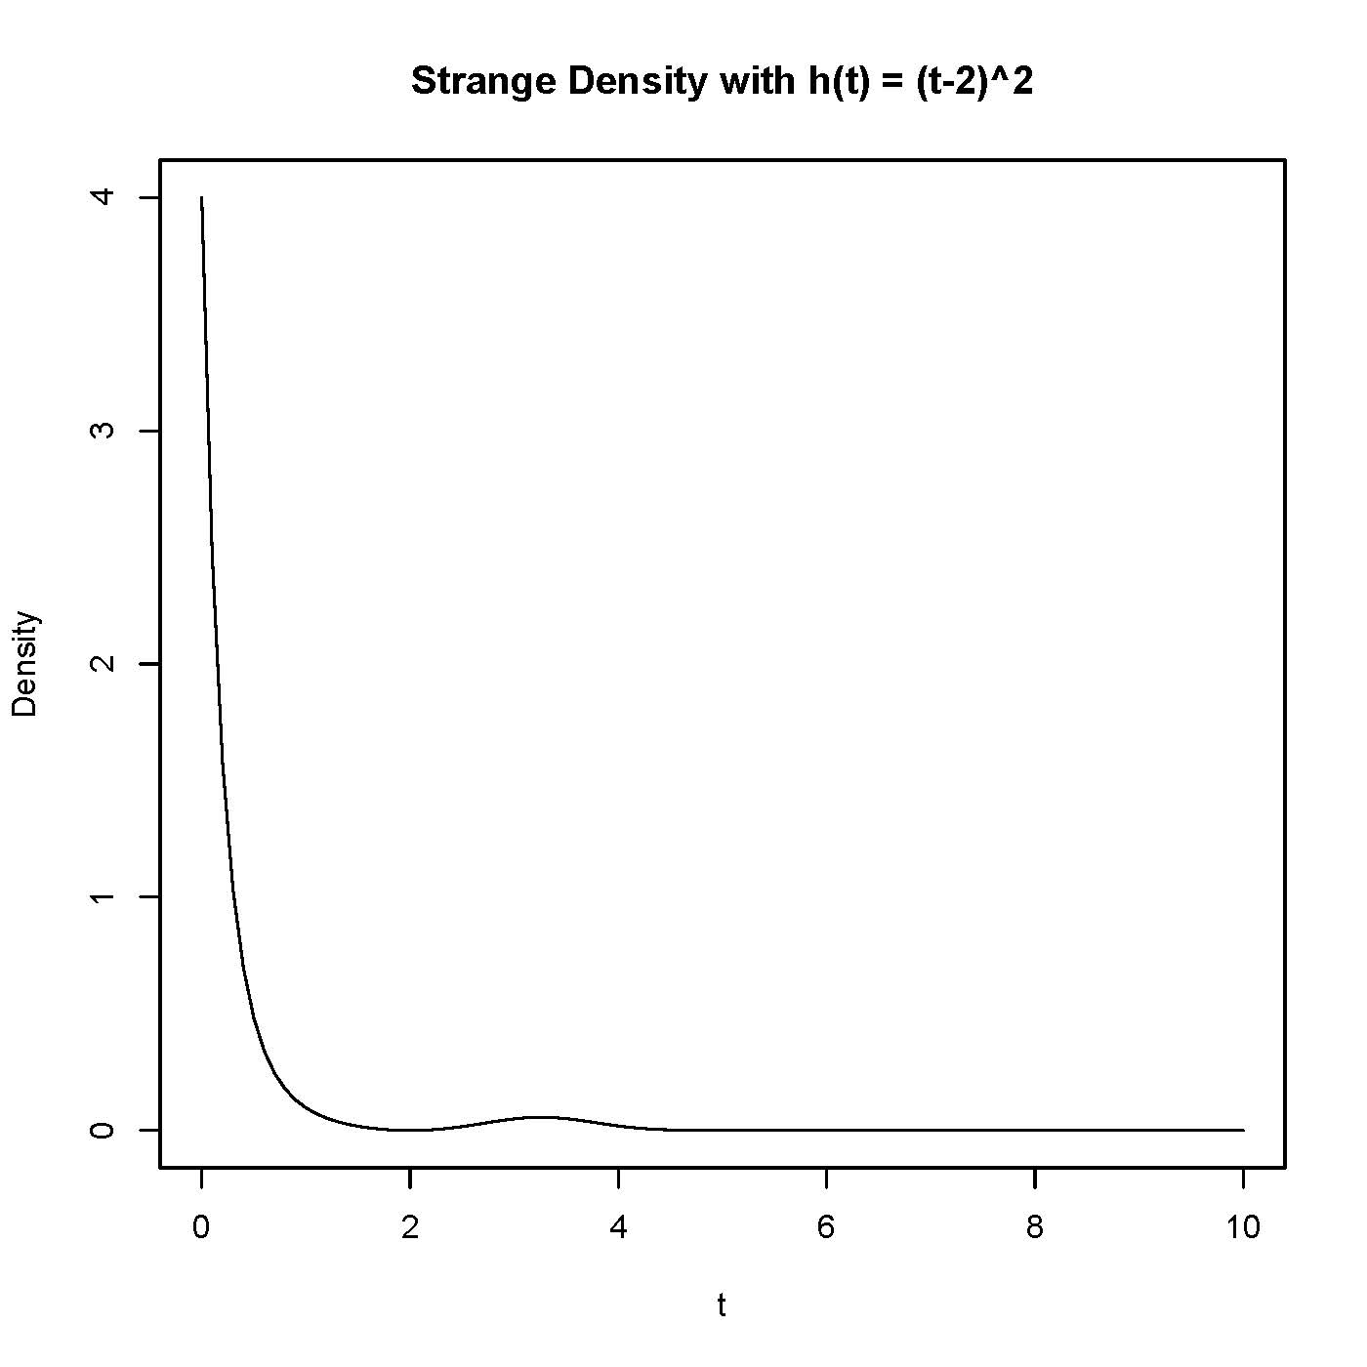
> plot(t,Density,type='l',main='Strange Density with h(t) = (t-2)^2')
> bowldat = read.table("http://www.utstat.toronto.edu/brunner/data/legal/bowlhaz.data.txt")
> head(bowldat); summary(bowldat)

Time Uncensored
1 0.72275893 1
2 0.12004774 0
3 0.53171197 1
4 0.05997346 1
5 0.35008144 1
6 0.65936362 1
Time Uncensored
Min. :0.000144 Min. :0.000
1st Qu.:0.062032 1st Qu.:1.000
Median :0.158124 Median :1.000
Mean :0.352768 Mean :0.862
3rd Qu.:0.376218 3rd Qu.:1.000
Max. :3.722165 Max. :1.000

> Time = bowldat$Time; Uncensored = bowldat$Uncensored # Writing over earlier vars
> # Weibull minus log likelihood again
> mloglike = function(theta,t,delta)
+ { # Minus log likelihood function for Weibull
+ alpha = theta[1]; lambda = theta[2]
+ # logf and logS will be of length n
+ logf = log(alpha)+log(lambda)+(alpha-1)*log(lambda*t) + -(lambda*t)^alpha
+ logS = -(lambda*t)^alpha
+ value = -sum(logf*delta) - sum(logS*(1-delta))
+ return(value)
+ } # End of function mloglike
>
> ################################################################################
> # Find MLE
> ################################################################################
>
> startvals = c(1,1/2)
> search = optim(par=startvals, fn=mloglike, t=Time,delta=Uncensored,
+ hessian=TRUE, lower=c(0,0), method='L-BFGS-B')
> search
$par
[1] 0.699065 2.914821

$value
[1] -13.33825

$counts
function gradient
13 13

$convergence
[1] 0

$message
[1] "CONVERGENCE: REL_REDUCTION_OF_F <= FACTR*EPSMCH"

$hessian
[,1] [,2]
[1,] 1586.58497 38.24125
[2,] 38.24125 24.79069

>
> alphahat = search$par[1]; lambdahat = search$par[2]
>
> ################################################################################
> # Plot hazard function h(t) = alpha*lambda^alpha * t^(alpha-1)
> ################################################################################
>
> x = seq(from=0,to=5,length=101)
> esthazard = alphahat*lambdahat^alphahat * x^(alphahat-1)
> truehazard = (x-2)^2
>
> plot(x,truehazard,type='l',xlab='Time',ylab='Hazard', main='Hazard Function for the Bowl Data')
> lines(x,esthazard,lty=2)
> # Annotate the plot (Make the legend)
> x1 = c(0.5,1.5); y1 = c(7,7)
> lines(x1,y1,lty=1)
> text(2,7,'True h(t)')
> x2 = c(0.5,1.5); y2 = c(6,6)
> lines(x2,y2,lty=2)
> text(2.2,6,'Estimated h(t)')

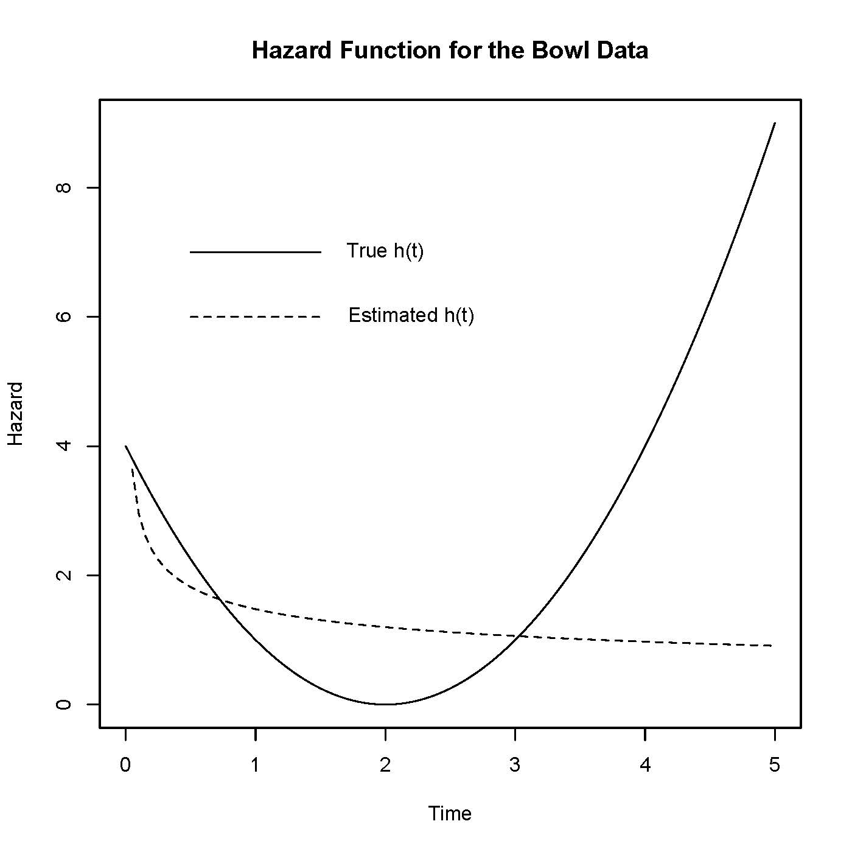
> # This is bad, but the worst part is outside the range of the data: Max = 3.72
> # 75th percentile is 0.38
> # From HW4, S(t) = exp(-1/3 ((t-2)^3 + 8)
> # At t=2, where hazard starts increasing,
> exp(-8/3)
[1] 0.06948345
> # So for 93% of the distribution, the hazard function is decreasing.
> # Try estimating the survival function
> x = seq(from=0,to=5,length=101)
> Shat = exp(-(lambdahat*x)^alphahat)
> trueS = exp( -1/3*((x-2)^3 + 8) )
> tstring = 'Survival Function for the Bowl Data'
> plot(x,trueS,type='l',xlab='Time',ylab='Survival',ylim=c(0,1), main=tstring)
> lines(x,Shat,lty=2)
> # Annotate the plot (Make the legend)
> x1 = c(2.5,3.5); y1 = c(0.8,0.8)
> lines(x1,y1,lty=1)
> text(4,0.8,'True S(t)')
> x2 = x1; y2 = c(0.7,0.7)
> lines(x2,y2,lty=2)
> text(4.2,0.7,'Estimated S(t)')

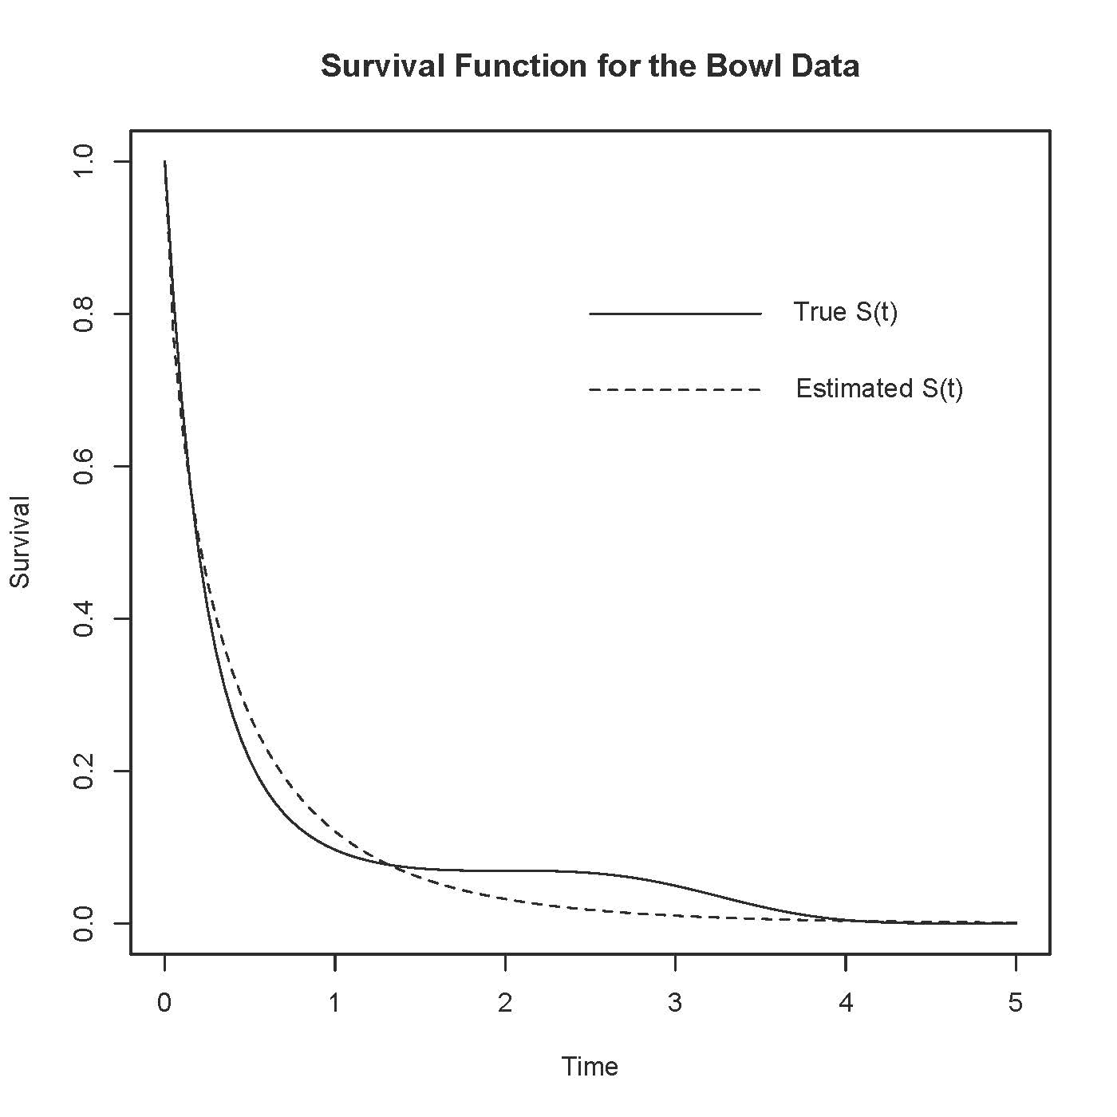

This document was prepared by Jerry Brunner, University of Toronto. It is licensed under a Creative Commons Attribution - ShareAlike 3.0 Unported License: http://creativecommons.org/licenses/by-sa/3.0/deed.en_US. Use any part of it as you like and share the result freely. It is available in OpenOffice.org format from the course website: http://www.utstat.toronto.edu/brunner/oldclass/312f23

* This document is free and open source. See last page for copyright information.

