Repeated measures on the recursion data

> rm(list=ls()); options(scipen=999) # To avoid scientific notation
> rec1 = read.table("recursion-horizontal.data.txt",header=T)
> head(rec1)
Participant AgeinMonths Group AgeGroups KABC_Concept KABC_Face KABC_Tri
1 1 48.5 Child 4yos 7 13 13
2 2 63.9 Child 5yos 19 12 16
3 4 64.2 Child 5yos 11 8 18
4 5 71.6 Child 5yos 14 11 24
5 6 53.1 Child 4yos 14 5 13
6 7 55.5 Child 4yos 13 13 11
KABC_Pattern KABC_Hand CELF_SS CELF_WS CELF_EV CELF_ConDir CELF_Sent
1 NA 4 16 13 22 8 21
2 7 7 19 22 29 16 34
3 4 5 16 15 31 14 26
4 9 5 21 19 30 12 27
5 NA 5 19 21 36 19 34
6 NA 5 18 17 34 15 19
CELF_Basic PPVT KBIT RecursionStrictTarget RecursionALLtargets
1 16 92 NA 0.10344828 0.10344828
2 NA 96 NA 0.35483871 0.35483871
3 NA 108 NA 0.12903226 0.35483871
4 NA 102 NA 0.06451613 0.16129032
5 16 111 NA 0.29032258 0.45161290
6 17 99 NA 0.06451613 0.06451613
A.Strict B.Strict C.strict E.Strict A.alltargets B.alltargets
1 0.1666667 0.3333333 0.0000000 0 0.1666667 0.3333333
2 0.5714286 0.5000000 0.1666667 0 0.5714286 0.5000000
3 0.2857143 0.0000000 0.1666667 0 0.2857143 0.5000000
4 0.2857143 0.0000000 0.0000000 0 0.4285714 0.0000000
5 0.4285714 0.1666667 0.5000000 0 0.4285714 0.6666667
6 0.2857143 0.0000000 0.0000000 0 0.2857143 0.0000000
C.alltargets E.alltargets
1 0.0000000 0.0000000
2 0.1666667 0.0000000
3 0.3333333 0.1666667
4 0.1666667 0.0000000
5 0.5000000 0.1666667
6 0.0000000 0.0000000
>
> # Let's try adult vs child (between) by Condition ABCE, with the dependent variable proportion of strictly recursive responses.
>
> # Extract the variables we need.
> Group = rec1$Group
> Strict = rec1[,20:23]; head(Strict)
A.Strict B.Strict C.strict E.Strict
1 0.1666667 0.3333333 0.0000000 0
2 0.5714286 0.5000000 0.1666667 0
3 0.2857143 0.0000000 0.1666667 0
4 0.2857143 0.0000000 0.0000000 0
5 0.4285714 0.1666667 0.5000000 0
6 0.2857143 0.0000000 0.0000000 0
> dim(Strict)
[1] 84 4

>
> # Look at means
> aggregate(Strict,by=list(Group),FUN=mean)
Group.1 A.Strict B.Strict C.strict E.Strict
1 Adult 0.6043956 0.3717949 0.2179487 0.13076923
2 Child 0.2287726 0.1150235 0.0657277 0.01643192
> Means = as.matrix(aggregate(Strict,by=list(Group),FUN=mean)[,2:5]); Means
A.Strict B.Strict C.strict E.Strict
[1,] 0.6043956 0.3717949 0.2179487 0.13076923
[2,] 0.2287726 0.1150235 0.0657277 0.01643192
> rownames(Means) = c("Adult","Child")
> addmargins(Means,FUN=mean, quiet=T)

A.Strict B.Strict C.strict E.Strict mean
Adult 0.6043956 0.3717949 0.2179487 0.13076923 0.3312271
Child 0.2287726 0.1150235 0.0657277 0.01643192 0.1064889
mean 0.4165841 0.2434092 0.1418382 0.07360058 0.2188580

Strategy: We are not interested in testing Adult vs. Child averages, though we could. Let the responses from each participant stay together. They are what they are. But perhaps any apparent main effect for Condition and any apparent Group by Condition interaction came from the random ordering of presentation of the conditions.

Measure difference among marginal means for condition by the variance of the marginal means. Measure the interaction ("it depends") by the variance of the adult-child differences.

> # Condition (marginal) means and adult-child differences
> Conmeans = apply(Means,2,mean); Conmeans
A.Strict B.Strict C.strict E.Strict
0.41658412 0.24340917 0.14183821 0.07360058
> D = Means[1,]-Means[2,]; D # Row 1 minus row 2
A.Strict B.Strict C.strict E.Strict
0.3756230 0.2567714 0.1522210 0.1143373
>
> # Test statistics
> Vmeans0 = var(Conmeans); Vmeans0 # Variance of the marginal means
[1] 0.02224338
> Vdiff0 = var(D); Vdiff0 # Variance of the differences
[1] 0.01374648

> # Randomize
> set.seed(9999); nsim = 10000
> Vmeans = Vdiff = numeric(nsim) # To hold simulated test statistics
> n = length(Group); n
[1] 84
>
> for(j in 1:nsim)
+ {
+ strict = Strict
+ for(i in 1:n) strict[i,] = sample(strict[i,]) # Shuffle row i
+ # Make a table of means for the shuffled data
+ means = as.matrix(aggregate(strict,by=list(Group),FUN=mean)[,2:5])
+ # Compute test statistics
+ conmeans = apply(means,2,mean)
+ d = means[1,]-means[2,]
+ # Store the test statistics
+ Vmeans[j] = var(conmeans)
+ Vdiff[j] = var(d)
+ } # Next simulation j
>

> # That took a few minutes.
> title1 = paste('Variances of randomized marginal means: Vmeans0 = ',
+ round(Vmeans0,4))
> hist(Vmeans,breaks='fd', main = title1)
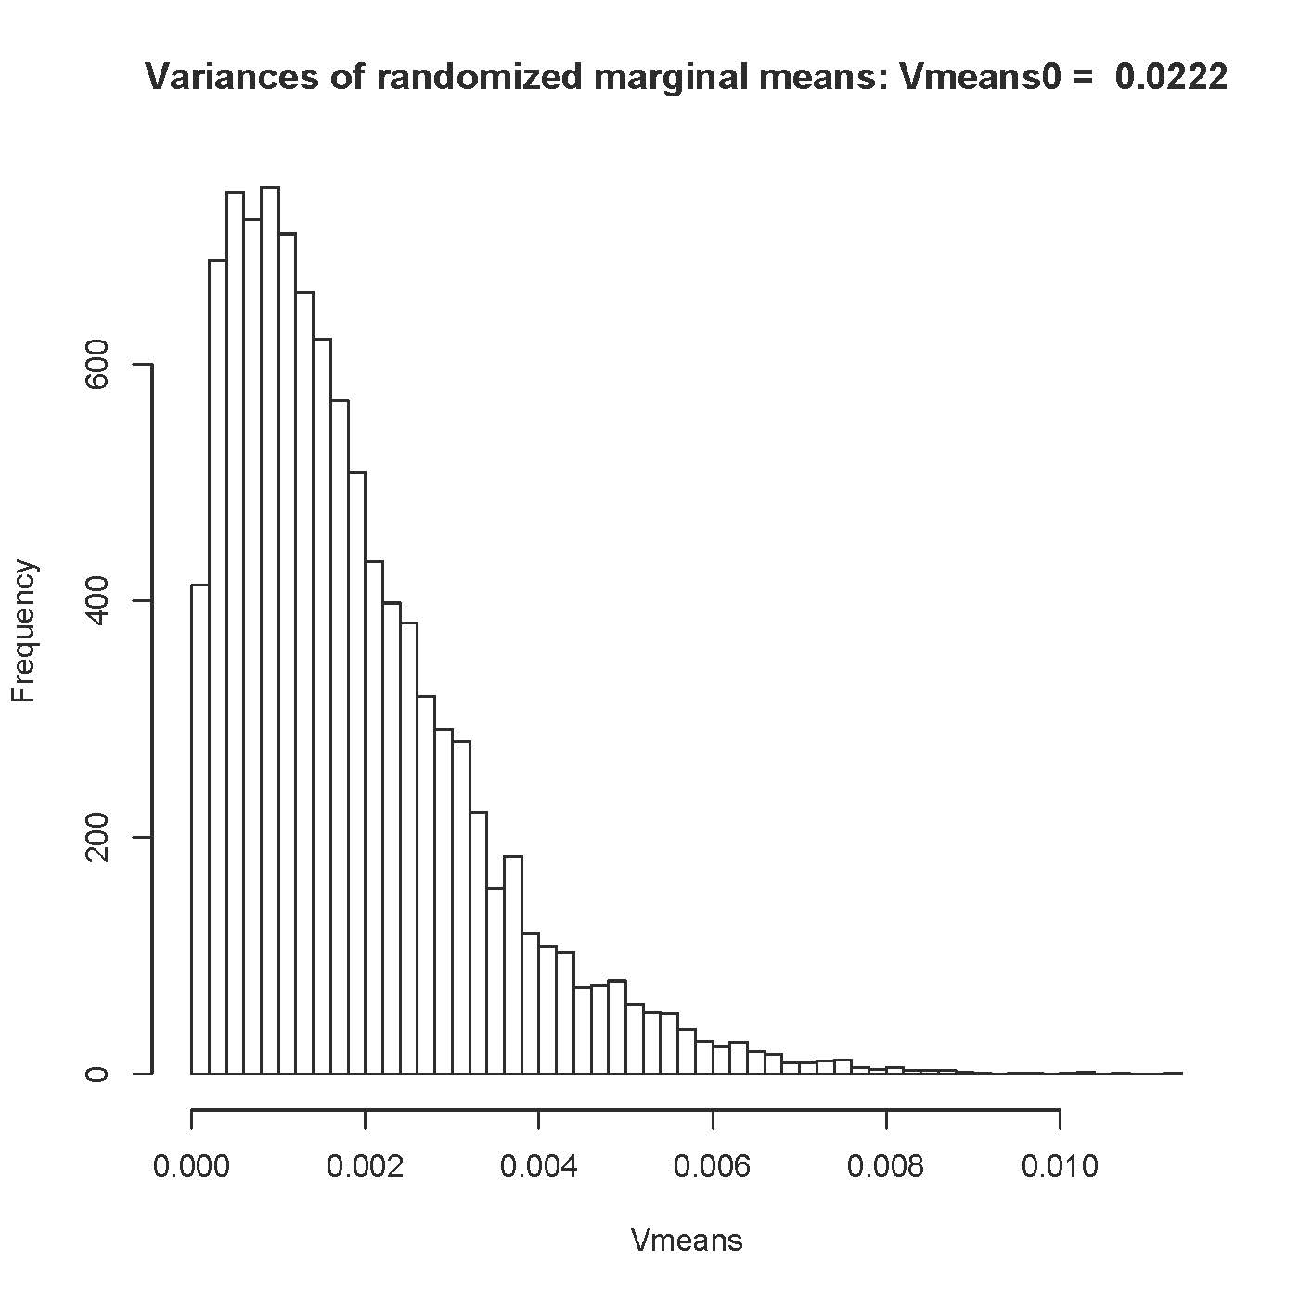

> # p-value
> p1 = length(Vmeans[Vmeans>=Vmeans0])/nsim; p1 # Main effect for condition
[1] 0
> c(Vmeans0,max(Vmeans))
[1] 0.02224338 0.01121872

> title2 = paste('Variances of Adult mean - Child mean: Vdiff0 = ',round(Vdiff0,4))
> hist(Vdiff,breaks='fd', main = title2)

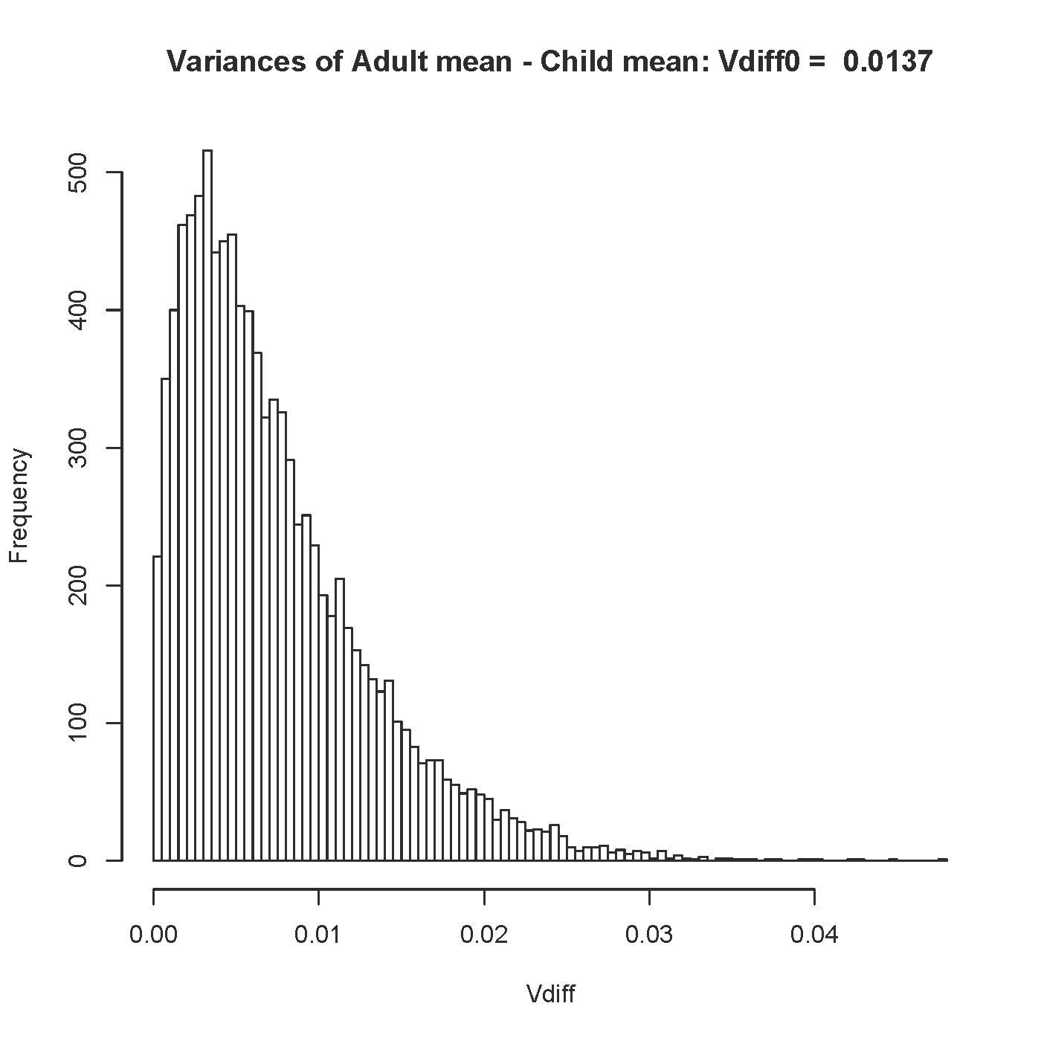

> # p-value
> p2 = length(Vdiff[Vdiff>=Vdiff0])/nsim; p2 # Group by Condition interaction
[1] 0.1344

> # Comparable mixed model results (For all targets)
> # p-value for Condition was approximately zero
> # p-value for Group by Condition was 0.746.

