Randomization tests on the tubes data (between cases)

Fungus of different genetic types was grown in a test tubes for 14 days. Twice a day, the investigators' graduate students measured the length of the fungus in the tube and other variables. In this analysis, the independent variable is type of fungus (mycelial compatibility group or MCG), and the dependent variable is the length of the fungus in the tube at day 10: average of morning and evening measurements.

> rm(list=ls()); options(scipen=999) # To avoid scientific notation
> # install.packages("car") # Just do this once
> library(car) # For F-tests, likelihood ratio and Wald chi-squared tests
> tubes = read.table("http://www.utstat.toronto.edu/~brunner/data/legal/LittleTubes2.data.txt")
> # tubes = read.table("LittleTubes2.data.txt") # Local copy
> head(tubes); attach(tubes)
id mcg length10 sclr10 weight rate
1 1 198 27.80 26.0 0.5996 3.145
2 15 198 28.20 27.0 0.6040 3.235
3 29 198 27.60 28.0 0.6172 3.160
4 43 198 27.50 24.5 0.6053 3.140
5 57 205 24.95 28.0 0.6769 2.975
6 71 205 25.70 29.0 0.7057 2.975
> table(mcg)
mcg
198 205 213 221 223 225
4 4 4 4 4 4
>
> plot(mcg,length10,xaxt='n', xlab = 'mcg: 198, 205, 213, 221, 223, 225')

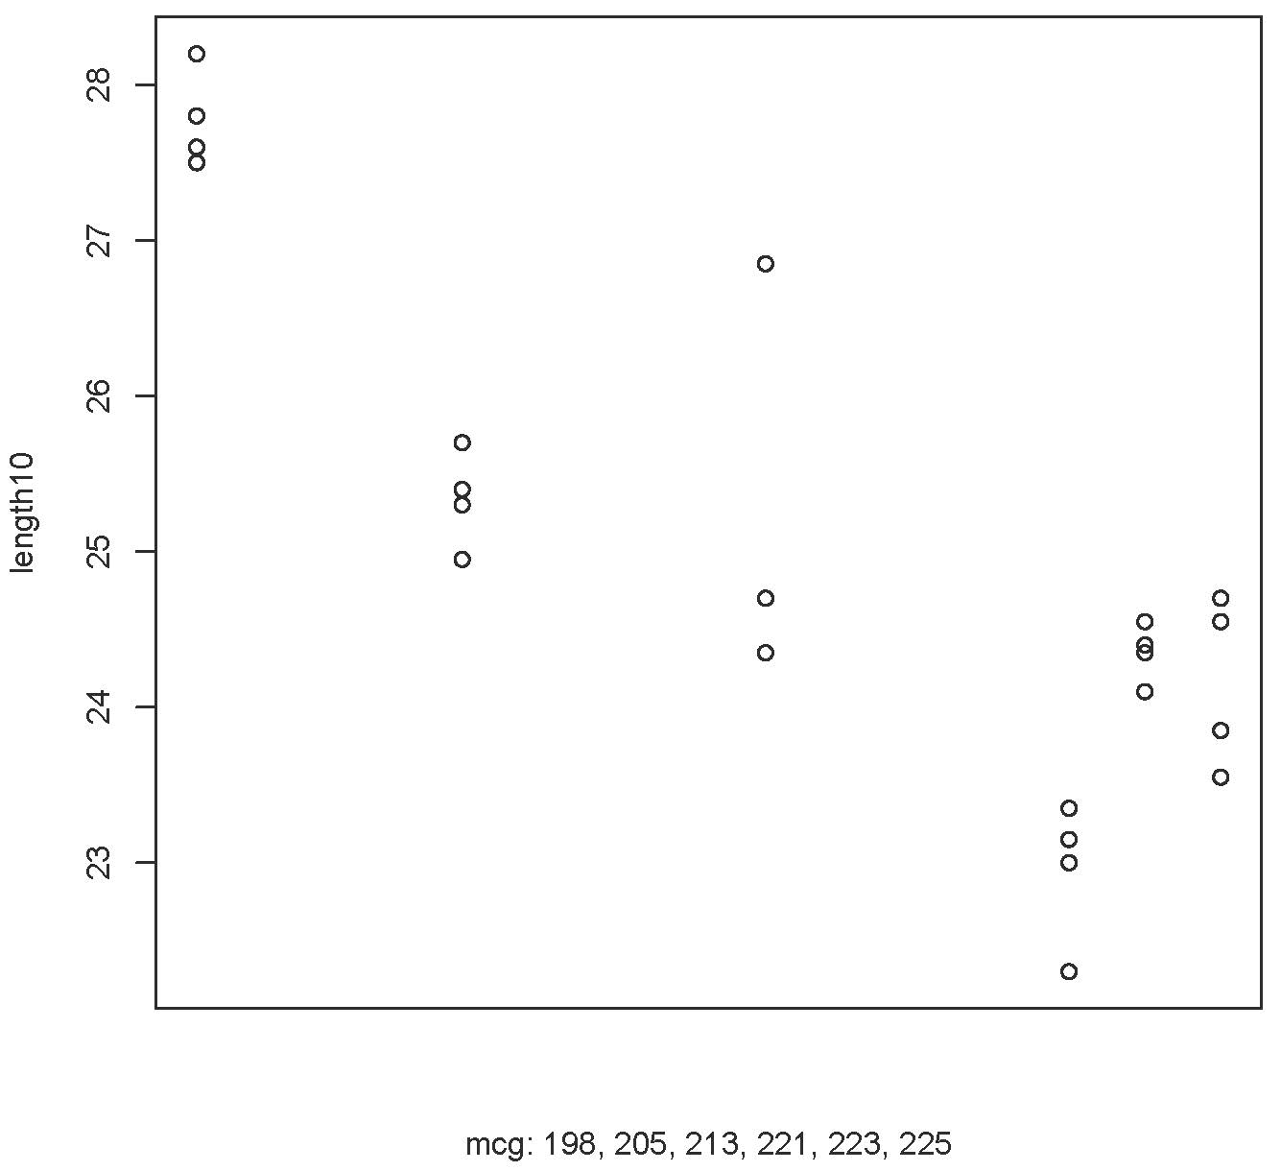

> # Note outlier, and also that mcg=198 is a monster. Set it aside and compare the others.

> length10=length10[mcg!=198]; mcg=mcg[mcg!=198]
> MCG=factor(mcg)
> aggregate(length10,by=list(MCG),FUN=mean) # Look at means
Group.1 x
1 205 25.3375
2 213 25.0625
3 221 22.9500
4 223 24.3500
5 225 24.1625
> # Ordinary one-way ANOVA -- questionable because of the outlier.
> mod0 = lm(length10~MCG); anova(mod0)
Analysis of Variance Table

Response: length10
Df Sum Sq Mean Sq F value Pr(>F)
MCG 4 13.9017 3.4754 8.3136 0.0009646 ***
Residuals 15 6.2706 0.4180
---
Signif. codes: 0 ‘***’ 0.001 ‘**’ 0.01 ‘*’ 0.05 ‘.’ 0.1 ‘ ’ 1
> Fstat0 = summary(mod0)$fstatistic[1] # Just the F statistic
> Fstat0
value
8.313615
> # Multiple comparisons
> TukeyHSD(aov(mod0),ordered=T)
Tukey multiple comparisons of means
95% family-wise confidence level
factor levels have been ordered

Fit: aov(formula = mod0)

$MCG
diff lwr upr p adj
225-221 1.2125 -0.1992619 2.624262 0.1100107
223-221 1.4000 -0.0117619 2.811762 0.0524505
213-221 2.1125 0.7007381 3.524262 0.0026214
205-221 2.3875 0.9757381 3.799262 0.0008387
223-225 0.1875 -1.2242619 1.599262 0.9934146
213-225 0.9000 -0.5117619 2.311762 0.3263124
205-225 1.1750 -0.2367619 2.586762 0.1267851
213-223 0.7125 -0.6992619 2.124262 0.5434644
205-223 0.9875 -0.4242619 2.399262 0.2467446
205-213 0.2750 -1.1367619 1.686762 0.9726917

> # MCG 221 is different from (lower than) 213 and 205
>
> # Randomization test
> # There are 305,540,235,000 ways to scramble the data
> set.seed(9999); nsim=10000; Fstat=numeric(nsim)
> for(j in 1:nsim)
+ {
+ y = sample(length10) # Sample with replacement = random permutation
+ Fstat[j] = summary(lm(y~mcg))$fstatistic[1]
+ } # Next simulation
> Fstat[1:10] # Look at the first 10
[1] 0.45587198 0.07947568 0.38558024 2.60447372 0.39070831 2.39021682 0.57327407 0.61473615
[9] 0.18128631 0.79134788
> length(Fstat[Fstat>=Fstat0])/nsim
[1] 0.0094
> # Compare p = 0.0009646 Still significant, but 10 times as large
> # Doing it a few more times, got p = 0.0091, 0.0109, 0.0093, 0.0091

> kruskal.test(length10~MCG) # Kruskal-Wallis one way analysis of variance by ranks

Kruskal-Wallis rank sum test

data: length10 by MCG
Kruskal-Wallis chi-squared = 13.924, df = 4, p-value = 0.007543

>
> # The coin package (COnditionalINference) has various permutation tests.
> # install.packages("coin") # Only need to do this once
> library(coin)

> # help(oneway_test)
> oneway_test(length10~MCG) # p = 0.01083

Asymptotic K-Sample Fisher-Pitman Permutation Test

data: length10 by MCG (205, 213, 221, 223, 225)
chi-squared = 13.094, df = 4, p-value = 0.01083

>
> # Multiple comparisons via randomization
> # Compute all pairwise t-tests (unequal variance assumption)
> tvals = matrix(0,5,5)
> mcgval = sort(unique(mcg))
> rownames(tvals) = colnames (tvals) = mcgval
> for(Row in 1:4)
+ {
+ for(Col in (Row+1):5)
+ {
+ A = length10[mcg==mcgval[Row]]
+ B = length10[mcg==mcgval[Col]]
+ tvals[Row,Col] = abs( t.test(A,B)$statistic )
+ }
+ }
> tvals
205 213 221 223 225
205 0 0.4427835 8.660966 5.464544 3.7176130
213 0 0.0000000 3.283566 1.170437 1.3601864
221 0 0.0000000 0.000000 5.676194 3.3880756
223 0 0.0000000 0.000000 0.000000 0.6441071
225 0 0.0000000 0.000000 0.000000 0.0000000

> # Find critical values of maximum absolute t statistic. If null hypothesis
> # is true, the probability that all are below equals 0.95, and the
> # probability of one or more is (wrongly) above is 0.05.
>
> simtvals = tvals-tvals # Hold simulated t-values in matrix simtvals
> set.seed(8888)
> nsim = 10000; maxT = numeric(nsim)
> for(j in 1:nsim)
+ {
+ for(Row in 1:4)
+ {
+ for(Col in (Row+1):5)
+ {
+ datta = c(length10[mcg==mcgval[Row]],
+ length10[mcg==mcgval[Col]]) # Put data in one pot
+ scramble = sample(datta) # Mix it up
+ A = scramble[1:4]; B = scramble[5:8]
+ simtvals[Row,Col] = abs( t.test(A,B)$statistic )
+ } # Next Col in the table
+ } # Next Row in the table
+ maxT[j] = max(simtvals)
+ } # Next simulation j
> hist(maxT, breaks='fd')

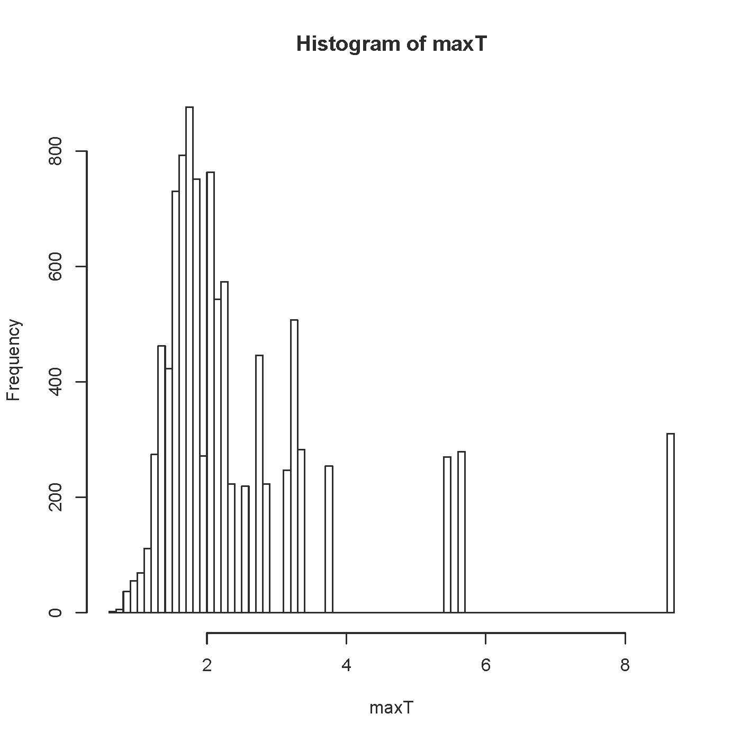

> length(unique(maxT))
[1] 136
> # There are only 136 unique values, because the sample sizes are so small.
> table(maxT)
maxT
0.631393473296017 0.686061604809112 0.710909286751898 0.799021429604816 0.799144411695704
1 1 1 3 2
0.804032108985107 0.82092803241773 0.820928032417733 0.826767381914332 0.833472299723665
1 1 2 2 1
0.837218358278921 0.837860948440368 0.842489683950126 0.850230301897703 0.878365973360015
1 1 3 3 5
0.878431740526561 0.884390199085696 0.886681576989414 0.893064637781637 0.903994441358834
5 3 5 4 2
0.917044355745298 0.931652523402094 0.932448967957128 0.933256525257381 0.933256525257395
3 16 9 3 2
0.938253160996928 0.939393939393947 0.942912927702791 0.957591317878072 0.977461894333811
6 2 1 3 8
1.00994121985473 1.01923755806376 1.02417347552625 1.0372715186439 1.04582256735224
3 5 17 3 6
1.07185598641969 1.08359046574615 1.09906734049839 1.10074141558049 1.10959399278472
20 8 7 14 12
1.12058367048475 1.12757446635522 1.14627454820992 1.15470053837926 1.15794745626015
9 9 11 8 10
1.16075889974966 1.17043696905226 1.21434602004128 1.21722333737947 1.21722333737948
13 25 25 17 15
1.22150329338751 1.22874585642994 1.23596912797325 1.24393264329409 1.26116828954168
41 16 16 45 38
1.26577242682571 1.26724522422693 1.30060972317916 1.31710976071664 1.32389270974355
45 16 31 20 22
1.33520587983849 1.33672278941056 1.33916314673729 1.35896476250056 1.36018640868858
31 23 51 51 65
1.37201584386816 1.38297872340425 1.38304473424466 1.40175993827342 1.40954724433621
32 68 68 42 46
1.439944828299 1.44265656103573 1.44564436859466 1.44783958657606 1.45087383528466
24 57 56 47 53
1.49037128976401 1.50961311293385 1.50961311293386 1.51627586174069 1.52687907035753
98 49 54 61 59
1.54303349962092 1.56913026454941 1.59399690361129 1.60951003943655 1.61235856741763
57 234 216 72 74
1.64473347565137 1.65344827962325 1.68166904394841 1.68167564648372 1.69282947806063
101 96 87 77 96
1.69616651560716 1.71636003902653 1.71652792061004 1.72806282553573 1.74340243627067
189 87 192 118 241
1.77281052085584 1.79106694237798 1.80578779628654 1.82915960136083 1.83482698437864
105 133 124 136 120
1.86917960927774 1.89467013843749 1.94494475178437 1.96937014151971 2.00713014739239
115 256 121 151 163
2.01504408998011 2.03930016560806 2.05815659595423 2.07763008319333 2.14269564023653
143 142 170 145 172
2.15890677135333 2.22408237769114 2.2514481561646 2.26668570332764 2.35392939710549
371 182 185 206 223
2.5988129407631 2.72378086566882 2.74562589193457 2.89071939090841 3.18177346164191
219 219 227 223 247
3.2305139641303 3.28356581394543 3.38807563773945 3.71761301197124 5.46454426454198
254 253 283 254 270
5.67619397855569 8.66096629812587
279 310
> 0.05*10000
[1] 500
> # Critical value should cut off the top 500 values
> # 310/10,000 = 0.031, and (279+310)/10,000 = 0.0589, so t > 5.68
> # is required for significance. Only values of t = 8.660966 are
> # significant, at the 0.031 level. Alpha = 0.05 is not available.
> # That's mcg 205 versus 221 (highest versus lowest)

