Repeated measures analysis with R

Summary for experienced R users

The lmer function from the lme4 package has a syntax like lm.

Add something like + (1|subject) to the model for the random subject effect.

To get p-values, use the car package.

Avoid the lmerTest package.

For balanced designs, Anova(dichotic, test="F")

For unbalanced designs,

Set contrasts on the factors like this: contrasts(Time) = contr.sum(5)
And BlueModel = lmer(Beck ~ Time*Drug*Treatment + (1|Subject))
And Anova(BlueModel, test="F", type="III")

Or

BlueModel = lmer(Beck ~ Time*Drug*Treatment + (1|Subject),
contrasts = list(Time="contr.sum", Drug="contr.sum",
Treatment="contr.sum"))
And Anova(BlueModel, test="F", type="III")

# Install packages if necessary. Only need to do this once.
# install.packages("lme4")
# install.packages("car")
# Load packages -- do this every time
library(lme4) # For the lmer function
library(car) # For F and Wald tests with p-values

The glmer function from the lme4 package has a syntax like glm.

hoops = glmer(Hit ~ Spot*Hand + (1 | Subject), family=binomial)
Anova(hoops, type="III")

> # Hand-ear dichotic listening study
> # Install packages if necessary. Only need to do this once.
> # install.packages("lme4")
> # install.packages("car")
> # Load packages -- do this every time
> library(lme4) # For lmer function
Loading required package: Matrix
> library(car) # For F-tests, likelihood ratio and Wald chi-squared tests
> # Read data into a data frame
> dichotic = read.table("http://www.utstat.toronto.edu/~brunner/data/legal/HandEar.data.txt")
> head(dichotic) # Look at the first few lines.
subject handed ear rtime
1 1 Left Left 330
2 1 Left Right 327
3 1 Left Both 303
4 2 Left Left 294
5 2 Left Right 339
6 2 Left Both 315
> attach(dichotic) # Make variable names available
>
> # Sample sizes
> table(handed,ear)
ear
handed Both Left Right
Left 20 20 20
Right 20 20 20
>
> # Treatment means
> aggregate(rtime,by=list(ear,handed),FUN=mean) # First changes fastest
Group.1 Group.2 x
1 Both Left 317.90
2 Left Left 326.60
3 Right Left 332.80
4 Both Right 315.10
5 Left Right 324.65
6 Right Right 320.85
>
> # Two-way table of means
> LeftHanded = meantable[1:3,3]; RightHanded = meantable[4:6,3]
> TwoWay = rbind(LeftHanded,RightHanded)
> colnames(TwoWay) = c("BothEars","LeftEar","RightEar")
> TwoWay
>
BothEars LeftEar RightEar
LeftHanded 317.9 326.60 332.80
RightHanded 315.1 324.65 320.85
>
> # Marginal means
> aggregate(rtime,by=list(handed),FUN=mean)
Group.1 x
1 Left 325.7667
2 Right 320.2000
> aggregate(rtime,by=list(ear),FUN=mean)
Group.1 x
1 Both 316.500
2 Left 325.625
3 Right 326.825

> # Plot the means
> Means = meantable[,3] # All the rows, column 3
> lhand = Means[1:3]; rhand = Means[4:6]
> Ear = c(1:3,1:3)
> # Invisible points at first, x axis points at 1,2,3; see help(plot)
> plot(Ear,Means,pch=" ",xaxp=c(1,3,2),
+ xlab="Ear Receiving Signal: 1=Both, 2=Left, 3=Right",
+ ylab="Mean Reaction Time")
> title("Reaction Time")
> points(1:3,lhand,col='red',pch=15) # Red squares
> points(1:3,rhand,col='blue',pch=19) # Blue circles
> lines(1:3,lhand,lty=1,col='red'); lines(1:3,rhand,lty=3,col='blue')
> # Annotate the plot
> x1 = c(1.1,1.6); y1 = c(332,332); lines(x1,y1,lty=1,col='red')
> points(1.35,332,col='red',pch=15)
> text(1.80,332,'Left Handed',col='red')
> x2 = c(1.1,1.6); y2 = c(331,331); lines(x2,y2,lty=3,col='blue')
> points(1.35,331,col='blue',pch=19)
> text(1.82,331,'Right Handed',col='blue')

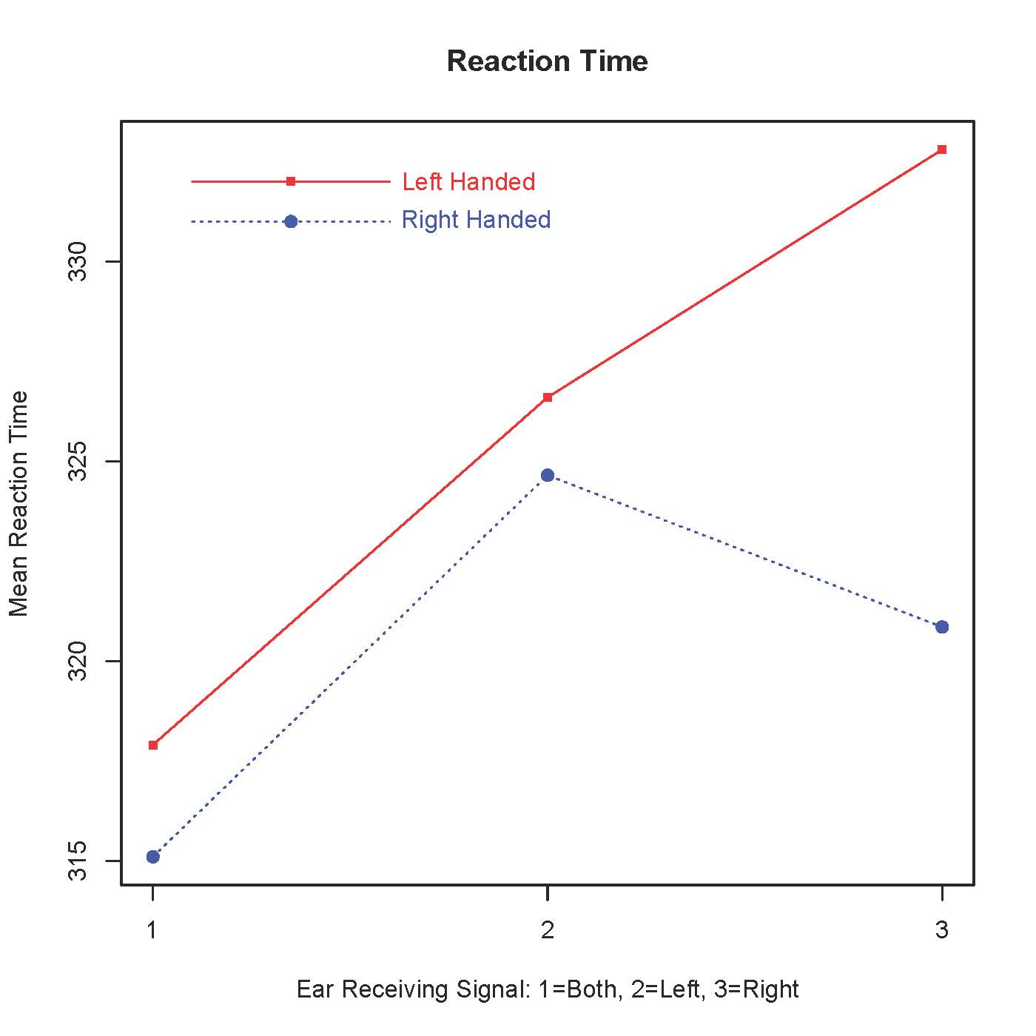

> # Naive fixed effects analysis
> anova(lm(rtime ~ handed*ear))

Analysis of Variance Table

Response: rtime
Df Sum Sq Mean Sq F value Pr(>F)
handed 1 930 929.63 1.8556 0.17582
ear 2 2551 1275.41 2.5458 0.08286 .
handed:ear 2 615 307.41 0.6136 0.54317
Residuals 114 57113 500.99
---
Signif. codes: 0 ‘***’ 0.001 ‘**’ 0.01 ‘*’ 0.05 ‘.’ 0.1 ‘ ’ 1
>
> # Repeated measures with a mixed model
> dichotic = lmer(rtime ~ handed*ear + (1 | subject))
> Anova(dichotic, test="F") # F tests (from car package)
Analysis of Deviance Table (Type II Wald F tests with Kenward-Roger df)

Response: rtime
F Df Df.res Pr(>F)
handed 0.9706 1 38 0.33075
ear 4.6787 2 76 0.01213 *
handed:ear 1.1277 2 76 0.32914
---
Signif. codes: 0 ‘***’ 0.001 ‘**’ 0.01 ‘*’ 0.05 ‘.’ 0.1 ‘ ’ 1
>
> # Multiple comparisons: Which marginal means are different?
>
> # The combination variable HandEar will have 6 values
> n = length(rtime); n
[1] 120
> HandEar = character(n) # A character-valued variable of length n
> for(j in 1:n) HandEar[j] = paste(handed[j],ear[j],sep='')
> HandEar = factor(HandEar) # Maybe would be interpreted as a factor anyway
> head(data.frame(handed,ear,HandEar))
handed ear HandEar
1 Left Left LeftLeft
2 Left Right LeftRight
3 Left Both LeftBoth
4 Left Left LeftLeft
5 Left Right LeftRight
6 Left Both LeftBoth
> table(HandEar) # Sample sizes
HandEar
LeftBoth LeftLeft LeftRight RightBoth RightLeft RightRight
20 20 20 20 20 20
>
> # Want a table of means in a similar format.
> meantable # Again
Ear Handed Mean RT
1 Both Left 317.90
2 Left Left 326.60
3 Right Left 332.80
4 Both Right 315.10
5 Left Right 324.65
6 Right Right 320.85
> ComboMeans = meantable[,3] # All the rows, 3d column
> names(ComboMeans) = sort(unique(HandEar)); ComboMeans
LeftBoth LeftLeft LeftRight RightBoth RightLeft RightRight
317.90 326.60 332.80 315.10 324.65 320.85

>
> # For a no-intercept model on a combination variable, the regression
> # coefficients are the treatment combination means. Details omitted.
>
> # Fit a no-intercept model
> ComboModel = lmer(rtime ~ 0 + HandEar + (1 | subject))
>
> # Contrast matrix for testing Ear, just as a check
> CM1 = rbind(c(1, -1, 0, 1, -1, 0), # Both - Left
+ c(0, 1, -1, 0, 1, -1)) # Left - Right
> colnames(CM1) = sort(unique(HandEar)) # Makes it easier to look at
> CM1
LeftBoth LeftLeft LeftRight RightBoth RightLeft RightRight
[1,] 1 -1 0 1 -1 0
[2,] 0 1 -1 0 1 -1
> linearHypothesis(ComboModel,CM1,test="F") # Compare F = 4.6787
Linear hypothesis test

Hypothesis:
HandEarLeftBoth - HandEarLeftLeft + HandEarRightBoth - HandEarRightLeft = 0
HandEarLeftLeft - HandEarLeftRight + HandEarRightLeft - HandEarRightRight = 0

Model 1: restricted model
Model 2: rtime ~ 0 + HandEar + (1 | subject)

Res.Df Df F Pr(>F)
1 78
2 76 2 4.6787 0.01213 *
---
Signif. codes: 0 ‘***’ 0.001 ‘**’ 0.01 ‘*’ 0.05 ‘.’ 0.1 ‘ ’ 1

>
> # Now 3 pairwise comparisons of marginal means for ear.
> # Use a Bonferroni correction, meaning compare p-value to
> # 0.05 divided by the number of tests: 0.05/3 = 0.01666667
>
> bothVSleft = c(1, -1, 0, 1, -1, 0)
> linearHypothesis(ComboModel,bothVSleft,test="F")
Linear hypothesis test

Hypothesis:
HandEarLeftBoth - HandEarLeftLeft + HandEarRightBoth - HandEarRightLeft = 0

Model 1: restricted model
Model 2: rtime ~ 0 + HandEar + (1 | subject)

Res.Df Df F Pr(>F)
1 77
2 76 1 6.109 0.01569 *
---
Signif. codes: 0 ‘***’ 0.001 ‘**’ 0.01 ‘*’ 0.05 ‘.’ 0.1 ‘ ’ 1
> bothVSright = c(1, 0, -1, 1, 0, -1)
> linearHypothesis(ComboModel,bothVSright,test="F")
Linear hypothesis test

Hypothesis:
HandEarLeftBoth - HandEarLeftRight + HandEarRightBoth - HandEarRightRight = 0

Model 1: restricted model
Model 2: rtime ~ 0 + HandEar + (1 | subject)

Res.Df Df F Pr(>F)
1 77
2 76 1 7.8214 0.006536 **
---
Signif. codes: 0 ‘***’ 0.001 ‘**’ 0.01 ‘*’ 0.05 ‘.’ 0.1 ‘ ’ 1
> leftVSright = c(0, 1, -1, 0, 1, -1)
> linearHypothesis(ComboModel,leftVSright,test="F")
Linear hypothesis test

Hypothesis:
HandEarLeftLeft - HandEarLeftRight + HandEarRightLeft - HandEarRightRight = 0

Model 1: restricted model
Model 2: rtime ~ 0 + HandEar + (1 | subject)

Res.Df Df F Pr(>F)
1 77
2 76 1 0.1056 0.746
>
>

Baayen, Davidson and Bates (2008)

> # Baayen, Davidson and Bates (2008) Data (Item is a random effect)
>
> # Reproduce Baayen, Davidson and Bates numbers
> rm(list=ls()); options(scipen=999) # To avoid scientific notation
> # Install packages if necessary. Only need to do this once.
> # install.packages("lme4")
> # install.packages("car")
> # install.packages("tables")
> # Load packages -- do this every time
> library(lme4) # For lmer function
Loading required package: Matrix
> library(car) # For F-tests, likelihood ratio and Wald chi-squared tests
> library(tables) # For nice-looking tables
Loading required package: Hmisc
Loading required package: lattice
Loading required package: survival
Loading required package: Formula
Loading required package: ggplot2

This data.table install has not detected OpenMP support. It will work but slower in single threaded mode.

Attaching package: ‘Hmisc’

The following objects are masked from ‘package:base’:

format.pval, round.POSIXt, trunc.POSIXt, units

> # Read data into a data frame
>
> rt = read.table("BaayenDavidsonBates.Data.txt",header=T)
> rt; attach(rt)
Subject Item Treatment ReactionTime
1 s1 w1 Long 466
2 s1 w2 Long 520
3 s1 w3 Long 502
4 s1 w1 Short 475
5 s1 w2 Short 494
6 s1 w3 Short 490
7 s2 w1 Long 516
8 s2 w2 Long 566
9 s2 w3 Long 577
10 s2 w1 Short 491
11 s2 w2 Short 544
12 s2 w3 Short 526
13 s3 w1 Long 484
14 s3 w2 Long 529
15 s3 w3 Long 539
16 s3 w1 Short 470
17 s3 w2 Short 511
18 s3 w3 Short 528

> table(Treatment, Item) # Sample sizes
Item
Treatment w1 w2 w3
Long 3 3 3
Short 3 3 3

>
> # In the tabular syntax, + means stick it together
> # Row descriptions are on the left of ~
> tabular(Treatment ~ ReactionTime*(mean+sd))

ReactionTime
Treatment mean sd
Long 522.1 35.91
Short 503.2 25.41
> tabular(Item ~ ReactionTime*(mean+sd))

ReactionTime
Item mean sd
w1 483.7 18.29
w2 527.3 25.33
w3 527.0 30.46
>
> # Fit a mixed model: Treatment effect is fixed, Subject and Item are random
> # and independent.
> mixedmod = lmer(ReactionTime ~ Treatment + (1|Item) + (1|Subject) )
> summary(mixedmod)

Linear mixed model fit by REML ['lmerMod']
Formula: ReactionTime ~ Treatment + (1 | Item) + (1 | Subject)

REML criterion at convergence: 141.4

Scaled residuals:
Min 1Q Median 3Q Max
-1.1932 -0.6004 -0.2425 0.4418 1.7307

Random effects:
Groups Name Variance Std.Dev.
Item (Intercept) 607.9 24.66
Subject (Intercept) 499.4 22.35
Residual 137.3 11.72
Number of obs: 18, groups: Item, 3; Subject, 3

Fixed effects:
Estimate Std. Error t value
(Intercept) 522.111 19.605 26.632
TreatmentShort -18.889 5.525 -3.419

Correlation of Fixed Effects:
(Intr)
TretmntShrt -0.141

> Anova(mixedmod, test="F")
Analysis of Deviance Table (Type II Wald F tests with Kenward-Roger df)

Response: ReactionTime
F Df Df.res Pr(>F)
Treatment 11.69 1 12 0.005087 **
---
Signif. codes: 0 ‘***’ 0.001 ‘**’ 0.01 ‘*’ 0.05 ‘.’ 0.1 ‘ ’ 1
>
>

Unbalanced designs: Beat the Blues study

This R data set contains data from a longitudinal clinical trial of an interactive, multimedia program known as "Beat the Blues" designed to deliver cognitive behavioural therapy to depressed patients via a computer terminal. Patients with depression recruited in primary care were randomised to either the Beating the Blues program, or to "Treatment as Usual" (TAU). The variables are

- id: Patient identification code
- drug: Did the patient take anti-depressant drugs (No or Yes).
- length: The length of the current episode of depression, a factor with values <6m (less than six months) and >6m (more than six months).
- treatment: Treatment group, a factor with levels TAU (treatment as usual) and
BtheB (Beat the Blues)
- bdi_pre: Beck Depression Inventory score before treatment.
- bdi_2m: Beck Depression Inventory score after two months
- bdi_4m: Beck Depression Inventory score after four months
- bdi_6m: Beck Depression Inventory score after six months
- bdi_8m: Beck Depression Inventory score after eight months

> # Install packages if necessary. Only need to do this once.
> # install.packages("lme4")
> # install.packages("car")
> # Load packages -- do this every time
> library(lme4) # For lmer function
Loading required package: Matrix
> library(car) # For F-tests, likelihood ratio and Wald chi-squared tests
>
> # install.packages("HSAUR") # Handbook of Statistical Analyses Using R
> library(HSAUR)
Loading required package: tools
> attach(BtheB); head(BtheB) # Beat the Blues data
drug length treatment bdi.pre bdi.2m bdi.4m bdi.6m bdi.8m
1 No >6m TAU 29 2 2 NA NA
2 Yes >6m BtheB 32 16 24 17 20
3 Yes <6m TAU 25 20 NA NA NA
4 No >6m BtheB 21 17 16 10 9
5 Yes >6m BtheB 26 23 NA NA NA
6 Yes <6m BtheB 7 0 0 0 0
>
> # Format is wrong -- need one line per response for lmer

> # Format is wrong -- need one line per response for lmer
> Subject = Drug = Treatment = Beck = Time = NULL
> n = length(drug); n
[1] 100
> for(j in 1:n)
+ {
+ Time = c(Time, 0)
+ Beck = c(Beck,bdi.pre[j])
+ Subject = c(Subject, j)
+ Drug = c(Drug, as.character(drug[j]))
+ Treatment = c(Treatment, as.character(treatment[j]))
+ Time = c(Time, 2)
+ Beck = c(Beck,bdi.2m[j])
+ Subject = c(Subject, j)
+ Drug = c(Drug, as.character(drug[j]))
+ Treatment = c(Treatment, as.character(treatment[j]))
+ Time = c(Time, 4)
+ Beck = c(Beck,bdi.4m[j])
+ Subject = c(Subject, j)
+ Drug = c(Drug, as.character(drug[j]))
+ Treatment = c(Treatment, as.character(treatment[j]))
+ Time = c(Time, 6)
+ Beck = c(Beck,bdi.6m[j])
+ Subject = c(Subject, j)
+ Drug = c(Drug, as.character(drug[j]))
+ Treatment = c(Treatment, as.character(treatment[j]))
+ Time = c(Time, 8)
+ Beck = c(Beck,bdi.8m[j])
+ Subject = c(Subject, j)
+ Drug = c(Drug, as.character(drug[j]))
+ Treatment = c(Treatment, as.character(treatment[j]))
+ }
> Time = factor(Time) # Otherwise it's numeric
> blues = data.frame(Subject,Time,Drug,Treatment,Beck)
> dim(blues) # Number of rows and columns
[1] 500 5
> head(blues)
Subject Time Drug Treatment Beck
1 1 0 No TAU 29
2 1 2 No TAU 2
3 1 4 No TAU 2
4 1 6 No TAU NA
5 1 8 No TAU NA
6 2 0 Yes BtheB 32

>
> # Sample sizes
> table(Treatment,Time,Drug)
, , Drug = No

Time
Treatment 0 2 4 6 8
BtheB 22 22 22 22 22
TAU 34 34 34 34 34

, , Drug = Yes

Time
Treatment 0 2 4 6 8
BtheB 30 30 30 30 30
TAU 14 14 14 14 14

> table(Treatment,Drug) # Unbalanced
Drug
Treatment No Yes
BtheB 110 150
TAU 170 70
>
> # For unbalanced designs, set contrasts to contr.sum on all factors and
> # use the type="III" (Type III sums of squares) option on the Anova function.
> # This way, tests of main effects and interactions will correspond to what you
> # would get by testing contrasts on a combination variable, which is usually
> # what you want. Details are definitely omitted.
>
> BlueModel = lmer(Beck ~ Time*Drug*Treatment + (1 | Subject),
+ contrasts = list(Time="contr.sum", Drug="contr.sum", Treatment="contr.sum"))
> Anova(BlueModel, test="F", type="III") # Satterthwaite adjustment to df
Analysis of Deviance Table (Type III Wald F tests with Kenward-Roger df)

Response: Beck
F Df Df.res Pr(>F)
(Intercept) 241.0743 1 99.215 < 2e-16 ***
Time 37.9453 4 269.910 < 2e-16 ***
Drug 0.1434 1 99.215 0.70571
Treatment 3.3556 1 99.215 0.06998 .
Time:Drug 3.0517 4 269.910 0.01748 *
Time:Treatment 0.4104 4 269.910 0.80108
Drug:Treatment 1.1329 1 99.215 0.28974
Time:Drug:Treatment 1.8645 4 269.910 0.11693
---
Signif. codes: 0 ‘***’ 0.001 ‘**’ 0.01 ‘*’ 0.05 ‘.’ 0.1 ‘ ’ 1

>
> # This calls for a 2-way table of means
> # install.packages("apaTables")
> library(apaTables) # For 2-way tables of means and Sds

Warning message:
Installed Rcpp (0.12.8) different from Rcpp used to build dplyr (0.12.11).
Please reinstall dplyr to avoid random crashes or undefined behavior.

> apa.2way.table(Drug,Time,Beck,data=blues, show.marginal.means = T)

Means and standard deviations for Beck as a function of a 2(Drug) X 5(Time) design

Time
0 2 4 6 8 Marginal
Drug M SD M SD M SD M SD M SD M SD
No 21.55 8.97 17.69 10.98 15.63 10.78 13.88 11.96 12.00 10.19 16.99 10.91
Yes 25.59 12.58 15.90 10.57 13.75 13.13 11.38 10.14 10.12 8.25 16.51 12.58
Marginal 23.33 10.84 16.92 10.79 14.81 11.82 12.76 11.15 11.13 9.31

Note. M and SD represent mean and standard deviation, respectively.
Marginal indicates the means and standard deviations pertaining to main effects.

>
> # I actually edited the table by hand to get rid of the standard deviations

Time
Drug 0 2 4 6 8 Marginal
No 21.55 17.69 15.63 13.88 12.00 16.99
Yes 25.59 15.90 13.75 11.38 10.12 16.51
Marginal 23.33 16.92 14.81 12.765 11.13

